# 3. Arduino analog input and output

Difficult Level: 

## A. Introduction

The world is analog. And any inputs we can perceive are analog. For example, sounds are analog signals; they are continuous time and continuous value. Our ears listen to analog signals and we speak with analog signals. Images, pictures, and video are all analog at the source and our eyes are analog sensors.

## B. The analog in this Kit

An analog input pin can read a voltage level that ranges from the supply voltage of your board 3.3 v (3.3V) down to 0 v (GND). The value returned to your program from reading the pin is not the actual voltage value but a number that is between 0 and 1023. This is because the microcontroller on the board is a digital system and must convert the analog signal at an input pin to a digital number. The value representing the input voltage that is returned is relative to the actual voltage level present at the pin.

Reading an analog input pin is quite simple. There’s just one block to does it which returns a number that represents the input voltage level. The raindrop sensor is an analog quantity in the kit. Now let’s read the raindrop sensor.

### What you need?

* Arduino IDE software
* 1 x Arduino UNO R4 Wi-Fi
* 1 x USB 2.0 cable Type C
* 1 x Raindrop Sensor Module
* 3 x Female-Male Jumper wires

### How to wiring circuit diagram?

|  |  |
| --- | --- |
| Arduino UNO R4 WIFI | Raindrop Sensor Module |
| 7 | VCC |
| GND | GND |
| NC | DO |
| A0 | AO |

You can look at the circuit connection diagram below to connect our own devices.

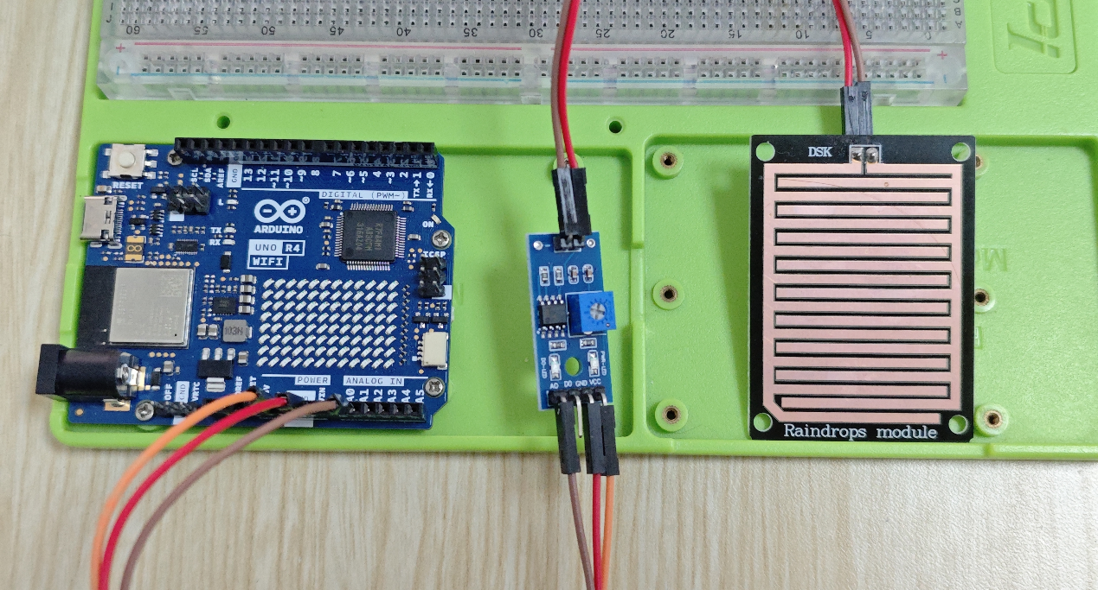

Then connect the computer with the Arduino UNO R4 WIFI, and open the Arduino IDE. Then copy the code and upload it. It’s easy to know we need only read from the A0 pin.

**#define AO_PIN A0 // Arduino's pin connected to AO pin of the rain sensor**

**void setup() {**

**// initialize serial communication**

**Serial.begin(9600);**

**}**

**void loop() {**

**//read analog from A0 pin**

**int rainValue = analogRead(AO_PIN);**

**Serial.println(rainValue); // print out the analog value**

**delay(1000); // pause for 1 sec to avoid reading sensors frequently to prolong the sensor lifetime**

**}**

After upload finished we can get our answer from the serial monitor. (By put some water drops on the sensor and dry it slowly, its value gradually increases)

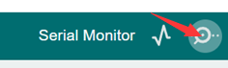

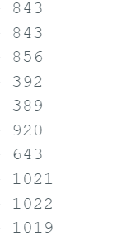

An analog-to-digital converter (ADC) transforms an analog signal to a digital one. In the previous arduino Uno board, the arduino Uno r4 Wi-Fi updates the standard resolution. You can use analogReadResolution () to update the standard resolution to 12-bit resolutions or 14-bit resolutions. The standard resolution on Arduino boards the default is set to 10-bit (0-1023)).

This means that it will map input voltages between 0 and the operating voltage (5V or 3.3V) into integer values between 0 and 1023(0-4095 for 12 bits, 0-16383 for 14 bits). On 10-bit resolution, for example, this yields a resolution between readings of: 5 volts / 1024 units or, 0.0049 volts (4.9 mV) per unit.

You can modify your code to read the data more accurately based on the image below.

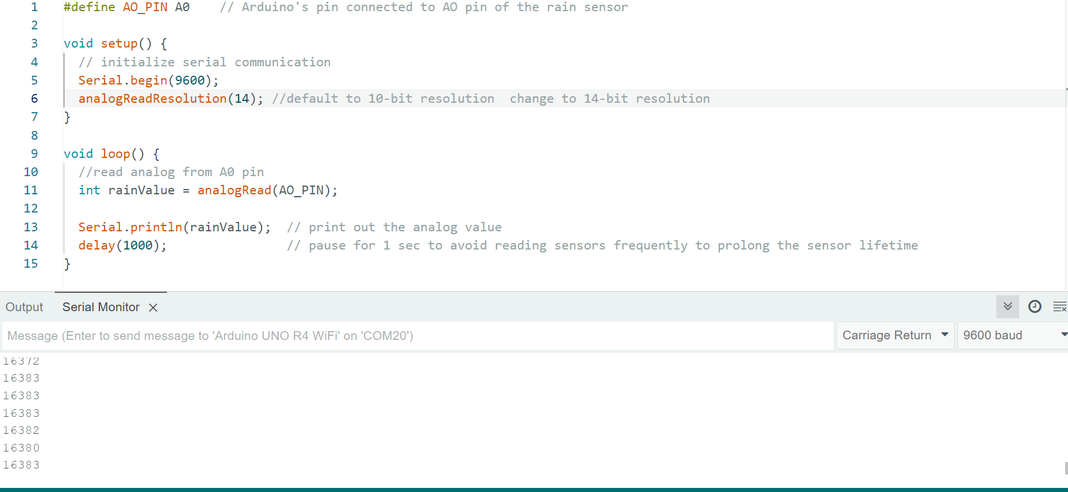

## C. Other analog sensor and code

### The soil moisture sensor

Code:

**#define AO_PIN A0    // Arduino's pin connected to AO pin of the rain sensor**

**void setup() {**

**// initialize serial communication**

**Serial.begin(9600);**

**analogReadResolution(14); //default to 10-bit resolution  change to 14-bit resolution**

**}**

**void loop() {**

**//read analog from A0 pin**

**int moistureValue = analogRead(AO_PIN);**

**Serial.println(moistureValue);  // print out the analog value**

**delay(1000);                // pause for 1 sec to avoid reading sensors frequently to prolong the sensor lifetime**

**}**

This sensor is very similar to the raindrop sensor, you just read the A0 data to print the moisture in the soil, and you can also percentage it to get the water content of the soil.

When you run this code, after it finished you should put the sensor into the water slowly. (Note: don’t put all sensor into the water, only put the bottle part, and its value gradually decreases)

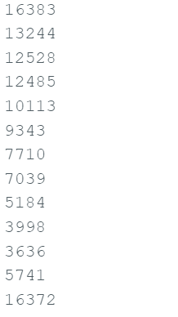

If you have succeeded, then congratulations, you can already try to use this module to make an automatic watering system for your flowers and plants. You can judge whether watering is needed by detecting the moisture of the soil, and you can also water it automatically!