ADAFRUIT DASHBOARD TUTORIAL

Prerequisite

Steps

- Install ADAFRUIT_IO library for python3 or python2

Command
>> sudo pip install Adafruit_IO
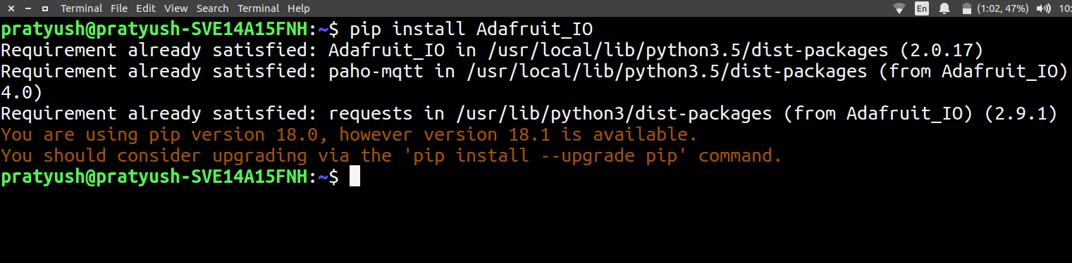

- Create an Account on Adafruit.io

Steps to create Feed and Dashboard

- navigate to Adafruit.io and Login
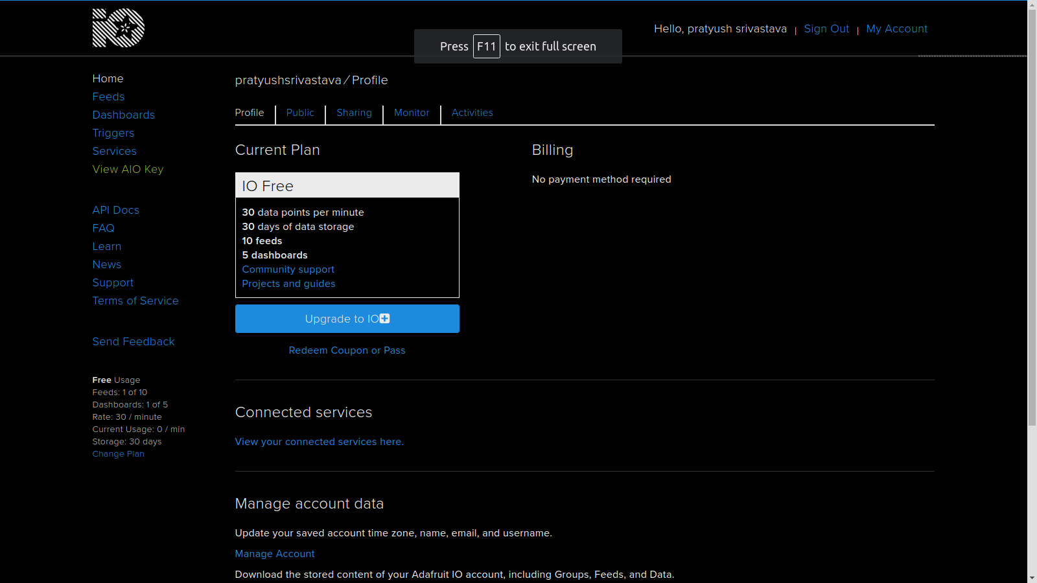

- Click on Feeds on the left panel
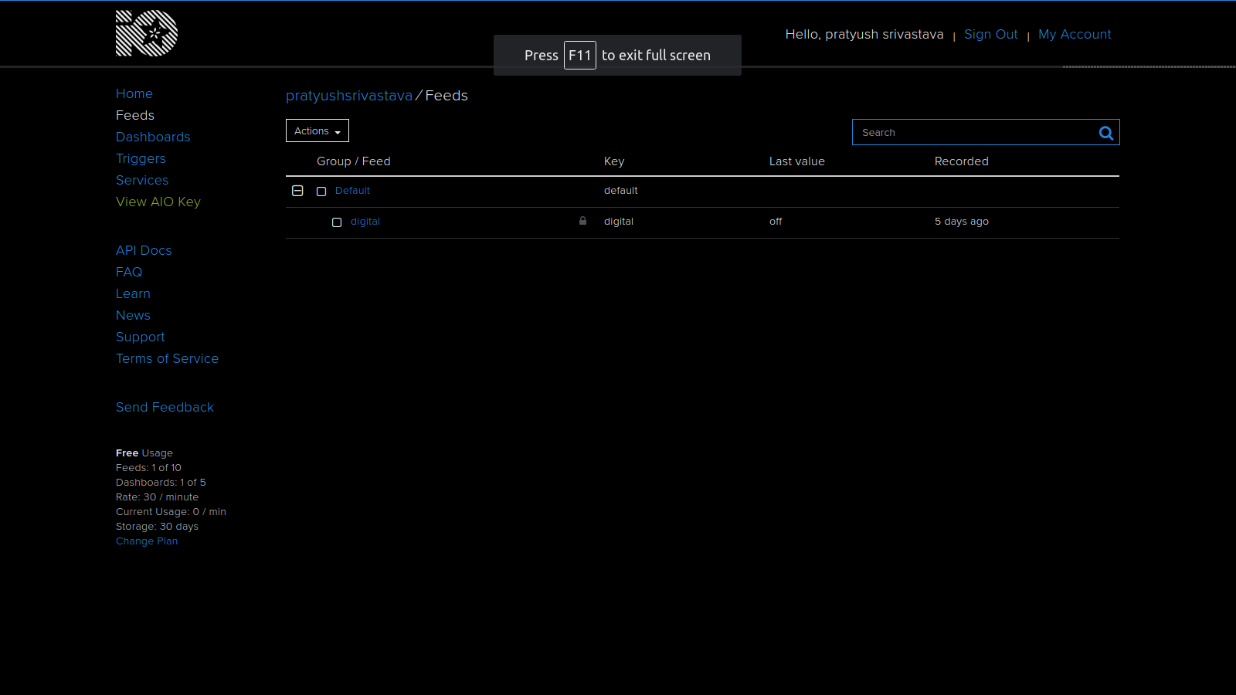

- Click on Actions > Create New Feed
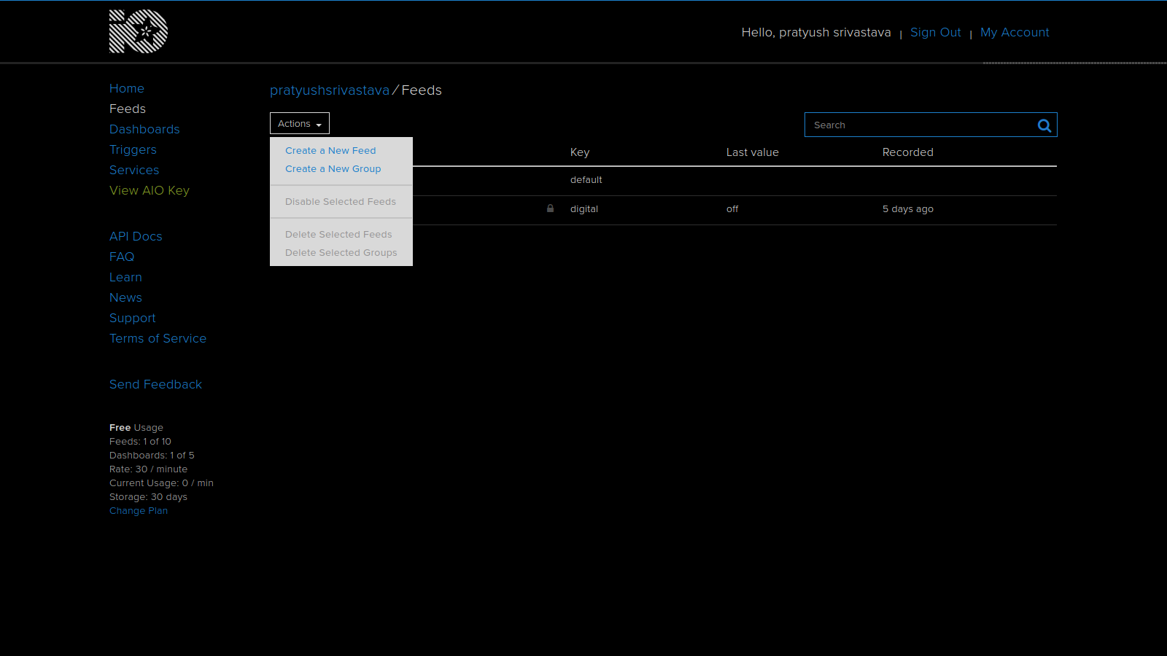

- Give Name and description and click save
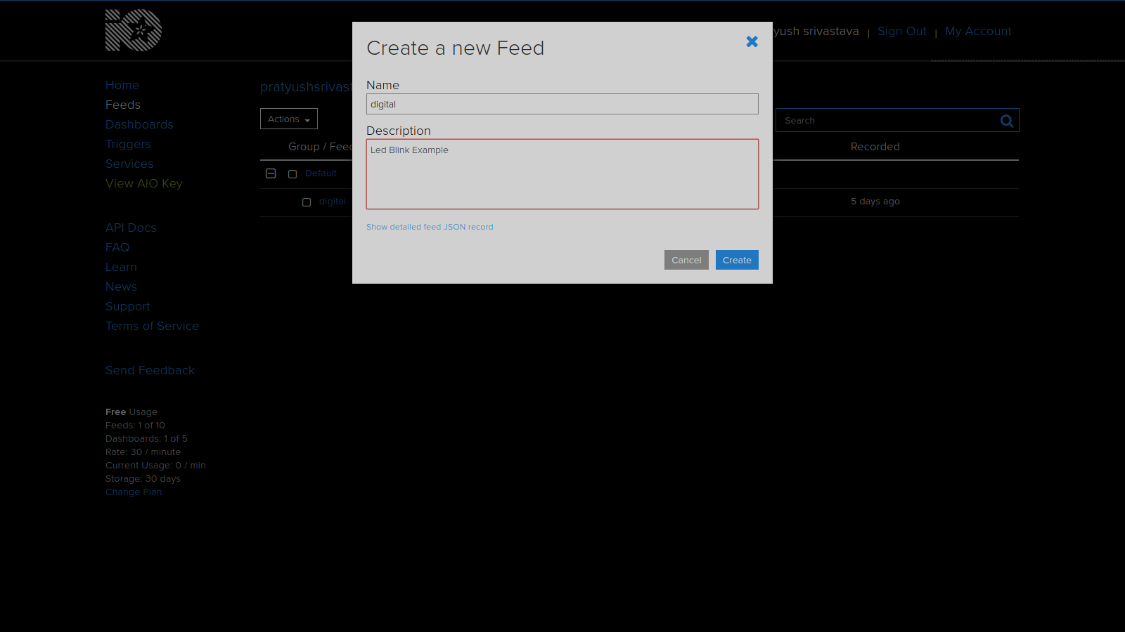
- Click on Dashboard on left panel

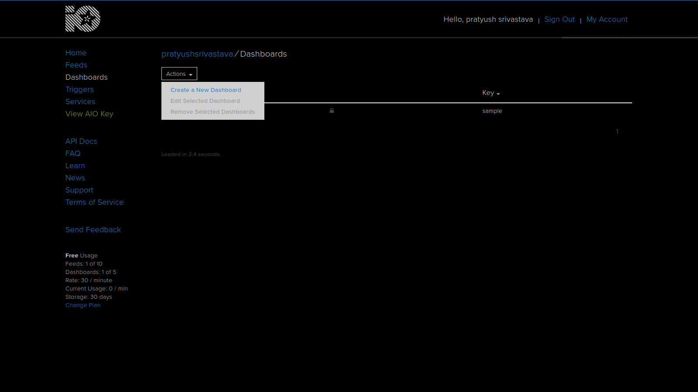
Click on Actions > Create a new Dashboard

- Give name and description and click on save
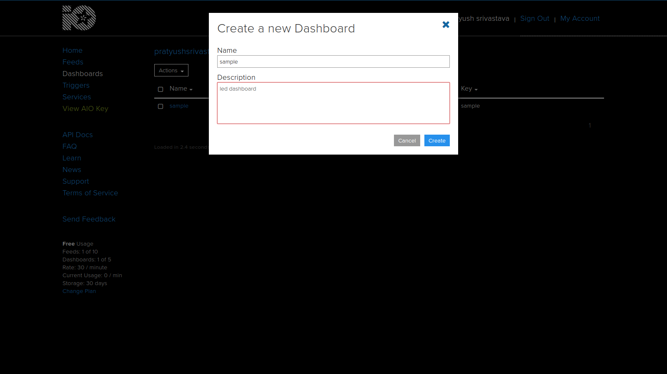
- Click on the blue + icon on the top right
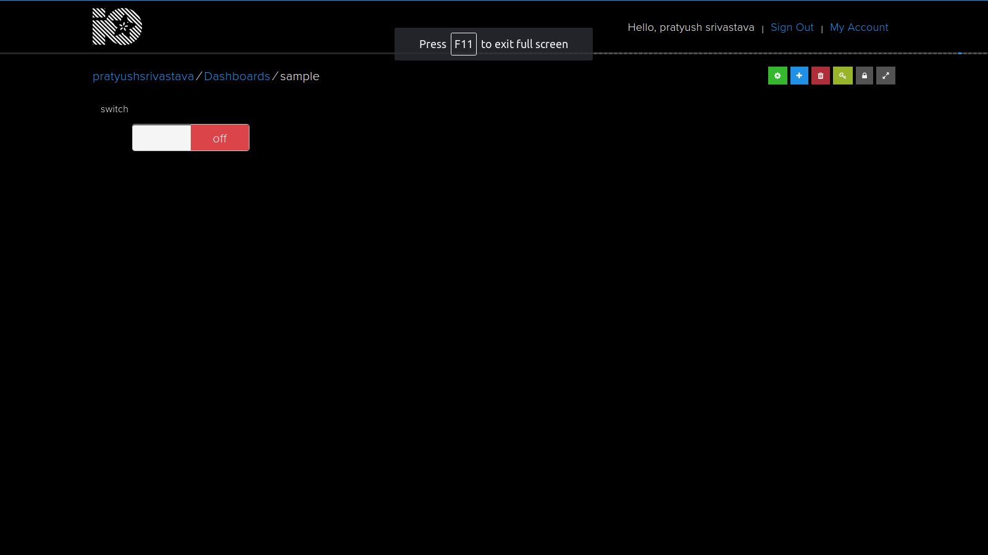

- Choose the toggle block
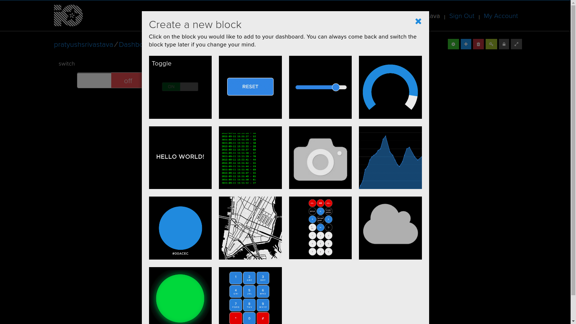
- choose the feed you created earlier and click next
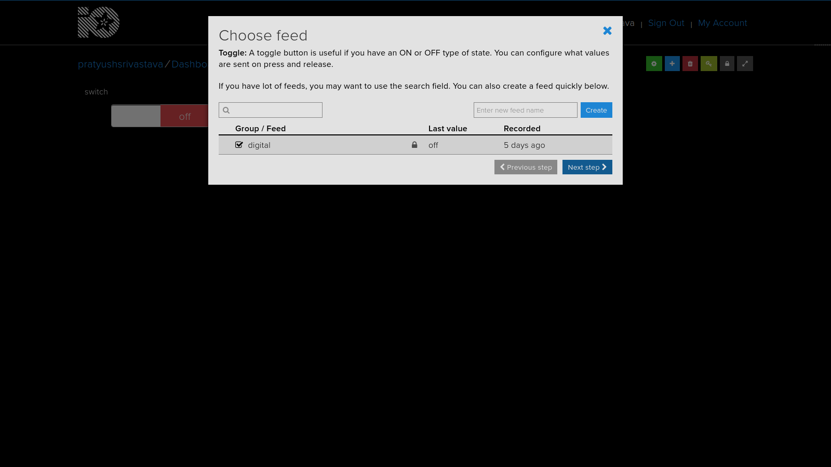

- Give a Block name and leave everything as it is and click Create block
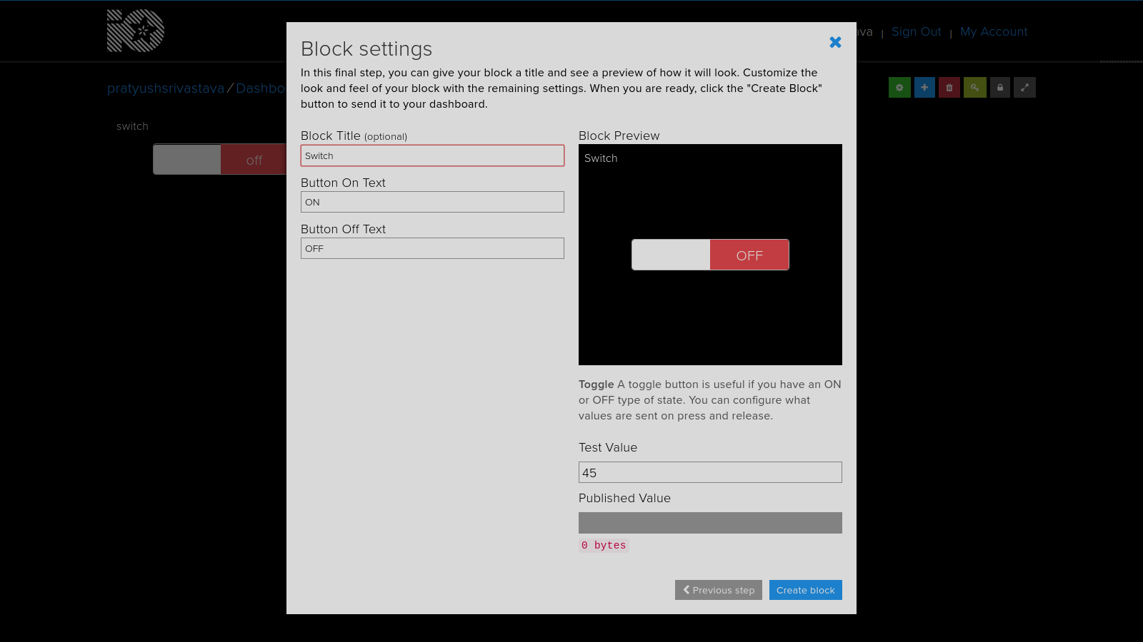
- Your Block will appear on screen

Communicating Using Serial in Arduino
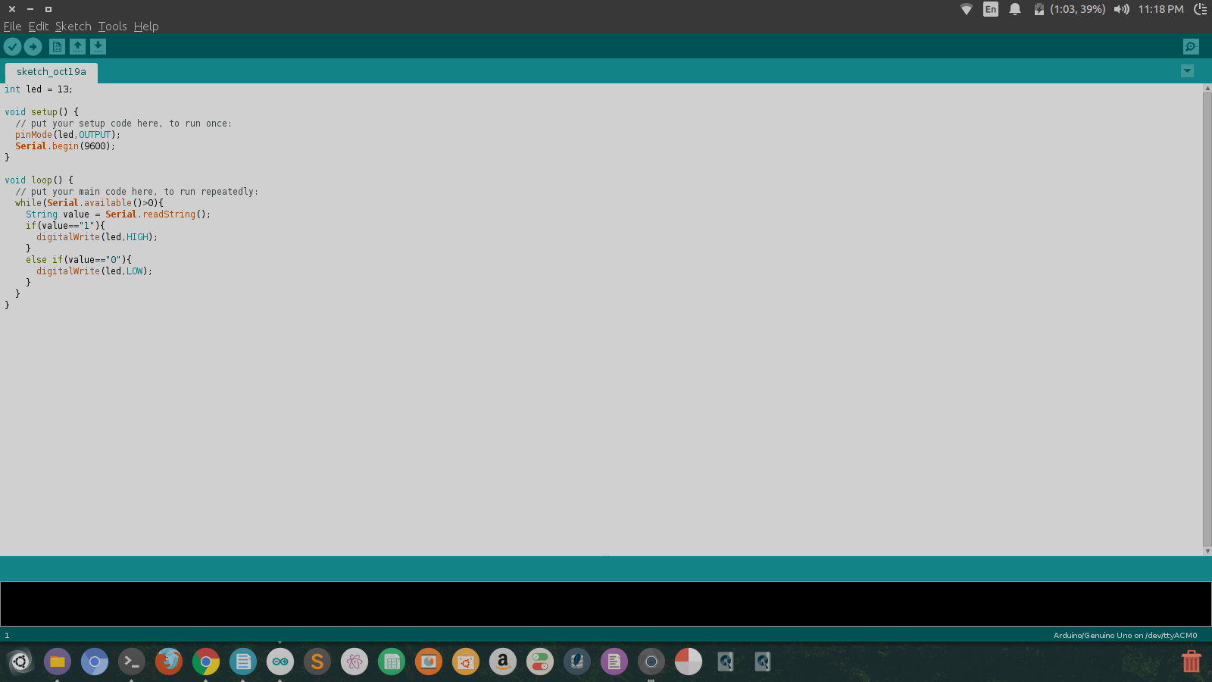

Python Script for Raspberry pi

Steps
- Navigate to Adafruit Dashboard and Click on View AIO key on left Panel
- Note Down your username and AIO key
- Create a new python file sample.py
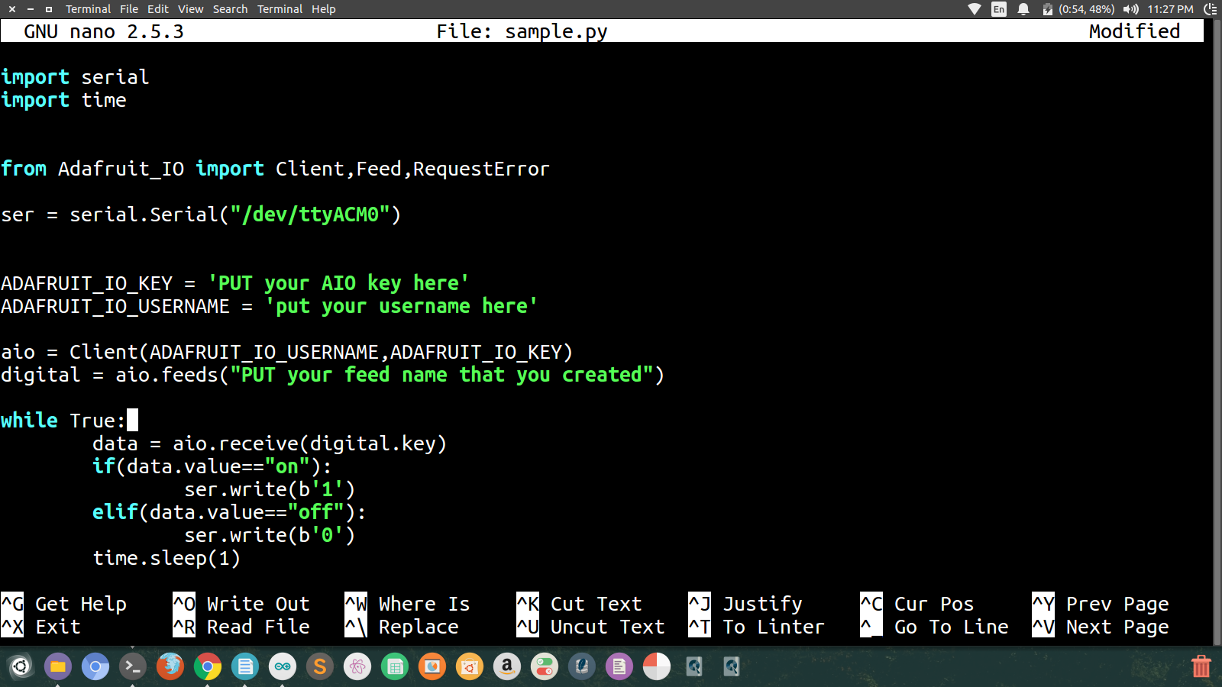

- Run the script and toggle from Dashboard
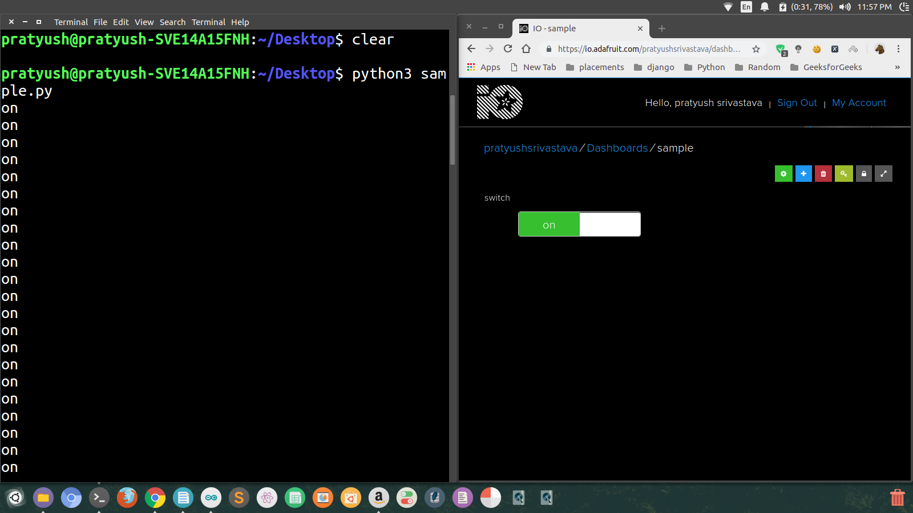

resources
https://learn.adafruit.com/adafruit-io-basics-digital-output?view=all

