Design Pattern Notes

Service Locator Pattern
- Service Locator Pattern is a design pattern used in software development to encapsulate the process involved in obtaining a service with a strong Abstraction layer.
- Service Locator Pattern doesn’t describe how to instantiate the services but it describes a way to register services & locate them.
- This pattern uses a central Registry (ServiceLocator) that is responsible for returning the instances of services when requested by service consumers or clients.

Design Components

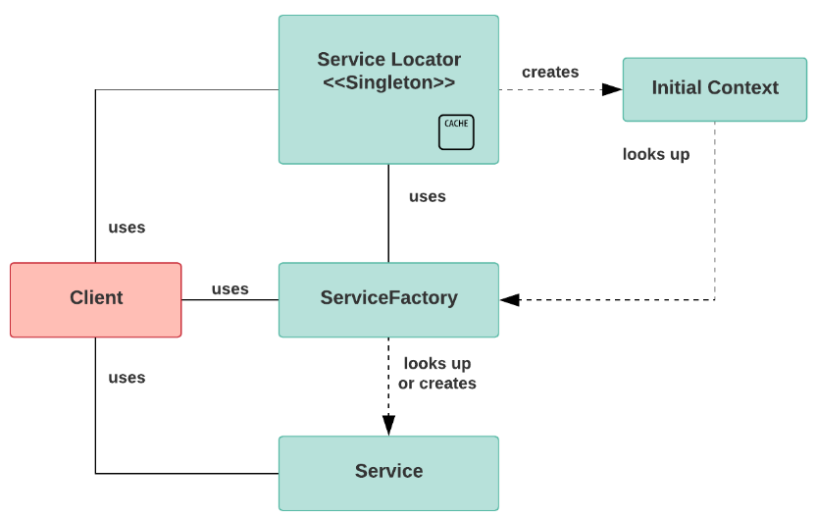

- Service Locator: It abstracts the API lookup services; vendor dependencies & business object creations & provides a simple interface to clients.

- Initial Context: It acts as the start point in the lookup & creation process. Service Providers provide the context object that varies based on business type.

- ServiceFactory: It represents an object that provides the life cycle management for the BusinessService objects. The ServiceFactory object for enterprise beans is EJBHome object.

- Business Service: It is the role fulfilled by the service that client is seeking to access. The BusinessService object is created or looked up or removed by the ServiceFactory.

Example:
