**Design Patterns**

* Design Patterns are typical reusable solutions to commonly occurring problems in software design.
* Design Patterns are not finished code but templates or blueprints only that we can customize to solve a recurring design problem in our code.
* The pattern is not a specific piece of code, but a general concept for solving a particular problem. We can follow the pattern details & implement a solution that suits the realities of our own program.

**Design Pattern Vs Algorithm**

* Both concepts describe typical solutions to some known problems.
* An Algorithm always defines a clear set of actions that can achieve some goal.
* While a Pattern is more high-level description of a solution.

**Classification of Patterns**

* Design Patterns differ by their complexity, level of detail & scale of applicability to the entire system being designed.
* For e.g., Road Construction – We can make an intersection safer by either installing some traffic lights or building an entire multi-level interchange with underground passages for pedestrians.
* The most basic & low-level patterns are often called **Idioms**. They usually apply only to a single programming language.
* The most universal & high-level patterns are Architectural patterns. Developers can implement these patterns in virtually any language. Unlike other patterns, they can be used to design the architecture of an entire application.

**1. Creational Patterns**

* They provide object creation mechanisms that increase flexibility & reuse of existing code.
* **Creational Design Patterns** focus on the process of object creation or problems related to object creation. They help in making a system independent of how its objects are created, composed & represented.

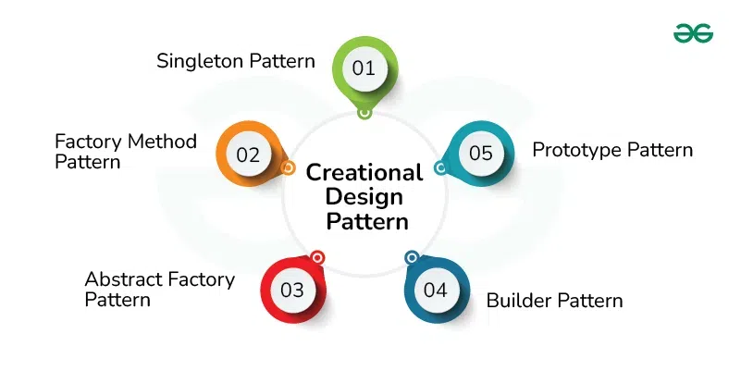

**2. Structural Patterns**

* They explain how to assemble objects & classes into larger structures, while keeping these structure flexible & efficient.
* Structural Design Patterns solves problems related to how classes & objects are composed/assembled to form larger structures which are efficient & flexible in nature.
* They use inheritance to compose interfaces or implementations.

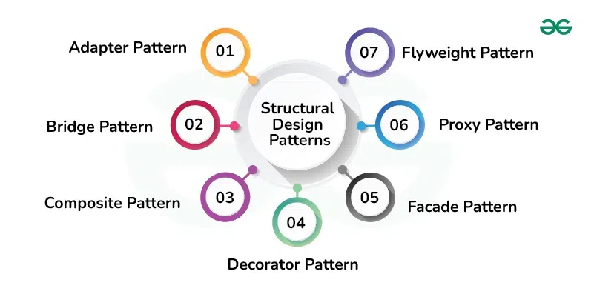

**3. Behavioral Patterns**

* They take care of effective communication & the assignment of responsibilities b/w objects.
* Behavioral Design Patterns are concerned with algorithms & the assignment of responsibilities b/w objects.
* They describe not just patterns of objects or classes but also the patterns of communication b/w them.
* These patterns characterize complex control flow that’s difficult to follow at run-time.

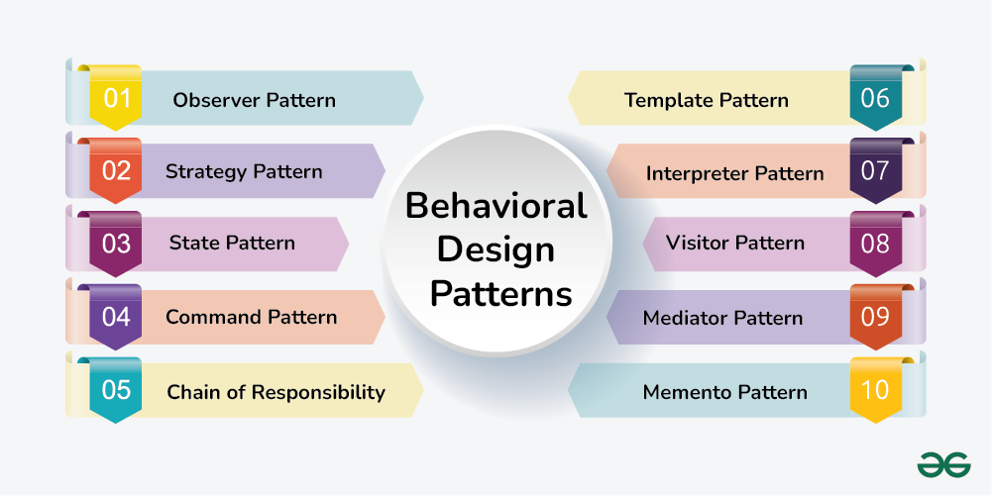

**Creational Design Patterns**

**1. Factory Method Design Pattern**

* Factory method design pattern provides an interface for creating objects in a superclass, but allows subclasses to alter the type of objects that will be created.

2. Abstract Factory Method Design Pattern

3. Builder Design Pattern

* Builder design pattern lets us construct complex objects step by step. This pattern separates the construction of a complex object from its representation, allowing the same construction process to create different representations.

**Strategy Design Pattern**

* Strategy Design pattern is a **behavioral Design pattern** that lets us dynamically choose or change the behavior of an object by encapsulating it into different strategies rather than sticking with one.
* In simpler terms, this pattern provides a way to extract the behavior of an object into separate classes that can be swapped in & out at runtime.
* This enable the object to be more flexible & reusable, as different strategies can be easily added or modified without changing the client’s core code.
* It is based on the principle of Composition over Inheritance.

**Components of Strategy Design Pattern**

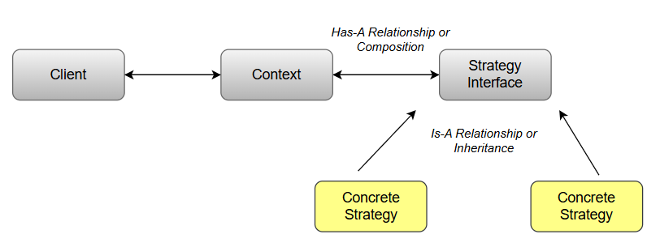

**Note:**

* Communications b/w the components happen in a structured & decoupled manner i.e.; the context is not required to be aware of the exact behavior of each strategy.
* As long as they follow the same interface, strategies can be switched without affecting the client or other strategies.

**1. Client**

* Client is responsible for configuring the appropriate strategy based on the requirement & providing it to the context.
* It creates an instance of the desired concrete strategy & passes it to the context, enabling the context to use the selected strategy to perform the task.

**2. Context**

* Context acts as a mediator between the clients & strategies and it maintains a reference to a strategy object & calls its methods to perform the task without exposing the actual strategies behavior to client.

**3. Strategy Interface**

* Strategy interface enables decoupling between the context & the specific/concrete strategies by ensuring that all the strategies follow the same set of rules & can be interchangeable used by the context.
* It can be an abstract class or interface that specifies a set of methods that all concrete strategies must implement.

**4. Concrete Strategies**

* Concrete strategies are the various implementations of the Strategy interface with each concrete strategy defining a specific algorithm or behavior to the task/method defined by the Strategy interface.
* They are interchangeable & can be selected by the client based on the task requirement.

**Use cases**

* Avoid Code Duplication – Suppose multiple concrete classes have same functionality, then they can be encapsulated to one generic strategy class.
* Multiple algorithms: e.g., Sorting algorithm – Different sorting algos can be encapsulated into separate strategies & passed to an object that needs sorting.
* Encapsulating algorithms
* Runtime selection
* Reducing conditional statements
* Testing & Extensibility
* Validation rules
* Text formatting
* Database access
* Payment strategy

**Benefits**

* Improved code flexibility
* Better code reusability
* Encourages better coding practices
* Simplifies testing

**Disadvantages**

* The application must be aware of all the strategies to select the right one for the right solution.
* The Strategy interface defines a set of features, some of which might be not relevant for some concrete strategies. ----> *Violating the Liskov Substitution Principle* (its solution can be used)
* **Imp:** In most cases, the client/application configures the context with the required strategy object. Therefore, the client needs to create & maintain 2 objects instead of one.

**Best Practices for implementing the Strategy Design Pattern**

* Keep the interface simple & focused on a single responsibility
* Encapsulate any stateful behavior in the concrete strategy classes, rather than in the context class.
* Use Dependency injection to pass the concrete strategy to the context class, rather than creating it directly in the context class.
* Use an enum or a factory class to provide a centralized place for creating & managing concrete strategy objects.

Example 1: Vehicle

**Scenarios:**

Suppose we’ve a “Vehicle” class with drive () method & multiple classes extend Vehicle class & according to their requirement, drive () method is being overridden by these inheritors.

* class **Vehicle**: drive () method – Sysout (“Normal Drive Capability”)
* class **SportsVehicle** extends **Vehicle**: Overrides drive () method – Sysout (“Sports Capability”)
* class **PassengerVehicle** extends **Vehicle**: uses parent Vehicle class drive () method definition
* class **OffRoadVehicle** extends **Vehicle**: Overrides drive () method – Sysout (“Sports Capability”)
* class **GoodsVehicle** extends **Vehicle**: uses parent Vehicle class drive () method definition

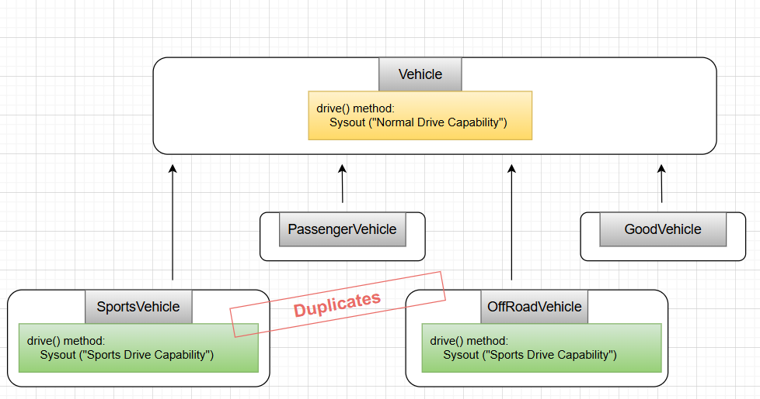

**Problem:**

Above, we can see SportsVehicle & OffRoadVehicle classes have common definition that is resulting in code duplication.

**Observer Design Pattern (Publish-Subscribe Pattern)**

* Observer Design pattern is a behavioral design pattern that lets us define a subscription mechanism to notify multiple objects (called Observers) about any changes in the state of the object they’re observing i.e., one to many dependencies between objects: Observable & Observers.
* In this pattern, many observers (subscriber objects) observe a particular subject (publisher object). Observers register with a subject to be notified when a change is made inside that subject.
* *These objects are loosely coupled* as an observer object can register or unregister from a subject at any point of time.

**Components of Observer Design Pattern**

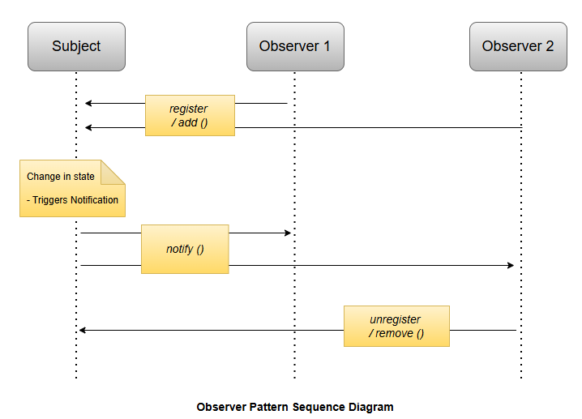

**1. Subject / Observable / Publisher**

* Subject maintains a list of observers & also provides method to register, unregister & notify observers about any changes in the state of subject / observable / publisher object.
* It can be interface or abstract class.

**2. Concrete Subject**

* Concrete subjects are specific implementations of the subject interface.
* They hold the actual state or data under observation & notify the subscribed observers about any changes in the state.
* E.g., if a Weather Station is the Subject, Specific Weather Stations in different locations would be Concrete Subjects.

**3. Observer / Subscriber interface**

* Observer defines an interface with an update method to ensure that concrete observers receive updates from the subject in a consistent way.
* It can be interface or abstract class.

**4. Concrete Observer**

* Concrete observers are specific implementations of the observer interface.
* They get registered to the concrete subjects & react when notified of a state change i.e., when the subject’s state changes, the concrete observer’s update () method is invoked, allowing it to take appropriate actions.
* E.g., A Weather app on smartphone can be a concrete observer that reacts to changes from a weather station.

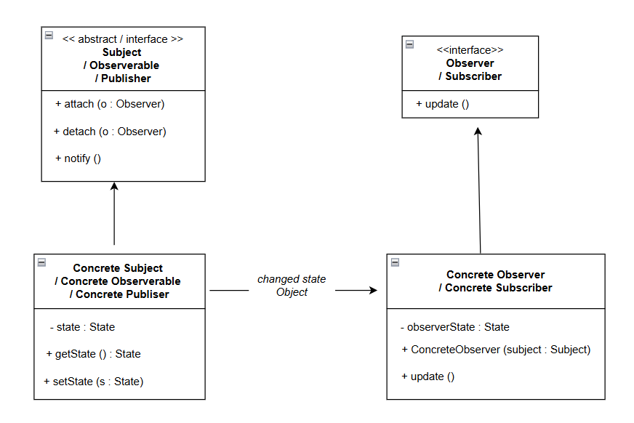

**When to use the Observer Design Pattern?**

Below is when to use observer design pattern:

* When you need one object to notify multiple others about changes.
* When you want to keep objects loosely connected, so they don’t rely on each other’s details.
* When you want observers to automatically respond to changes in the subject’s state.
* When you want to easily add or remove observers without changing the main subject.
* When you’re dealing with event systems that require various components to react without direct connections.

**When not to use the Observer Design Pattern?**

Below is when not to use observer design pattern:

* When the relationships between objects are simple and don’t require notifications.
* When performance is a concern, as many observers can lead to overhead during updates.
* When the subject and observers are tightly coupled, as it defeats the purpose of decoupling.
* When number of observers is fixed and won’t change over time.
* When the order of notifications is crucial, as observers may be notified in an unpredictable sequence.

**Example1** – Weather Application

**Use case:**

Design a weather application that will used on TV & Mobile to get current weather update from multiple weather stations.

* TV Display will receive update from Weather station 1 & 2
* Mobile Display will receive update from Weather station 1

**Implementation:**

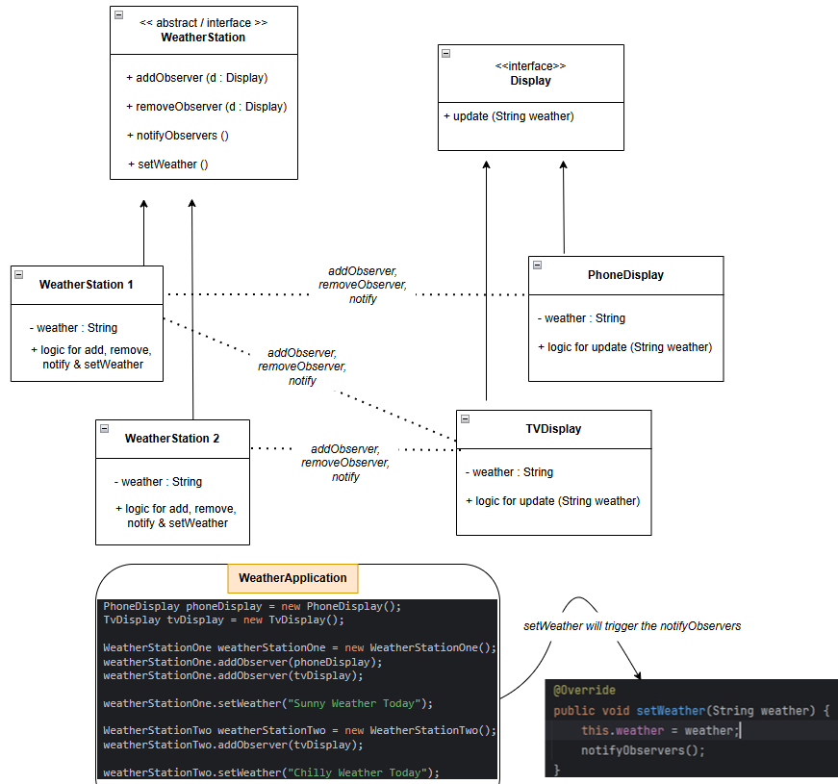

Key points:

* Observer: **PhoneDisplay** observes **WeatherStation 1** and **TvDisplay** observes **WeatherStation 1** & **WeatherStation 2**
* **WeatherStation** setWeather () will trigger the notifyObservers () method
* 2 ways to consume weather update in Observers

1. Pass the state/message through update method arguments
2. ***Imp****: Observer class can have state/message as property & initialized through constructor injection i.e., Has_A Relationship*

**Decorator / Wrapper Design Pattern**

* Decorator design pattern is a structural design pattern that let us add new behaviour to individual objects dynamically, without affecting the behaviour of other objects from the same class.

**Components of Decorator Design Pattern**

**1. Component Interface**

* It specifies the operations that can be performed on the objects & it is common interface for both concrete components & decorators.
* This can be an abstract class or interface.

**2. Concrete Component**

* These are the basic classes that implement the Component interface & add new behavior or responsibilities to Concrete Component objects.

**3. Decorator** (HAS_A Relationship + IS_A Relationship)

* Decorator is an abstract class that has a reference to component object & also implements the Component interface.
* Decorators are responsible for adding new behaviors to the wrapped Component object.

**4. Concrete Decorators**

* These are the concrete classes that extends the Decorator class & add a specific behaviors or responsibilities to the already existing Concrete Component objects.

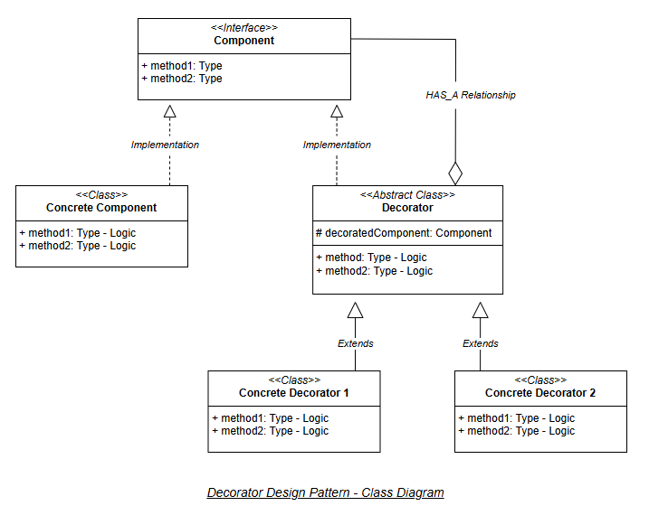

**Advantages of Decorator Design Pattern**

* **Composition over Inheritance**
* Unlike traditional inheritance, which can lead to a deep & inflexible class hierarchy, the decorator pattern uses composition.
* We can compose objects with different decorators to achieve desired functionality, avoiding the drawbacks of inheritance, such as tight coupling & rigid hierarchies.
* **Open-Closed Principle**
* Using this pattern, we can introduce new functionality to an existing class without changing its source code.
* **Flexibility**
* It allows us to add or remove responsibilities (i.e., behaviors) from objects at runtime.
* This flexibility makes it easy to create complex object structures with varying combinations of behaviors.
* **Reusable Code**
* Decorators are reusable components. We can create a library of decorator classes & apply them to different objects & classes as needed, reducing code duplication.
* **Dynamic Behavior Modification**
* Decorators can be applied or removed at runtime, providing dynamic behavior modification for objects.
* This is particularly useful when we need to adapt an object’s behavior based on changing requirements or user preferences.
* **Clear Code Structure**
* The Decorator pattern promotes a clear & structured design, making it easier for developers to understand how different features & responsibilities are added to objects.

**Disadvantages of Decorator Design Pattern**

* **Order of Decoration**
* The order in which decorators are applied can affect the final behavior of the object.
* If decorators are not applied in correct order, it can lead to unexpected results.
* Managing the order of decorators can be challenging, especially in complex scenarios.
* **Increased number of classes**
* When using the decorator pattern, we often end up with a large number of small, specialized decorator classes.
* This can lead to a proliferation of classes in our codebase, which may increase maintenance overhead.
* **Potential for Overuse**
* As it’s easy to add decorators to objects, there is a risk of overusing the decorator pattern, making the codebase unnecessarily complex.
* It’s important to use decorators effectively & only when they genuinely add value to the design.
* **Complexity**
* As we add more decorators to an object, the code can become more complex & harder to understand.
* The nesting of decorators can make the codebase difficult to navigate & debug, especially when there are many decorators involved.
* **Limited Support in some languages**
* Some Programming language may not provide convenient support for implementing decorators.
* Implementing the pattern can be more verbose (uses more words) & less intuitive in such language.

**Example:** Coffee Shop Application

**Scenario:**

Suppose we’re building a coffee shop application where customers can order different types of coffee.

* Each coffee can have various optional add-ons such as milk, sugar, whipped cream etc.
* We want to implement a system where we can dynamically add these add-ons to a coffee order without modifying the coffee classes themselves.

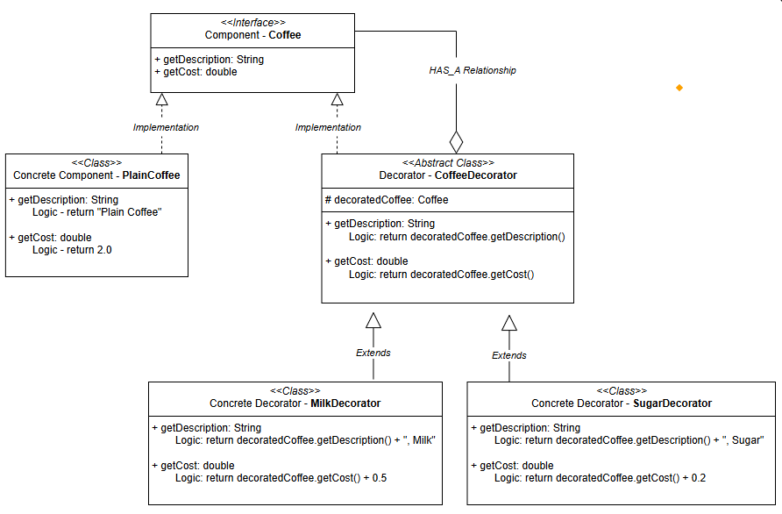

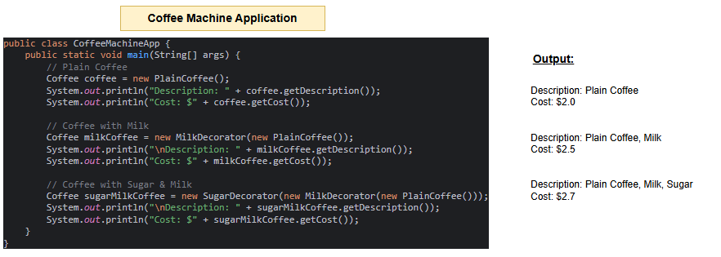

**Factory Design Pattern**

* Factory Design pattern is a creational design pattern that provides an interface for creating objects in a superclass, while allowing subclasses to alter/specify the type of objects that will be created.
* This pattern simplifies the object creation process by placing it in a dedicated method, promoting loose coupling between the object creator & the objects themselves.
* This pattern is particularly useful when the exact types of objects to be created may vary or need to be determined at runtime, enabling flexibility & extensibility in object creation.

**Components of Factory design pattern**

**1. Product**

* The Product defines the common interface for all the objects that factory method can create.
* This can be an interface or abstract class.

**2. Concrete Product**

* Concrete Product classes are the actual objects that the factory method creates.
* Each concrete Product class implements the Product interface or extend the Product abstract class.

**3. Creator/Factory interface**

* The Creator/Factory typically contains a method that serves as a factory for creating objects.
* It may also contain other methods that work with the created objects.
* This can be an interface or abstract class.

**4. Concrete Creator/Factory**

* Concrete Creator classes are subclasses of the Creator that implements the factory methods to create specific types of objects.
* Each concrete creator is responsible for creating a particular product.

**Advantages of Factory method**

* Separate object creation logic from Client code, improving flexibility.
* New product types can be added easily
* Simplifies unit testing by allowing mock product creation
* Centralizes object creation logic across the application
* Hides specific product classes from clients, reducing dependency.

**Disadvantages of Factory method**

* Add more classes & interfaces, which can complicate maintenance.
* Slight performance impacts due to polymorphism.
* Concrete creators are linked to their products.
* Clients need knowledge of specific subclasses.
* May lead to unnecessary complexity if applied too broadly.
* Factory logic can be harder to test.

**Use cases of Factory method**

* Used in JDBC for creating connections & in frameworks like Spring for managing beans.
* Libraries like Swing & JavaFX use factories to create flexible UI components.
* Tools like Log4j rely on factories to create configurable loggers.
* Factories help create objects from serialized data, supporting various formats.

**Example:**

Consider a software application that needs to handle the creation of various types of vehicles, such as Two Wheelers, Three Wheelers, and Four Wheelers. Each type of vehicle has its own specific properties and behaviours.

**Issues without Factory method:**

* The Client class creates the Product objects like TwoWheeler, ThreeWheeler objects directly based on ProductType from application.
* This strong dependency makes the code hard to maintain or update.
* The client class not only decides which Product to create but also handles its lifecycle due to the object creation.
* This mixes responsibilities, which goes **against the Single Responsibility principle** i.e., a class should only have one reason to change.
* To add new Product type, we must modify the Client class, which makes it difficult to scale the design. This **conflict with Open/Closed principle** i.e., the class should be open for extension but closed for modification.

**Using Factory Method**:

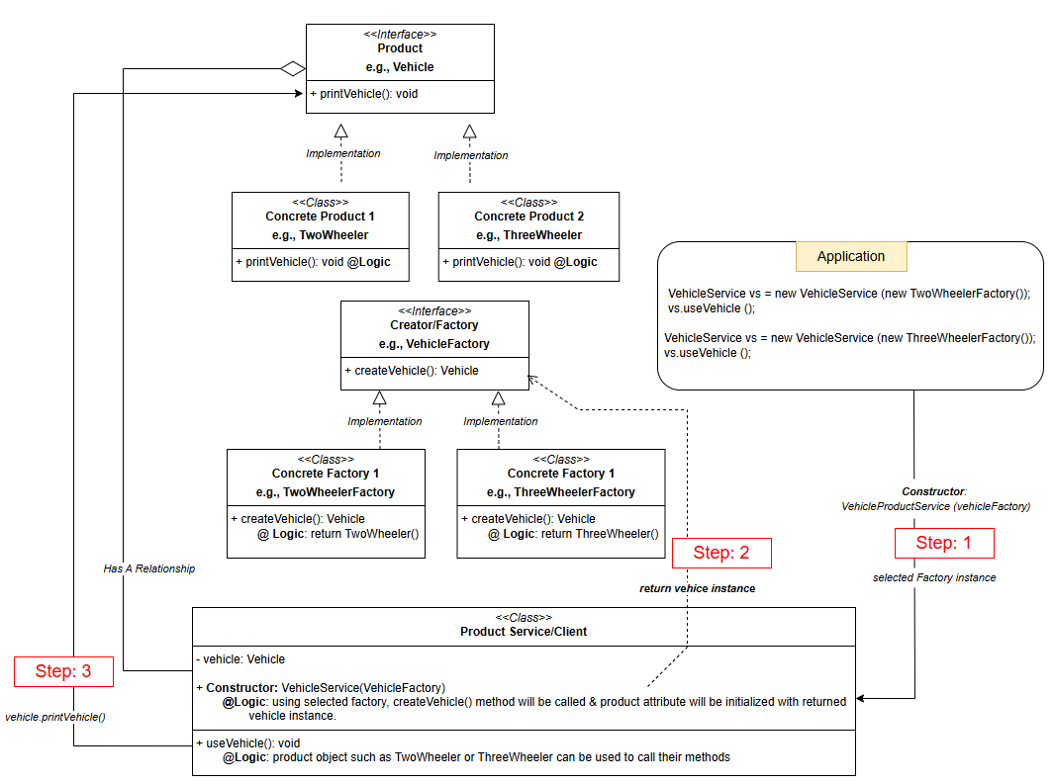

**Abstract Factory Method Design Pattern**

* Abstract Factory is a creational design pattern that lets us encapsulate groups/families of related objects without specifying their concrete classes.
* This is considered another layer of abstraction over factory pattern i.e., Factory of Factories

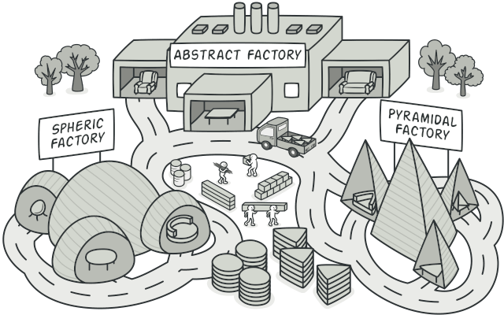

**Components of Abstract Factory Pattern**

**1. Abstract Factory**

* It provides a high-level blueprint that defines rules for encapsulating groups of the related objects without specifying their concrete classes.
* Concrete Factories follow the common interface i.e., Abstract factory, providing consistent way to produce related set of objects.

**2. Concrete Factories**

* Concrete Factories implement the rules specified by the abstract factory. It contains the logic for creating specific instances of objects within a family.
* Also, multiple concrete factories can exist, each produce a distinct family of related objects.

**3. Abstract Products**

* Abstract Products represent a family of related objects by defining a set of common methods or properties.
* It acts as an abstract or interface type that all concrete products within a family must follow to & provides a unified way for concrete products to be used interchangeably.

**4. Concrete Products**

* They are the actual instances of objects created by concrete factories.
* They implement the methods declared in the abstract products, ensuring consistency within a family & belong to a specific category or family of related objects.

**5. Client**

* Client utilizes the abstract factory to create families of objects without specifying their concrete types & interacts with objects through abstract interfaces provided by abstract products.

**Benefits of using Abstract Factory Pattern**

* The Abstract Factory pattern separates the creation of objects, so client don’t need to know specific classes.
* Clients interact with objects through abstract interfaces, keeping class names hidden from client code.
* Changing the factory allows for different product configurations, as all related products change together.
* The pattern ensures that an application uses objects from only one family at a time for better compatibility.

**Challenges of using Abstract Factory pattern**

* The Abstract Factory pattern can add unnecessary complexity to simpler projects with multiple factories & interfaces.
* Adding new product types may require changes to both concrete factories & the abstract factory interface, impacting existing code.
* Introducing more factories & product families can quickly increase the no. of classes, making code management difficult in smaller projects.
* It may violate the dependency Inversion principle if client code depends directly on concrete factories rather than abstract interfaces.

**When to use Abstract Factory Pattern**

* When our system requires multiple families of related products & we want to ensure compatibility b/w them.
* When we need flexibility & extensibility, allowing for new product variants to be added without changing existing client code.
* When we want to encapsulate the creation logic, making it easier to modify or extend the object creation process without affecting the client.
* When we aim to maintain consistency across different product families, ensuring a uniform interface for the products.

**When not to use Abstract Factory Pattern**

* The product families are unlikely to change, as it may add unnecessary complexity.
* When our application only requires single, independent objects & isn’t concerned with families of related products.
* When overhead of maintaining multiple factories outweighs the benefits, particularly in smaller applications.
* When simpler solution, like the Factory Method or Builder pattern, if they meet your needs without adding the complexity of the Abstract Factory pattern.

**Example 1** – Global Car Manufacturing Company

**Scenario:** Imagine we’re managing a global car manufacturing company

* We want to design a system to create cars with specific configuration for different regions, such as North America & Europe.
* Each region may have unique requirements & regulations, & we want to ensure that cars produced for each region meet those standards.

**Challenges while implementing this system**

* Designing the system for different regions having different cars with different features
* Ensuring consistency in the production of cars & their specifications within each region.
* Any updation to new cars in different regions & adapting the system to changes in regulations or introducing new features for a specific region becomes challenging.
* Modifications would need to be made in multiple places, increasing the chances of introducing bugs & making the system more prone to errors.

**How Abstract Factory Pattern help to solve above challenges.**

* Different regions have their own factory to create cars for local needs.
* This helps to keep the design & features the same for vehicle in each region.
* We can change one region without affecting others (e.g., updating North America doesn’t impact Europe)
* To add a new region, just create a new factory, no need to change existing code.
* The pattern keeps car creation separate from how they are used.

