http://www.iconico.com/download.aspx?app=Caliper

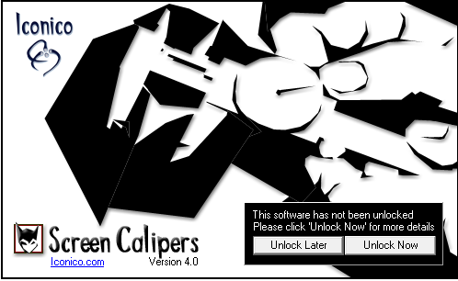

The accurate way to measure on a screen, at any angle in pixels, inches or any unit.

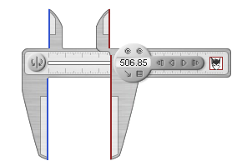

Load a photo of a key.

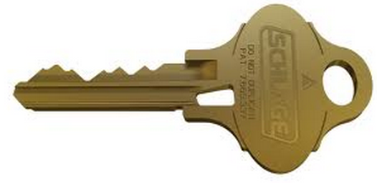

The FREE version of the Screen Calipers program will not allow you to rotate the tool vertically.

So rotate your key image if necessary – and enlarge it for more accurate readings:



To calibrate the calipers for our key, we first measure a known distance (Schlage shoulder is ½”, or 500 thousandths).

First set the calipers on the key shoulder:

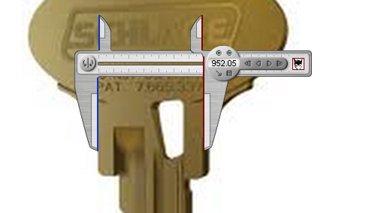

Click on the menu and set the units – I use Pixels:

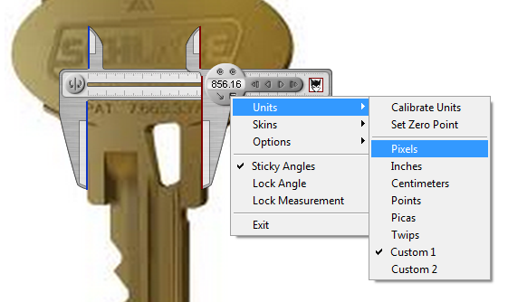

The shoulder here is 124 Pixels:

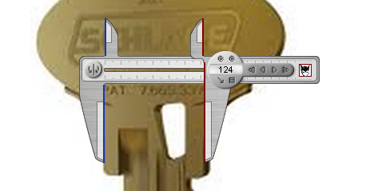

Select Units / Calibrate

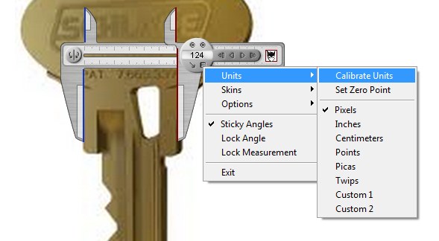

Set “Custom 1” Number of Pixels to 124 and the Length in Units to 500 then click Ok:

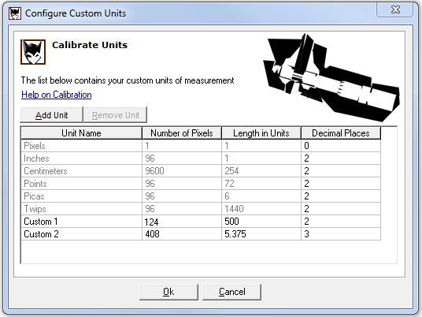

The shoulder reading should now show 500 for 500 thousandths.

Note: I use two decimal places to allow me to round the results.

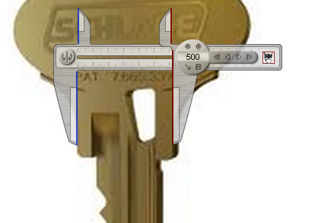

Now we can measure the depth of the key cuts and record the results.

Do this Bow-to-Tip:

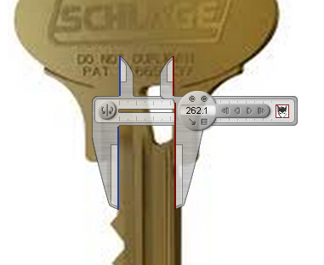

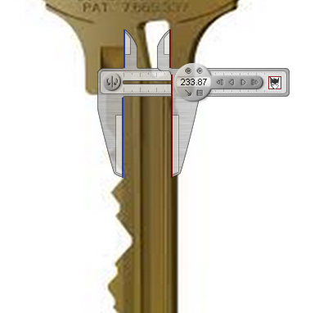

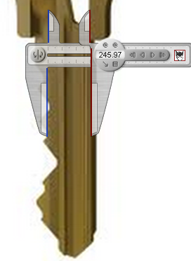

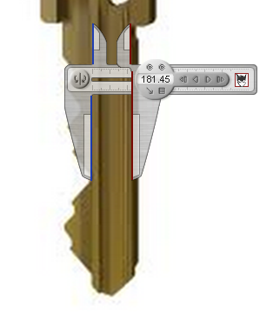

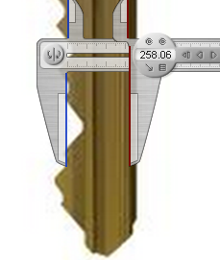

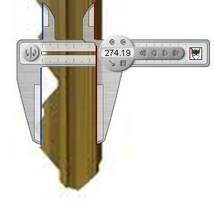

Here are the depths (rounded) for our six cuts:

262

234

246

181

258

274

We can convert these depths to key cuts manually:

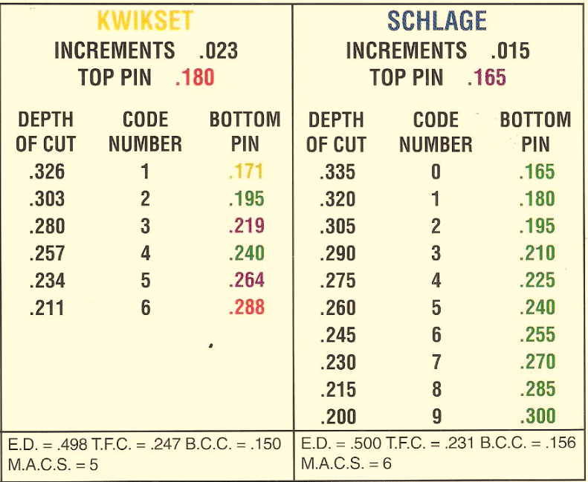

Here are the Depths (rounded) converted to Key Codes:

262 = 5

234 = 7

246 = 6

181 = 9

258 = 5

274 = 4

These codes can be used to cut a new key on a standard code machine…

or on a duplicator with depth and space keys… or copy the depths on a duplicator with a micrometer, or…

… we can enter the depths or codes into a 3D Key program currently under development at TSS and it will convert the depths to the nearset codes for you

:

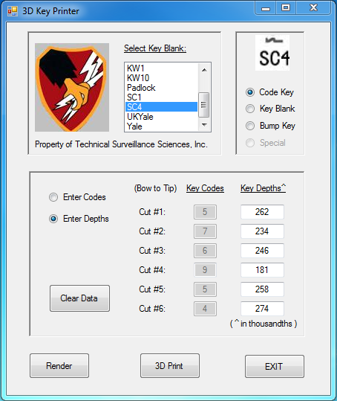

Here’s our key rendered in an open source CAD program OpenSCAD.

Compare it to our original:

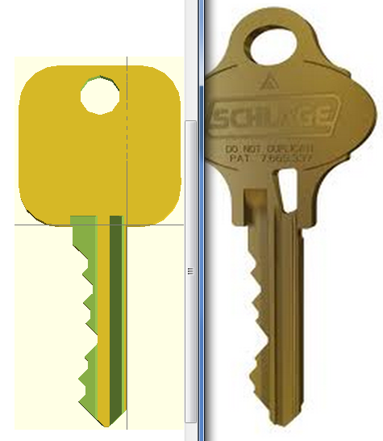

Here’s a key we actually decoded and printed on a 3D printer:

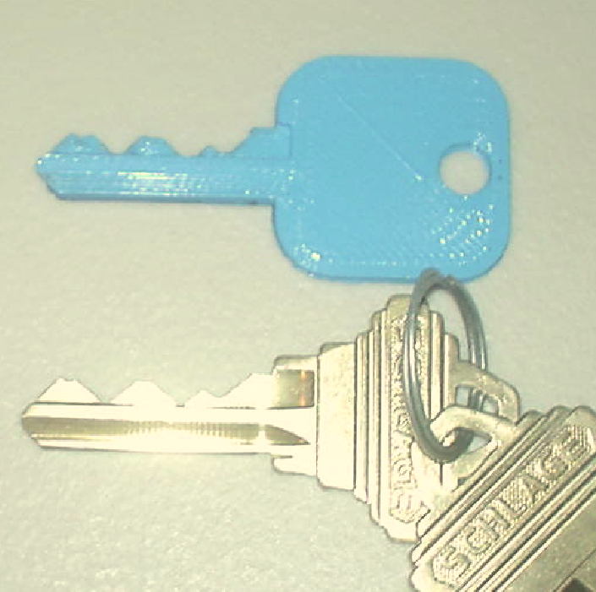

This key worked the first time we tried it!

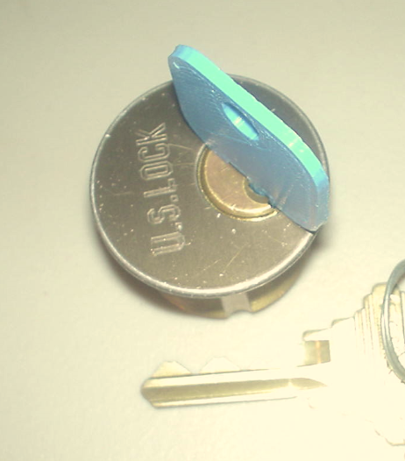

3DKeys is a functional prototype and still under development but we are very excited at the implications!