Universal Structure, Contextual Effectiveness? Exploratory Evidence on Management Control Practices in Seven Advanced Economies
A study using World Bank Enterprise Surveys for the G7 economies, 2024–2025
[Author name(s) and affiliation(s)] — Revised draft for internal review (version 2)

Abstract
Are management control practices universally effective, or does their effectiveness depend on their alignment with national and organisational contexts? Using the management-practices module of the World Bank Enterprise Surveys for seven G7 economies (6,316 establishments, mostly with 20 or more employees), we separate four ideas: universality of practices, of statistical structure, of effectiveness, and contextual fit. For six common items, practices share a dominant continuous dimension; latent classes are poorly separated (relative entropy 0.53–0.60) and add no explanatory power beyond a continuous score. Measurement invariance across countries is partial and depends on the number of classes, and the reliability of the score varies from 0.35 to 0.65. The association between the score and productivity is positive in most countries but close to zero in France and the United Kingdom, and its heterogeneity is statistically detectable in most, though not all, specifications; growth associations are small. Firm-level moderators, combinations of practices and nonlinearities are not reliably different from zero after multiple-testing correction, and equifinality is neither demonstrated nor rejected. Because implementation, integration and national context are not measured, contextual fit is treated as a theoretical interpretation and a research agenda, including a separate agenda for Morocco, rather than as an empirical finding. All results are exploratory, cross-sectional associations, and wording of several items could not be verified.
Keywords: management control systems; contextual fit; management practices; latent class analysis; measurement invariance; institutional context; World Bank Enterprise Surveys

1. Introduction
Management control practices such as performance indicators, formal targets and performance-related pay are promoted internationally as good practice. A long-standing question in management accounting is whether such practices operate in the same way wherever they are adopted, or whether their effectiveness depends on their fit with organisational and institutional conditions (Otley, 2016; Chenhall, 2003). Two research traditions point in different directions. Economists measuring management practices report that more structured management is associated with higher productivity across firms and countries (Bloom & Van Reenen, 2007), a largely universalist reading. Management-control scholars stress that controls operate as a package (Malmi & Brown, 2008) whose elements must be integrated into a system (Grabner & Moers, 2013), and that effects depend on how controls are used (Simons, 1995) and on context.
This article asks to what extent the structure and the performance associations of observable management control practices are universal across advanced economies, and to what extent they are contingent on national and organisational contexts. We use the management-practices module of the World Bank Enterprise Surveys (WBES) for seven G7 economies in 2024–2025 (6,316 establishments). We separate four ideas that are often conflated: universality of practices (they are observed everywhere), of structure (they share a common statistical dimension), of effectiveness (their association with performance is stable) and contextual fit (effectiveness depends on alignment with context). Only the first three can be examined with WBES; contextual fit can be examined only indirectly and is treated as a theoretical interpretation.
The paper preserves the findings of an earlier exploratory phase, in which observed practices were found to be organised predominantly along a continuous sophistication dimension rather than in distinct latent classes, and adds new analyses of measurement comparability, cross-country heterogeneity in the practice–performance association, firm-level contingencies and equifinality. Its contribution is bounded: it shows what co-occurrence data can and cannot say about control systems, and it formulates, without claiming to test, a proposition about the coexistence of a common architecture of practices with heterogeneous outcomes.

2. Literature review and theoretical framework
Verification note: bibliographic records were checked against publisher, repository or database records; full texts were not consulted, so statements are limited to what abstracts and records state.
Management control as a package. Malmi and Brown (2008) propose a typology of planning, cybernetic, reward and compensation, administrative and cultural controls and call for research on controls as a package. Grabner and Moers (2013) distinguish packages from designed systems and define internal consistency. The observed presence of a practice is not evidence that it is integrated into a coherent system. WBES covers only selected cybernetic (monitoring, targets) and reward (bonus) controls; it does not measure the package.
Use of controls. Simons (1995) distinguishes belief, boundary, diagnostic and interactive systems by the way managers use them; Tessier and Otley (2012) show conceptual ambiguity and propose separating managerial intentions from employee perceptions. Because WBES does not measure diagnostic or interactive use, Simons is used here only to formulate propositions.
Management practices and performance. Bloom and Van Reenen (2007) relate scored practices to productivity, profitability and survival; Bloom et al. (2019) document large dispersion in US plants, and Scur et al. (2021) review the World Management Survey. Bloom, Sadun and Van Reenen (2012) report that decentralisation in firms varies with country-level trust, an example of context shaping organisational choice. A universalist reading predicts a stable positive association between practice sophistication and productivity; we distinguish the accumulation of practices, their implementation, their integration and their contextual effectiveness.
Contingency and institutional perspectives. Contingency research asks how control design relates to context (Chenhall, 2003); Otley (2016) argues that a mechanistic, predictive search for optimal control systems is a dead end and that studies should follow changing packages and the mechanisms deployed. Drazin and Van de Ven (1985) distinguish selection, interaction and systems forms of fit, and Gresov and Drazin (1997) distinguish forms of equifinality. Institutional perspectives emphasise rules and routines in management accounting change (Burns & Scapens, 2000), isomorphic pressures (DiMaggio & Powell, 1983) and national institutional arrangements (Hall & Soskice, 2001). Cross-cultural work on management control is reviewed by Harrison and McKinnon (1999), while McSweeney (2002) criticises treating national cultures as causal entities. We therefore treat culture, institutions and country fixed effects as different concepts: the data contain only country identifiers, which cannot be interpreted as measures of either culture or institutions.
Exploratory methods. Nielsen (2022) argues that exploratory data analysis and unsupervised learning should be part of management accounting research. We use latent class and continuous latent-variable models as complementary lenses on heterogeneity; statistical structure is not theoretical interpretation, and neither method guarantees that the structure it finds corresponds to meaningful organisational systems. Configurational work on control (Bedford & Malmi, 2015) and latent class analysis of Enterprise Surveys data on transactional governance (Murrell, Karalashvili & Francis, 2024) are the closest precedents.
Framework. Figure 1 links management practices, organisational implementation, contextual alignment and outcomes. Practices, their statistical structure and outcomes are observed or estimable; implementation (use, articulation, managerial ownership) and contextual alignment are not observed and are treated as theoretical. International diffusion of controls — budgets, indicators, targets, incentives — may fail to produce integrated decision-making because of limited managerial ownership, misalignment with decision processes, weak linkage with routines, incompatible incentives, institutional constraints, insufficient capabilities or resistance to change. These are theoretical mechanisms; WBES cannot show why a particular organisation abandoned a control reform.
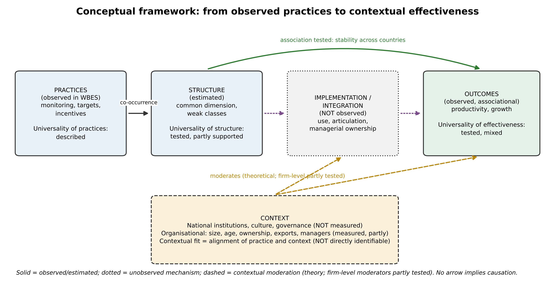
Figure 1. Conceptual framework: practices, structure, implementation/integration, context and outcomes. Solid = observed or estimated; dotted = unobserved mechanism; dashed = contextual moderation (theory). No arrow implies causation.

3. Research questions and hypotheses
Central question. To what extent are the structure and performance associations of management control practices universal across advanced economies, and to what extent are they contingent on national and organisational contexts?
The hypotheses were formulated after the earlier exploratory phase on the same data and were not pre-registered. Each was retained only if it could be operationalised.
- H1 (universality of structure). The observed practices share a common underlying sophistication dimension across the seven economies. Testable; examined by factor structure, discrete-versus-continuous model comparison and country-specific solutions.
- H2 (measurement). The measurement structure differs across countries. Testable; multi-group invariance and item differential functioning.
- H3 (universality of effectiveness). The association between the sophistication score and performance varies across countries. Testable; country-specific slopes and formal tests of equality.
- H4 (combinations and context). Performance associations of monitoring, targets and incentives depend on their combination and on organisational context. Partly testable; gate combinations at equal core-score levels, class-by-country interactions and firm-level moderators. National institutional moderation is not testable with seven countries and is a theoretical proposition.
- H5 (equifinality). Different combinations of practices are associated with comparable performance. Weakly testable within levels of the core score; cross-country equifinality is reformulated as a proposition.

4. Data and measurement
Sample. The study uses a merged file of WBES microdata for Canada (2024), France (2025), Germany (2025), Italy (2024), Japan (2025), the United Kingdom (2024) and the United States (2024), with 10,968 establishments. The original country files with value labels were not available; the merged file contains codes only. The management-practices module is asked of 6,316 establishments (88.5% with 20 or more permanent full-time employees); the remaining establishments are outside the module's universe, not missing responses. Table 1 gives the sample by country.
Management-practice items. Eleven items (r1–r11) cover monitoring, targets, bonuses and two further items. Skip patterns were verified empirically: r3 is asked only if r2 is yes, r5–r7 only if r4 is yes, r9 only if r8 is yes. Question wording was verified only partially (r5 for Italy 2024; r1–r3 and r8–r9 through secondary descriptions; r4 inferred); wording and category order of r6, r7, r10 and r11 remain unverified, so categories are treated as nominal and no substantive label is assigned to these items. The main specification uses six items asked of all firms in the module (r1, r2, r4, r8, r10, r11); "don't know" and "does not apply" codes are treated as missing, with full-information likelihood.
Outcomes and controls. Outcomes are log sales per employee, annualised three-year sales growth and annualised three-year employment growth. The definitions of the base-year variables (n3, l2) are assumed to be sales and employment three fiscal years earlier and are unverified. Sales are in local currency, so levels are compared only within country. Controls are log employment, log age and sector fixed effects; sector codes are country-specific. Firm-level moderators are foreign ownership of at least 10% (b2b), exporter status (d3b, d3c), top-manager experience (b7) and female top manager (b7a); their labels were checked only against data-dictionary records of other 2024 surveys.
Survey design. Sampling weights are available but the module universe is a subset of the sampled establishments; stratum and cluster identifiers are not in the file. Main analyses are unweighted, with weighted sensitivity checks, and robust or sector-clustered standard errors.

5. Empirical strategy
Structure and measurement (retained and extended). Categorical latent class models (one to eight classes) were compared on the same likelihood with a one-dimensional nominal-response trait model, a two-dimensional model and a hybrid (classes × one trait), using BIC, entropy and posterior probabilities. Cross-country comparability was assessed with multi-group latent class models (item-response probabilities shared versus free), item-wise likelihood-ratio tests of differential functioning and country-specific solutions. A five-item score excluding r8 (the item with differential functioning in both the three- and four-class solutions) serves as a sensitivity measure.
Country-specific associations. For each country c, y_i = α_s(i) + β_c θ_i + γ_c′X_i + ε_i, where s(i) is the sector fixed effect and X contains log size and log age. The latent trait θ is the posterior mean of the nominal one-dimensional model computed with a country-specific prior (regression calibration), which accounts for differential reliability across countries; the pooled-prior posterior mean, the five-item score and the core score (number of practices present among r2, r4, r8) are alternatives. Unconditional plausible values were tried first and rejected because they attenuate slopes by roughly the reliability.
Heterogeneity. The pooled model y_ic = α_s(i) + Σ_c β_c θ_i·1[c] + γ′X_i + ε is used to test H0: β_1 = … = β_7 with robust Wald statistics (HC3 and sector-clustered), with and without country-specific control slopes. Heterogeneity in separately estimated slopes is summarised by Cochran's Q, I² (Higgins & Thompson, 2002), a DerSimonian–Laird random-effects mean and a 95% prediction interval. Because results depend on scoring and specification, results are reported as a specification summary rather than a single test.
Contingencies and equifinality. Interactions of θ with size, age, foreign ownership, export status, manager experience and manager gender, with and without θ-by-country terms. Equifinality: equality of adjusted performance across combinations of r2, r4, r8 with the same core score (levels one and two), with equivalence judged by confidence intervals against explicit, illustrative margins (±0.05 log points; ±0.005 for growth). Class-by-country interactions and country-specific nonlinearity (spline versus linear) complete the analysis. Holm corrections are applied within families (Holm, 1979). All results are associations; no causal claim is made.

6. Results
6.1 Sample and descriptive differences (retained). The module universe contains 6,316 establishments (Table 1). Reported use of indicator monitoring (r2) ranges from 47% in Japan to 92% in the United Kingdom, targets (r4) from 60% in Italy to 93% in the United Kingdom, and target-linked bonuses (r8) from 36% in Italy to 76% in the United Kingdom. Larger firms report more practices (mean core score 1.86 for firms with fewer than 50 employees and 2.51 for 250 or more). These differences are descriptive and confounded by size composition; they are not evidence of institutional or cultural effects.
Table 1. Management-module universe by country: sample size, median permanent full-time employees, share reporting each practice among valid responses, and mean core score (number of practices present among r2, r4, r8; 0–3).
Country | N | Median employees | r2 monitoring (%) | r4 targets (%) | r8 bonuses (%) | Mean core score
CAN | 580 | 40 | 72 | 75 | 63 | 2.10
FRA | 451 | 48 | 85 | 87 | 48 | 2.21
DEU | 1233 | 67 | 69 | 62 | 59 | 1.90
ITA | 641 | 46 | 55 | 60 | 36 | 1.51
JPN | 1321 | 80 | 47 | 87 | 54 | 1.88
GBR | 610 | 98 | 92 | 93 | 76 | 2.61
USA | 1480 | 46 | 81 | 85 | 67 | 2.34
6.2 Structure of observed practices (retained). Latent class models fit the six common items poorly as distinct types (Table 2): BIC is lowest at four classes but differs by at most 13 points between three and five classes, relative entropy is 0.53–0.60, and residual dependence between items is large. The three-class solution is ordered along the core score without crossings on monitoring, targets and bonuses (0 of 9 comparisons; the ordering is partly by construction because classes are ordered by the same items). On the same likelihood, a hybrid model (three classes × one trait) has a BIC 129 points below the best latent class model, and two-dimensional continuous models outperform latent class models by 236 to 368 points in the specifications that include conditional items. Parallel analysis retains one factor (eigenvalue 2.54 versus 1.09). The reliability of the one-dimensional trait is 0.60 (Figure 2). A small class in the four-class solution (about 5–7%) pairs near-universal targets with few bonuses but is unstable across subsamples and weights. Conclusion retained: for these six items, a common continuous dimension is a better description than distinct configurations; this does not refute the package view, because most control categories are unobserved.
Table 2. Latent class models, specification A (r1, r2, r4, r8, r10, r11; N = 6,294), retained from the earlier analysis (one to six classes). Smallest class in %.
K | Parameters | Log-likelihood | BIC | Adjusted BIC | Relative entropy | Min. AvePP | Smallest class (%)
1 | 11 | -27,895.0 | 55,886.3 | 55,851.3 | 1.00 | 1.00 | 100.0
2 | 23 | -26,577.8 | 53,356.9 | 53,283.8 | 0.62 | 0.86 | 36.1
3 | 35 | -26,446.5 | 53,199.1 | 53,087.9 | 0.53 | 0.70 | 20.9
4 | 47 | -26,387.7 | 53,186.6 | 53,037.3 | 0.60 | 0.64 | 6.6
5 | 59 | -26,337.6 | 53,191.3 | 53,003.8 | 0.58 | 0.61 | 5.6
6 | 71 | -26,303.7 | 53,228.5 | 53,002.9 | 0.62 | 0.66 | 5.9
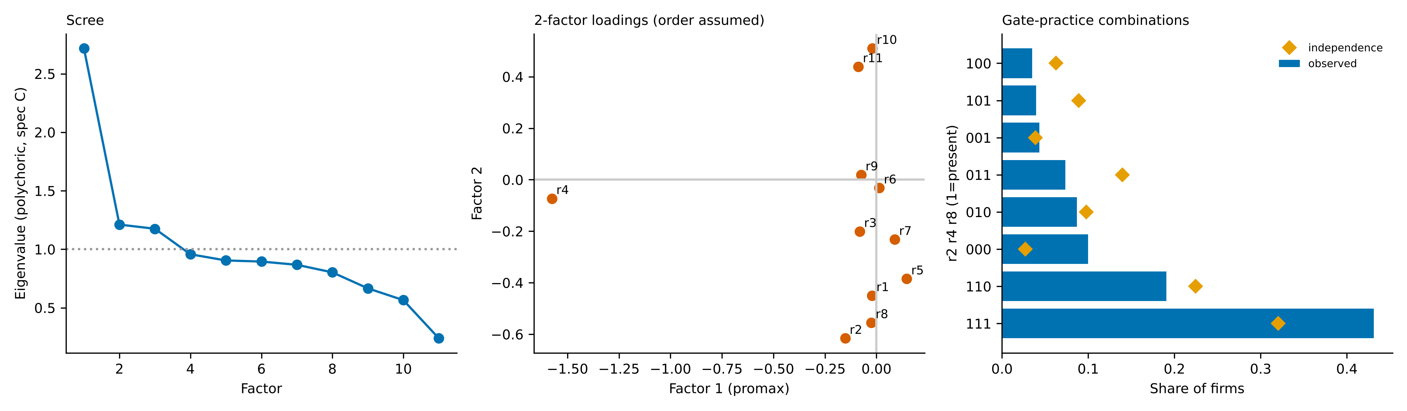
Figure 2. Retained structural evidence. Left: polychoric eigenvalues (supporting only). Centre: two-factor loadings (assumes code order = ordinal order). Right: observed versus independence-expected combinations of r2, r4, r8.
6.3 Measurement comparability (extended). Multi-group results depend on the number of classes (Table 3). With three classes full invariance is rejected by BIC (free item parameters preferred by 245 points), with differential functioning for r2, r8, r10 and r11; with four classes the invariant model is preferred by 541 points and only r8 shows differential functioning. Country-specific latent class models favour two classes in Canada, France, Germany, Japan and the United States and three in Italy and the United Kingdom, and one-factor solutions are similar across countries (congruence 0.93–0.99). Under country-specific priors, the reliability of the trait score varies markedly: Canada 0.64, France 0.40, Germany 0.57, Italy 0.65, Japan 0.35, United Kingdom 0.42, United States 0.57. Cross-country comparisons of slopes are therefore qualified by partial invariance and differential reliability.
Table 3. Cross-country invariance (specification A). Upper panel: multi-group latent class models (ΔBIC relative to the best model within K). Lower panel: item-wise tests, freeing one item across countries (ΔBIC < 0 favours non-invariance).
K | Model | Parameters | BIC | ΔBIC
3 | full invariance (pooled theta, country-specific prevalence) | 47 | 51,036.4 | 245.1
3 | no invariance (country-specific theta) | 245 | 50,791.4 | 0.0
3 | pooled, no country differences in prevalence | 35 | 53,199.1 | 2,407.8
4 | full invariance (pooled theta, country-specific prevalence) | 65 | 50,655.4 | 0.0
4 | no invariance (country-specific theta) | 329 | 51,196.8 | 541.4
4 | pooled, no country differences in prevalence | 47 | 53,186.6 | 2,531.2

K | Item | LR | df | ΔBIC (free − invariant) | Verdict
3 | r1 | 378.2 | 54 | 94.2 | invariant (BIC)
3 | r2 | 455.0 | 18 | -297.5 | non-invariant (BIC)
3 | r4 | 100.3 | 18 | 57.1 | invariant (BIC)
3 | r8 | 246.3 | 18 | -88.9 | non-invariant (BIC)
3 | r10 | 549.9 | 54 | -77.5 | non-invariant (BIC)
3 | r11 | 393.9 | 36 | -79.0 | non-invariant (BIC)
4 | r1 | 297.6 | 72 | 332.2 | invariant (BIC)
4 | r2 | 135.1 | 24 | 74.9 | invariant (BIC)
4 | r4 | 87.0 | 24 | 122.9 | invariant (BIC)
4 | r8 | 230.3 | 24 | -20.4 | non-invariant (BIC)
4 | r10 | 351.0 | 72 | 278.8 | invariant (BIC)
4 | r11 | 259.8 | 48 | 160.1 | invariant (BIC)
6.4 Country-specific associations with performance (new). Table 4 and Figure 3 report country-specific slopes of the calibrated latent trait. For productivity, slopes are positive with confidence intervals excluding zero in Canada, Germany, Italy, Japan and the United States, and close to zero with wide intervals in France (0.033) and the United Kingdom (0.037). Cochran's Q is 17.7 (df = 6, p = 0.007, I² = 66%), the random-effects mean is 0.169 and the 95% prediction interval, −0.007 to 0.345, includes zero. For sales and employment growth, individual slopes are small and mostly consistent with zero, and heterogeneity is not significant (Q p = 0.081 and 0.110). Formal pooled tests (Table 5) reject equality of productivity slopes in 12 of 16 specifications (p-values range from below 0.001 to 0.126); equality is not rejected when the pooled-prior EAP is used without country-specific control slopes (p = 0.12) or with weights (Q p = 0.84). The evidence for cross-country heterogeneity in the productivity association is therefore moderate and specification-dependent. The two countries with weak slopes are also those with the highest reported adoption of monitoring (85% and 92%) and targets (87% and 93%) and with low calibrated reliability (0.40 and 0.42); across the seven countries the calibrated slope is negatively related to the country mean of the trait (Spearman ρ = −0.75, p = 0.052; n = 7, descriptive). This pattern is compatible with ceiling effects, restricted range or measurement error and cannot be attributed to institutions or culture.
Table 4. Country-specific associations between the latent score (country-specific-prior posterior mean, per latent SD) and outcomes: slope [95% CI] (n). Country and sector fixed effects (sector within country), log size and log age; HC3. Heterogeneity: Cochran's Q and I²; random-effects mean.
Country | Log sales per employee | Sales growth (annual) | Employment growth (annual)
CAN | 0.159 [0.079, 0.240] (n=576) | -0.0031 [-0.0133, 0.0071] (n=560) | -0.0003 [-0.0081, 0.0076] (n=559)
FRA | 0.033 [-0.151, 0.217] (n=444) | -0.0056 [-0.0257, 0.0145] (n=441) | 0.0120 [-0.0033, 0.0273] (n=442)
DEU | 0.178 [0.115, 0.241] (n=1232) | 0.0103 [0.0039, 0.0167] (n=1226) | -0.0004 [-0.0050, 0.0041] (n=1220)
ITA | 0.237 [0.150, 0.324] (n=636) | 0.0052 [-0.0040, 0.0145] (n=632) | 0.0076 [0.0024, 0.0129] (n=628)
JPN | 0.404 [0.239, 0.568] (n=1235) | 0.0151 [-0.0030, 0.0332] (n=1189) | 0.0111 [-0.0006, 0.0227] (n=1230)
GBR | 0.037 [-0.091, 0.166] (n=609) | -0.0098 [-0.0257, 0.0060] (n=604) | -0.0039 [-0.0158, 0.0080] (n=606)
USA | 0.139 [0.088, 0.190] (n=1467) | 0.0076 [0.0023, 0.0129] (n=1416) | 0.0028 [-0.0019, 0.0074] (n=1434)
Random-effects pooled | 0.169 (SE 0.030) | 0.0046 (SE 0.0027) | 0.0032 (SE 0.0018)
Q (df = 6), p; I² | 17.7, p = 0.007; I² = 66% | 11.3, p = 0.081; I² = 47% | 10.4, p = 0.110; I² = 42%
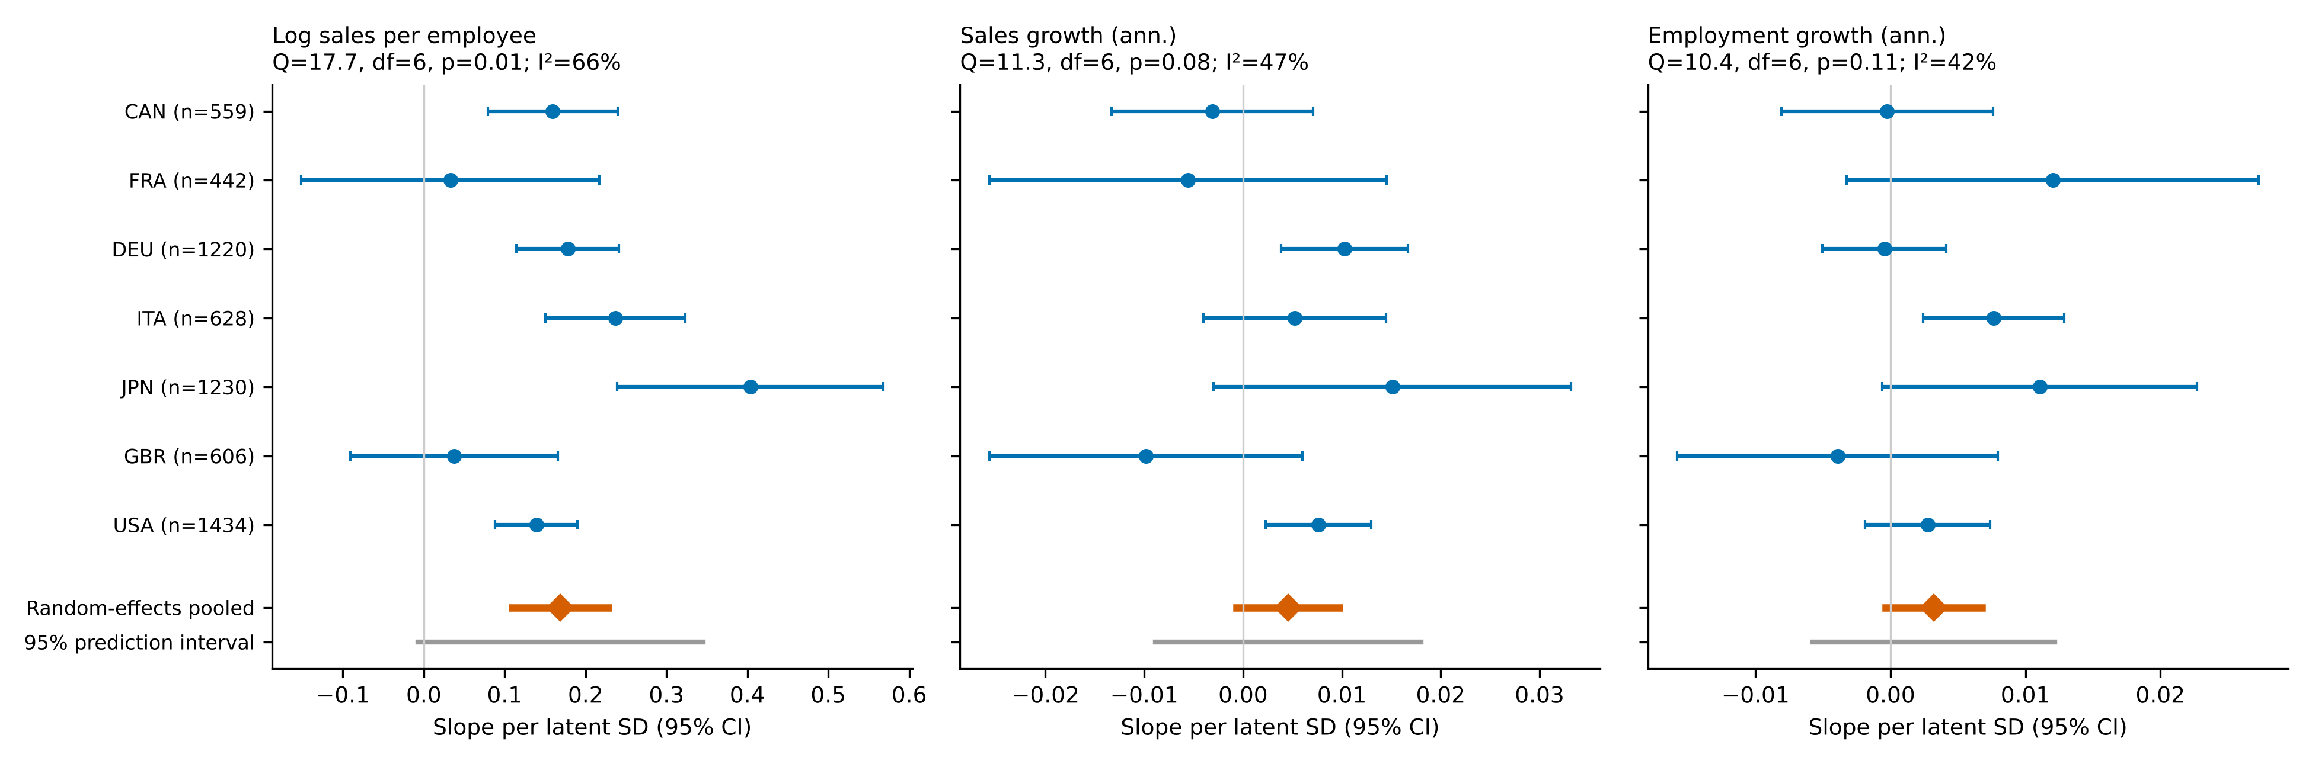
Figure 3. Country-specific slopes of the latent score (95% CI), random-effects pooled mean and 95% prediction interval, by outcome.
Table 5. Tests of equality of country-specific slopes, productivity (6 df): robust Wald statistics across scores and specifications.
Score | Country-specific control slopes | Covariance | Wald χ² | p
latent trait, country-specific prior | no | HC3 | 22.1 | 0.0011
latent trait, country-specific prior | no | cluster(sector) | 37.4 | 0.0000
latent trait, country-specific prior | yes | HC3 | 17.7 | 0.0071
latent trait, country-specific prior | yes | cluster(sector) | 27.6 | 0.0001
EAP | no | HC3 | 10.1 | 0.1224
EAP | no | cluster(sector) | 10.0 | 0.1262
EAP | yes | HC3 | 13.5 | 0.0364
EAP | yes | cluster(sector) | 16.7 | 0.0103
5-item invariant subset | no | HC3 | 11.0 | 0.0883
5-item invariant subset | no | cluster(sector) | 12.9 | 0.0438
5-item invariant subset | yes | HC3 | 14.4 | 0.0257
5-item invariant subset | yes | cluster(sector) | 19.8 | 0.0030
core score | no | HC3 | 12.6 | 0.0490
core score | no | cluster(sector) | 10.3 | 0.1144
core score | yes | HC3 | 18.2 | 0.0057
core score | yes | cluster(sector) | 20.9 | 0.0019
EAP, weighted WLS (wmedian) - Q test | - | HC3 | 2.7 | 0.8427
6.5 Organisational contingencies (new). Among the six firm-level moderators of the productivity association (Table 6, Figure 4), only foreign ownership shows a sizeable interaction (0.120 log points per SD of the score; 95% CI 0.020 to 0.220; unadjusted p = 0.019), and it does not survive Holm correction (p = 0.33; 0.137 with p = 0.008 and Holm p = 0.14 when country-specific slopes are included). Size, age, export status and manager characteristics show no reliable moderation, and no moderator is significant for either growth outcome after correction. The labels of the ownership, export and manager variables are unverified for the G7 files.
Table 6. Firm-level moderators of the score–productivity association (interaction with the pooled-prior score, per SD): estimate [95% CI], unadjusted and Holm p, and estimate when θ×country terms are included.
Moderator | N | Interaction [95% CI] | p | Holm p | With country slopes
Size (log employees) | 6199 | 0.019 [-0.004, 0.043] | 0.107 | 1.00 | 0.020 (p = 0.089)
Age (log years) | 6199 | -0.012 [-0.033, 0.009] | 0.271 | 1.00 | -0.015 (p = 0.170)
Foreign ownership >=10% | 6179 | 0.120 [0.020, 0.220] | 0.019 | 0.33 | 0.137 (p = 0.008)
Exporter (any) | 6172 | 0.011 [-0.032, 0.055] | 0.607 | 1.00 | 0.015 (p = 0.510)
Top-manager experience (log) | 6035 | 0.005 [-0.018, 0.028] | 0.685 | 1.00 | 0.004 (p = 0.759)
Female top manager | 6194 | 0.026 [-0.031, 0.082] | 0.376 | 1.00 | 0.026 (p = 0.375)
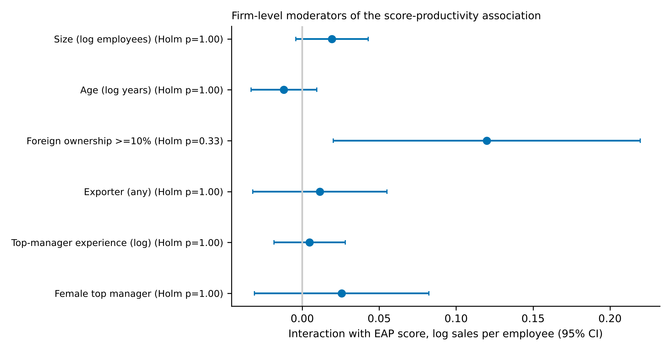
Figure 4. Interactions of the score with firm-level moderators, productivity (95% CI).
6.6 Configurations and equifinality (new). Latent classes add no explanatory power beyond country-specific trait slopes for any outcome (p = 0.78, 0.18, 0.51). Class-by-country interactions are not significant for productivity (p = 0.33) but are for sales growth (F(12) = 2.45, Holm p = 0.021, ΔR² = 0.004) and employment growth (F(12) = 2.29, Holm p = 0.033, ΔR² = 0.004); the increments are tiny and may reflect country-specific meaning of pooled classes given partial invariance. Among firms with the same core score, combinations of practices differ in productivity at level two (Wald p = 0.009, Holm p = 0.26; Table 7), mainly because firms with monitoring and bonuses but no targets (101) have higher productivity than those with monitoring and targets but no bonuses (110) (difference 0.187, 95% CI 0.067 to 0.308). Equivalence within ±0.05 log points is not established for any contrast because confidence intervals are wide, so the data neither demonstrate nor reject equifinality. Country-level tests were possible only in Canada, Germany, Italy and the United States (minimum cell size 15) and none is significant after correction.
Table 7. Equifinality: equality of adjusted performance across combinations of r2, r4, r8 with the same core score (pooled; Wald test), and equivalence of productivity differences against an illustrative margin of ±0.05 log points.
Outcome | Core score | Combinations | N | Wald χ² | p | Holm p
Log sales per employee | 1 | 100/010/001 | 1000 | 3.7 | 0.155 | 1.00
Log sales per employee | 2 | 110/101/011 | 1853 | 9.4 | 0.009 | 0.26
Sales growth (ann.) | 1 | 100/010/001 | 973 | 3.8 | 0.151 | 1.00
Sales growth (ann.) | 2 | 110/101/011 | 1820 | 4.4 | 0.111 | 1.00
Employment growth (ann.) | 1 | 100/010/001 | 985 | 6.7 | 0.036 | 0.89
Employment growth (ann.) | 2 | 110/101/011 | 1833 | 3.1 | 0.216 | 1.00

Core score | Contrast | Difference [95% CI] | Margin | Equivalent?
1 | 001 vs 100 | 0.081 [-0.077, 0.239] | ±0.05 | no
1 | 010 vs 100 | -0.060 [-0.212, 0.091] | ±0.05 | no
2 | 011 vs 110 | 0.047 [-0.052, 0.146] | ±0.05 | no
2 | 101 vs 110 | 0.187 [0.067, 0.308] | ±0.05 | no
6.7 Nonlinearity (new for countries; pooled result retained). Pooled, a spline is preferred to a linear term for productivity (p = 0.006), but the largest departure from linearity is 0.03 standard deviations of the outcome. Across seven countries and three outcomes, no spline-versus-linear test survives Holm correction and the largest deviations are at most 0.13 outcome standard deviations. Nonlinearity is not a substantive finding.
6.8 Associations with performance (retained). Pooled within countries, one standard deviation of the pooled-prior score is associated with 0.128 log points higher sales per employee (about 13.7%), 0.0033 higher annual sales growth and 0.0018 higher annual employment growth; classes add no predictive information once the continuous score is included (pseudo-class tests p = 0.29–0.62), and out-of-sample gains are modest for productivity (cross-validated RMSE 0.810 to 0.803) and negligible for growth. These are associations, not effects.

7. Discussion
Universal structure, qualified. For the six common items, practices share a dominant continuous dimension in every country, and latent classes add little. This supports universality of structure (H1) in a limited sense: congruent loadings, but not strict measurement equivalence (H2 partly supported). The common dimension is a statistical regularity among observed practices; it is not a theory of control and does not show that practices are integrated into systems.
Effectiveness: heterogeneous but not interpretable as contextual fit. The association between the score and productivity is positive in most countries, weak in France and the United Kingdom, and heterogeneous in most specifications (H3 moderately supported for productivity, not supported for growth). Three considerations prevent a contextual-fit interpretation. First, the countries with weak slopes combine high adoption, low reliability and, for the score, partial non-invariance; restricted range or measurement error would produce the same pattern. Second, country indicators bundle institutions, culture, sampling frames and sector composition, and seven countries cannot identify which, if any, matters. Third, fit is an alignment between a practice and a context, and neither the implementation of the practice nor the context is measured. The finding that effectiveness may vary across countries is thus an invitation to measure integration and context directly, not evidence that national systems require distinct control arrangements.
Combinations and equifinality. Configurations add little beyond the continuous score, and firm-level moderators are not reliably different from zero after correction. The productivity advantage of monitoring-plus-bonus combinations over monitoring-plus-targets, and the class-by-country interactions for growth, are exploratory leads of small magnitude. Equifinality is neither demonstrated nor rejected because the equivalence intervals are too wide.
Accumulation, configuration, integration. Accumulation of practices accounts for most of the structure and the performance association that can be detected; configuration adds little; integration is unobserved. This asymmetry limits what co-occurrence data can say about management control systems: a firm can hold indicators, targets and bonuses without those mechanisms operating as a coherent system (Grabner & Moers, 2013), and a country can display similar prevalence without similar use (Simons, 1995). Consistent with Otley (2016), a predictive search for a universally optimal configuration is not supported by these data, and neither is a claim that every context requires a unique arrangement.

8. Theoretical contributions
- Measurement. Observable practices have a largely common continuous structure across seven advanced economies, with partial, K-dependent invariance and differential reliability; cross-country comparison requires explicit invariance checks and measurement-error treatment.
- Contextual heterogeneity. The association between practice sophistication and productivity is positive in most countries but heterogeneous in most specifications; its heterogeneity cannot be attributed to national institutions or culture with these data, and firm-level moderators are not reliably different from zero.
- Concepts. Separating universality of practices, structure and effectiveness from contextual fit, and accumulation and configuration from integration, clarifies what presence-based data can support. The proposition that a common architecture of practices can coexist with heterogeneous organisational outcomes, without implying that identical arrangements are equally appropriate everywhere, is a theoretical interpretation consistent with the evidence on structure and with moderate evidence of heterogeneous associations; it is not demonstrated contextual fit.

9. Managerial and policy implications
Implications are cautious. Managers adopting practices inspired by other settings should not infer from adoption that the practices are integrated into decisions; they should assess ownership, fit with decision processes and incentives. Policy programmes that promote management practices should monitor integration and use, not only adoption. Because associations are cross-sectional and heterogeneous, the results do not support promoting a single set of practices as universally effective.

10. Limitations and future research
Limitations. (i) The original country files and questionnaires were not available; wording of r6, r7, r10 and r11 and category order are unverified; outcome base-year variables and moderator labels are unverified. (ii) Measurement invariance is partial; the latent score is not strictly comparable across countries, and its reliability varies from 0.35 to 0.65. (iii) The module covers mainly firms with 20 or more employees. (iv) Analyses are cross-sectional, unweighted in the main specifications, without design-based variance estimation, and sales are in local currency. (v) With seven countries, institutional or cultural moderators cannot be tested; country effects are not measures of either. (vi) The hypotheses were formulated after exploratory work and are not pre-registered; many tests were run and conclusions rest on the pattern across specifications. (vii) A systematic literature search remains to be completed. Additional analyses requiring raw files: verification of all labels, design variables, other waves, and firm-level variables on managerial autonomy and governance.
Future research. (1) Measure integration and use of controls directly (diagnostic and interactive use, articulation among controls, managerial ownership). (2) Collect panel data around the introduction of controls. (3) Use country-level institutional indicators with many more countries and multilevel designs.
A separate research agenda on Morocco. The G7 findings are not generalised to Moroccan organisations, and the dataset contains no Moroccan firms. The agenda is motivated by the conceptual distinction between adopting, combining and integrating controls. Its central question is: under what organisational and institutional conditions can internationally diffused management-control practices become effective and sustainable in Moroccan organisations? Contexts of interest include SMEs, public establishments and public enterprises, family-owned businesses and subsidiaries of multinational companies. Existing Moroccan work identified through a single search includes a survey of 190 industrial firms relating contingency factors to control design (Hammouch, Manta & Palazzo, 2024) and an exploratory study of changes in control systems of large industrial companies (Daanoune & Tirhzaoui); these records were read at abstract level and their quality was not assessed. Proposed studies: interviews with management accountants and controllers; organisational case studies; manager surveys with measures of control integration; longitudinal implementation studies; and measures of readiness and resistance to change. This agenda connects to the doctoral project on management control systems, artificial intelligence, internal auditing and performance, where AI-enabled control, audit follow-up and dynamic capabilities (Teece, 2007) and readiness for change (Armenakis & Harris, 2002) would be examined in a distinct study.

11. Conclusion
Observable management control practices in seven G7 economies are organised mainly along a common continuous dimension; distinct configurations add little. The association of that dimension with productivity is positive in most countries but heterogeneous in most specifications, and the heterogeneity cannot be attributed to national institutions or culture with these data. A common architecture of practices may coexist with heterogeneous outcomes, but whether and why contextual fit matters requires direct measurement of integration, use and context. The article therefore contributes a bounded empirical result and a clearer conceptual separation, and sets out a research agenda rather than an established theory of contextual fit.

Data availability and reproducibility
Analyses used a merged WBES file supplied by the research team. Scripts, seeds, software versions and logs are in the project repository (MCS_G7_RESEARCH/02_SCRIPTS, 07_REPRODUCIBILITY, 08_CONTEXTUAL_FIT). The original manuscript and dataset were not overwritten.

References
Armenakis, A. A., & Harris, S. G. (2002). Crafting a change message to create transformational readiness. Journal of Organizational Change Management, 15(2), 169–183. https://doi.org/10.1108/09534810210423080
Bedford, D. S., & Malmi, T. (2015). Configurations of control: An exploratory analysis. Management Accounting Research, 27, 2–26. https://doi.org/10.1016/j.mar.2015.04.002
Bloom, N., Brynjolfsson, E., Foster, L., Jarmin, R., Patnaik, M., Saporta-Eksten, I., & Van Reenen, J. (2019). What drives differences in management practices? American Economic Review, 109(5), 1648–1683. https://doi.org/10.1257/aer.20170491
Bloom, N., Sadun, R., & Van Reenen, J. (2012). The organization of firms across countries. Quarterly Journal of Economics, 127(4), 1663–1705. https://doi.org/10.1093/qje/qje029
Bloom, N., & Van Reenen, J. (2007). Measuring and explaining management practices across firms and countries. Quarterly Journal of Economics, 122(4), 1351–1408. https://doi.org/10.1162/qjec.2007.122.4.1351
Burns, J., & Scapens, R. W. (2000). Conceptualizing management accounting change: An institutional framework. Management Accounting Research, 11(1), 3–25. https://doi.org/10.1006/mare.1999.0119
Chenhall, R. H. (2003). Management control systems design within its organizational context: Findings from contingency-based research and directions for the future. Accounting, Organizations and Society, 28(2–3), 127–168.
Daanoune, & Tirhzaoui. (n.d.). The changes in management control systems of industrial companies in Morocco: An exploratory study. HAL working paper. [Authors' initials, year and details to be completed from the original record.]
DiMaggio, P. J., & Powell, W. W. (1983). The iron cage revisited: Institutional isomorphism and collective rationality in organizational fields. American Sociological Review, 48(2), 147–160.
Drazin, R., & Van de Ven, A. H. (1985). Alternative forms of fit in contingency theory. Administrative Science Quarterly, 30(4), 514–539.
Grabner, I., & Moers, F. (2013). Management control as a system or a package? Conceptual and empirical issues. Accounting, Organizations and Society, 38(6), 407–419. https://doi.org/10.1016/j.aos.2013.09.002
Gresov, C., & Drazin, R. (1997). Equifinality: Functional equivalence in organization design. Academy of Management Review, 22(2), 403–428.
Hall, P. A., & Soskice, D. (Eds.). (2001). Varieties of capitalism: The institutional foundations of comparative advantage. Oxford University Press.
Hammouch, Manta, & Palazzo. (2024). Adapting management control systems to organizational contingency factors: A study of Moroccan industrial companies. Businesses. [Volume and pages to be completed from the original record.]
Harrison, G. L., & McKinnon, J. L. (1999). Cross-cultural research in management control systems design: A review of the current state. Accounting, Organizations and Society, 24(5–6), 483–506.
Higgins, J. P. T., & Thompson, S. G. (2002). Quantifying heterogeneity in a meta-analysis. Statistics in Medicine, 21(11), 1539–1558. https://doi.org/10.1002/sim.1186
Holm, S. (1979). A simple sequentially rejective multiple test procedure. Scandinavian Journal of Statistics, 6(2), 65–70.
Malmi, T., & Brown, D. A. (2008). Management control systems as a package: Opportunities, challenges and research directions. Management Accounting Research, 19(4), 287–300. https://doi.org/10.1016/j.mar.2008.09.003
McSweeney, B. (2002). Hofstede's model of national cultural differences and their consequences: A triumph of faith – a failure of analysis. Human Relations, 55(1), 89–118.
Murrell, P., Karalashvili, N., & Francis, D. C. (2024). Transactional governance structures: New cross-country data and an application to the effect of uncertainty. Journal of Law, Economics, and Organization, 40(3), 891–929.
Nielsen, S. (2022). Management accounting and the concepts of exploratory data analysis and unsupervised machine learning: A literature study and future directions. Journal of Accounting & Organizational Change, 18(5), 811–853.
Otley, D. (2016). The contingency theory of management accounting and control: 1980–2014. Management Accounting Research, 31, 45–62.
Scur, D., Sadun, R., Van Reenen, J., Lemos, R., & Bloom, N. (2021). The World Management Survey at 18: Lessons and the way forward. Oxford Review of Economic Policy, 37(2), 231–258. https://doi.org/10.1093/oxrep/grab009
Simons, R. (1995). Levers of control: How managers use innovative control systems to drive strategic renewal. Harvard Business School Press.
Teece, D. J. (2007). Explicating dynamic capabilities: The nature and microfoundations of (sustainable) enterprise performance. Strategic Management Journal, 28(13), 1319–1350. https://doi.org/10.1002/smj.640
Tessier, S., & Otley, D. (2012). A conceptual development of Simons' Levers of Control framework. Management Accounting Research, 23(3), 171–185.

