Beyond Management Control Packages: Toward an Empirically Grounded Model of Management Control Practices
An Exploratory Investigation Using World Bank Enterprise Surveys Across G7 Countries
[Author name(s) and affiliation(s)] — Draft for internal review

Abstract
Management control research treats controls as a package, whereas management-practice research summarises practices in aggregate scores. We ask whether observable control practices form qualitatively distinct configurations or mainly differ in managerial sophistication. Using the management module of the World Bank Enterprise Surveys for seven G7 economies in 2024–2025 (6,316 establishments, mostly with 20 or more employees), we handle survey skip patterns explicitly and compare latent class, continuous latent-trait and hybrid models on a common likelihood scale. Latent classes are poorly separated (relative entropy 0.53–0.60 with three to four classes), residual dependence is substantial, and the three-class solution is ordered along the sophistication gradient without crossing on monitoring, targets and bonuses. Continuous and hybrid models fit better than purely discrete ones, and classes add no explanatory power over a continuous score for productivity or growth, which show modest positive associations with the score. Cross-country measurement invariance is only partial. A small, unstable class with targets but few bonuses is a tentative lead. We propose a four-layer model separating observed practices, empirical structure, theoretical interpretation and associations. The findings are exploratory, cross-sectional and limited by unverified question wording for several items; they are not evidence of distinct control systems and say nothing about interactive control use, AI, internal audit or dynamic capabilities.
Keywords: management control systems; management control packages; latent class analysis; levers of control; World Bank Enterprise Surveys; management practices

1. Introduction
Management control research has long argued that controls operate as a package rather than in isolation (Malmi & Brown, 2008; Grabner & Moers, 2013), whereas economists measure management through scored practices and relate the aggregate to productivity (Bloom & Van Reenen, 2007). The two traditions raise a question that is rarely posed explicitly: when firms are observed deploying individual practices, do their combinations form qualitatively distinct configurations, or do they mainly reflect different levels of managerial sophistication?
We address this question exploratorily with the management module of the World Bank Enterprise Surveys (WBES) in seven G7 economies in 2024–2025. We do not test the full doctoral model on artificial intelligence, internal auditing or dynamic capabilities; WBES does not measure these constructs. Our aims are to (i) describe the empirical structure of observable control practices, (ii) test configurations against a continuous gradient, and (iii) propose a model, restricted to what is observable, that can inform subsequent questionnaire design.
Configurations of control have been investigated before (Bedford & Malmi, 2015), and latent class analysis has been applied to Enterprise Surveys data on transactional governance (Murrell, Karalashvili & Francis, 2024). Our contribution is therefore not the use of a configurational method itself but a likelihood-based comparison of discrete, continuous and hybrid structures on practice-level data from several advanced economies, with explicit attention to survey skip patterns and cross-country comparability.

2. Theoretical background and prior research
Verification note: references were checked against bibliographic records; full texts were not read. See `05_THEORY/literature_review/CRITICAL_LITERATURE_SYNTHESIS.md` for details and the verification status of each citation.
Package perspective. Malmi and Brown (2008) propose a typology of planning, cybernetic, reward and compensation, administrative and cultural controls and call for research on controls as a package. Grabner and Moers (2013) distinguish packages from designed systems and define internal consistency.
Configurations. Bedford and Malmi (2015) derive five configurations of control from a survey of about 400 firms. This is our closest precedent and a reason for caution about claims of novelty.
Use of controls. Simons (1995) differentiates belief, boundary, diagnostic and interactive systems by the way managers use them. Tessier and Otley (2012) show conceptual ambiguity and propose distinguishing managerial intentions from employee perceptions. Because use cannot be inferred from the presence of a practice, we use Simons only for interpretation.
Measurement of management. Bloom and Van Reenen (2007) relate scored practices to productivity, profitability and survival; Bloom et al. (2019) document large dispersion in US plants; Scur et al. (2021) review the World Management Survey. The WBES module follows this tradition and has been grouped into monitoring, target setting and incentives in World Bank briefs.
Complementarity. Milgrom and Roberts (1995) define complementarity through supermodularity; Athey and Stern (1998) warn that cross-sectional tests can be biased. We therefore distinguish co-occurrence, statistical interaction and economic complementarity.
Methods. Class enumeration follows Nylund, Asparouhov and Muthén (2007); classification uncertainty is handled with soft assignment and pseudo-class draws, motivated by Vermunt (2010).

3. Data and methods
Data. The user-supplied merged file contains 10,968 establishments from seven WBES country-years (Canada 2024, France 2025, Germany 2025, Italy 2024, Japan 2025, United Kingdom 2024, United States 2024). The original .dta files could not be accessed; the CSV contains codes without value labels. Question wording was verified only partially (r5 for Italy 2024; r1–r3, r8–r9 through secondary descriptions) and not at all for r6, r7, r10 and r11, which are therefore treated as nominal without substantive labels.
Universe and skip patterns. The management module is asked of 6,316 establishments (88.5% with ≥20 permanent full-time employees). Within this universe r1, r2, r4, r8, r10 and r11 are asked of all; r3 only if r2 = yes, r5–r7 only if r4 = yes, r9 only if r8 = yes (verified in the data). Code −9 (don't know) is treated as missing; −7 (does not apply; r1, r10, r11) is set to missing in the main analyses and kept as a category in a sensitivity specification.
Specifications. A: r1, r2, r4, r8, r10, r11 (N = 6,294 with ≥1 observed item). B: conditional items with a structural-absence category. C: all 11 items, skipped items omitted from the likelihood. D: A with −7 retained.
Latent class analysis. Categorical LCA by EM with full-information treatment of missing items, 40–60 random starts, eight full runs per K, K = 1–8, fixed seeds. The implementation was verified against StepMix (log-likelihood differences ≤0.003). Selection used AIC, BIC, adjusted BIC, relative entropy, average posterior probabilities, class sizes, local-maximum diagnostics and bivariate residuals. Profiles carry bootstrap intervals (150 replicates with class alignment).
Gradient versus configuration. (i) Class ordering and crossings on directional indicators (r2, r4, r8); (ii) BIC comparison on the same likelihood of K-class LCA, a 1-D nominal-response trait, a 2-D trait and a hybrid (K classes × 1-D trait); (iii) outcome regressions comparing a transparent score (number of r2/r4/r8 present), the continuous trait and latent classes (soft posterior regressors, pseudo-class draws with Rubin's rules, 10-fold cross-validated RMSE).
Dimensionality. Polychoric correlations, parallel analysis, minimum-residual EFA with promax rotation (assumes code order = ordinal order and is therefore used only as supporting evidence), nominal MCA and country-specific Tucker congruence.
Cross-country. Pooled, country-specific and multi-group LCA (shared item-response probabilities, country-specific prevalence), item-wise differential item functioning by likelihood ratio, leave-one-country-out, weights, size, split-half, leave-one-item-out.
Outcomes and nonlinearity. Log sales per employee, annualised three-year sales growth and employment growth (definitions of n3 and l2 unverified), winsorised, with country and country-specific sector fixed effects, log size and log age; HC3 standard errors; natural cubic splines, quadratic terms and interactions; Holm correction over 30 tests. All associations are cross-sectional.

4. Results
4.1 Sample and variables. The module universe contains 6,316 establishments (CAN 580, FRA 451, DEU 1,233, ITA 641, JPN 1,321, GBR 610, USA 1,480). Cross-country heterogeneity in response distributions is substantial (Cramér's V 0.12–0.33). Shares reporting indicator monitoring (r2) range from 47% (JPN) to 92% (GBR); targets (r4) from 60% (ITA) to 93% (GBR); target-linked bonuses (r8) from 36% (ITA) to 76% (GBR). Pairwise associations among practices are modest (maximum bias-corrected V = 0.41, r2–r4).
Table 1. Management-module universe by country: sample size, median permanent full-time employees, share reporting each practice (among valid responses) and mean core score (number of practices present among r2, r4, r8; range 0–3).
Country | N | Median employees | r2 monitoring (%) | r4 targets (%) | r8 bonuses (%) | Mean core score
CAN | 580 | 40 | 72 | 75 | 63 | 2.10
FRA | 451 | 48 | 85 | 87 | 48 | 2.21
DEU | 1233 | 67 | 69 | 62 | 59 | 1.90
ITA | 641 | 46 | 55 | 60 | 36 | 1.51
JPN | 1321 | 80 | 47 | 87 | 54 | 1.88
GBR | 610 | 98 | 92 | 93 | 76 | 2.61
USA | 1480 | 46 | 81 | 85 | 67 | 2.34
4.2 Number of classes. In specification A BIC is minimal at K = 4 (53,186.6) but differs from K = 3 and K = 5 by ≤ 13 points; relative entropy is 0.53 (K = 3) and 0.60 (K = 4). Specifications B, C and D select K = 5, 4 and 6 respectively. Local independence is violated for a large share of item pairs.
4.3 Profiles. With K = 3 (prevalence 21%, 32%, 47%) the classes are ordered by the presence of monitoring, targets and bonuses (P(r2 = yes) = .19, .66, .95; P(r4 = yes) = .23, .92, .94; P(r8 = yes) = .27, .52, .78): no crossing occurs on these indicators (0/9). With K = 4 a small class (about 5–7%) combines near-universal targets with few bonuses; it is unstable across subsamples.
Table 2. Latent class models, specification A (r1, r2, r4, r8, r10, r11; N = 6,294). Smallest class share in %.
K | Parameters | Log-likelihood | BIC | Adjusted BIC | Relative entropy | Min. AvePP | Smallest class (%)
1 | 11 | -27,895.0 | 55,886.3 | 55,851.3 | 1.00 | 1.00 | 100.0
2 | 23 | -26,577.8 | 53,356.9 | 53,283.8 | 0.62 | 0.86 | 36.1
3 | 35 | -26,446.5 | 53,199.1 | 53,087.9 | 0.53 | 0.70 | 20.9
4 | 47 | -26,387.7 | 53,186.6 | 53,037.3 | 0.60 | 0.64 | 6.6
5 | 59 | -26,337.6 | 53,191.3 | 53,003.8 | 0.58 | 0.61 | 5.6
6 | 71 | -26,303.7 | 53,228.5 | 53,002.9 | 0.62 | 0.66 | 5.9
7 | 83 | -26,275.2 | 53,276.5 | 53,012.7 | 0.65 | 0.62 | 6.0
8 | 95 | -26,260.1 | 53,351.2 | 53,049.3 | 0.63 | 0.53 | 3.6
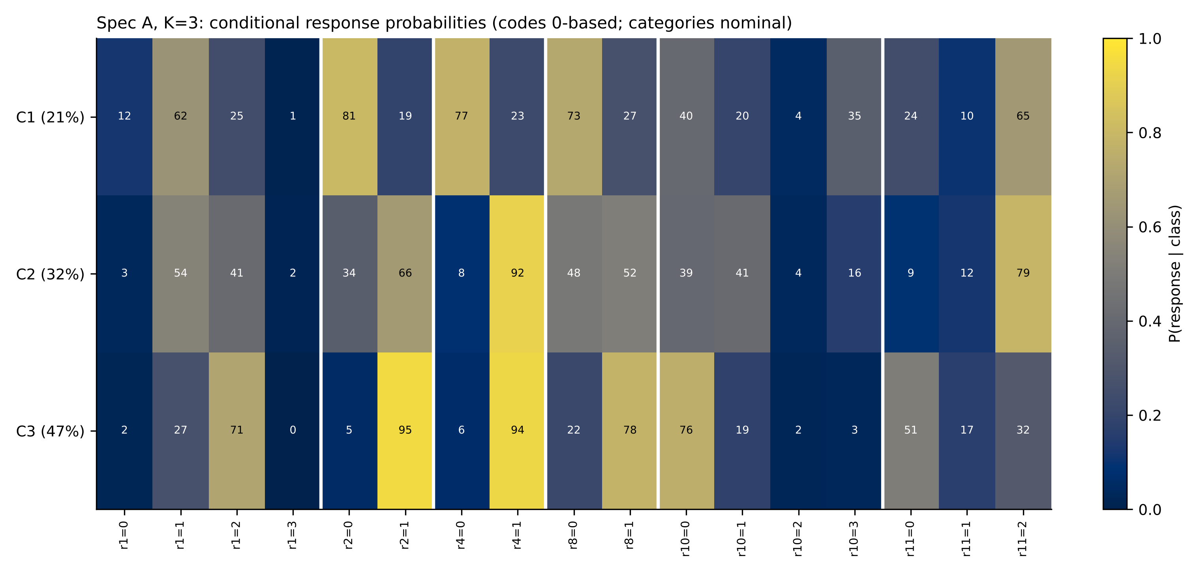
Figure 1. Conditional response probabilities (%) of the three-class solution (specification A). Codes are 0-based and categories nominal; classes are ordered by mean core score and carry no substantive label.
4.4 Gradient versus configuration. On the same likelihood a hybrid (three classes × one trait) outperforms the best LCA by 129 BIC points in specification A, and a two-dimensional continuous model outperforms LCA by 236–368 points in B, C and D. Parallel analysis retains a single factor for the six universal items. In outcome models, a continuous score and the transparent core score account for the associations; latent classes add nothing once the continuous score is included (pseudo-class F tests p between 0.29 and 0.62 across outcomes), and out-of-sample RMSE is lowest for the score models.
Table 3. Best model by family and specification (BIC; ΔBIC relative to the best model of the specification). 'nrm1/nrm2' = one/two-dimensional continuous latent-trait models; 'hyb_K' = K classes × one trait.
Spec. | Family | Model | Parameters | BIC | ΔBIC
A | 1-D continuous | nrm1 | 22 | 53,180.5 | 122.3
A | 2-D continuous | nrm2 | 32 | 53,083.7 | 25.6
A | LCA (discrete) | lca_K4 | 47 | 53,186.6 | 128.5
A | hybrid class x 1-D trait | hyb_K3 | 46 | 53,058.1 | 0.0
B | 1-D continuous | nrm1 | 56 | 107,124.2 | 1,111.6
B | 2-D continuous | nrm2 | 83 | 106,012.6 | 0.0
B | LCA (discrete) | lca_K5 | 144 | 106,380.3 | 367.7
B | hybrid class x 1-D trait | hyb_K3 | 114 | 106,048.0 | 35.4
C | 1-D continuous | nrm1 | 52 | 106,076.0 | 156.4
C | 2-D continuous | nrm2 | 77 | 105,919.6 | 0.0
C | LCA (discrete) | lca_K4 | 107 | 106,155.5 | 235.9
C | hybrid class x 1-D trait | hyb_K2 | 79 | 105,935.7 | 16.0
D | 1-D continuous | nrm1 | 28 | 63,536.6 | 1,136.0
D | 2-D continuous | nrm2 | 41 | 62,400.6 | 0.0
D | LCA (discrete) | lca_K6 | 89 | 62,638.3 | 237.7
D | hybrid class x 1-D trait | hyb_K3 | 58 | 62,452.3 | 51.7
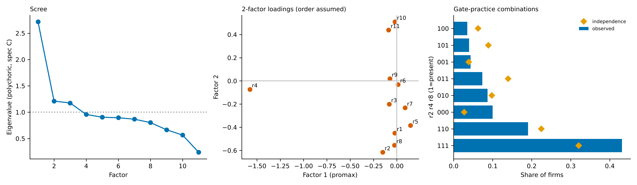
Figure 2. Left: scree of polychoric eigenvalues (specification C; supporting only, unstable). Centre: two-factor loadings (assumes code order = ordinal order). Right: observed versus independence-expected combinations of r2, r4, r8.
4.5 Cross-country validity. Country-specific analyses favour two classes in five countries and three in GBR and ITA. Multi-group results depend on K (invariance rejected at K = 3, retained at K = 4 by BIC). Tucker congruence of one-factor solutions is .93–.99.
4.6 Outcomes and nonlinearity. One SD of the continuous score is associated with +0.128 log sales per employee (HC3 SE 0.005), +0.0033 annual sales growth and +0.0018 annual employment growth. After Holm correction, two nonlinearity tests for productivity remain significant but explain ≤0.04% of variance; no interaction among monitoring, targets and bonuses survives correction.
Table 4. Associations of the continuous score and the core score with outcomes (OLS, country and country-specific sector fixed effects, log size, log age; HC3 SE in parentheses), p-value of latent classes (K = 3) added to the continuous score (median over 50 pseudo-class draws), and 10-fold cross-validated RMSE for controls only / continuous score / classes. Associations only.
Outcome | Continuous score (per SD) | Core score (per practice) | Classes | score: p | CV-RMSE (controls / score / classes)
Log sales per employee | 0.1283 (0.0049) | 0.1272 (0.0046) | 0.58 | 0.8101 / 0.8028 / 0.8037
Annualised sales growth (3y) | 0.0033 (0.0006) | 0.0037 (0.0006) | 0.50 | 0.0874 / 0.0873 / 0.0873
Annualised employment growth (3y) | 0.0018 (0.0005) | 0.0029 (0.0004) | 0.62 | 0.0644 / 0.0644 / 0.0644
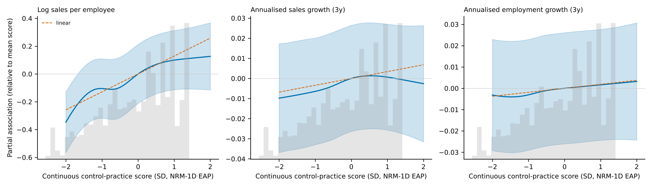
Figure 3. Partial association of the continuous score with outcomes (cubic regression spline, 95% CI; dashed: linear). Histogram shows the score distribution.

5. Discussion
The evidence supports a predominantly gradient reading of observable control practices in these data: the practices share a dominant continuous dimension; latent classes are poorly separated, ordered along that dimension when K = 3, and add no explanatory value over the continuous score. A small, unstable class suggests that targets without matching incentives may exist, but this is tentative. We do not claim distinct forms of control.
Relative to Bloom and Van Reenen (2007), an aggregate score is not shown to be inadequate here; configuration-based analysis adds little for the outcomes examined. Relative to Malmi and Brown (2008), we find co-occurrence of monitoring, targets and bonuses beyond independence, but cannot speak to cultural, planning or administrative controls. Relative to Simons (1995), the observed practices are compatible with diagnostic control, but nothing in WBES identifies interactive use. The results are mainly descriptive and should not be treated as a theory of management control.
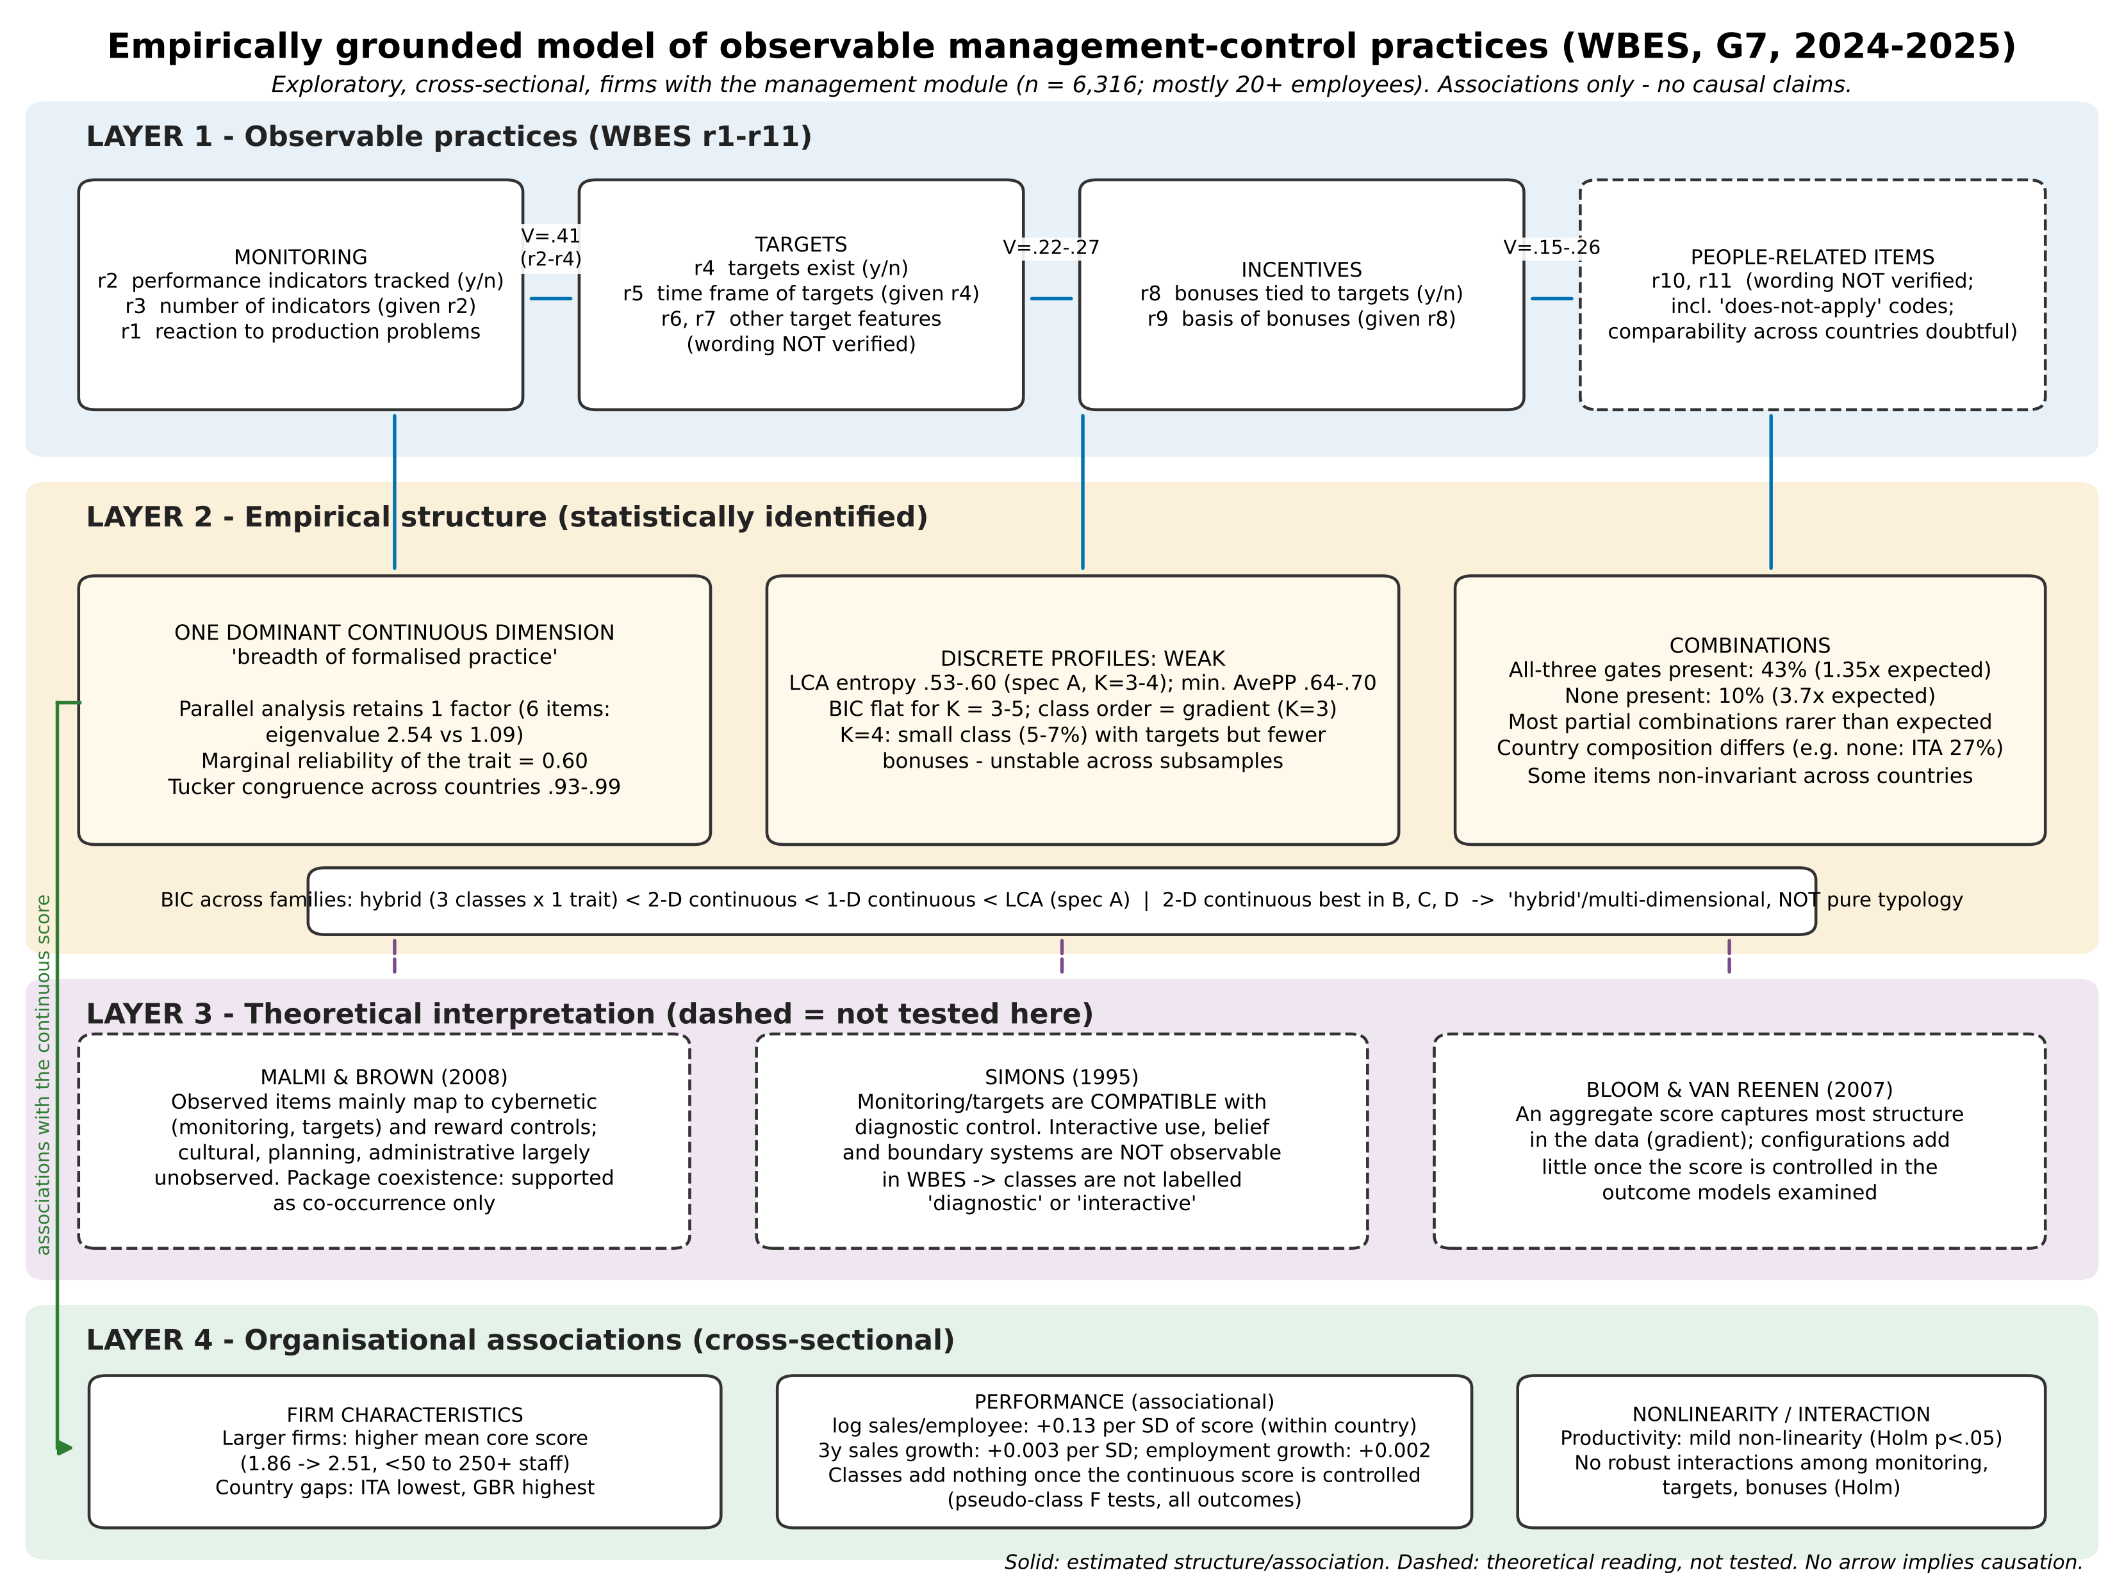
Figure 4. Proposed four-layer model of observable management-control practices. Solid lines: structure or associations estimated in this study; dashed: theoretical interpretation not tested. No arrow implies causation.

6. Theoretical contribution and implications for future doctoral research
Contribution (bounded). (i) Evidence that, at the level of WBES practice items, structure is predominantly dimensional rather than typological; (ii) a procedure for testing gradient against configuration on one likelihood scale; (iii) an explicit separation of co-occurrence, statistical interaction and complementarity; (iv) a layered model that distinguishes observed practices, statistical structure, theoretical reading and associations.

IMPLICATIONS FOR FUTURE DOCTORAL RESEARCH
These are research propositions, not findings of the G7 study.
- Questionnaire design. Retain separate indicators for monitoring, target setting and incentives; the single dominant dimension suggests multi-item scales with distinct, verified wording.
- Additional indicators. Information use (diagnostic vs interactive), beliefs, boundaries, planning, cultural and administrative controls.
- AI-enabled control. Operationalise AI use in performance measurement, forecasting and anomaly detection as additional items on the same practice scales plus use-mode items.
- Internal audit. Measure audit coverage, follow-up of findings and feedback into target setting.
- Dynamic capabilities and readiness. Use validated scales (Teece, 2007; Armenakis & Harris, 2002) and test measurement invariance.
- Data needs. Longitudinal or panel data (e.g. before/after AI adoption) and, where possible, quasi-experimental variation.

7. Limitations
- Original .dta files and questionnaire wording could not be accessed; wording of r6, r7, r10, r11 is unverified and category order unknown (hence nominal treatment).
- Module universe is mostly 20+ employee firms; results do not generalise to smaller firms.
- Cross-sectional, self-reported practices; no causal interpretation; outcome definitions (n3, l2) unverified.
- Sector codes are country-specific; sampling designs differ; analyses are unweighted except sensitivity checks; design-based inference not implemented.
- Measurement invariance is partial and depends on K.
- Bootstrap likelihood-ratio tests, BCH/ML three-step estimation and R/poLCA replication were not performed. The 2-D continuous comparator uses a coarse quadrature grid.
- Literature search was a verified selection, not a systematic review.

Data availability and reproducibility
The analysis used a merged file of WBES microdata supplied by the research team (10,968 establishments, seven country-years). Scripts, seeds, software versions and an execution log are provided in the project repository (MCS_G7_RESEARCH/07_REPRODUCIBILITY). Bibliographic records were verified through publisher and repository metadata; full texts were not consulted, and a systematic literature search remains to be completed.

References
Armenakis, A. A., & Harris, S. G. (2002). Crafting a change message to create transformational readiness. Journal of Organizational Change Management, 15(2), 169–183. https://doi.org/10.1108/09534810210423080
Athey, S., & Stern, S. (1998). An empirical framework for testing theories about complementarity in organizational design (NBER Working Paper No. 6600). National Bureau of Economic Research.
Bedford, D. S., & Malmi, T. (2015). Configurations of control: An exploratory analysis. Management Accounting Research, 27, 2–26. https://doi.org/10.1016/j.mar.2015.04.002
Bedford, D. S., Malmi, T., & Sandelin, M. (2016). Management control effectiveness and strategy: An empirical analysis of packages and systems. Accounting, Organizations and Society, 51, 12–28. https://doi.org/10.1016/j.aos.2016.04.002
Bhimani, A. (2020). Digital data and management accounting: Why we need to rethink research methods. Journal of Management Control, 31(1–2), 9–23. https://doi.org/10.1007/s00187-020-00295-z
Bloom, N., Brynjolfsson, E., Foster, L., Jarmin, R., Patnaik, M., Saporta-Eksten, I., & Van Reenen, J. (2019). What drives differences in management practices? American Economic Review, 109(5), 1648–1683. https://doi.org/10.1257/aer.20170491
Bloom, N., & Van Reenen, J. (2007). Measuring and explaining management practices across firms and countries. Quarterly Journal of Economics, 122(4), 1351–1408. https://doi.org/10.1162/qjec.2007.122.4.1351
Grabner, I., & Moers, F. (2013). Management control as a system or a package? Conceptual and empirical issues. Accounting, Organizations and Society, 38(6), 407–419. https://doi.org/10.1016/j.aos.2013.09.002
Hyland, M. C., Francis, D. C., & Rodriguez Meza, J. (n.d.). Are management practices failing or aiding the private sector in South America? (Policy Research Working Paper No. 8783). World Bank. [Year and details to be completed from the original record.]
Knudsen, D.-R. (2020). Elusive boundaries, power relations, and knowledge production: A systematic review of the literature on digitalization in accounting. International Journal of Accounting Information Systems, 36, 100441. https://doi.org/10.1016/j.accinf.2019.100441
Malmi, T., & Brown, D. A. (2008). Management control systems as a package: Opportunities, challenges and research directions. Management Accounting Research, 19(4), 287–300. https://doi.org/10.1016/j.mar.2008.09.003
Milgrom, P., & Roberts, J. (1995). Complementarities and fit: Strategy, structure, and organizational change in manufacturing. Journal of Accounting and Economics, 19(2–3), 179–208.
Murrell, P., Karalashvili, N., & Francis, D. C. (2024). Transactional governance structures: New cross-country data and an application to the effect of uncertainty. Journal of Law, Economics, and Organization, 40(3), 891–929. [Earlier version: Francis, D. C., Karalashvili, N., & Murrell, P. (2018), World Bank Policy Research Working Paper 8564.]
Nielsen, S. (2022). Management accounting and the concepts of exploratory data analysis and unsupervised machine learning: A literature study and future directions. Journal of Accounting & Organizational Change, 18(5), 811–853.
Nylund, K. L., Asparouhov, T., & Muthén, B. O. (2007). Deciding on the number of classes in latent class analysis and growth mixture modeling: A Monte Carlo simulation study. Structural Equation Modeling, 14(4), 535–569.
Scur, D., Sadun, R., Van Reenen, J., Lemos, R., & Bloom, N. (2021). The World Management Survey at 18: Lessons and the way forward. Oxford Review of Economic Policy, 37(2), 231–258. https://doi.org/10.1093/oxrep/grab009
Simons, R. (1995). Levers of control: How managers use innovative control systems to drive strategic renewal. Harvard Business School Press.
Teece, D. J. (2007). Explicating dynamic capabilities: The nature and microfoundations of (sustainable) enterprise performance. Strategic Management Journal, 28(13), 1319–1350. https://doi.org/10.1002/smj.640
Tessier, S., & Otley, D. (2012). A conceptual development of Simons' Levers of Control framework. Management Accounting Research, 23(3), 171–185.
Vermunt, J. K. (2010). Latent class modeling with covariates: Two improved three-step approaches. Political Analysis, 18(4), 450–469.
Widener, S. K. (2007). An empirical analysis of the levers of control framework. Accounting, Organizations and Society, 32(7–8), 757–788.

