Universality and Transferability of Management Control Practices: Exploratory Evidence from Seven Advanced Economies
A study using World Bank Enterprise Surveys for the G7 economies, 2024–2025
[Author name(s) and affiliation(s)] — Revised draft for internal review (version 4)

Abstract
Are management practices universally effective, or must they be adapted to national and organisational contexts? We interpret evidence from the management-practices module of the World Bank Enterprise Surveys (seven G7 economies, 6,316 establishments, mostly with 20 or more employees) through general management frameworks (management as a technology, contingency theory, institutional decoupling, transfer of practices) and then relate it to the management control literature. We formalise the main control frameworks, map their constructs to WBES items, and judge three competing models — universal (M1), organisationally contingent (M2) and nationally contextualised (M3) — by out-of-sample prediction and by an international transferability matrix. The items follow a single dimension; no framework-implied split (cybernetic versus reward, monitoring versus targets versus rewards) improves on it, and WBES does not observe belief, boundary, interactive, administrative or cultural controls or the integration of controls. The universal model gives a small, reliable predictive gain for productivity (1.3% lower mean squared error); organisational contingency and national slopes add no reliable out-of-sample value, and M3 is nested in the national-slope model and cannot be estimated with seven countries. Single-country models transfer imperfectly (the local model is better in 88% of source-target pairs, by 0.02 R² units on average), but a model estimated on the other six countries is nearly as good as a local one. In-sample, the association with productivity is positive in most countries but heterogeneous in most specifications and flattens at high levels of the score, so decoupling cannot be separated from ceiling or measurement artefacts. The evidence supports structural universality and limited, conditional transferability; it does not establish that contexts require distinct control systems, and contextual fit is treated as a theoretical interpretation. Results are exploratory cross-sectional associations, and the wording of several items could not be verified.
Keywords: management control systems; transferability; management practices; universal versus contingent models; predictive validation; World Bank Enterprise Surveys

1. Introduction
Whether a management practice works the same way wherever it is adopted is a core question of general management research. Universalist accounts treat management as a technology whose adoption raises productivity (Bloom & Van Reenen, 2007; Bloom, Sadun & Van Reenen, 2016). Contingency theory holds that there is no single best way and that performance depends on fit with conditions (Lawrence & Lorsch, 1967; Donaldson, 2001). Institutional theory adds that practices may be adopted for legitimacy and remain decoupled from operations (Meyer & Rowan, 1977; Zbaracki, 1998), and work on the transfer of practices shows that success depends on institutionalisation in the receiving unit and on its institutional and organisational context (Kostova, 1999).
This article interprets evidence on observable management practices through these general frameworks and then relates it to the management control literature. We use the management-practices module of the World Bank Enterprise Surveys (WBES) for seven G7 economies in 2024–2025 (6,316 establishments) and ask: to what extent are the structure and the performance associations of observable management practices universal across advanced economies, and how far do models of those associations transfer from one national context to another?
Three propositions organise the study. P1 (structural universality): some control practices share a common architecture across countries. P2 (functional contextualisation): their association with performance may depend on organisational and institutional characteristics. P3 (conditional transferability): a model estimated in one national context may lose predictive power in another. Three competing models operationalise them: a universal model (M1), an organisational-contingency model (M2) and a nationally contextualised model (M3). We judge them by out-of-sample prediction, not only by coefficients, and we first formalise the main management control frameworks and map them to the WBES items to establish what the data can address at all. Management control concepts (Malmi & Brown, 2008; Grabner & Moers, 2013; Simons, 1995) enter as domain-specific counterparts of the general concepts of adoption, integration and use.
Four ideas are kept apart: universality of practices, of structure, of effectiveness and contextual fit. Only the first three can be examined with WBES; contextual fit is a theoretical interpretation. The paper preserves the findings of an earlier exploratory phase, in which practices were organised predominantly along a continuous dimension rather than in distinct latent classes.

2. Theoretical framework
Verification note: bibliographic records were checked against publisher, repository or database records; full texts were not consulted, so statements are limited to what abstracts and records state.

2.1 General management frameworks
Management as a technology. Bloom and Van Reenen (2007, 2010) measure practices of monitoring, target setting and incentives and relate them to productivity; differences in practices persist because of weak competition, family ownership, regulation and informational barriers. Bloom, Sadun and Van Reenen (2016) ask whether practices are akin to a technology or contingent styles and report large cross-country differences in adoption. A universalist reading predicts a common structure and a stable positive association with performance, with countries differing mainly in adoption.
Contingency and fit. Contingency theory (Lawrence & Lorsch, 1967; Donaldson, 2001) holds that no single structure is best and that performance depends on fit with contingencies such as size, environment and technology. Drazin and Van de Ven (1985) distinguish selection, interaction and systems forms of fit; Gresov and Drazin (1997) distinguish forms of equifinality. A contingency reading predicts that the practice–performance association varies with measured contingencies.
Institutional theory and decoupling. Formal structures may reflect institutionalised rules and be decoupled from operations (Meyer & Rowan, 1977), isomorphic pressures make organisations similar (DiMaggio & Powell, 1983), and rhetoric about a practice can diverge from its use (Zbaracki, 1998). Varieties-of-capitalism work stresses national institutional complementarities (Hall & Soskice, 2001). An institutional reading predicts widespread adoption with a weaker link to outcomes where adoption is driven by legitimacy rather than use.
Transfer of practices and capabilities. Kostova (1999) defines transfer success as institutionalisation of the practice at the recipient unit and models it as shaped by country institutional profile, organisational context and individuals; Kostova and Roth (2002) identify conditions of ceremonial adoption. Absorptive capacity (Cohen & Levinthal, 1990) and dynamic capabilities (Teece, 2007) suggest that implementation depends on prior knowledge and capabilities.
Culture, institutions and country effects. Culture, institutions and country fixed effects are different things; McSweeney (2002) criticises treating national cultures as causal entities. The data contain only country identifiers, which cannot be read as measures of culture or institutions.
Exploratory methods. Nielsen (2022) argues for exploratory data analysis and unsupervised learning in management accounting research. We use latent class and continuous latent-variable models as complementary lenses; statistical structure is not theoretical interpretation, and neither method guarantees that the structure found corresponds to meaningful organisational systems.

2.2 From general frameworks to testable implications
Each framework implies a different pattern in WBES (Table 13, Section 8): a common structure and stable positive slopes (technology); slopes varying with measured contingencies (contingency); weak slopes where adoption is widespread (institutional decoupling); stronger links under parental or relational support (transfer); stronger links with more experienced managers (capabilities); comparable performance across combinations (equifinality). Figure 1 summarises the chain practices → implementation → context → outcomes used throughout; implementation and contextual alignment are not observed.

2.3 Relating the framework to management control (second step)
The management control literature supplies domain-specific counterparts of these general concepts. Malmi and Brown (2008) propose a package of planning, cybernetic, reward, administrative and cultural controls; Grabner and Moers (2013) distinguish packages from systems with internal consistency, which parallels the distinction between adoption and integration; Simons (1995) and Tessier and Otley (2012) distinguish uses of controls, which parallels the distinction between adoption and implementation; Burns and Scapens (2000) treat management accounting change as institutionalisation of rules and routines; Chenhall (2003) and Otley (2016) review contingency research on control; Harrison and McKinnon (1999) review cross-cultural control research; Bedford and Malmi (2015) study configurations of control. WBES covers only selected cybernetic and reward controls and does not measure use or integration. The relation between general concepts and control concepts is set out in Table 14 (Section 8).
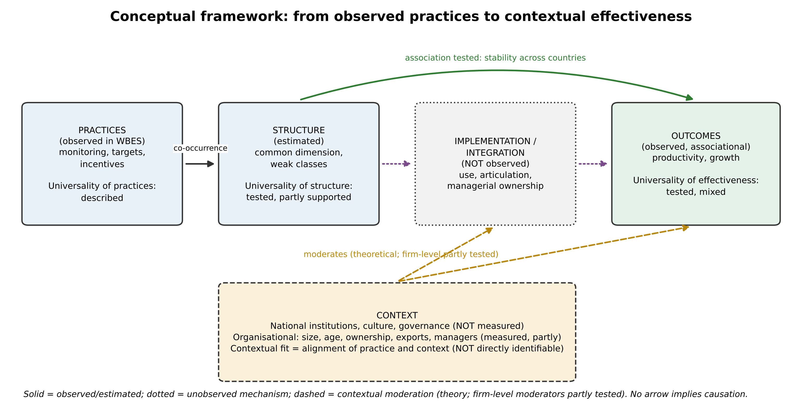
Figure 1. Conceptual framework: practices, structure, implementation/integration, context and outcomes. Solid = observed or estimated; dotted = unobserved mechanism; dashed = contextual moderation (theory). No arrow implies causation.

3. Propositions, competing models and hypotheses
Central question. To what extent are the structure and performance associations of management practices universal across advanced economies, and how far do models of those associations transfer across national and organisational contexts?
Propositions. P1 (structural universality): some control practices have a common architecture across countries. P2 (functional contextualisation): the association with performance may depend on organisational and institutional characteristics. P3 (conditional transferability): a model estimated in one national context may lose predictive power elsewhere.
Competing models. M1 (universal): Performance_ic = α_c + β·MCS_ic + γ′X_ic + ε, with a single β for all countries (Bloom & Van Reenen). M2 (organisational contingency): M1 plus MCS × organisational characteristics (Chenhall; Otley). M3 (national contextualisation): M2 plus MCS × Z_c, with Z_c national institutional characteristics (institutional theory; Kostova). M3 cannot be estimated with seven countries, and it is nested in a model with country-specific slopes; the national-slope model therefore serves as the upper bound for any Z_c interaction.
Operational hypotheses (derived from the frameworks of Section 2; formulated after an earlier exploratory phase on the same data; not pre-registered).
- H1 (P1; technology). The practices share a common dimension across countries. Factor structure, discrete-versus-continuous comparison, country-specific solutions.
- H2 (P1; measurement). The measurement structure differs across countries. Multi-group invariance, item differential functioning.
- H3 (P2; technology versus contingency). The score–performance association varies across countries. Country-specific slopes, formal equality tests.
- H4 (P2; contingency and capabilities). The association depends on organisational characteristics and combinations of practices. Moderators, equal-score combinations, class-by-country interactions.
- H5 (P2; decoupling versus artefact). The association is weaker where adoption is high and flattens at high levels of the score. Level-dependent shapes, common support.
- H6 (equifinality). Combinations with equal core scores perform comparably.
- H7 (framework structure). WBES items follow the structure implied by control frameworks (cybernetic versus reward, monitoring versus targets versus rewards). Confirmatory item-structure comparison.
- H8 (P2, P3; prediction and transfer). National slopes or organisational contingency improve out-of-sample prediction over M1, and models transfer imperfectly across countries. Cross-validated comparison; transferability matrix.

4. Formalising management control frameworks and mapping them to WBES
Frameworks formalised. Table 1 states, in a common notation, the frameworks used in the literature on management control. The specifications are restricted to what bibliographic records support; where a record gave only the number of elements (for example the twelve questions of Ferreira and Otley, 2009), the elements are not itemised. Malmi and Brown (2008) treat controls as a package of five types, so that the package is the joint distribution of control-type constructs and a configuration is a region of that space. Simons (1995) and Tessier and Otley (2012) distinguish four systems and modes of use, so that effects depend on use rather than presence. Otley (1999) and Ferreira and Otley (2009) describe areas of a performance management system (objectives, strategies and plans, targets, rewards, information flows); Merchant and Van der Stede distinguish results, action, personnel and cultural controls; Ouchi (1979) distinguishes market, bureaucratic and clan mechanisms; Grabner and Moers (2013) define a system as a package with internal consistency; Bloom and Van Reenen (2007) summarise practices in a score.
Table 1. Management control frameworks in a common notation and their observability in WBES.
Framework | Specification (our notation) | WBES observability
Malmi & Brown (2008) | x_ij = λ_jk C_ik + ε_ij (items j, control type k, firm i); package = joint distribution of (C_i1..C_i5); configuration = region of that space; Performance_i = f(C_i) | WBES covers cybernetic and reward only
Simons (1995); Tessier & Otley (2012) | x_ij = λ_jk S_ik + μ_jk U_ik; U_ik ∈ {diagnostic, interactive}; effects depend on U (interaction), not on presence | Use not observed
Otley (1999); Ferreira & Otley (2009) | Performance management system as a set of areas A1..A5 (objectives, strategies and plans, targets, rewards, information flows); coherence across areas | Targets, rewards, information flows partly observed
Merchant & Van der Stede | Results, action, personnel, cultural controls; tightness of each | Results controls observed; others weakly or not
Ouchi (1979) | Mechanism choice determined by ability to measure outputs/behaviours and goal congruence | Output measurement partly; congruence not observed
Grabner & Moers (2013) | System = package + internal consistency (formal definition per abstract) | Not identifiable from presence
Bloom & Van Reenen (2007) | Score_i = Σ_j s_ij (monitoring, targets, incentives); Productivity = f(Score) | Direct counterpart of WBES module
Contingency (Chenhall, 2003; Otley, 2016) | Effect = β + δ'Context (interaction/fit) | Organisational context partly observed; national institutions not
Mapping and coverage. Each construct was mapped to WBES items with a strength (strong, proxy, none) that reflects both conceptual fit and the verification status of the item wording (Table 2, Figure 2); the coverage score (observed + 0.5 × partial, divided by constructs) is a summary of that judgement, not a measurement. The scoring-based tradition has full coverage by construction. Frameworks that centre on targets, rewards and information flows are covered in part, the package of Malmi and Brown is covered only for cybernetic and reward controls, and the constructs that distinguish the control literature from the management-practice literature — belief and boundary systems, interactive use, administrative and cultural controls, clan control and internal consistency — are not observed.
Table 2. Coverage of control frameworks by WBES items: constructs observed, partially observed and not observed; coverage = (observed + 0.5 × partial) / constructs (judgemental summary).
Framework | Constructs | Observed | Partial | Not observed | Coverage
Malmi & Brown (2008) | 5 | 2 | 1 | 2 | 0.50
Simons (1995) | 4 | 0 | 1 | 3 | 0.12
Otley (1999) / Ferreira & Otley (2009) | 5 | 3 | 1 | 1 | 0.70
Merchant & Van der Stede | 4 | 1 | 2 | 1 | 0.50
Ouchi (1979) | 3 | 0 | 2 | 1 | 0.33
Grabner & Moers (2013) | 1 | 0 | 0 | 1 | 0.00
Chenhall (2003) / Otley (2016) | 1 | 0 | 1 | 0 | 0.50
Bloom & Van Reenen (2007) WMS tradition | 3 | 3 | 0 | 0 | 1.00
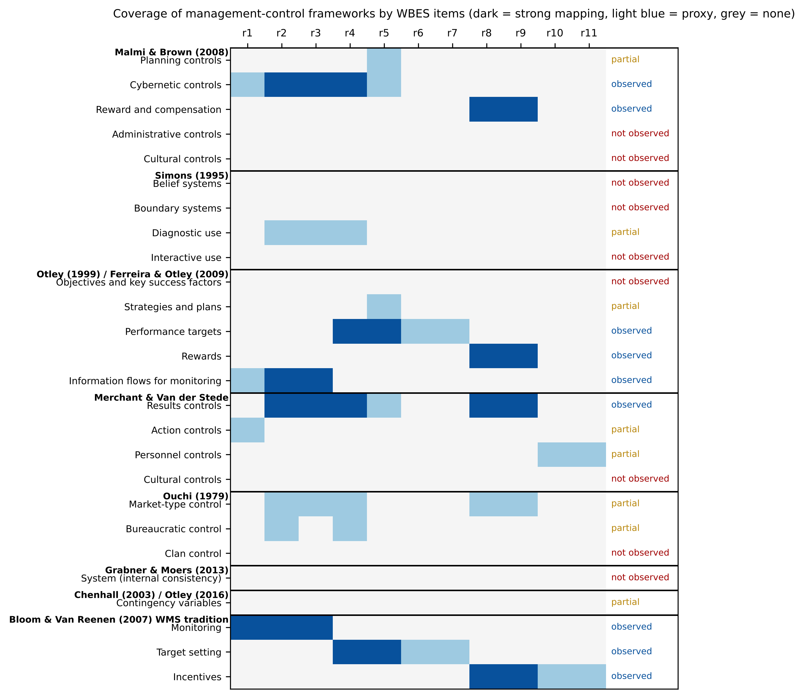
Figure 2. Coverage of management-control frameworks by WBES items (dark = strong mapping, light = proxy, grey = none; right: observed / partial / not observed).
What this implies. (i) WBES can address the cybernetic, results and reward controls and the organisational contingencies; it cannot address use, integration or consistency. (ii) Competing frameworks differ mostly in constructs that WBES does not observe, so the data can compare their implications only for the observed subset. (iii) Claims about the structure of a control system cannot be derived from the data. Section 7.10 tests whether the observed items follow the item structures implied by the frameworks.

5. Data and measurement
Sample. The study uses a merged file of WBES microdata for Canada (2024), France (2025), Germany (2025), Italy (2024), Japan (2025), the United Kingdom (2024) and the United States (2024), with 10,968 establishments. The original country files with value labels were not available; the merged file contains codes only. The management-practices module is asked of 6,316 establishments (88.5% with 20 or more permanent full-time employees); the remaining establishments are outside the module's universe, not missing responses. Table 3 gives the sample by country.
Management-practice items. Eleven items (r1–r11) cover monitoring, targets, bonuses and two further items. Skip patterns were verified empirically: r3 is asked only if r2 is yes, r5–r7 only if r4 is yes, r9 only if r8 is yes. Question wording was verified only partially (r5 for Italy 2024; r1–r3 and r8–r9 through secondary descriptions; r4 inferred); wording and category order of r6, r7, r10 and r11 remain unverified, so categories are treated as nominal and no substantive label is assigned to these items. The main specification uses six items asked of all firms in the module (r1, r2, r4, r8, r10, r11); "don't know" and "does not apply" codes are treated as missing, with full-information likelihood.
Outcomes and controls. Outcomes are log sales per employee, annualised three-year sales growth and annualised three-year employment growth. The definitions of the base-year variables (n3, l2) are assumed to be sales and employment three fiscal years earlier and are unverified. Sales are in local currency, so levels are compared only within country. Controls are log employment, log age and sector fixed effects; sector codes are country-specific. Firm-level moderators are foreign ownership of at least 10% (b2b), exporter status (d3b, d3c), top-manager experience (b7) and female top manager (b7a); their labels were checked only against data-dictionary records of other 2024 surveys.
Survey design. Sampling weights are available but the module universe is a subset of the sampled establishments; stratum and cluster identifiers are not in the file. Main analyses are unweighted, with weighted sensitivity checks, and robust or sector-clustered standard errors.

6. Empirical strategy
Structure and measurement (retained and extended). Categorical latent class models (one to eight classes) were compared on the same likelihood with a one-dimensional nominal-response trait model, a two-dimensional model and a hybrid (classes × one trait), using BIC, entropy and posterior probabilities. Cross-country comparability was assessed with multi-group latent class models (item-response probabilities shared versus free), item-wise likelihood-ratio tests of differential functioning and country-specific solutions. A five-item score excluding r8 (the item with differential functioning in both the three- and four-class solutions) serves as a sensitivity measure.
Country-specific associations. For each country c, y_i = α_s(i) + β_c θ_i + γ_c′X_i + ε_i, where s(i) is the sector fixed effect and X contains log size and log age. The latent trait θ is the posterior mean of the nominal one-dimensional model computed with a country-specific prior (regression calibration), which accounts for differential reliability across countries; the pooled-prior posterior mean, the five-item score and the core score (number of practices present among r2, r4, r8) are alternatives. Unconditional plausible values were tried first and rejected because they attenuate slopes by roughly the reliability.
Heterogeneity. The pooled model y_ic = α_s(i) + Σ_c β_c θ_i·1[c] + γ′X_i + ε is used to test H0: β_1 = … = β_7 with robust Wald statistics (HC3 and sector-clustered), with and without country-specific control slopes. Heterogeneity in separately estimated slopes is summarised by Cochran's Q, I² (Higgins & Thompson, 2002), a DerSimonian–Laird random-effects mean and a 95% prediction interval. Because results depend on scoring and specification, results are reported as a specification summary rather than a single test.
Contingencies and equifinality. Interactions of θ with size, age, foreign ownership, export status, manager experience and manager gender, with and without θ-by-country terms. Equifinality: equality of adjusted performance across combinations of r2, r4, r8 with the same core score (levels one and two), with equivalence judged by confidence intervals against explicit, illustrative margins (±0.05 log points; ±0.005 for growth). Class-by-country interactions and country-specific nonlinearity (spline versus linear) complete the analysis. Holm corrections are applied within families (Holm, 1979). All results are associations; no causal claim is made.
Item structures implied by control frameworks. Seven items with verified or partly verified wording (r1, r2, r3, r4, r5, r8, r9) were assigned to the factors of each framework-implied structure and compared on the same likelihood with nominal-response models: one common factor; cybernetic {r1–r5} versus reward {r8, r9} (Malmi and Brown-type); monitoring {r1–r3} versus results controls {r4, r5, r8, r9} (Merchant and Van der Stede-type); three families (monitoring, targets, rewards; Otley-type); and an unrestricted two-factor model. Factors are exchangeably correlated (grid 0.5–0.95). Gate items and follow-up items share questionnaire blocks, which can mimic family structure.
Competing predictive models and transferability. Models U0 (controls), M1 (common linear slope), M1′ (common level-dependent shape), M2 (M1′ plus score × organisational characteristics), national-slope models and their combination are compared by 10-fold cross-validation repeated three times, with folds stratified by country and identical for all models. All models carry the same controls and the same main effects of the moderators so that differences isolate the control-practice terms. The item parameters of the score are re-estimated within training folds and applied to test firms; the score does not use outcomes. Paired comparisons use firm-level squared errors. M3 is not estimated (Section 3). Transferability is assessed with slope-only models on country-by-sector-demeaned data: a model estimated on a source country (or on the other six countries, LOCO) is applied to each target country, and its out-of-sample R² is compared with that of a model estimated locally by repeated cross-validation; bootstrap intervals (200 replicates) are reported for transferred models.

7. Results
7.1 Sample and descriptive differences (retained). The module universe contains 6,316 establishments (Table 3). Reported use of indicator monitoring (r2) ranges from 47% in Japan to 92% in the United Kingdom, targets (r4) from 60% in Italy to 93% in the United Kingdom, and target-linked bonuses (r8) from 36% in Italy to 76% in the United Kingdom. Larger firms report more practices (mean core score 1.86 for firms with fewer than 50 employees and 2.51 for 250 or more). These differences are descriptive and confounded by size composition; they are not evidence of institutional or cultural effects.
Table 3. Management-module universe by country: sample size, median permanent full-time employees, share reporting each practice among valid responses, and mean core score (number of practices present among r2, r4, r8; 0–3).
Country | N | Median employees | r2 monitoring (%) | r4 targets (%) | r8 bonuses (%) | Mean core score
CAN | 580 | 40 | 72 | 75 | 63 | 2.10
FRA | 451 | 48 | 85 | 87 | 48 | 2.21
DEU | 1233 | 67 | 69 | 62 | 59 | 1.90
ITA | 641 | 46 | 55 | 60 | 36 | 1.51
JPN | 1321 | 80 | 47 | 87 | 54 | 1.88
GBR | 610 | 98 | 92 | 93 | 76 | 2.61
USA | 1480 | 46 | 81 | 85 | 67 | 2.34
7.2 Structure of observed practices (retained). Latent class models fit the six common items poorly as distinct types (Table 4): BIC is lowest at four classes but differs by at most 13 points between three and five classes, relative entropy is 0.53–0.60, and residual dependence between items is large. The three-class solution is ordered along the core score without crossings on monitoring, targets and bonuses (0 of 9 comparisons; the ordering is partly by construction because classes are ordered by the same items). On the same likelihood, a hybrid model (three classes × one trait) has a BIC 129 points below the best latent class model, and two-dimensional continuous models outperform latent class models by 236 to 368 points in the specifications that include conditional items. Parallel analysis retains one factor (eigenvalue 2.54 versus 1.09). The reliability of the one-dimensional trait is 0.60 (Figure 3). A small class in the four-class solution (about 5–7%) pairs near-universal targets with few bonuses but is unstable across subsamples and weights. Conclusion retained: for these six items, a common continuous dimension is a better description than distinct configurations; this does not refute the package view, because most control categories are unobserved.
Table 4. Latent class models, specification A (r1, r2, r4, r8, r10, r11; N = 6,294), retained from the earlier analysis (one to six classes). Smallest class in %.
K | Parameters | Log-likelihood | BIC | Adjusted BIC | Relative entropy | Min. AvePP | Smallest class (%)
1 | 11 | -27,895.0 | 55,886.3 | 55,851.3 | 1.00 | 1.00 | 100.0
2 | 23 | -26,577.8 | 53,356.9 | 53,283.8 | 0.62 | 0.86 | 36.1
3 | 35 | -26,446.5 | 53,199.1 | 53,087.9 | 0.53 | 0.70 | 20.9
4 | 47 | -26,387.7 | 53,186.6 | 53,037.3 | 0.60 | 0.64 | 6.6
5 | 59 | -26,337.6 | 53,191.3 | 53,003.8 | 0.58 | 0.61 | 5.6
6 | 71 | -26,303.7 | 53,228.5 | 53,002.9 | 0.62 | 0.66 | 5.9
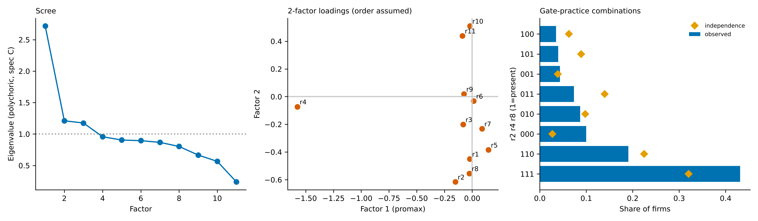
Figure 3. Retained structural evidence. Left: polychoric eigenvalues (supporting only). Centre: two-factor loadings (assumes code order = ordinal order). Right: observed versus independence-expected combinations of r2, r4, r8.
7.3 Measurement comparability (extended). Multi-group results depend on the number of classes (Table 5). With three classes full invariance is rejected by BIC (free item parameters preferred by 245 points), with differential functioning for r2, r8, r10 and r11; with four classes the invariant model is preferred by 541 points and only r8 shows differential functioning. Country-specific latent class models favour two classes in Canada, France, Germany, Japan and the United States and three in Italy and the United Kingdom, and one-factor solutions are similar across countries (congruence 0.93–0.99). Under country-specific priors, the reliability of the trait score varies markedly: Canada 0.64, France 0.40, Germany 0.57, Italy 0.65, Japan 0.35, United Kingdom 0.42, United States 0.57. Cross-country comparisons of slopes are therefore qualified by partial invariance and differential reliability.
Table 5. Cross-country invariance (specification A). Upper panel: multi-group latent class models (ΔBIC relative to the best model within K). Lower panel: item-wise tests, freeing one item across countries (ΔBIC < 0 favours non-invariance).
K | Model | Parameters | BIC | ΔBIC
3 | full invariance (pooled theta, country-specific prevalence) | 47 | 51,036.4 | 245.1
3 | no invariance (country-specific theta) | 245 | 50,791.4 | 0.0
3 | pooled, no country differences in prevalence | 35 | 53,199.1 | 2,407.8
4 | full invariance (pooled theta, country-specific prevalence) | 65 | 50,655.4 | 0.0
4 | no invariance (country-specific theta) | 329 | 51,196.8 | 541.4
4 | pooled, no country differences in prevalence | 47 | 53,186.6 | 2,531.2

K | Item | LR | df | ΔBIC (free − invariant) | Verdict
3 | r1 | 378.2 | 54 | 94.2 | invariant (BIC)
3 | r2 | 455.0 | 18 | -297.5 | non-invariant (BIC)
3 | r4 | 100.3 | 18 | 57.1 | invariant (BIC)
3 | r8 | 246.3 | 18 | -88.9 | non-invariant (BIC)
3 | r10 | 549.9 | 54 | -77.5 | non-invariant (BIC)
3 | r11 | 393.9 | 36 | -79.0 | non-invariant (BIC)
4 | r1 | 297.6 | 72 | 332.2 | invariant (BIC)
4 | r2 | 135.1 | 24 | 74.9 | invariant (BIC)
4 | r4 | 87.0 | 24 | 122.9 | invariant (BIC)
4 | r8 | 230.3 | 24 | -20.4 | non-invariant (BIC)
4 | r10 | 351.0 | 72 | 278.8 | invariant (BIC)
4 | r11 | 259.8 | 48 | 160.1 | invariant (BIC)
7.4 Country-specific associations with performance (new). Table 6 and Figure 4 report country-specific slopes of the calibrated latent trait. For productivity, slopes are positive with confidence intervals excluding zero in Canada, Germany, Italy, Japan and the United States, and close to zero with wide intervals in France (0.033) and the United Kingdom (0.037). Cochran's Q is 17.7 (df = 6, p = 0.007, I² = 66%), the random-effects mean is 0.169 and the 95% prediction interval, −0.007 to 0.345, includes zero. For sales and employment growth, individual slopes are small and mostly consistent with zero, and heterogeneity is not significant (Q p = 0.081 and 0.110). Formal pooled tests (Table 7) reject equality of productivity slopes in 12 of 16 specifications (p-values range from below 0.001 to 0.126); equality is not rejected when the pooled-prior EAP is used without country-specific control slopes (p = 0.12) or with weights (Q p = 0.84). The evidence for cross-country heterogeneity in the productivity association is therefore moderate and specification-dependent. The two countries with weak slopes are also those with the highest reported adoption of monitoring (85% and 92%) and targets (87% and 93%) and with low calibrated reliability (0.40 and 0.42); across the seven countries the calibrated slope is negatively related to the country mean of the trait (Spearman ρ = −0.75, p = 0.052; n = 7, descriptive). This pattern is compatible with ceiling effects, restricted range or measurement error and cannot be attributed to institutions or culture.
Table 6. Country-specific associations between the latent score (country-specific-prior posterior mean, per latent SD) and outcomes: slope [95% CI] (n). Country and sector fixed effects (sector within country), log size and log age; HC3. Heterogeneity: Cochran's Q and I²; random-effects mean.
Country | Log sales per employee | Sales growth (annual) | Employment growth (annual)
CAN | 0.159 [0.079, 0.240] (n=576) | -0.0031 [-0.0133, 0.0071] (n=560) | -0.0003 [-0.0081, 0.0076] (n=559)
FRA | 0.033 [-0.151, 0.217] (n=444) | -0.0056 [-0.0257, 0.0145] (n=441) | 0.0120 [-0.0033, 0.0273] (n=442)
DEU | 0.178 [0.115, 0.241] (n=1232) | 0.0103 [0.0039, 0.0167] (n=1226) | -0.0004 [-0.0050, 0.0041] (n=1220)
ITA | 0.237 [0.150, 0.324] (n=636) | 0.0052 [-0.0040, 0.0145] (n=632) | 0.0076 [0.0024, 0.0129] (n=628)
JPN | 0.404 [0.239, 0.568] (n=1235) | 0.0151 [-0.0030, 0.0332] (n=1189) | 0.0111 [-0.0006, 0.0227] (n=1230)
GBR | 0.037 [-0.091, 0.166] (n=609) | -0.0098 [-0.0257, 0.0060] (n=604) | -0.0039 [-0.0158, 0.0080] (n=606)
USA | 0.139 [0.088, 0.190] (n=1467) | 0.0076 [0.0023, 0.0129] (n=1416) | 0.0028 [-0.0019, 0.0074] (n=1434)
Random-effects pooled | 0.169 (SE 0.030) | 0.0046 (SE 0.0027) | 0.0032 (SE 0.0018)
Q (df = 6), p; I² | 17.7, p = 0.007; I² = 66% | 11.3, p = 0.081; I² = 47% | 10.4, p = 0.110; I² = 42%
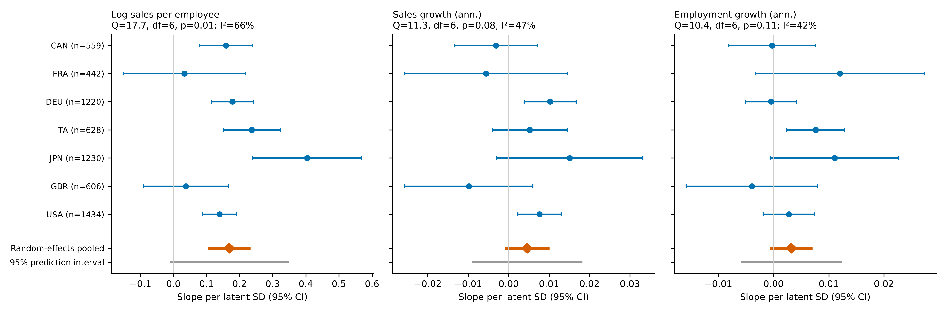
Figure 4. Country-specific slopes of the latent score (95% CI), random-effects pooled mean and 95% prediction interval, by outcome.
Table 7. Tests of equality of country-specific slopes, productivity (6 df): robust Wald statistics across scores and specifications.
Score | Country-specific control slopes | Covariance | Wald χ² | p
latent trait, country-specific prior | no | HC3 | 22.1 | 0.0011
latent trait, country-specific prior | no | cluster(sector) | 37.4 | 0.0000
latent trait, country-specific prior | yes | HC3 | 17.7 | 0.0071
latent trait, country-specific prior | yes | cluster(sector) | 27.6 | 0.0001
EAP | no | HC3 | 10.1 | 0.1224
EAP | no | cluster(sector) | 10.0 | 0.1262
EAP | yes | HC3 | 13.5 | 0.0364
EAP | yes | cluster(sector) | 16.7 | 0.0103
5-item invariant subset | no | HC3 | 11.0 | 0.0883
5-item invariant subset | no | cluster(sector) | 12.9 | 0.0438
5-item invariant subset | yes | HC3 | 14.4 | 0.0257
5-item invariant subset | yes | cluster(sector) | 19.8 | 0.0030
core score | no | HC3 | 12.6 | 0.0490
core score | no | cluster(sector) | 10.3 | 0.1144
core score | yes | HC3 | 18.2 | 0.0057
core score | yes | cluster(sector) | 20.9 | 0.0019
EAP, weighted WLS (wmedian) - Q test | - | HC3 | 2.7 | 0.8427
7.5 Organisational contingencies (new). Among the six firm-level moderators of the productivity association (Table 8, Figure 5), only foreign ownership shows a sizeable interaction (0.120 log points per SD of the score; 95% CI 0.020 to 0.220; unadjusted p = 0.019), and it does not survive Holm correction (p = 0.33; 0.137 with p = 0.008 and Holm p = 0.14 when country-specific slopes are included). Size, age, export status and manager characteristics show no reliable moderation, and no moderator is significant for either growth outcome after correction. The labels of the ownership, export and manager variables are unverified for the G7 files.
Table 8. Firm-level moderators of the score–productivity association (interaction with the pooled-prior score, per SD): estimate [95% CI], unadjusted and Holm p, and estimate when θ×country terms are included.
Moderator | N | Interaction [95% CI] | p | Holm p | With country slopes
Size (log employees) | 6199 | 0.019 [-0.004, 0.043] | 0.107 | 1.00 | 0.020 (p = 0.089)
Age (log years) | 6199 | -0.012 [-0.033, 0.009] | 0.271 | 1.00 | -0.015 (p = 0.170)
Foreign ownership >=10% | 6179 | 0.120 [0.020, 0.220] | 0.019 | 0.33 | 0.137 (p = 0.008)
Exporter (any) | 6172 | 0.011 [-0.032, 0.055] | 0.607 | 1.00 | 0.015 (p = 0.510)
Top-manager experience (log) | 6035 | 0.005 [-0.018, 0.028] | 0.685 | 1.00 | 0.004 (p = 0.759)
Female top manager | 6194 | 0.026 [-0.031, 0.082] | 0.376 | 1.00 | 0.026 (p = 0.375)
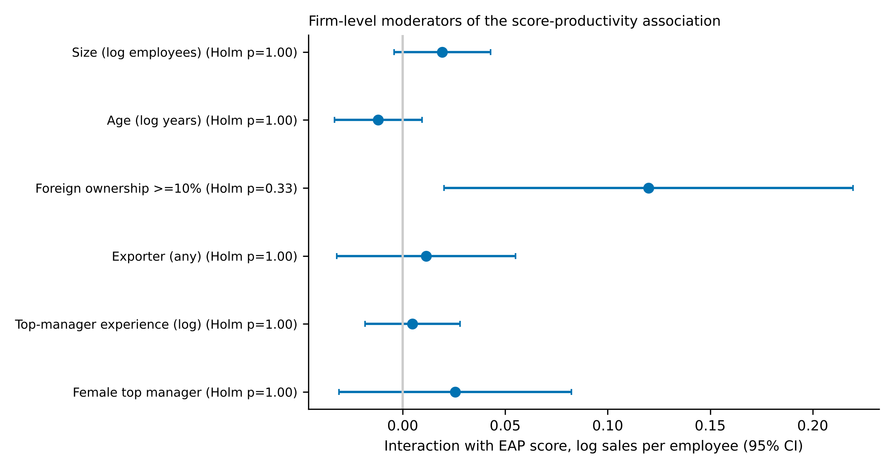
Figure 5. Interactions of the score with firm-level moderators, productivity (95% CI).
7.6 Configurations and equifinality (new). Latent classes add no explanatory power beyond country-specific trait slopes for any outcome (p = 0.78, 0.18, 0.51). Class-by-country interactions are not significant for productivity (p = 0.33) but are for sales growth (F(12) = 2.45, Holm p = 0.021, ΔR² = 0.004) and employment growth (F(12) = 2.29, Holm p = 0.033, ΔR² = 0.004); the increments are tiny and may reflect country-specific meaning of pooled classes given partial invariance. Among firms with the same core score, combinations of practices differ in productivity at level two (Wald p = 0.009, Holm p = 0.26; Table 9), mainly because firms with monitoring and bonuses but no targets (101) have higher productivity than those with monitoring and targets but no bonuses (110) (difference 0.187, 95% CI 0.067 to 0.308). Equivalence within ±0.05 log points is not established for any contrast because confidence intervals are wide, so the data neither demonstrate nor reject equifinality. Country-level tests were possible only in Canada, Germany, Italy and the United States (minimum cell size 15) and none is significant after correction.
Table 9. Equifinality: equality of adjusted performance across combinations of r2, r4, r8 with the same core score (pooled; Wald test), and equivalence of productivity differences against an illustrative margin of ±0.05 log points.
Outcome | Core score | Combinations | N | Wald χ² | p | Holm p
Log sales per employee | 1 | 100/010/001 | 1000 | 3.7 | 0.155 | 1.00
Log sales per employee | 2 | 110/101/011 | 1853 | 9.4 | 0.009 | 0.26
Sales growth (ann.) | 1 | 100/010/001 | 973 | 3.8 | 0.151 | 1.00
Sales growth (ann.) | 2 | 110/101/011 | 1820 | 4.4 | 0.111 | 1.00
Employment growth (ann.) | 1 | 100/010/001 | 985 | 6.7 | 0.036 | 0.89
Employment growth (ann.) | 2 | 110/101/011 | 1833 | 3.1 | 0.216 | 1.00

Core score | Contrast | Difference [95% CI] | Margin | Equivalent?
1 | 001 vs 100 | 0.081 [-0.077, 0.239] | ±0.05 | no
1 | 010 vs 100 | -0.060 [-0.212, 0.091] | ±0.05 | no
2 | 011 vs 110 | 0.047 [-0.052, 0.146] | ±0.05 | no
2 | 101 vs 110 | 0.187 [0.067, 0.308] | ±0.05 | no
7.7 Nonlinearity (new for countries; pooled result retained). Pooled, a spline is preferred to a linear term for productivity (p = 0.006), but the largest departure from linearity is 0.03 standard deviations of the outcome. Across seven countries and three outcomes, no spline-versus-linear test survives Holm correction and the largest deviations are at most 0.13 outcome standard deviations. Nonlinearity is not a substantive finding.
7.8 Level dependence and common support (new). Because the two countries with weak productivity slopes also report the highest adoption, two diagnostics were run (pooled score on a common scale). On the range of the score present in all countries (−0.40 to 0.69 pooled SD; 29–51% of each country's firms), heterogeneity in productivity slopes is attenuated (Q = 11.9, p = 0.064, I² = 50%) but not removed, and country slopes become imprecise. Pooled within countries, the productivity slope is 0.164 (95% CI 0.112 to 0.216) in the lower third of the score, 0.139 (0.068 to 0.211) in the middle third and 0.013 (−0.094 to 0.121) in the upper third; equality of the lower and upper slopes is rejected (p = 0.009, unadjusted). Allowing this common level-dependent shape lowers the Wald statistic for country-specific productivity slopes from 10.1 (p = 0.122) to 8.0 (p = 0.241); it makes no difference for growth outcomes. Within countries, slopes below and above the country median differ significantly only in Canada (−0.52, p = 0.002; seven tests, not adjusted). Part of the cross-country difference in productivity slopes is therefore compatible with a common level-dependent association; the remainder is unexplained.
7.9 Associations with performance (retained). Pooled within countries, one standard deviation of the pooled-prior score is associated with 0.128 log points higher sales per employee (about 13.7%), 0.0033 higher annual sales growth and 0.0018 higher annual employment growth; classes add no predictive information once the continuous score is included (pseudo-class tests p = 0.29–0.62), and out-of-sample gains are modest for productivity (cross-validated RMSE 0.810 to 0.803) and negligible for growth. These are associations, not effects.
7.10 Item structures implied by control frameworks. None of the framework-implied splits improves on a single common factor (Table 10): separating cybernetic from reward items (Malmi and Brown-type) raises BIC by 8.5, the results-control split by 13.8, the three families by 10.2, and an unrestricted two-factor model by 43.4. The restricted models collapse toward perfect factor correlation (0.7 to 0.95). The items therefore behave as one dimension of cybernetic, results and reward practices; the caveats are partly verified wording, shared questionnaire blocks and the absence of items for the other control types.
Table 10. Framework-implied item structures compared with a single common factor (nominal-response models; items r1, r2, r3, r4, r5, r8, r9; N = 6,294).
Structure | Factors | Parameters | Log-likelihood | BIC | ΔBIC vs one factor | Factor correlation
One factor (common sophistication) | 1 | 26 | -28,700.8 | 57,628.9 | +0.0 | -
Malmi & Brown-type: cybernetic {r1-r5} + reward {r8, r9} | 2 | 27 | -28,700.6 | 57,637.5 | +8.5 | 0.70
Results-control-type: monitoring {r1-r3} + results {r4, r5, r8, r9} | 2 | 27 | -28,703.3 | 57,642.8 | +13.8 | 0.95
Three families: monitoring, targets, rewards | 3 | 27 | -28,701.5 | 57,639.1 | +10.2 | 0.95
Unrestricted two factors | 2 | 40 | -28,661.2 | 57,672.4 | +43.4 | 0.70
7.11 Universal versus contingent versus national models (out of sample). For productivity (N = 5,913) the common linear association (M1) lowers out-of-sample RMSE from 0.7924 to 0.7873 (a 1.3% reduction in mean squared error; 95% CI 0.0044 to 0.0118 in squared log points; Table 11). A common level-dependent shape (0.7872), organisational contingency (M2, 0.7871), national slopes (0.7877), national slopes with a level-dependent shape (0.7876) and the combination (0.7873) bring no reliable gain over M1 or M1′; national slopes are numerically slightly worse than M1. For sales and employment growth no model improves RMSE by more than 0.1% over controls (0.0876 and 0.0650). The apparent advantage of the contingency model in an initial specification disappeared once all models carried the same main effects. As M3 is nested in the national-slope model, the absence of gain from national slopes means there is no predictive justification for a Z_c interaction in these data.
Table 11. Out-of-sample comparison of universal (M1), contingent (M2) and national-slope models: cross-validated RMSE and incremental R² for productivity, RMSE for growth outcomes; lower panel: paired reductions in mean squared error for productivity with 95% CI (squared log points).
Model | RMSE productivity | Incremental R² (%) vs controls | RMSE sales growth | RMSE employment growth
U0 controls only | 0.7924 | 0.00 | 0.0876 | 0.0650
M1 universal (common linear slope) | 0.7873 | 1.29 | 0.0875 | 0.0650
M1' universal, level-dependent shape | 0.7872 | 1.31 | 0.0876 | 0.0650
M2 organisational contingency | 0.7871 | 1.34 | 0.0876 | 0.0651
National slopes (linear) | 0.7877 | 1.20 | 0.0875 | 0.0651
National slopes + level-dependent | 0.7876 | 1.22 | 0.0875 | 0.0651
M2 + national slopes | 0.7873 | 1.30 | 0.0876 | 0.0651

Comparison | Reduction in mean squared error [95% CI] | Relative reduction (%)
U1 vs U0 | 0.0081 [0.0044, 0.0118] | 1.29
U2 vs U1 | 0.0001 [-0.0008, 0.0011] | 0.02
M2 vs M1' | 0.0002 [-0.0017, 0.0020] | 0.03
National slopes vs M1 | -0.0006 [-0.0019, 0.0007] | -0.10
National + level vs M1' | -0.0006 [-0.0018, 0.0006] | -0.10
M2 + national vs M2 | -0.0003 [-0.0016, 0.0011] | -0.04
M2 + national vs national | 0.0005 [-0.0015, 0.0025] | 0.08
7.12 Transferability across countries. Out-of-sample R² is small in every country (productivity: local models 0.02 to 0.07, France negative; Table 12). Across the 42 source–target pairs, the model estimated locally is better in 88% of pairs, with a mean advantage of 0.020 R² units; some pairs transfer poorly (Italy as source predicts France and Germany with negative R²). A model estimated on the other six countries loses little: mean loss 0.006, local better in five of seven targets and outside the transfer interval only in the United States. Growth outcomes show no transferable signal. Single-country models therefore transfer imperfectly, but a pooled model is nearly as good as a local one for most countries.
Table 12. Transferability of the productivity model (linear shape): out-of-sample R² of a model estimated in the source country (rows) and applied to the target country (columns); LOCO = estimated on the other six countries; Local = estimated and cross-validated in the target.
Source / Target | CAN | FRA | DEU | ITA | JPN | GBR | USA
CAN | – | -0.018 | 0.021 | 0.064 | 0.030 | 0.008 | 0.013
FRA | 0.012 | – | 0.013 | 0.026 | 0.016 | 0.016 | -0.001
DEU | 0.022 | -0.014 | – | 0.032 | 0.032 | 0.010 | 0.009
ITA | 0.012 | -0.074 | -0.055 | – | -0.000 | -0.017 | -0.028
JPN | 0.026 | -0.023 | 0.023 | 0.053 | – | 0.023 | -0.005
GBR | 0.003 | -0.012 | 0.005 | 0.031 | 0.026 | – | -0.036
USA | 0.020 | -0.023 | 0.008 | 0.041 | -0.002 | -0.028 | –
LOCO | 0.030 | -0.012 | 0.028 | 0.050 | 0.030 | 0.009 | 0.002
Local (CV) | 0.021 | -0.016 | 0.032 | 0.070 | 0.034 | 0.021 | 0.021

8. Discussion

8.1 Interpretation through general management frameworks
Table 13 states what each framework implies for the data and how the evidence reads.
Table 13. Empirical implications of general management frameworks and how the evidence reads.
Framework | Implication in WBES | Observed | Reading
Management as a technology | Common structure; positive slope in every country; differences in adoption, not effects | Common dimension (partial invariance); positive in 5/7 countries, ≈0 in FRA and GBR; large adoption differences | Partly supported
Contingency / fit | Slope varies with measured contingencies | No moderator robust after Holm; foreign ownership suggestive (Holm p = 0.33) | Not supported with contingencies available
Institutional decoupling | Weak link to outcomes where adoption is widespread | Weakest slopes in highest-adoption countries; slope flattens in upper third (0.164 → 0.013) | Consistent; not discriminated from ceiling or measurement error
Transfer / embeddedness | Stronger link under parental or relational support | Foreign-ownership signal (suggestive); institutions not measured | Not testable beyond a proxy
Capabilities | Stronger link with more experienced managers | Manager experience: null | Not supported with this proxy
Equifinality | Equal-score combinations perform similarly | Not demonstrated, not rejected (wide intervals) | Inconclusive
Management as a technology (partly supported). Practices share a dominant continuous dimension in every country (partial invariance), adoption differs widely across countries, and the association with productivity is positive in five of seven countries. Heterogeneity in slopes is detectable in most specifications, and the association is weak in France and the United Kingdom, so a strictly universal effect is not supported in the in-sample analysis. Out of sample, however, a single common slope predicts as well as national slopes, and a model estimated on the other six countries is nearly as good as a local model in most targets: the universal model is hard to beat predictively.
Contingency and capabilities (not supported with available contingencies). None of the measured contingencies — size, age, foreign ownership, exports, manager experience or gender — moderates the association reliably after correction. Organisational contingency also adds no out-of-sample predictive value over the universal model. This does not refute contingency theory: the contingencies that theory emphasises, such as environmental uncertainty, technology and strategy, are not measured.
Institutional decoupling and transfer (consistent, not discriminated). The countries with the highest reported adoption have the weakest slopes, and the association flattens in the upper third of the score. This is what decoupling or ceremonial adoption would produce (Meyer & Rowan, 1977; Kostova & Roth, 2002), but it is equally what a ceiling effect, restricted range or measurement error would produce: reliability is lowest in the same countries, and a common level-dependent shape absorbs part of the cross-country heterogeneity. A measure of integration or use would be required to separate these explanations. The suggestive moderation by foreign ownership is compatible with a transfer reading but is not a test of it.
Equifinality (inconclusive). Combinations of practices with equal core score are neither shown to be equivalent nor shown to differ reliably.
Universality of practices, structure, effectiveness and fit. Practices are widely observed; structure is largely common; effectiveness is positive but heterogeneous and level-dependent; contextual fit is not identified. Seven countries cannot separate institutions, culture, sampling frames and sector composition, and country effects are not measures of any of them.

8.2 Rapprochement with the management control literature
Formalising the control frameworks (Section 4) shows that the part of each framework that WBES observes — cybernetic, results and reward controls — behaves as a single dimension (Section 7.10), and that the constructs that distinguish the frameworks from each other are not observed. Table 14 relates the general concepts to their management control counterparts. Adoption of formal practices corresponds to the presence of controls in a package (Malmi & Brown, 2008) and to the institutionalisation of rules and routines (Burns & Scapens, 2000); the observed common dimension therefore describes an accumulation of cybernetic and reward controls, not a designed system. Decoupling corresponds to the distinction between package and system (Grabner & Moers, 2013) and between presence and use of controls (Simons, 1995; Tessier & Otley, 2012): a firm may report indicators, targets and bonuses that do not operate as a coherent system. The weak association at high adoption is consistent with this reading but does not demonstrate it. The null firm-level moderation is consistent with Otley's (2016) argument that questionnaire-based contingency research is too narrow to identify mechanisms. Cross-country heterogeneity that cannot be traced to measured institutions illustrates the difficulty of cross-cultural control research (Harrison & McKinnon, 1999) and the risk of culture-as-explanation (McSweeney, 2002). Combinations of practices at equal sophistication offer no evidence of distinct configurations (cf. Bedford & Malmi, 2015), but only a subset of controls is observed.

8.3 Prediction, transferability and the three models
Of the three competing models, M1 (universal) is the benchmark that is not beaten: M2 (organisational contingency) and the national-slope upper bound for M3 bring no reliable out-of-sample gain, and transfer losses are modest and uneven (largest for Italy as source and for Italy and the United States as targets of a pooled model). This supports P1 and a weak version of P3 (conditional transferability: some pairs lose predictive power) but not a strong version of P2. It does not show that contexts are irrelevant: the associations are small in every country (maximum local R² of 0.07 within sector-by-country cells), WBES does not measure integration and use, and the institutional variables needed for M3 are not available for enough countries. A loss on transfer would in any case not show that the cause is institutional.

8.4 What cannot be concluded
That the same control arrangements are equally appropriate everywhere, or that each context requires its own system, is not established. Integration, use and context are unmeasured, and all results are cross-sectional associations.

9. Theoretical contributions
- Interpretation before domain translation. Each general framework (technology, contingency, institutional decoupling, transfer, capabilities, equifinality) is translated into an observable implication and compared with the evidence (Table 13). The comparison shows which frameworks the data can and cannot discriminate: the technology reading is partly supported, the contingency reading is not supported with the contingencies available, and institutional decoupling is consistent but not distinguishable from ceiling and measurement artefacts.
- Competing models and transferability. Cross-validated comparison of universal, contingent and national models, with an international transferability matrix, shows that the universal model is not improved on out of sample by organisational contingency or national slopes, and that single-country models transfer imperfectly but pooled models transfer well. The nesting of any institutional interaction within national slopes makes explicit what a seven-country sample can and cannot support.
- Measurement and heterogeneity. Observable practices have a largely common continuous structure across seven advanced economies, with partial, K-dependent invariance and differential reliability; the association with productivity is positive in most countries, heterogeneous in most specifications and partly level-dependent. Cross-country comparison therefore requires explicit invariance checks and measurement-error treatment.
- Formalisation and rapprochement with management control. Table 14 positions the package, system, use, institutionalisation, contingency and configuration concepts of the control literature as domain-specific counterparts of adoption, integration, implementation, fit and equifinality. The distinction between adopting, combining and integrating controls follows from that mapping. The proposition that a common architecture of practices can coexist with heterogeneous organisational outcomes, without implying that identical arrangements are equally appropriate everywhere, is a theoretical interpretation consistent with the evidence; it is not demonstrated contextual fit.

10. Managerial and policy implications
Implications are cautious. Managers adopting practices inspired by other settings should not infer from adoption that the practices are integrated into decisions; they should assess ownership, fit with decision processes and incentives. Policy programmes that promote management practices should monitor integration and use, not only adoption. Because associations are cross-sectional and heterogeneous, the results do not support promoting a single set of practices as universally effective.

11. Limitations and future research
Limitations. (i) The original country files and questionnaires were not available; wording of r6, r7, r10 and r11 and category order are unverified; outcome base-year variables and moderator labels are unverified. (ii) Measurement invariance is partial; the latent score is not strictly comparable across countries, and its reliability varies from 0.35 to 0.65. (iii) The module covers mainly firms with 20 or more employees. (iv) Analyses are cross-sectional, unweighted in the main specifications, without design-based variance estimation, and sales are in local currency. (v) With seven countries, institutional or cultural moderators cannot be tested; country effects are not measures of either. (vi) The hypotheses were formulated after exploratory work and are not pre-registered; many tests were run and conclusions rest on the pattern across specifications. (vii) A systematic literature search remains to be completed. (viii) M3 could not be estimated; institutional indicators were deliberately not added because seven countries cannot identify them. (ix) Predictive gains and transfer R² are small, and cross-validated comparisons use normal-approximation intervals that ignore dependence across folds. (x) The mapping of items to framework constructs and the coverage scores are judgemental, and item-structure tests are confounded by questionnaire blocks. Additional analyses requiring raw files: verification of all labels, design variables, other waves, and firm-level variables on managerial autonomy and governance.
Future research. (1) Measure integration and use of controls directly (diagnostic and interactive use, articulation among controls, managerial ownership). (2) Collect panel data around the introduction of controls. (3) Use country-level institutional indicators with many more countries and multilevel designs.
A separate research agenda on Morocco. The G7 findings are not generalised to Moroccan organisations, and the dataset contains no Moroccan firms. The agenda is motivated by the conceptual distinction between adopting, combining and integrating controls. Its central question is: under what organisational and institutional conditions can internationally diffused management-control practices become effective and sustainable in Moroccan organisations? Contexts of interest include SMEs, public establishments and public enterprises, family-owned businesses and subsidiaries of multinational companies. Existing Moroccan work identified through a single search includes a survey of 190 industrial firms relating contingency factors to control design (Hammouch, Manta & Palazzo, 2024) and an exploratory study of changes in control systems of large industrial companies (Daanoune & Tirhzaoui); these records were read at abstract level and their quality was not assessed. Proposed studies: interviews with management accountants and controllers; organisational case studies; manager surveys with measures of control integration; longitudinal implementation studies; and measures of readiness and resistance to change. This agenda connects to the doctoral project on management control systems, artificial intelligence, internal auditing and performance, where AI-enabled control, audit follow-up and dynamic capabilities (Teece, 2007) and readiness for change (Armenakis & Harris, 2002) would be examined in a distinct study.

12. Conclusion
Read through general management frameworks, the evidence is partly consistent with a universal management technology (common structure, mostly positive productivity associations), not supported by measured firm-level contingencies, and consistent with — but not distinguishable from artefacts of — institutional decoupling at high adoption. Judged by out-of-sample prediction, a universal model of the practice–performance association is not improved on by organisational contingency or by national slopes, and models transfer imperfectly between single countries but well from a pool of countries. Formalising the control frameworks shows that WBES observes only cybernetic, results and reward controls, which behave as one dimension. Related to the management control literature, observed practices describe an accumulation of cybernetic and reward controls whose integration and use are unobserved. Whether and why contextual fit matters requires direct measurement of integration, use and context. The article contributes a bounded empirical result, an explicit mapping from general to control concepts and a research agenda, not an established theory of contextual fit.

Data availability and reproducibility
Analyses used a merged WBES file supplied by the research team. Scripts, seeds, software versions and logs are in the project repository (MCS_G7_RESEARCH/02_SCRIPTS, 07_REPRODUCIBILITY, 08_CONTEXTUAL_FIT). The original manuscript and dataset were not overwritten.

References
Armenakis, A. A., & Harris, S. G. (2002). Crafting a change message to create transformational readiness. Journal of Organizational Change Management, 15(2), 169–183. https://doi.org/10.1108/09534810210423080
Bedford, D. S., & Malmi, T. (2015). Configurations of control: An exploratory analysis. Management Accounting Research, 27, 2–26. https://doi.org/10.1016/j.mar.2015.04.002
Bloom, N., & Van Reenen, J. (2007). Measuring and explaining management practices across firms and countries. Quarterly Journal of Economics, 122(4), 1351–1408. https://doi.org/10.1162/qjec.2007.122.4.1351
Bloom, N., & Van Reenen, J. (2010). Why do management practices differ across firms and countries? Journal of Economic Perspectives, 24(1), 203–224. https://doi.org/10.1257/jep.24.1.203
Bloom, N., Sadun, R., & Van Reenen, J. (2012). The organization of firms across countries. Quarterly Journal of Economics, 127(4), 1663–1705. https://doi.org/10.1093/qje/qje029
Bloom, N., Sadun, R., & Van Reenen, J. (2016). Management as a technology? (NBER Working Paper No. 22327). National Bureau of Economic Research.
Burns, J., & Scapens, R. W. (2000). Conceptualizing management accounting change: An institutional framework. Management Accounting Research, 11(1), 3–25. https://doi.org/10.1006/mare.1999.0119
Chenhall, R. H. (2003). Management control systems design within its organizational context: Findings from contingency-based research and directions for the future. Accounting, Organizations and Society, 28(2–3), 127–168.
Cohen, W. M., & Levinthal, D. A. (1990). Absorptive capacity: A new perspective on learning and innovation. Administrative Science Quarterly, 35(1), 128–152.
Daanoune, & Tirhzaoui. (n.d.). The changes in management control systems of industrial companies in Morocco: An exploratory study. HAL working paper. [Authors' initials, year and details to be completed from the original record.]
DiMaggio, P. J., & Powell, W. W. (1983). The iron cage revisited: Institutional isomorphism and collective rationality in organizational fields. American Sociological Review, 48(2), 147–160.
Donaldson, L. (2001). The contingency theory of organizations. Sage.
Drazin, R., & Van de Ven, A. H. (1985). Alternative forms of fit in contingency theory. Administrative Science Quarterly, 30(4), 514–539.
Ferreira, A., & Otley, D. (2009). The design and use of performance management systems: An extended framework for analysis. Management Accounting Research, 20(4), 263–282. https://doi.org/10.1016/j.mar.2009.07.003
Grabner, I., & Moers, F. (2013). Management control as a system or a package? Conceptual and empirical issues. Accounting, Organizations and Society, 38(6), 407–419. https://doi.org/10.1016/j.aos.2013.09.002
Gresov, C., & Drazin, R. (1997). Equifinality: Functional equivalence in organization design. Academy of Management Review, 22(2), 403–428.
Hall, P. A., & Soskice, D. (Eds.). (2001). Varieties of capitalism: The institutional foundations of comparative advantage. Oxford University Press.
Hammouch, Manta, & Palazzo. (2024). Adapting management control systems to organizational contingency factors: A study of Moroccan industrial companies. Businesses. [Volume and pages to be completed from the original record.]
Harrison, G. L., & McKinnon, J. L. (1999). Cross-cultural research in management control systems design: A review of the current state. Accounting, Organizations and Society, 24(5–6), 483–506.
Higgins, J. P. T., & Thompson, S. G. (2002). Quantifying heterogeneity in a meta-analysis. Statistics in Medicine, 21(11), 1539–1558. https://doi.org/10.1002/sim.1186
Holm, S. (1979). A simple sequentially rejective multiple test procedure. Scandinavian Journal of Statistics, 6(2), 65–70.
Kostova, T. (1999). Transnational transfer of strategic organizational practices: A contextual perspective. Academy of Management Review, 24(2), 308–324.
Kostova, T., & Roth, K. (2002). Adoption of an organizational practice by subsidiaries of multinational corporations: Institutional and relational effects. Academy of Management Journal, 45(1), 215–233.
Lawrence, P. R., & Lorsch, J. W. (1967). Organization and environment: Managing differentiation and integration. Division of Research, Harvard Business School.
Malmi, T., & Brown, D. A. (2008). Management control systems as a package: Opportunities, challenges and research directions. Management Accounting Research, 19(4), 287–300. https://doi.org/10.1016/j.mar.2008.09.003
McSweeney, B. (2002). Hofstede's model of national cultural differences and their consequences: A triumph of faith – a failure of analysis. Human Relations, 55(1), 89–118.
Merchant, K. A., & Van der Stede, W. A. (n.d.). Management control systems: Performance measurement, evaluation and incentives. Pearson. [Edition and year to be specified.]
Meyer, J. W., & Rowan, B. (1977). Institutionalized organizations: Formal structure as myth and ceremony. American Journal of Sociology, 83(2), 340–363.
Nielsen, S. (2022). Management accounting and the concepts of exploratory data analysis and unsupervised machine learning: A literature study and future directions. Journal of Accounting & Organizational Change, 18(5), 811–853.
Otley, D. (1999). Performance management: A framework for management control systems research. Management Accounting Research, 10(4), 363–382.
Otley, D. (2016). The contingency theory of management accounting and control: 1980–2014. Management Accounting Research, 31, 45–62.
Ouchi, W. G. (1979). A conceptual framework for the design of organizational control mechanisms. Management Science, 25(9), 833–848. https://doi.org/10.1287/mnsc.25.9.833
Simons, R. (1995). Levers of control: How managers use innovative control systems to drive strategic renewal. Harvard Business School Press.
Teece, D. J. (2007). Explicating dynamic capabilities: The nature and microfoundations of (sustainable) enterprise performance. Strategic Management Journal, 28(13), 1319–1350. https://doi.org/10.1002/smj.640
Tessier, S., & Otley, D. (2012). A conceptual development of Simons' Levers of Control framework. Management Accounting Research, 23(3), 171–185.
Zbaracki, M. J. (1998). The rhetoric and reality of total quality management. Administrative Science Quarterly, 43, 602–636.

