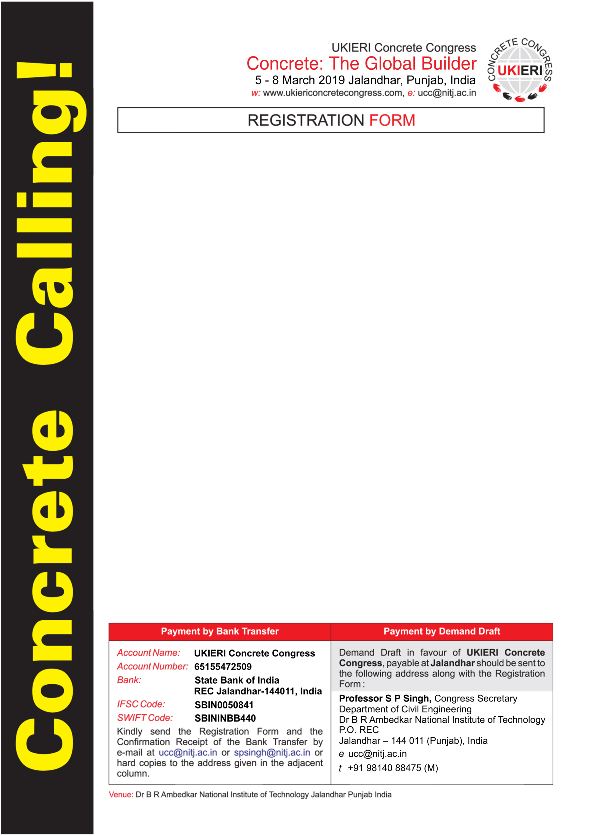s

1. Name:
2. Author: Non Author: Student: ­­ (Please tick appropriate box)
3. Paper ID (In Case of Authors): UCC
4. Position: Title:
5. Organisation:
6. Address:
7. Telephone (with Country Code): Fax (with Country Code):
8. Email id:
9. Applicable Fee:

Please tick one of the following payment options

|  |  |  |  |
| --- | --- | --- | --- |
|  | **Paid by Bank Transfer** | **Paid by Demand Draft** |  |