

**UNIVERSITY OF NAIROBI**

**COLLEGE OF BIOLOGICAL & PHYSICAL SCIENCES SCHOOL OF COMPUTING & INFORMATICS**

**Use of Intelligent Solar Panels to Facilitate Carbon Trading**

by

**Gichira Alvin Kaburu – P15/1553/2015**

**Supervisor**

Dr Wanjiku Ng’ang’a

A project report submitted in partial fulfillment of the requirements for the award of Degree in Computer Science of the University of Nairobi

**May 2018**

# Declaration

This project is my original work and, to the best of my knowledge, this research work has not been submitted for any other award in any University.

**Gichira Alvin Kaburu**: __________________________________ Date: ____________________ P15/1553/2015

This project report has been submitted in partial fulfillment of the requirements for the Degree in Computer Science of the University of Nairobi with my approval as the University supervisor.

**Dr Wanjiku Ng’ang’a**: __________________________________Date: ____________________School of Computing and Informatics

**Contents**

Declaration i

1. Introduction 1

1.1 Background Information 1

1.2 Problem Definition 3

1.3 Research objectives 4

1.4 System Objectives 4

1.5 Project Justification 4

1.5.1 Value Proposition of Carbon Trading Using Solar Panels 5

2. Literature Review 7

2.1 Evolution of Solar Panel Power Generation 7

2.2 Growth of Carbon Trading 8

2.3 Resources Required to implement Intelligent Solar Panel technologies 9

2.4 Exiting Technologies 10

2.5 Challenges with solar panel data intelligence 10

2.6 Proposed Solutions 11

3. System Analysis and Design 13

3.1 Development Methodology 13

3.2 Feasibility Study 14

3.2.1 Schedule Feasibility 14

3.2.2 Economic Feasibility 15

3.2.3 Operational Feasibility 15

3.2.4 Technical Feasibility 16

3.3 The Requirements Elicitation Process 16

3.3.1 The Goals of the Requirement Elicitation Process 16

3.3.2 Methods of Gathering Information 17

3.3.3 Findings from the requirement elicitation process 17

3.4 System Requirements 18

3.4.1 Functional Requirements 18

3.4.2 Non-Functional Requirements 19

3.5 System Design 20

3.5.1 Conceptual Design 20

3.5.2 Context Diagram 21

3.5.3 System Architecture 21

3.5.4 Level-0 Data Flow Diagram 22

3.6 Schedule: Project Gannt Chart 23

3.7 Budget Analysis 23

# Introduction

## Background Information

According the International Energy Agency (IEA) the world currently relies on renewable energy for about 23% of its total energy consumption. For a significant amount of sustainability to be achieved, it is important that renewable sources of energy play a larger predominant role, rather than a supportive one. The least that can be done to reduce the emission of Green House Gasses (GHGs) is by continuously adopting renewable sources of energy. One of the most important and increasingly popular sources of renewable energy is solar energy. This energy source is very promising due to its clean and reliable nature. Not only is this energy free to acquire – the sun is offered freely and widely – but it is also readily available all over the world at almost equal measure. This has led to huge investments in solar harnessing technology with the most common being photo voltaic cells packaged in a unit to form solar panels.

A solar panel is a device that is designed to absorb light using photo voltaic cells converting this form of energy to electric energy. Over the ages, solar panels have found use in lighting, heating and powering of devices. These devices, as solar harnessing devices sit at a direct angle to the sun at maximum efficiency. This position mostly manifests itself as building rooftops and other supportive structures. With an increase in the demand of this technology, many companies and organizations have widely invested in it building simple yet very powerful and innovative solar harnessing devices. Energy collected from the sun is now used both as a primary and secondary device power source at homes and institutions worldwide.

A Carbon credit (often called carbon offset) is a credit for greenhouse emissions reduced or removed from the atmosphere from an emission reduction project. These credits can be used, by governments, industry or private individuals to compensate for the carbon emissions they are generating into the atmosphere. When these credits are exchanged, they constitute carbon trade. This form of trading is a component of national and international attempts to mitigate the growth in concentrations of greenhouse gases (GHGs). One carbon credit is equal to one tonne of carbon dioxide, or in some markets, carbon dioxide equivalent gases. Greenhouse gas emissions are capped and then markets are used to allocate the emissions among the group of regulated sources.

Solar energy is widely referred to low carbon or carbon neutral form of energy. This is because of the fact that the form of energy does not emit carbon IV oxide in the course of its operation. By default, this reduces the amount of carbon dioxide in the environment. Therefore, harnessing solar energy can be useful as it reduces the amount of carbon credits required by a government or company. The extra credits can then be sold to countries or companies that require more credits to continue with their operations.

Time has seen widespread development of solar technology. In 1964, typical solar panels could only produce 12 watts of electricity at maximum efficiency. This put into context could only power one fifth of a 60w bulb at that time. The situation has drastically improved over the years. Currently, a typical solar panel produces around 265w to 330w of energy. These panels are said to be 20% efficient and can power up to four and a half 60w electric bulbs. The increase and improvement of solar harnessing technologies, in turn promises massive potential for carbon trading all over the world.

## Problem Definition

With little or no intelligence embodied onto the current solar panel design, currently no specific way to harness more value -other than energy- from them has been recommended. Non-corporate and some corporate solar panel owners therefore cannot claim financial benefits from programs like the Clean Development Mechanism (CDM) which was developed to give monetary rewards to individuals, body corporates and governments for their efforts to reduce the amount of carbon emission into the environment. As is currently, only the government and some body corporates around the world are benefiting from the program. This is inaccurate as the common mwananchi too, is a contributor and therefore deserves some financial recognition.

In order to capture as much solar energy as possible, and in the end benefit their owners, solar panels are positioned on top of buildings and other high facing structures. Unfortunately, many panels are stationary and rely on the assumption that the sun retains constant positioning during the day. This too is inaccurate as the sun in always in movement along a vertical 180-degree axis between east and west. On average, the solar energy harnessed from the sun is at its maximum at a particular region for 4hrs. These panels in addition do not have embedded data collection ability and therefore cannot influence decision making by interested parties.

This therefore calls for a need to develop efficient ways to ensure that solar panels become and remain highly intelligent in the course of their usage. Solar panels hence, should be intelligent enough to collect data from the environment so as to provide information that can be used by owners for some financial benefit as recommended in carbon trading.

## Research objectives

The goal of this project is to determine a method in which companies and individuals can benefit from carbon trading through use of an intelligent single axis solar panel with the ability to collect power and energy data from the environment.

## System Objectives

The following are the development objectives:

1. To modify an existing solar panel by adding the ability to collect data from its owners while following the sun.
2. To use the data collected to calculate extra carbon credits sold through the carbon market.
3. To facilitate financial benefit to individuals and body corporates through the sale of carbon credits.
4. To analyze the collected data and come up with information that can be used to improve business processes.

## Project Justification

Renewable energy is continuously helping many industries achieve economic transformation and achieve energy security. Solar energy as a form of renewable energy is one of the most abundant sources of energy. The use of this form of energy has extremely been on the rise over the years. Solar electricity generation is not only a good option when used as a secondary electricity source but can also completely be a primary source when used in areas where other forms of electricity are economically unviable. Since solar projects assist greatly to reduce the amount of Green House Gasses emitted into the atmosphere, they deserve executive consideration while running the activities of a carbon market under the Clean Development Mechanism (CDM). With the CDM allowing industrialized countries with a Green House Gasses emission reduction targets to invest in projects that reduce emissions in developing countries as an alternative to more expensive emission reductions in their own countries, solar projects can hence earn carbon credits in the form of Green House Gasses emission reduction.

### Value Proposition of Carbon Trading Using Solar Panels

Carbon emissions trading is a form of trading that allows countries that have higher carbon emissions to purchase the right to release more carbon dioxide into the atmosphere from countries that have lower carbon emissions. The carbon trade also refers to the ability of individual companies to trade polluting rights. Companies that pollute less can sell their unused pollution rights to companies that pollute more. The goal is to ensure that companies in the aggregate do not exceed a baseline level of pollution and to provide a financial incentive for companies to pollute less.  Since individuals owning solar panels also contribute to less carbon emission by producing some electric energy, they too, could benefit from carbon trading in the following way:

1. **Stationary solar panels receive a maximum of 4hrs of sunlight in a day. Assuming a 300w solar panel:**

**300w x 4hrs in a day = 1200wh = 1.2 kwh per day**

1. **Research shows that a solar tracker increases efficiency by 30%. This means that:**

**30% of 1.2kwh per day = an increased 0.36kwh = 1.56kwh per day is equal to 569.4 kwh per year**

1. **Assuming a 20 solar panel system:**

**569.4kwh per year x 20 solar panels is equal to 11,388 kwh per house per year**

1. **Research shows that In Africa, generation of 1kwh of nonrenewable electricity produces 0.705 kg of carbon dioxide. Therefore:**

**11,388 Kwh per house per year x 0.705 Kg = 8028.54 Kg is equal to 8.02854 Tons of carbon dioxide**

1. **Research shows that 1 carbon credit currently costs KES 1,200 in the carbon market. Therefore:**

**8.02854 Tons of carbon dioxide saved x KES 1,200 is equal to KES 9,634.25 earned by panel owner per year**

With these facts in mind, it is clear that individuals too could benefit greatly from carbon trading. If a methodology to ensure this is enforced, it will result to increased purchases of solar panels that will in turn lead to less reliance on the national grid. This will further lead to massive reduction on the pressure on carbon emitting sources of energy. To further reduce this pressure, solar panels should work at maximum efficiency. This can be achieved by embedding solar tracking technologies onto solar panels.

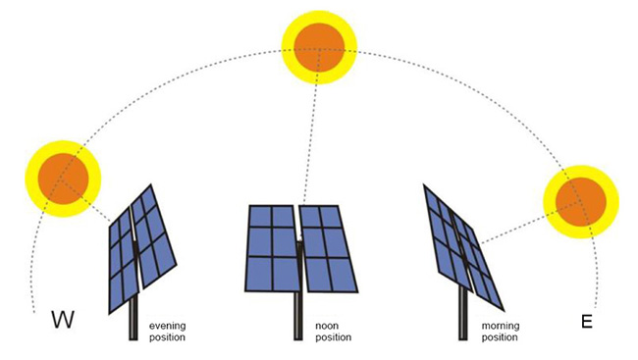

**Increased energy collection by Solar Trackers**

# Literature Review

## Evolution of Solar Panel Power Generation

Solar panels have greatly evolved over the ages. Photovoltaic technology was discovered by Alexandre Becquerel, in 1839. He placed an electrode in a conductive solution and when it was hit by sunlight, current was generated. This opened up research in the field. In the 1950s, solar panels designed were 6% efficient yielding 20 watts of electrical power. By 2012, this had drastically improved to 15% efficiency yielding an average of 200 watts. 2015, saw 20% efficient solar panels, yielding 265 watts of electricity. This is enough to power 4 and 2 fifth -60 watts bulbs.

Currently, 7% of renewable energy generation is solar energy. Glenn (2017). This is projected to grow to around 36% by 2055. China is the leading solar power generator in the world producing 100 GW of electrical power. South Africa is the leader in solar power in Africa yielding around 1329MW of electricity every year. However, solar generation is Africa is still considered very low and efforts are being made to improve generation of this form of energy.

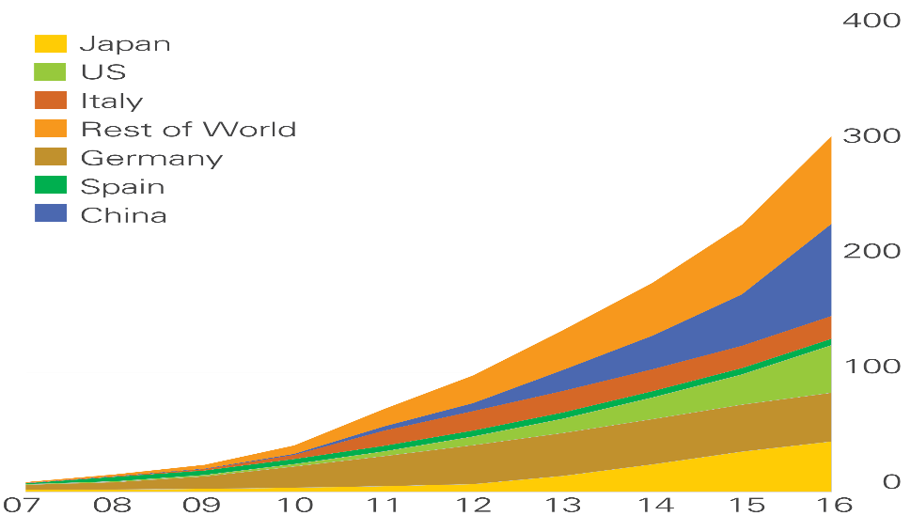

**World Distribution of Solar generation in Megawatts**

## Growth of Carbon Trading

Before the establishment of carbon trading, countries that use fossil fuels were not paying for the release of carbon dioxide. This is despite the fact that released carbon dioxide has a grievous effect on the atmosphere. The carbon trade originated with the 1997 Kyoto Protocol, with the objective of reducing carbon emissions and mitigating climate change and future global warming. At the time, the measure devised was intended to reduce overall carbon dioxide emissions to roughly 5% below 1990 levels by between 2008 and 2012.

Carbon trading occurs by providing economic incentives for achieving reductions in the emissions of pollutants into the environment. Quotas set a limit below which countries can produce Green House Gasses. All these countries have different quota levels. They however can increase their limits by purchasing credits from countries with extra carbon credits. Companies too can take part in the trading. They purchase and sell carbon credits from the government or other body corporates.

Solar energy is gaining increased use in the world. The growth has been exponential over the years with a cumulative growth rate of 30%. It is estimated that by 2050, the capacity of worldwide power from solar panels shall be 4600 GW (IEA, 2015). When converted to carbon credits, this power value shall create a trillion-dollar industry.

In Kenya, the Kenya Agricultural Carbon Project (KACP) in 2014, became the first organization to earn carbon credits under the Verified Carbon Standard (VCS) for locking carbon in soil. The credits represented a reduction of 24,788 metric tons of carbon dioxide, which at the time was equivalent to emissions from 5,164 vehicles in a year. They were also the first credits worldwide issued under the sustainable agricultural land management (SALM) carbon accounting methodology.

In an effort to improve the trade, the Nairobi Securities Exchange (NSE) plans to introduce carbon credits trading in the Kenyan Stock Exchange. Njoroge (2016) said that the formal trading platform within the exchange will be an easier way for companies to sell their credits to foreign buyers other than through signing emission reduction purchase agreements. So far, Mumias Sugar, KenGEN, East African Portland Cement and Kenya Power and Lighting company have been the largest beneficiaries of the sale of carbon credits.

## Resources Required to implement Intelligent Solar Panel technologies

Intelligent solar panels are capable of collecting information from the sun as it moves from east to west. They are implemented by a combination of tracking, data collection and transmission technologies.

Solar tracking technologies are technologies that assist the solar panels to follow the sun in its daily axis from east to west. There are 2 types of solar trackers:

1. Single axis trackers that follow the sun only on 1 axis.
2. Dual axis trackers that incorporate seasonal changes in the position of the sun.

Both trackers are implemented by incorporating an intelligent motor controlled by a micro controller. The micro controller sends information to the tracker based on variations in solar intensity. As solar trackers follow the sun, they collect information that can be used to facilitate achievement of various goals. This information collected is from voltage sensors that transmit signals over a network to interested parties.

## Exiting Technologies

All over the world, many stake holders have attempted to implement the technology. However, most of these plants concentrate more on solar tracking aspect than data collection which is equally as important.

Existing projects and plants are as follows:

1. The largest single axis tracker project in Asia, generating 172MW of energy. The project is controlled and managed by Arctech Solar company.
2. NEXTracker company projects to install solar trackers on behalf of customers on demand. The company also manages and maintains the solar trackers to ensure they remain efficient and effective.

## Challenges with solar panel data intelligence

Like any other technology, there are several challenges that could hinder perfect performance. To start with, collection of data by manufactures could result to privacy issues. Despite the fact that the data can be utilized to solar panel owners advantage, geographical and usage information could result to security breaches.

Carbon trading could result to misuse of the concept. The trading may be used as a means of bypassing the need to curb emissions by simply buying credits without investing in cleaner and carbon-free processes. This could result to emission of more carbon into the atmosphere, contrary to what the program was meant to prevent.

Hardware device get faulty from time to time. They therefore require maintenance which could result to extra pains. Trackers add cost and maintenance to the system - if they add the cost, and improve the output by an equal amount, then it could be argued that the same performance can be obtained by making the system larger. However, this could easily attract a counter argument. Making panel systems larger will occupy more space. Space is considerably a more expensive resource.

## Proposed Solutions

To satisfy carbon trading through intelligent solar panels, the following shall be the flow of activities:

1. The intelligent single axis tracker shall collect power, energy, temperature, humidity data from its environment.
2. The data shall be transmitted to a central company registered under the Clean Development Mechanism (CDM). This company is also a solar panel installation company.
3. The CDM registered company, will accumulate the energy collected from all solar panels from its customers and convert the value to its carbon weight equivalent.
4. The report shall be submitted to the government that will then determine how many carbon credits are earned or saved.
5. More carbon credits are made available for sale on the carbon market.
6. When a sale occurs, the money made trickles down to the company and is further dispensed to the solar panel owners.

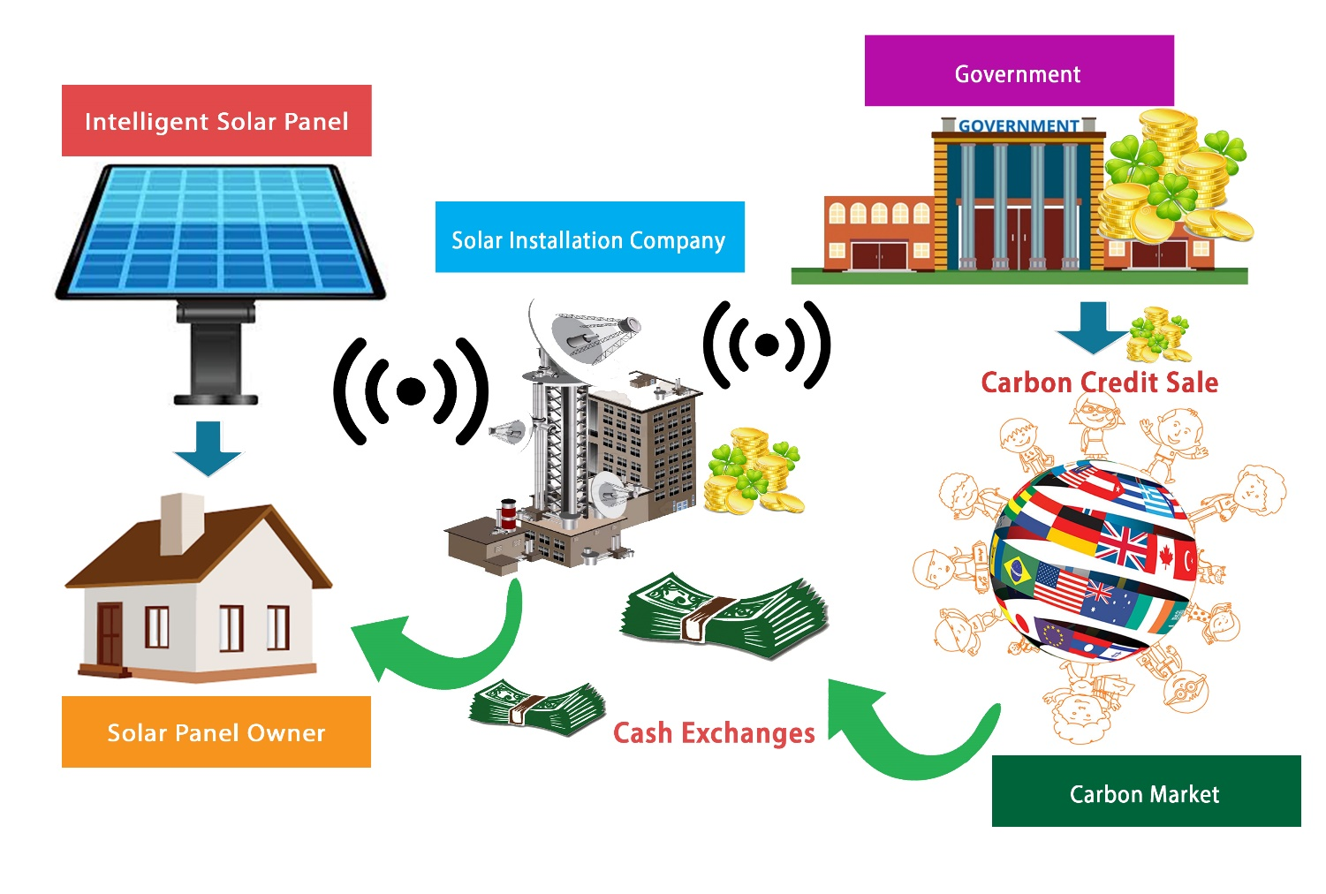

**Proposed process flow**

# System Analysis and Design

## Development Methodology

Development of an intelligent single axis solar panel will require a development model that will take into consideration the following fundamental attributes:

1. The budget constraint of implementing the panel technology and its risk evaluation is very important to manufacturers, distributors and panel owners.
2. The project is a medium to high-risk project.
3. Manufacture, sale, distribution and maintenance shall be long-term in nature due to potential changes in economic priorities as the requirements change with time.
4. Intelligent panels are uncommon and their uptake is uncertain. They shall be dispatched in phases to get significant and ample customer feedback.
5. Significant changes are expected in the product during the development cycle.

Based on the above attributes, a spiral model of development will be most appropriate. This is because this model allows for incremental releases of a specific product and its incremental refinement through each iteration around the spiral. From its identification, design, construct and evaluation phases as well as their iterations, the project will evolve from a simple concept to a practical use case that will find use in homes, schools, industries and other institutions.

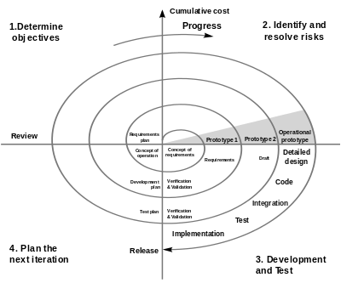

**Spiral Methodology of Development**

## Feasibility Study

### Schedule Feasibility

Development of a complete system is expected to last 9 months. This duration is necessary to facilitate complete:

1. Design of the hardware and software components of the system.
2. Development of the hardware and software components of the system.
3. Creation of relevant documentation.
4. Acquiring of new skills that are needed to complete development of the system.

### Economic Feasibility

The project is economically feasible in that all costs of installation will eventually be recovered by amounts earned by carbon credits. The revenue streams are incremental and perpetual and last throughout the life of the system.

**Cost Benefit Analysis for a 300w, 5 Panel System At 1000 kwh credit rate**

|  |  |  |  |  |
| --- | --- | --- | --- | --- |
| **Benefits** | **Year 1 (KSH)** | **Year 2 (KSH)** | **Year 3 (KSH)** | **Year 4 (KSH)** |
| 0.3kw **x** 8hrs of Sunlight **x** 5 Panels **x** 365 days = 4380 Kwh **/** 1000 credit- rate | 10,512.00  (KSH 2400/Cr) | 11.826.00  (Kshs 2700/Cr) | 13,140.00  (Kshs 3000/Cr) | 14,454.00  (Kshs 3300/Cr) |
| **Costs** |  |  |  |  |
| Purchase of 5 panels at 13000 | 65,0000.00 | 0 | 0 | 0 |
| Installation | 5,000.00 | 0 | 0 | 0 |
| Maintenance and Support Costs | 5,000.00 | 5,000.00 | 5,000.00 | 5,000.00 |
| **Total** | **(64,488.00)** | **6,826.00** | **8,140.00** | **9,454.00** |

### Operational Feasibility

A carbon trading system is operationally feasible because of the following reasons:

1. There is a need to invent ways to deal with excess emissions of carbon and carbon equivalents into the atmosphere
2. Solar panels harness naturally occurring energy from the sun and hence the supply is available as long as there exists sunlight.
3. It is currently possible to buy and sell credits in the carbon market for projects registered under the Clean Development Mechanism (CDM).
4. The world is currently pushing for investments in green energy so as to facilitate reduction in the amount of Green House Gasses into the atmosphere.

Development of such a system requires technical expertise and knowledge of aspects of the carbon market. Information regarding these fields is widely availed through years of documented research. This therefore creates a suitable operation environment supported by various professionals.

### **Technical Feasibility**

Incorporating a carbon trading system is technically feasible because of the following reasons;

1. Transmission technologies have improved and continue to improve with each passing day. This therefore means that data will be easily transmitted from a solar panel to a trading company.
2. Internet connection has increasingly become available; therefore, it is possible to harness its availability for benefit of the system.
3. There is a lot of support for IOT enabled devices all around the world. Technologies have now come up to support existence of these devices.
4. The technical expertise is also available. This is because the languages used are simple to learn and adjust to.

## The Requirements Elicitation Process

### The Goals of the Requirement Elicitation Process

The requirement elicitation process is meant to provide a deep understanding on what carbon trading entails, the parties involved and regulations around the mode of trade. This will ensure a deep understanding is gained so as to address input and output needs, processing needs and needs concerning maximum utility. Requirements gathering will ensure solar panel owners benefit to a maximum capacity from their solar panels through collection of energy and the sale of carbon credits generated from them. This process will also ensure that user experience is at an optimum level and customer needs are addressed.

### Methods of Gathering Information

Information gathering was majorly conducted through journals and research papers. Since carbon trading as a field has been in existence for a while, researchers have documented their findings through papers and journals. Other methods used included:

1. Observation of solar panels mounted on buildings.
2. Interviews conducted on solar panel owners.
3. Reading internet articles on experiences of many solar panel owners around the world.

### Findings from the requirement elicitation process

The requirement elicitation process provided information that is a motivation to this project. Major findings revolved around the following facts:

1. Only 3% of African Projects are registered under the Clean Development Mechanism. This is ironical as Africa -being relatively less industrial than other continents- should be one the largest beneficiary of green projects and carbon trading as a whole.
2. Upper mid and high-income citizens are capable of participating in carbon trading as long as they are empowered to do so.
3. Countries and company projects that lower carbon footprints can be registered under the Clean Development Mechanism hence facilitating investment in green energy.
4. Solar panels can be made intelligent enough to raise their efficiency to up to 40% equivalent to 8hrs supply of energy in a day.

## System Requirements

### Functional Requirements

The functional requirements of a carbon trading system that utilizes solar energy can be grouped into hardware and software requirements.

1. **Functional Hardware Requirements**

These requirements are met through intelligent solar panels that can follow the sun along its east to west axis and transmit information to both solar owners and trading companies. The solar panel should be able to:

1. Follow the sun on a single east to west axis while capturing maximum amounts of energy.
2. Collect and transmit energy collection information from the solar panel to a remote server.
3. Collect and transmit temperature and humidity information from the solar panel to a remote server.
4. **Functional Software Requirements**

The functional software requirements of the system will enable panel owners to do the following:

1. To monitor energy collection by their solar panels.
2. To monitor credit and amount information from the carbon market.
3. To filter information received based on preference.

### Non-Functional Requirements

Non-functional requirements of the system shall include;

1. **Performance** - By power of web technology and the Internet of things, the system shall be equipped with mechanisms to promote high levels of performance. These mechanisms shall include enhanced response time by use of improved frameworks, hardware devices, data input-output processing and functional dynamism.
2. **Scalability** - The system shall exhibit the ability to handle a growing amount of work. It shall also be adaptive to promising potential and accommodative to complexity and situational sophistication.
3. **Reliability** - The system shall be highly reliable to both primary and secondary users. Speed and efficiency in usage and data processing shall be enhanced to ensure that there are no delays in input processing. The system shall also be able to manage arithmetic operations, data analysis and decision making, using if else analysis.
4. **Security** - Due to the sensitive nature of the data in a carbon trading system, security is key. User account, password and encryption technology shall be used to ensure that data entered into the system remains inaccessible to unauthorized users. This ensures confidentiality and overall data security.
5. **Data Integrity** - Data connectivity and information dependency is necessary in any system. The marketing system shall maintain data integrity aimed at minimizing data quality and enhancing user efficiency, accessibility and quality.
6. **Interoperability**- The marketing system shall be hosted in the internet and this shall be available to all internet users from a variety of devices and operating systems. Solar panel owners will be able to access their information from anywhere with internet connection.
7. **Legality** - The design, operation and implementation of the system shall be in accordance with all legal provisions contained in the Intellectual property act, the Companies act, the sale of Goods act, Computer Misuse and Cybercrimes act, the carbon market among any other relevant laws of parliament applicable in Kenya.

## System Design

### Conceptual Design

**Trading Company API**

**Panel Owner**

**Trading Company’s Database**

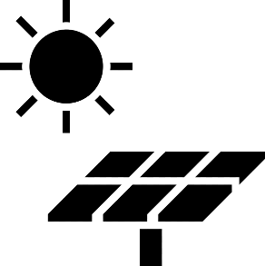

**Trading Company**

**Carbon Market Database**

**Solar Panel**

**Carbon Market API**

### Context Diagram

**Solar Credits Application**

**Carbon Market**

**Solar Trading Company**

**Solar Panel Owners**

Energy Information

Money and Credit Information

Financial and Credit Information

Energy, Financial and Credit Information

Energy Information

**Solar Panel**

Control Information

### System Architecture

**Solar Panels**

**HTTP Requests**

**HTTP Requests**

**HTTP Requests to and from Server**

**HTTP Requests to and from Server**

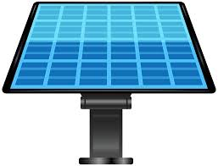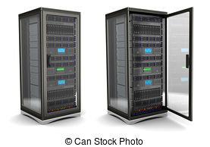

**Carbon Tracking System Running in Devices**

### Data Flow Diagrams

1. **Level-0 Data Flow Diagram**

Login Request

Panel Information

View Request

**SOLAR PANEL OWNER**

**USERS**

**D1**

**1**

**LOGIN TO SYSTEM**

Login Request

Customer Details

**2**

**CONTROL PANELS**

Control Request

**SOLAR PANELS**

**D2**

Control Details

**3**

**VIEW PANEL INFORMATION**

**CREDIT DETAILS**

**D3**

Credit Data Request

Panel Data Request

Panel Data

Credit Data

**TRADING COMPANY**

**4**

**CONTROL USERS**

View Request

Panel Information

User Data

User Data Request

**5**

**GET PANEL DATA**

**SOLAR PANEL**

Energy Data

Energy Data

Control Data

Data

1. **Level-1 Data Flow Diagram: Panel Control Module**

**SOLAR PANEL OWNER**

**2.1**

**GET LOCATION**

**2.2**

**GET ENVIRONMENT INFORMATION**

**2.3**

**CONTROL PANEL MODE**

**2.4**

**CONTROL PANEL RUNTIME**

**2.5**

**GET ENERGY INFORMATION**

**SOLAR PANEL**

**LOCATION**

**D1**

**ENVIRONMENT INFO**

**D1**

**MODE**

**D2**

**RUNTIME**

**D3**

**PANEL DATA**

**D4**

Location Request

Location Information

Request for Environment information

Environment information

New Control Mode

Panel Mode Information

Location Request

Location Information

Environment Information

Environment Request

Mode Information

Mode Request

Mode Action

New Runtime

Runtime Information

Energy Information

Request for Energy Information

Runtime Information

Runtime Request

Panel ID

Panel ID

Energy Information

Runtime Action

Energy Information

Energy Information Request

Environment Information

Location Information

1. **Level-1 Data Flow Diagram: View Financial Information Module**

**SOLAR PANEL OWNER**

**3.1**

**GET ENERGY INFORMATION**

**PANEL DATA**

**1**

**3.2**

**CALCULATE CREDITS**

**MARKET DATA**

**2**

**3.3**

**CALCULATE AMOUNTS**

**3.4**

**GENERATE MARKET INFOMATION**

**TRADING COMPANY**

Energy Information

Request

Energy Information

Energy Information Request

Energy Information

Energy Information Request

Energy Information

Credit Information

Request

Credit Information

Credit Information Request

Credit Information

Market data requests

Market Data

Amount Data

Market Data Request

Amount Data Requests

Market Data Request

Market Data

Market Data

Amount Information

Amount Information Request

Request Credit Data

Credit Data

Request Energy Data

Energy Data

## Schedule: Project Gannt Chart

|  |  |  |  |  |  |  |  |  |  |  |  |  |  |
| --- | --- | --- | --- | --- | --- | --- | --- | --- | --- | --- | --- | --- | --- |
| **ID** | **Task Name** | **Feb** | **Mar** | **Apr** | | **May** | **June** | | **Jul** | **Aug** | | **Sept** | **Oct** |
| **1** | Research |  |  |  | |  |  | |  |  | |  |  |
| **2** | Planning |  |  |  | |  |  | |  |  | |  |  |
| **3** | Testing of Alternatives |  |  |  |  |  |  | |  |  | |  |  |
| **4** | Choice Implementation plan and Design |  |  |  |  |  |  | |  |  | |  |  |
| **5** | Assembling of Hardware Components |  |  |  | |  |  | |  |  | |  |  |
| **6** | Testing of Hardware components |  |  |  | |  |  |  |  |  | |  |  |
| **7** | Software components design and testing |  |  |  | |  |  |  |  |  | |  |  |
| **8** | Integrating hardware and software |  |  |  | |  |  | |  |  | |  |  |
| **9** | Overall Testing and data collection |  |  |  | |  |  | |  |  |  |  |  |
| **10** | Review |  |  |  | |  |  | |  |  | |  |  |
| **11** | Documentation |  |  |  | |  |  | |  |  | |  |  |

## Budget Analysis

|  |  |  |
| --- | --- | --- |
|  | **KSH** | **KSH** |
| **Income** |  |  |
| Total Income |  | 0 |
| **Expenses** |  |  |
| Simple 6V 2A Solar Panel | 1000 |  |
| 2M PPR Pipes | 250 |  |
| 24 x 24 Inches Wood Board | 250 |  |
| Arduino Mega 2560 Rev3 | 2500 |  |
| ESP8266 Node MCU | 800 |  |
| DHT22 Sensor | 200 |  |
| 20 Pieces Resistors | 80 |  |
| 5 Pieces Light Dependent Resistors | 15 |  |
| 50 Pieces Male to Male Jumper Wires | 200 |  |
| 50 pieces Male to Female Jumper Wires | 200 |  |
| I2C LCD Display | 500 |  |
| 10 Pieces LEDs | 30 |  |
| Active and Passive Buzzer | 100 |  |
| **Total Expenses** |  | **6125** |