Deborah Barndt

Lab 1: Temp Converter

ITMD 455-02

1-17-17

Take a snapshot of your running application, which will show the result of 30 degrees Celsius converted to Fahrenheit.

**From Studio:**

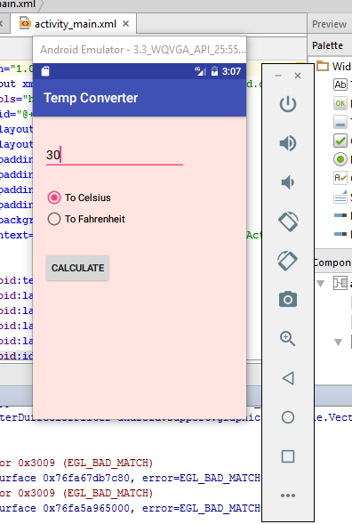

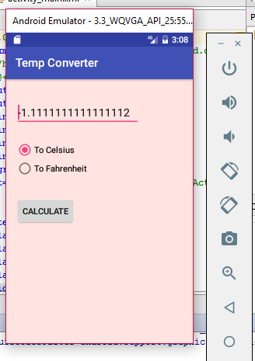

**From Emulator strip:**

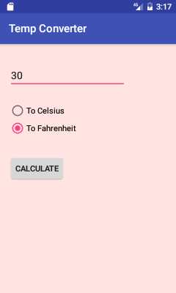

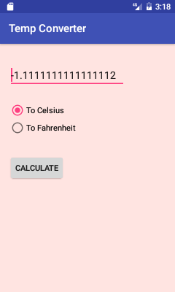

Take a snapshot of your Home screen showing your icon display.

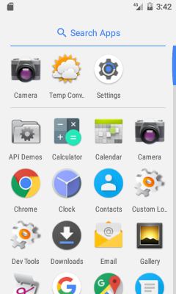

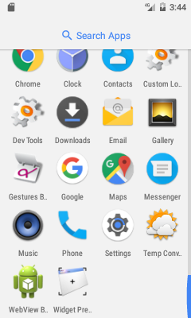

Snapshot of running temp converter with a temperature above 90

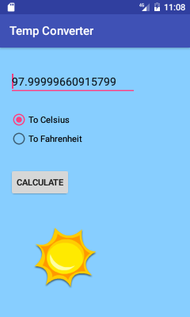

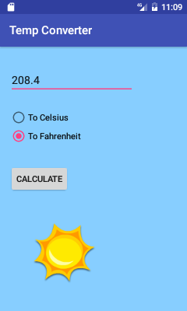

Snapshot of running temp converter with a temperature below 0

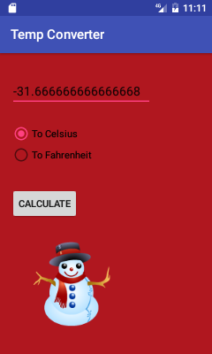

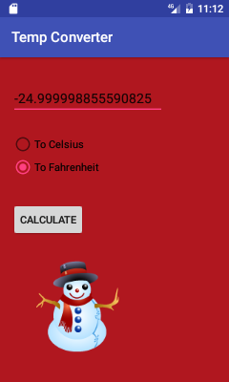

Snapshot of running temp converter with temperature between 0 and 90

