Deborah Barndt

ITMD 455-02: Android App

Lab 5

James Papademas

3-30-17

Snapshot of BookReviews App running:

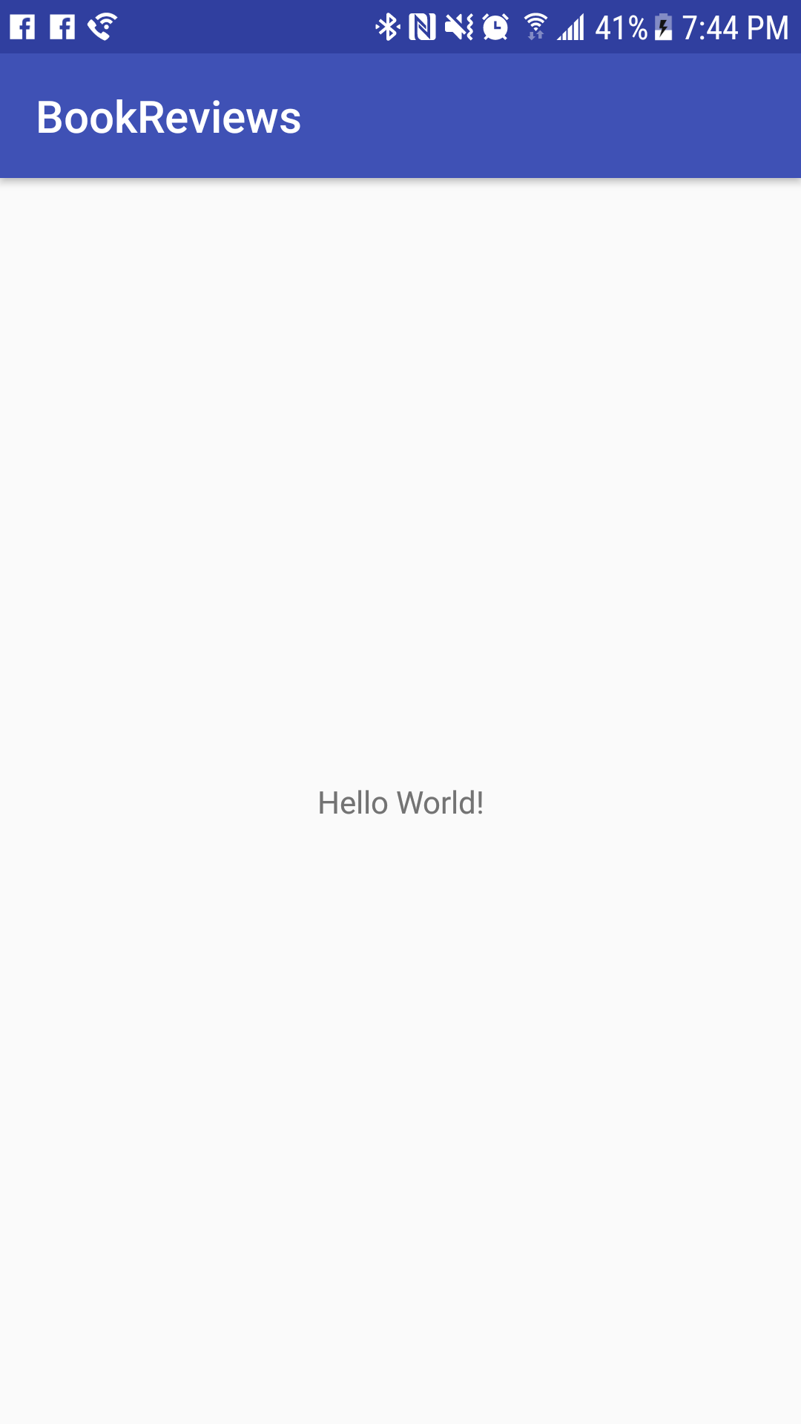

Snapshot of LogCat file displaying my name before the books:

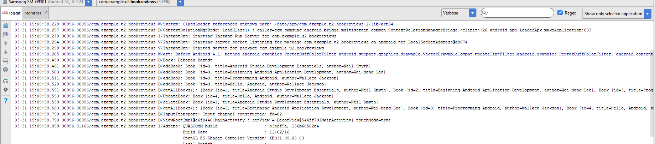

Snapshot of the BookReviews App Icon:

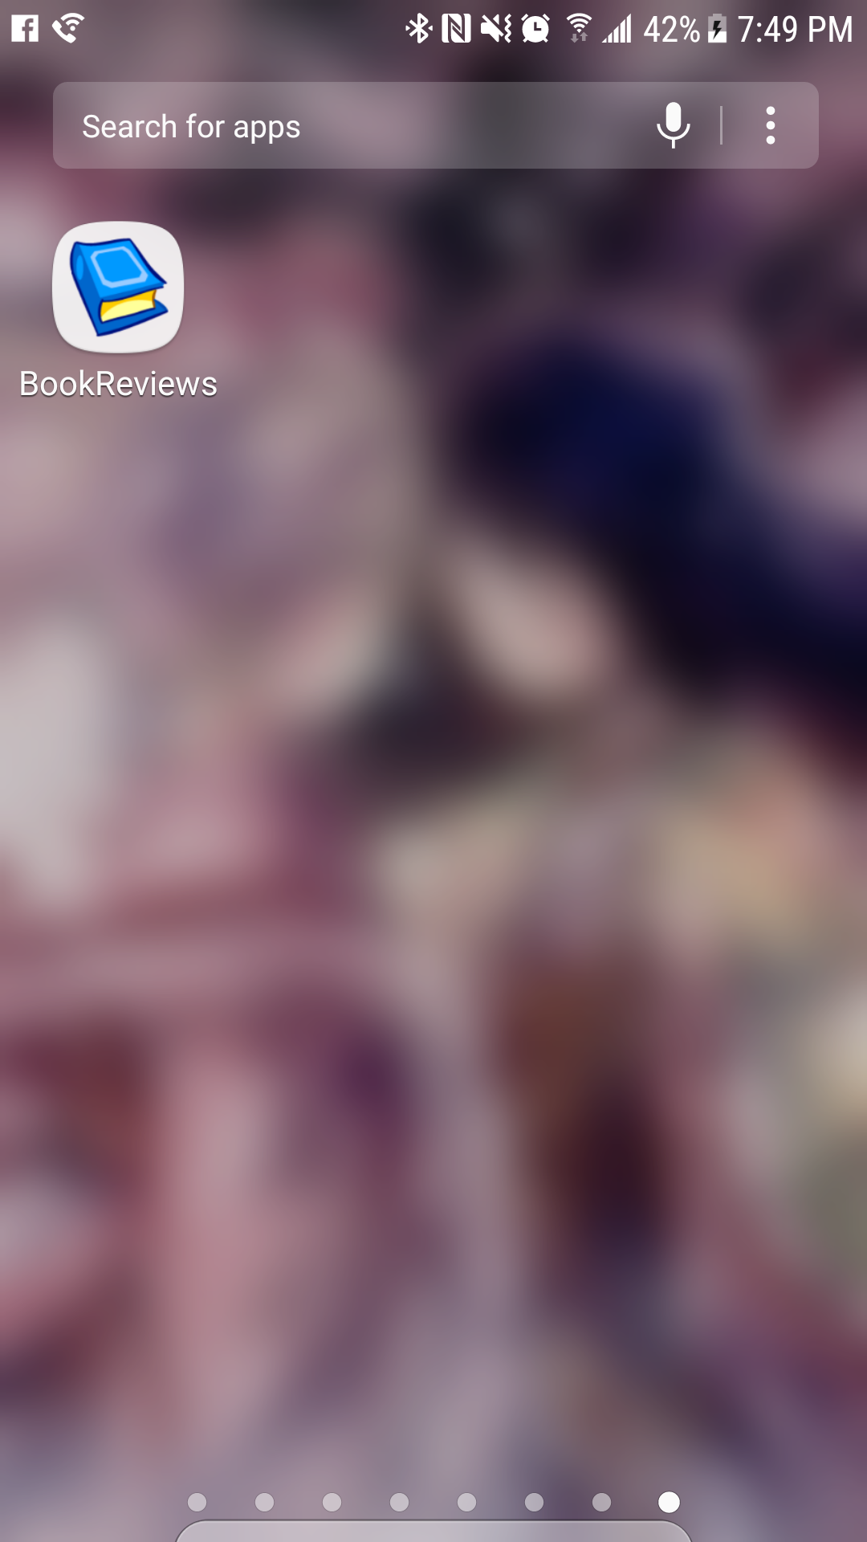

Snapshot of updating Book 4:

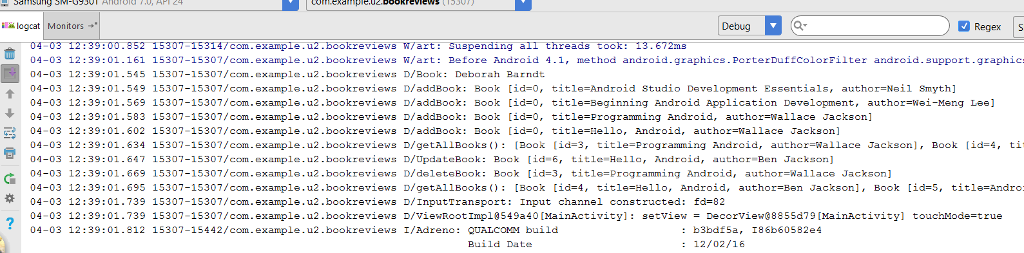

Snapshot of all of the transaction information and the total amount of books:

