Deborah Barndt

ITMD 455-02: Android App

Lab 8

James Papademas

4-27-17

Screenshot of the main screen:

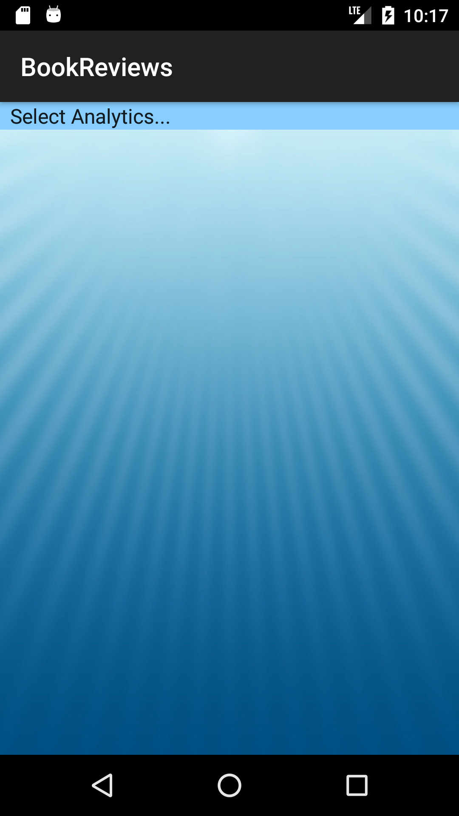

Screenshot of the analytics spinner:

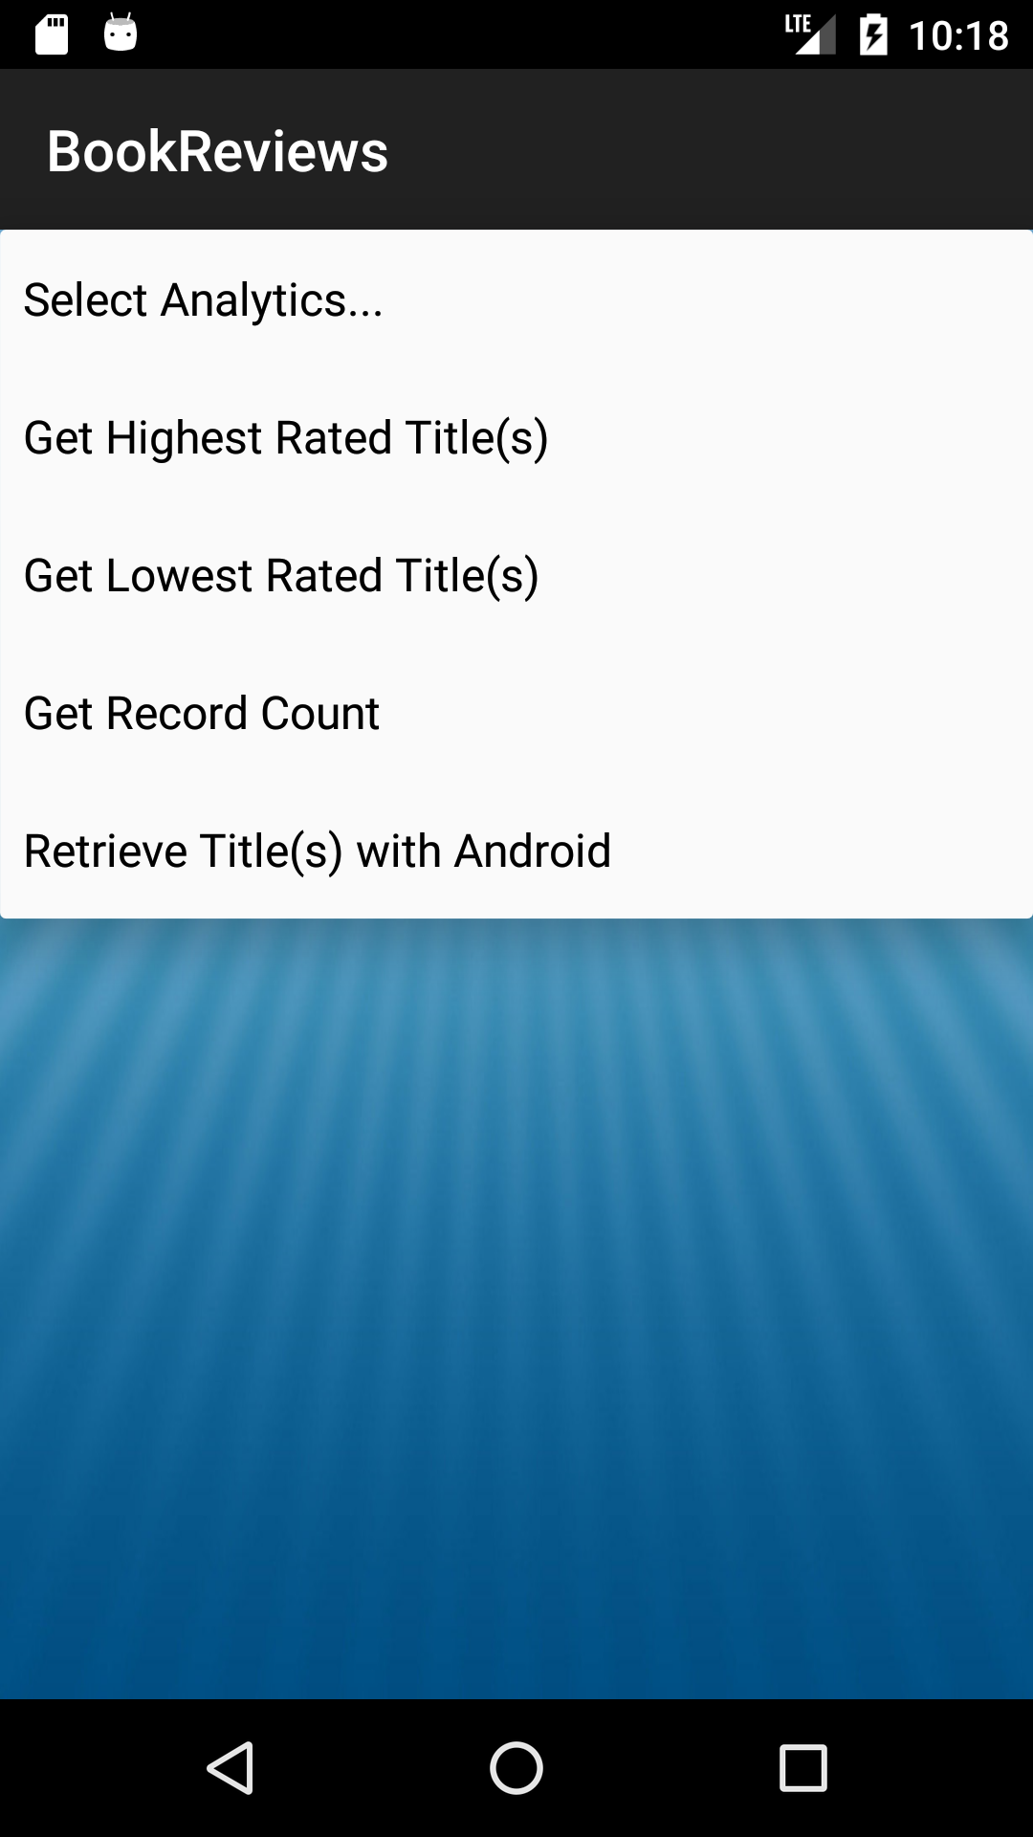

Screen shot of the Highest Rated Title:

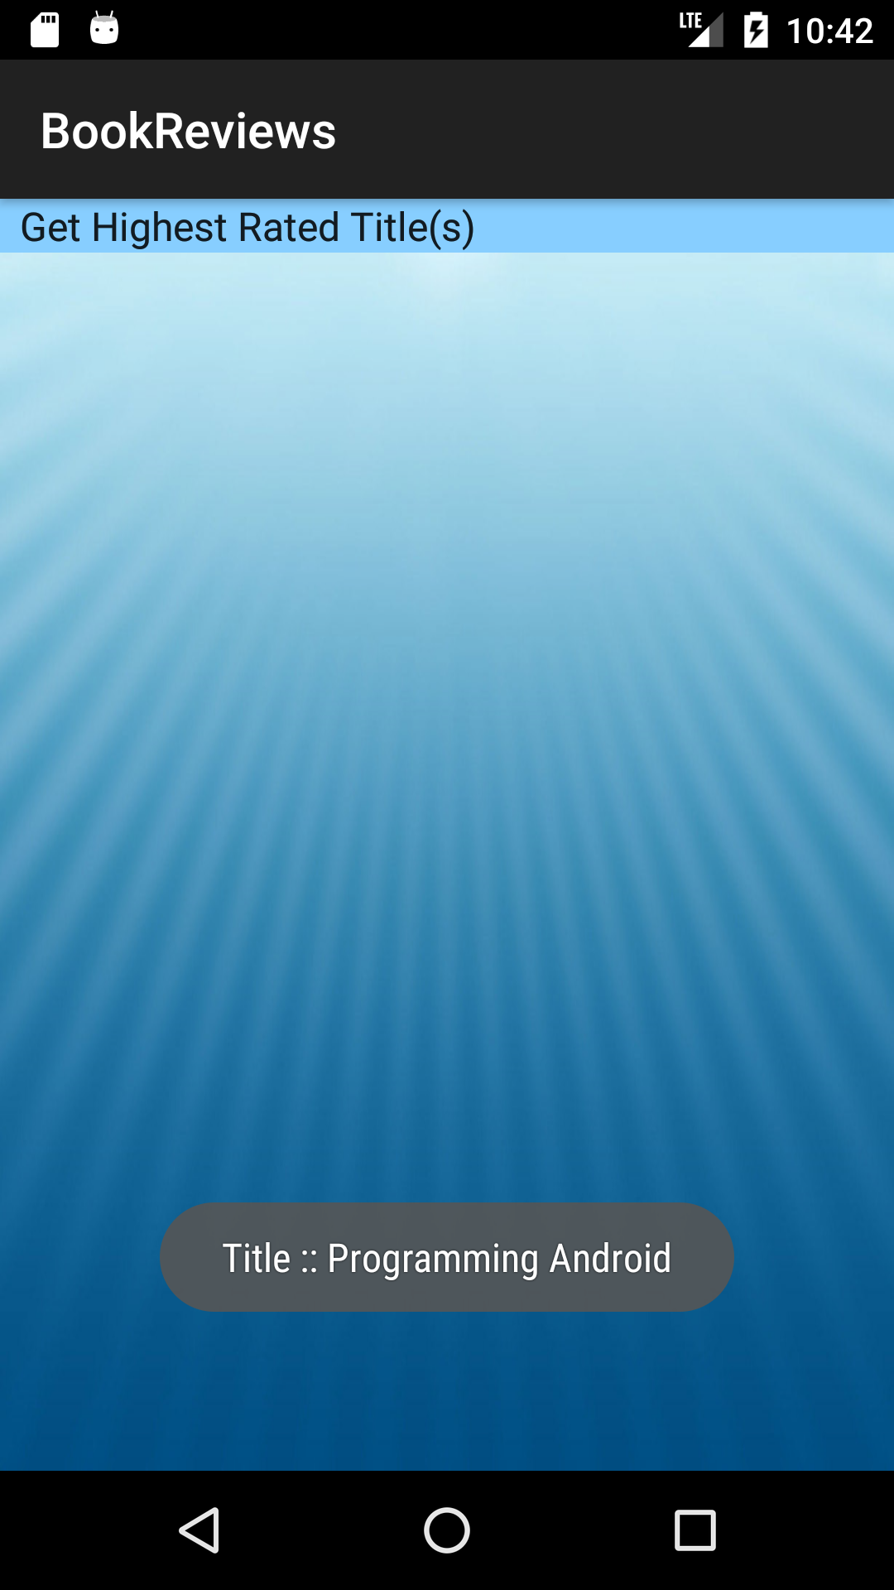

Screenshot of the Lowest Rated Title:

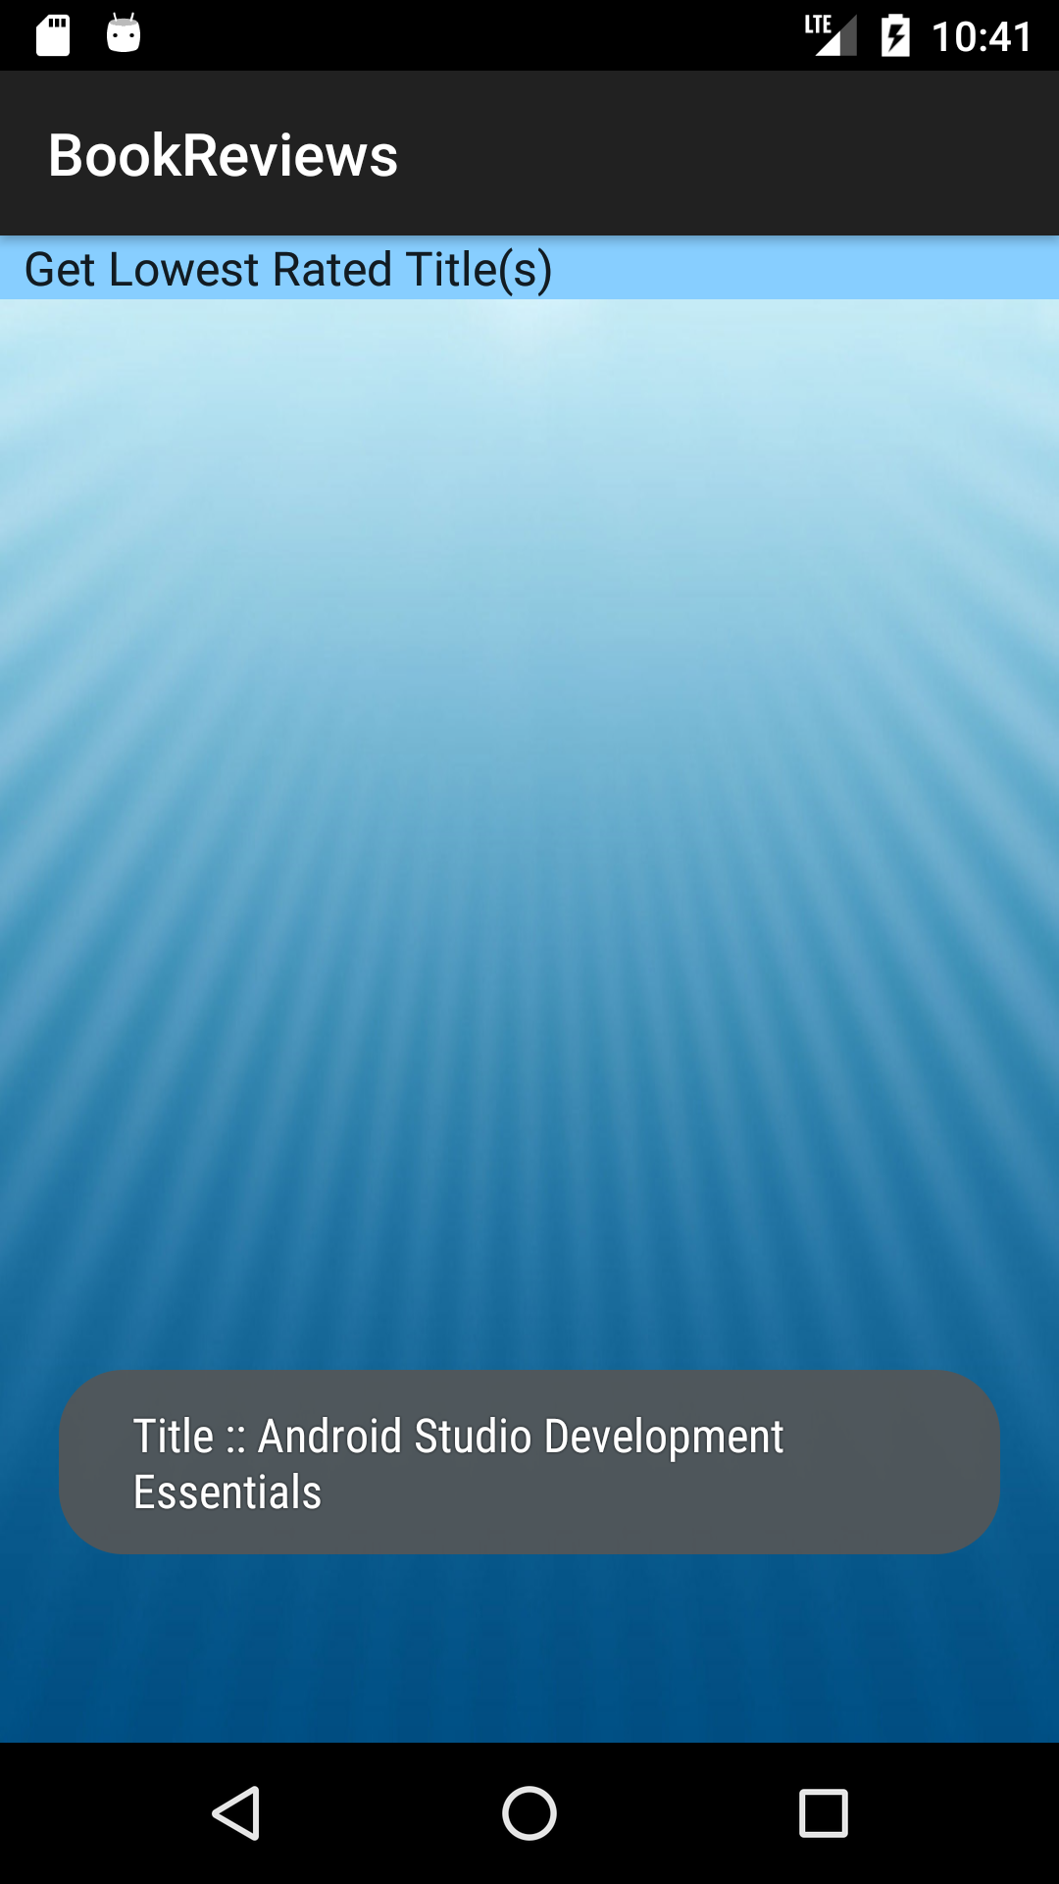

Screenshot of the Record Count:

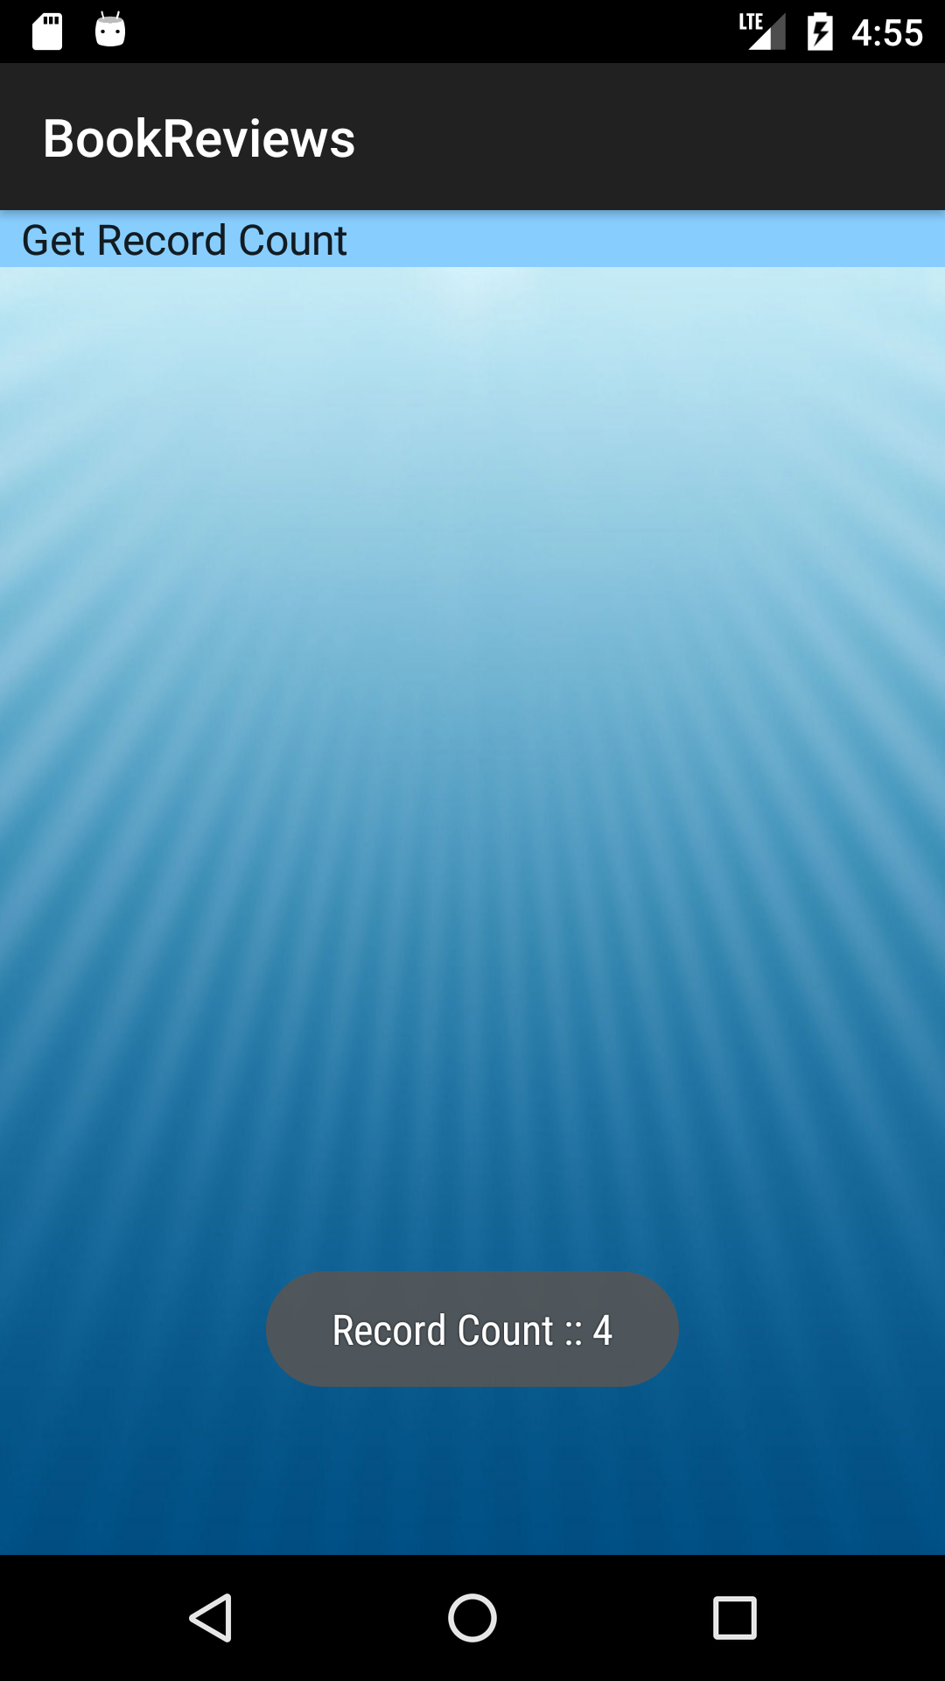

Screenshot of the Retrieve Title(s) with Android:

