Deborah Barndt & Craig Finnern

Final Project Specs Phase 1: Astronomy App

ITMD 455: Intelligent Device Android Apps

James Papademas

3-20-17

Table of Contents

Project Idea & Description 3

App Wireframe 4-7

UML Diagram 8

Project Idea:

Astronomy App (We’ll come up with a better name later.)

Description:

This application is meant to encourage the 6th – 8th grade YOUmedia students at the Humboldt Park Library to be more interested in STEM activities. Our goal is to teach them about astronomy, and get them to use the SkyQuest XT6 telescope that was donated to the YOUmedia program by the Adler Planetarium.

The app will contain the following features:

* Astronomy quiz questions about the constellations, planets, and stars
* Fun facts: how a star is born, stories about the planets, facts about the solar system, how to become an astronaut, and stories about the constellations
* Star maps that would match location and possibly the season
* Interactive links that can take the students to more information
* Video and audio explanations of the stars, planets, and constellations
* Motivational activities such as calculating the time it will take for them to get to the moon or mini-games
* Objects will be named when they are touched on the screen, then lead to a detail page about them

Prototype Wireframing of UI

Snapshot of Prototype Splash Screen:

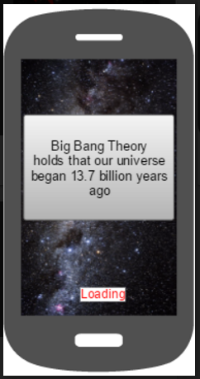

Snapshot of Prototype Menu Screen:

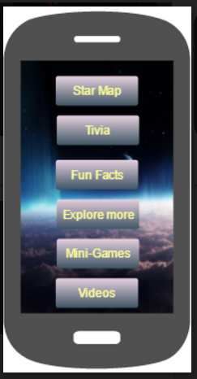

Snapshot of Prototype Star Chart Screen:

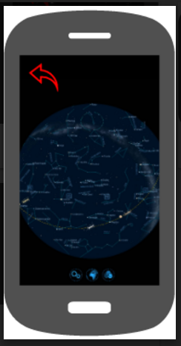

Snapshot of Prototype Quiz Screen:

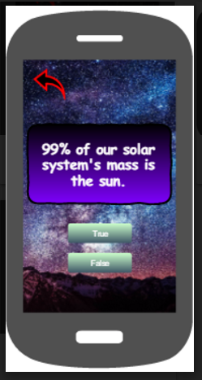

Snapshot of Prototype Fun Facts Screen:

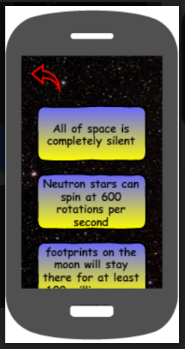

Snapshot of Prototype Explore More Screen:

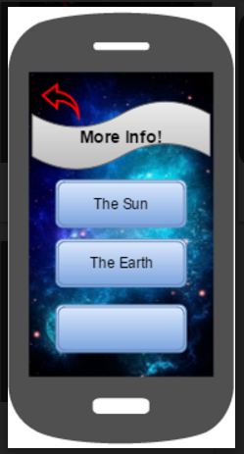

Snapshot of Prototype Games Screen (Motivational Activities):

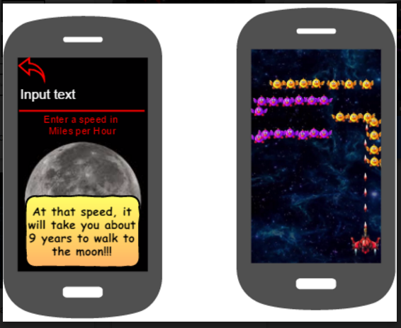

Snapshot of Prototype Videos Screen:

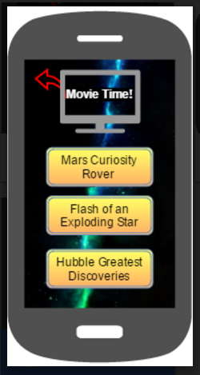

UML Diagram

Snapshot of Preliminary UML Flowchart Diagram:

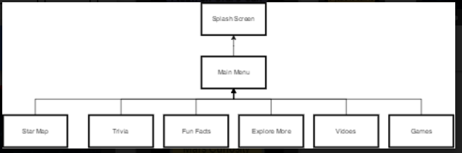

Link to folder of all the images for the Prototypes Screens and the Flowchart:

https://drive.google.com/open?id=0B5BEqSSmvI35NWZ5Q2NQSTJINm8