Deborah Barndt & Craig Finnern

Final Project Specs Phase 2: Astronomy App

ITMD 455: Intelligent Device Android Apps

James Papademas

4-25-17

Table of Contents

Abstract 3

Design and Development 4

Functionality and Screenshots 5-12

Conclusion 13

Abstract

We wanted to get the 6th-8th grade students at the YOUmedia program to learn more about astronomy in a fun and interesting way. Since the students were already engaging with technology, we developed Star Mission. The app is user-friendly, geared towards 6th-8th grade, engaging, has a consistent theme, utilizes links and videos, challenges them to do hands-on learning, provides them with a fun and educational study guide, and can be expanded on.

Design and Development

The first step in our design process was figuring out how many activities we wanted in the app. We came up with a total of 10 activities, 5 activities running in the front end and 5 running in the back end. The activities that we came up with were Fun Facts, Quiz, Challenges, Star Map, Videos, Splash Screen, and the Main Activity. Our main activity loads the picture of the day from NASA, and when the user taps on the picture they are taken to the NASA website for further information on the picture. For the design navigation, we decided to go with a similar navigation to Google and go with a dark theme for the app. The splash screen loads 10 random fun fact images that changes every time they load the app, so they learn something new each time. For the fun facts activity, we have 25 hard coded astronomy fun facts that are geared towards the 6th-8th graders and is meant as a study guide for the quiz. Each of the list of fun facts goes to a detailed view and has a different picture from the fact icon image. The quiz activity utilizes the fun facts to give them 10 true/false questions directly from the fun facts themselves. If they get one wrong, they can always go back to the fun facts and learn more. At the end of the quiz the user is given a rating out of 5 stars on how they did. The star map activity downloads the Chicago Star Chart during that specific day and time that it is loaded, and provides them with a button to locate where the North Star is during that time of day so that they can find it. In the challenges activity, we try to get the user to utilize their tools and locate specific constellations using a telescope. The videos activity loads a list of pictures and links to various YouTube videos for them to watch a video and learn more about astronomy. The final part of development was a custom-made app specifically for Star Mission.

Functionality and Screenshots

Screenshot of our custom-designed application icon:

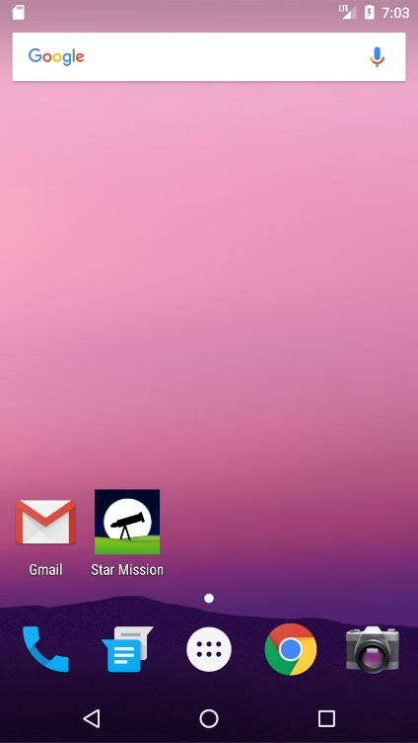

Screenshot of the Splash screen that loads the 10 random images:

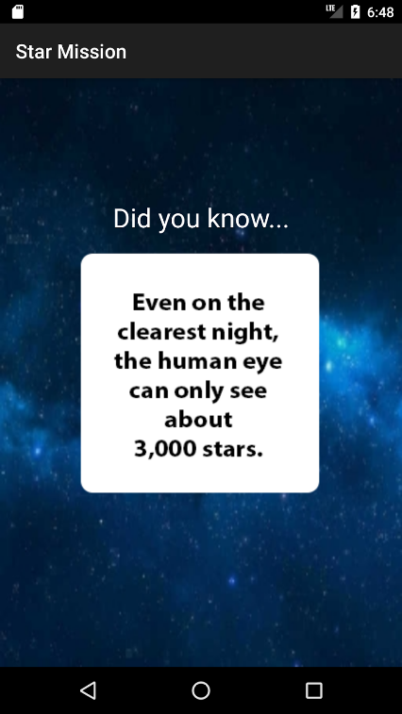

Screenshot of the main activity screen loading the NASA picture of the day:

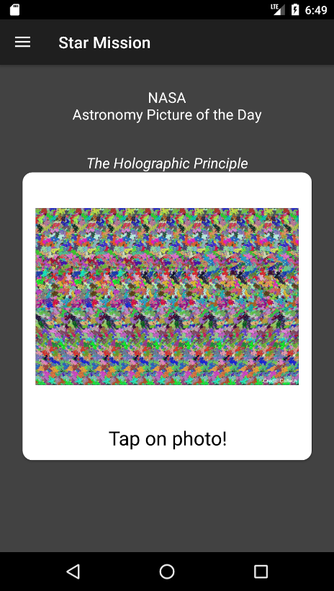

Screenshot of the NASA website when the user taps the photo:

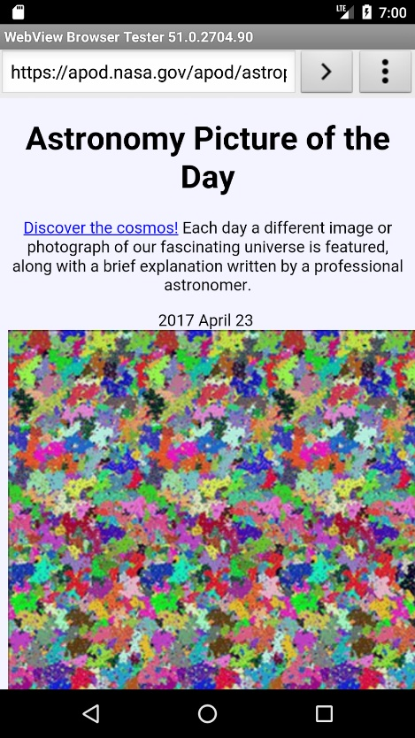

Screenshot of our main activity navigation:

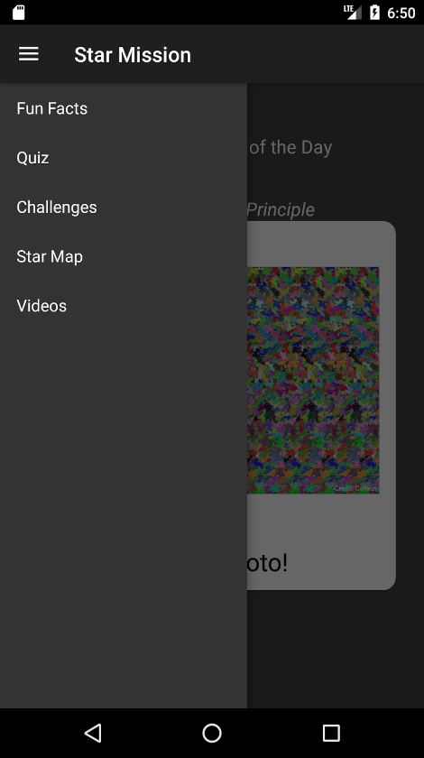

Screenshot of the Fun Facts activity screen:

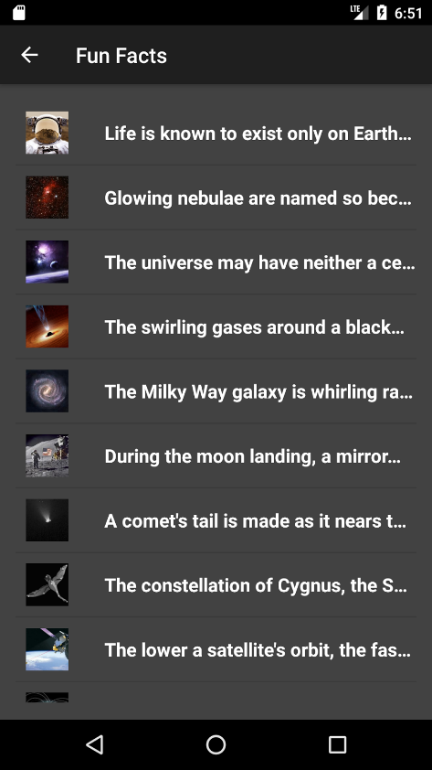

Screenshot of the detailed view of the Fun Facts:

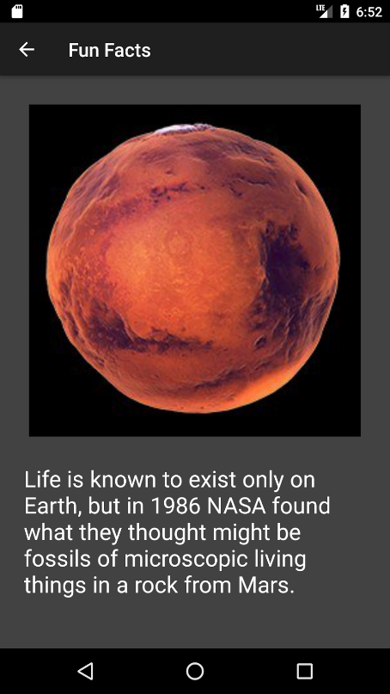

Screenshot of the Quiz activity:

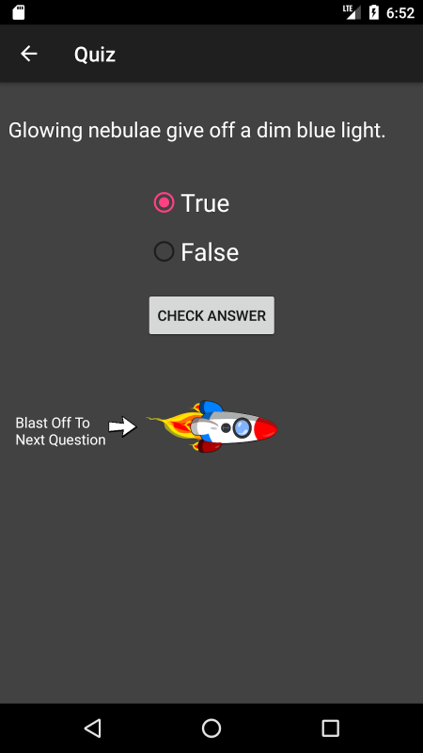

Screenshot of the star rating at the end of the quiz:

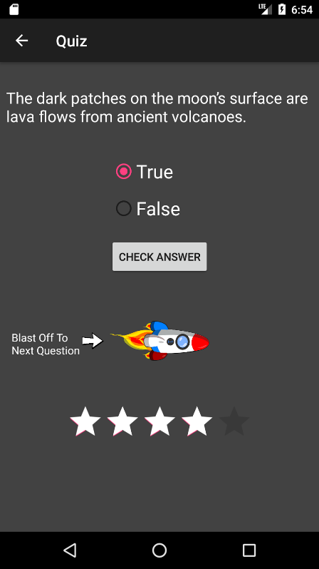

Screenshot of the Challenges activity with a pop-up message:

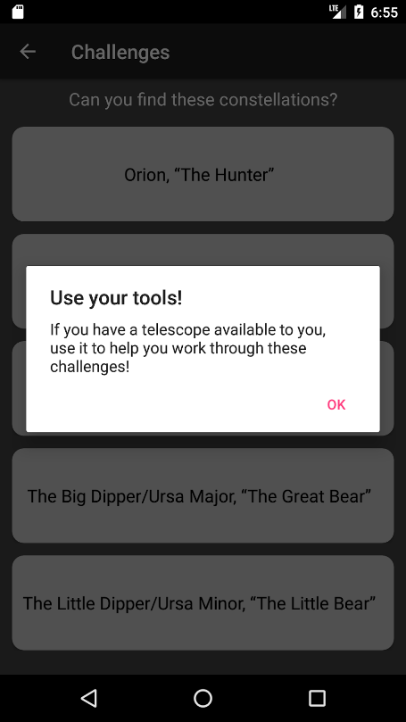

Screenshot of the list of constellation buttons on the Challenges activity:

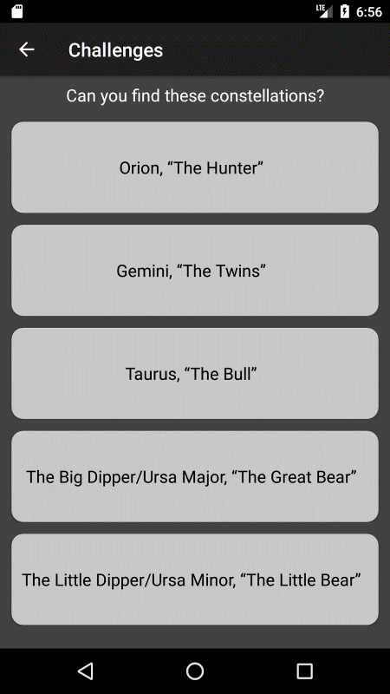

Screenshot of the constellation for the user to locate:

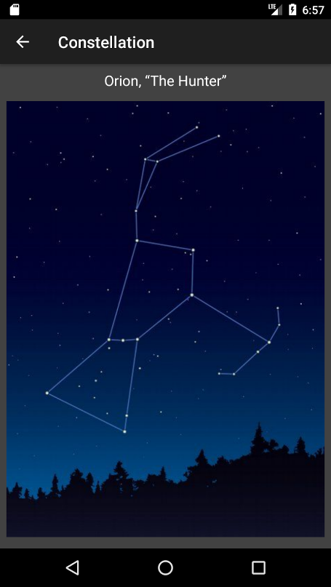

Screenshot of our Star Map activity:

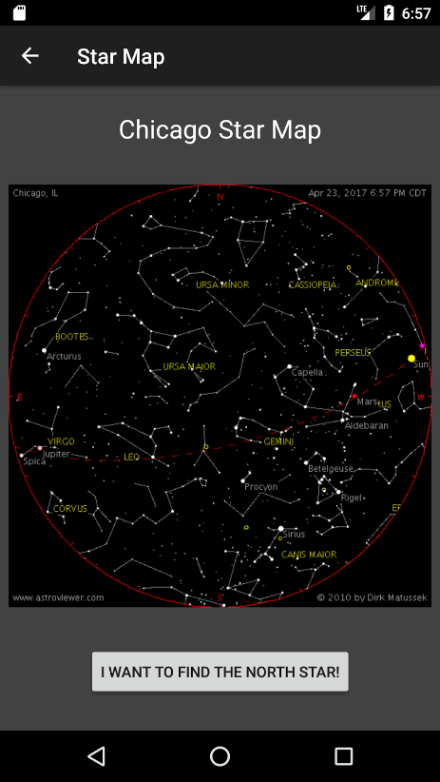

Screenshot of the North Star location:

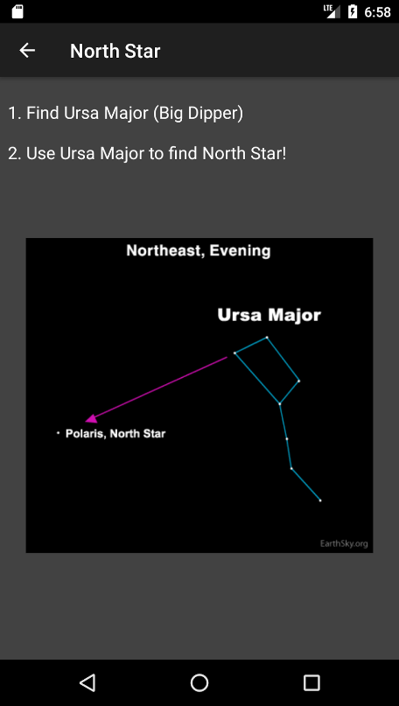

Screenshot of the Videos Activity:

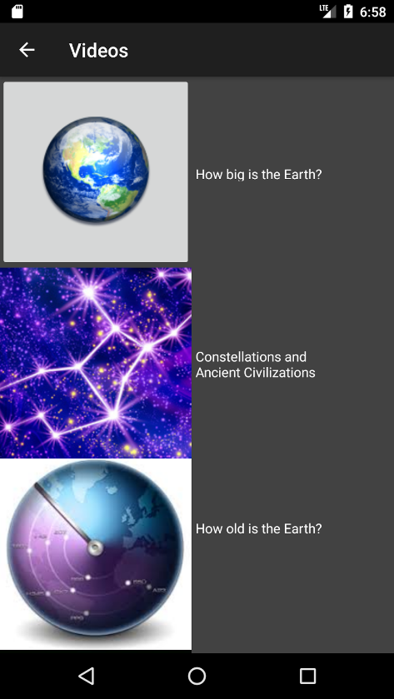

Screenshot of the YouTube page that the videos link goes to:

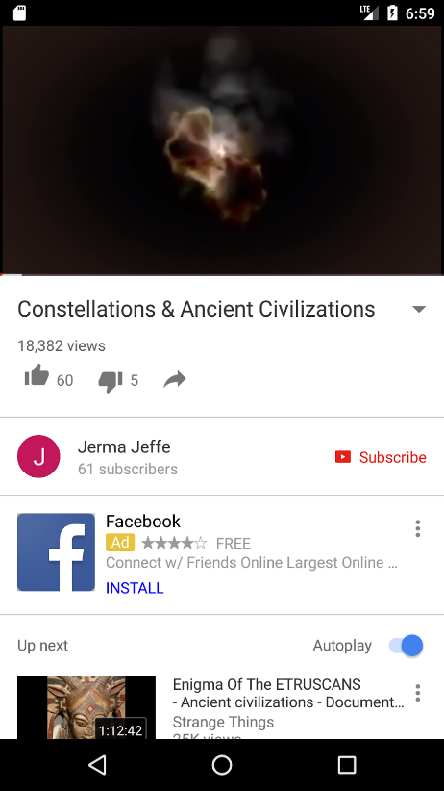

Conclusion

The app was demoed at IPRO Day for other users to look, test it out, and give feedback. While demoing Star Mission, we got some great feedback for suggestions. One user tester was a young 6th grade girl who got all excited while playing with the app. She said, “That’s so cool! I want to play with it! Can I, have it?!” For the future, we would like to expand the amount of activities app, possibly offer an educators version for teachers to tailor the information to their curriculum, have different difficulty levels for the quiz, expand to different age groups (great for college general education classes), give the user the ability for sharing with family and friends, get more links and videos, and have a VR version of the Star Map to use GPS and camera. We also encountered a few problems throughout development and during demoing. One of the major problems was combining all our code together, and then combining it to make a fully-functioning base application for YOUmedia. We were also donating 5 android devices to the program with various API version, which made it difficult sometimes when testing the app. We did have a slight problem with the web view handling an extremely high resolution image, which ended up making the application crash unbeknownst to us. In the end and between the three of us, Star Mission was a success and will be available on the Google Play Store.