Deborah Barndt

ITMD 513 Open Source Programming

Professor Dr. Sam

Hw5

2-20-19

Question 1: (Sorted?)

'''

Deborah Barndt

2-20-19

SortedList.py

hw5: Question 1 Sorted List

This program will prompt the user to enter a list and display whether the list

is sorted or not sorted.

Written by Deborah Barndt.

'''

# Function that returns true if the list is already sorted in increasing order.

def isSorted(lst):

for i in range(len(lst) - 1):

if (lst[i] > lst[i + 1]):

return False

return True

# Function that will prompt the user to enter a list and then displays whether

# the list is sorted or is not sorted.

def main():

enterAgain = 'y'

while (enterAgain == 'y'):

lst = input('Please enter a list of numbers with spaces: ')

lst = lst.split(' ')

for i in range(len(lst)):

lst[i] = int(lst[i])

if isSorted(lst):

print('The list is already sorted.')

# Ask the user if they would like to enter another list.

enterAgain = input('\nWould you like to enter another list? (y/n) ')

else:

print('The list is not sorted.')

# Ask the user if they would like to enter another list.

enterAgain = input('\nWould you like to enter another list? (y/n) ')

if (enterAgain == 'n'):

print('\nThank you. Please come again.')

# Call the main function to begin the test program.

main()

Output Result:

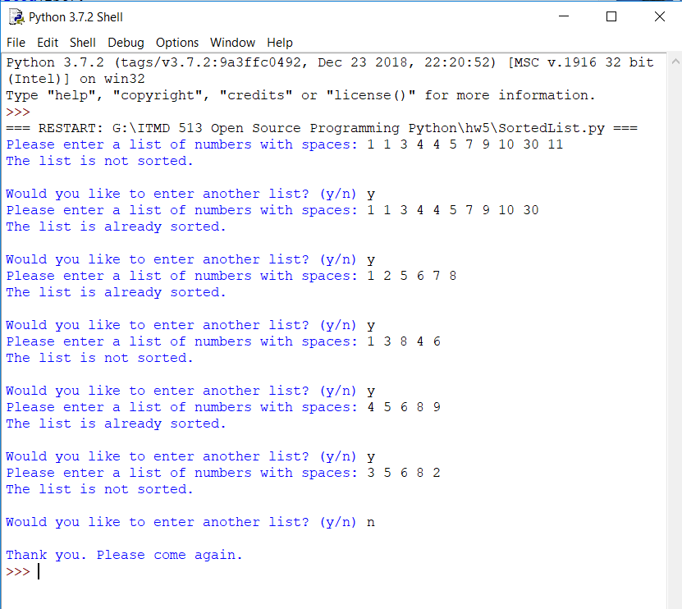

Question 2: (Algebra: multiply two matrices)

'''

Deborah Barndt

2-20-19

AlgebraMatrix.py

hw5: Question 2 Algebra Matrix

This program will prompt a user to enter two 3 x 3 matrices and display their

product.

Written by Deborah Barndt.

'''

# Function that will multiply two matrices given by the user.

def multiplyMatrix(a, b):

rowA = len(a)

colA = len(a[0])

rowB = len(b)

colB = len(b[0])

if (colA != rowB):

print('You entered the wrong dimensions for matrices.')

return

result = [[0 for row in range(colB)] for col in range(rowA)]

# For loop to iterate through each of the rows and columns.

for i in range(rowA):

for j in range(colB):

for k in range(colA):

result[i][j] += round(a[i][k] * b[k][j], 1)

return result

# Function to prompt the user to enter the two 3 x 3 matrices and displays

# the product.

def userMatrix(num):

userinput = input('Enter a matrix with spaces for matrix' + str(num) + ': ').split()

userinput = list(map(float, userinput))

total = len(userinput)

row = int(total ** 0.5)

matrix = [userinput[i:i + row] for i in range(0, total, row)]

return matrix

# Function that will store the input into both matrices.

def main():

matrix1 = userMatrix(1)

matrix2 = userMatrix(2)

productMatrix = multiplyMatrix(matrix1, matrix2)

display = [[' ', ' '], ['* ', '= '], [' ', ' ']]

print('The multplication of the matrices is:\n')

for i in range(len(matrix1)):

print(str(matrix1[i][0]) + ' ' + str(matrix1[i][1]) + ' '

+ str(matrix1[i][2]) + '\t ' + display[i][0] + str(matrix2[i][0])

+ ' ' + str(matrix2[i][1]) + ' ' + str(matrix2[i][2]) + '\t '

+ display[i][1] + str(productMatrix[i][0]) + ' '

+ str(productMatrix[i][1]) + ' ' + str(productMatrix[i][2]))

# Call the main function to begin the program.

main()

Output Result:

