Deborah Barndt & Thomas Boller

ITMD 415/515 Advanced Software Programming

Group Project: Phase 1

1-19-18

**1.1 Requirement Specification Document**

**1.1.1 Requirements Table**

Car Services Modules: Taxi and Messenger Services (Package delivery)

|  |  |  |  |
| --- | --- | --- | --- |
| **Requirement Number** | **Version**  **Number** | **Priority Level** | **Requirement Description** |
| 1 | 1 | High | User shall have either a driver, admin or customer account |
| 2 | 1 | High | User shall be able to request a ride from A to B |
| 3 | 1 | High | User (rider) shall be able to be picked up from A |
| 4 | 1 | High | User (driver) shall be notified of user (rider)’s request for a ride |
| 5 | 1 | High | User (driver) shall be able to confirm or not the pick-up |
| 6 | 1 | Low | User (rider) shall be able to rate their experience |
| 7 | 1 | Low | User (rider) shall be able to tip along with their payment |
| 8 | 1 | Medium | User (driver) shall get updates to the rider on the status of their ride |
| 9 | 1 | Medium | User (rider) shall get a reward either through referral or after a number of rides |
| 10 | 1 | High | User shall be able to request a delivery from A to B |
| 11 | 1 | High | User (driver) shall be notified of user (customer)’s request for a delivery |
| 12 | 1 | High | User (driver) shall be able to confirm or not the delivery |
| 13 | 1 | Low | User (customer) shall be able to rate their delivery experience |
| 14 | 1 | Low | User (customer) shall be able to tip delivery driver with payment |
| 15 | 1 | Medium | User (driver) shall get updates to the customer on the status of their delivery |
| 16 | 1 | Medium | User (customer) shall get a reward either through referral or after a number of deliveries |

**1.1.2 Taxi Service Use Case Diagram**

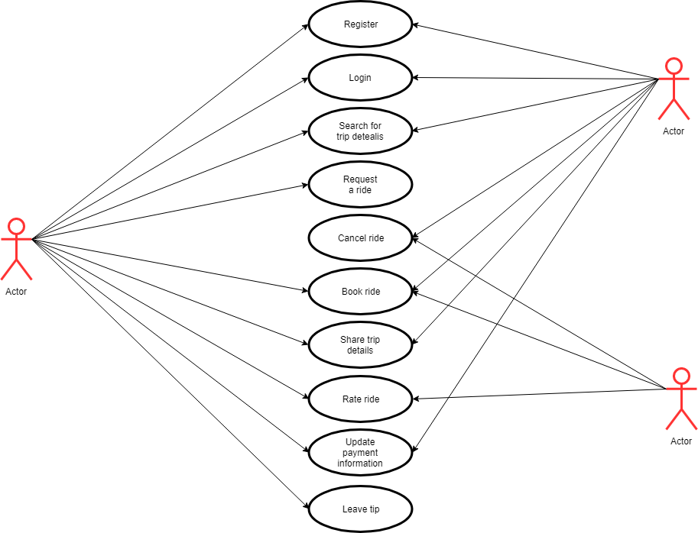

**1.1.3 Delivery Service Use Case Diagram**

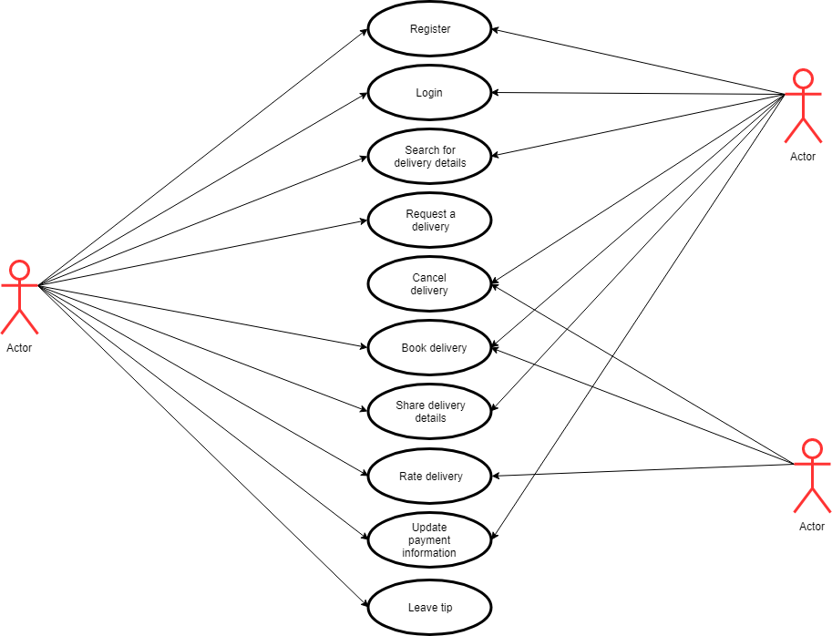

**1.2 Design Phase**

**1.2.1 Architecture Diagram using MVC**

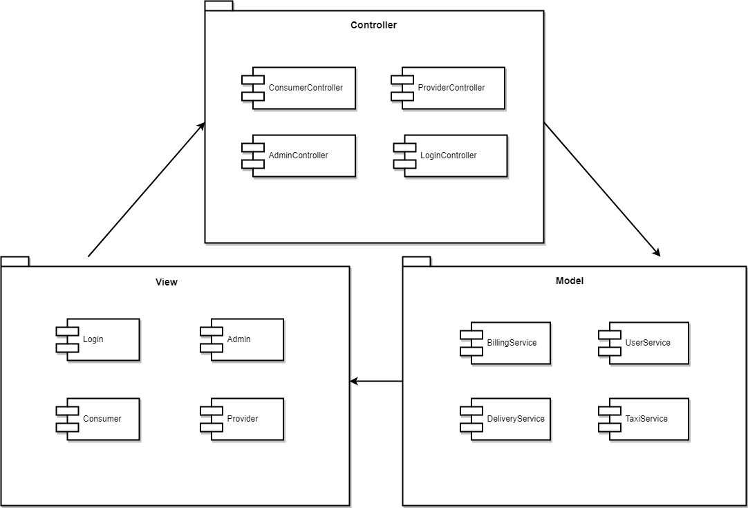

**1.2.2 Database Design**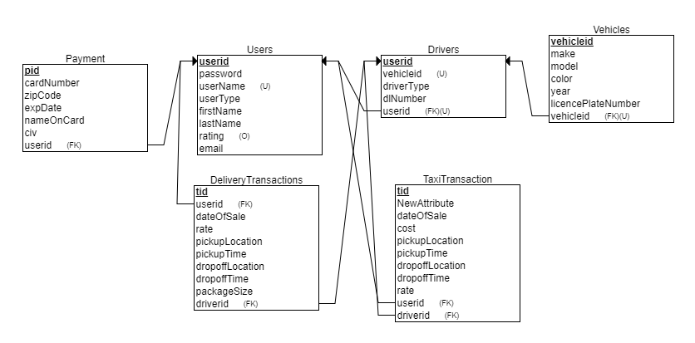

**1.2.3 UML Class Diagram**

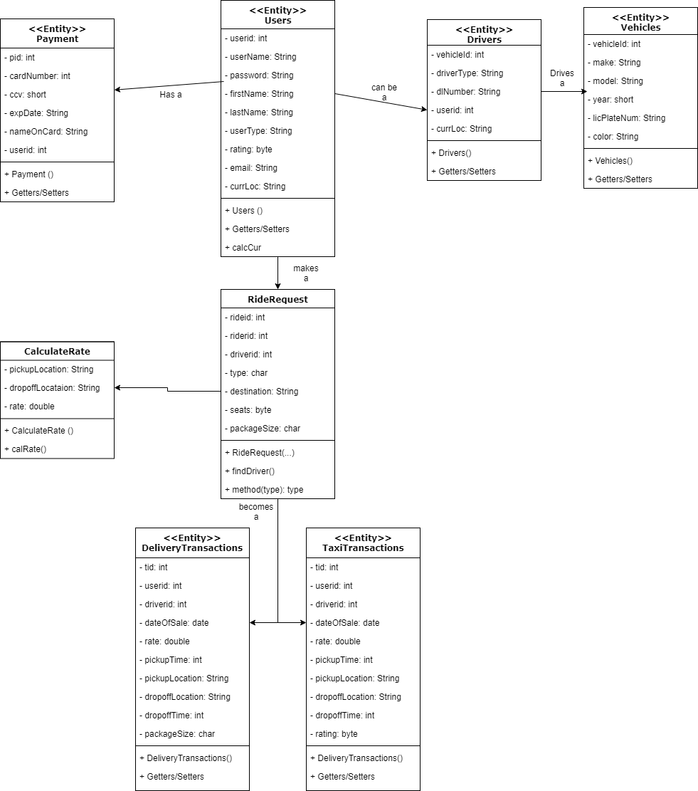

**1.2.4 High Level Architecture Diagram**

