Deborah Barndt

ITMD 534: Human Computer Interaction

Professor Subhashish Ghosh

HW1

8-30-18

HW1

Good Design: Adobe XD

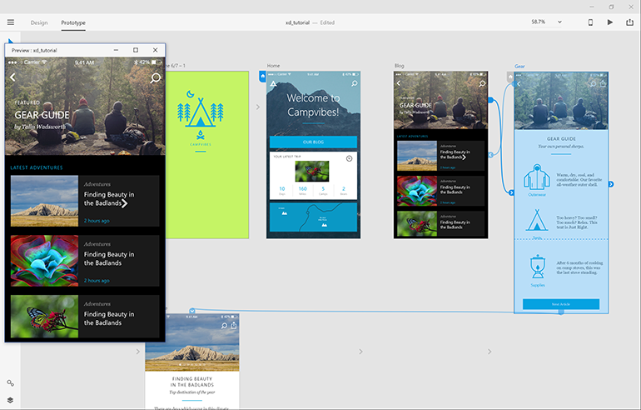

*Image credit: Mary Branscombe/ZDNet*

The purpose of the desktop software interface Adobe XD is to allow designers to create a prototype application for various mobile devices without having to wait for engineers to create the algorithms. Adobe XD has a simple/clean UI design containing explanatory tools such as shapes, pen tool, cursor, line tool, text, and artboards. The two-menu option of the design allows designers to switch between design mode and prototype mode. In prototype mode, buttons can be activated on the artboards using a directional arrow and choosing the interactive simulation response from a drop-down menu. Additional features to the software are mobile application simulation, desktop simulation, and share your application online. The software also comes with a quick tutorial for the user to learn about the application and get their “feet wet” by building a splash screen, activating buttons, and testing out the prototype design, which provides the user with an easy learning experience on how to use the software.

Bad Design: Parking Signs

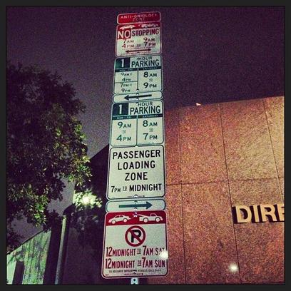

*Image credit:* [*https://everythingshilarious.com/tag/driving/*](https://everythingshilarious.com/tag/driving/)

The purpose of the parking sign interface is to inform drivers about the rules and regulations when parking your car in certain areas. While the signs do contain the information that is necessary for the drivers and uses a font style that is easy to read, the visibility of some of the information that is posted on these signs can not be read clearly from far away. Some of the information that is posted on the parking signs indicating parking times are contradictory of each other, which could lead to confusion for the driver and force them to park elsewhere or not at all. The signs present information overload as well for the intended users. Too much information at once can confuse and overwhelm the users from understanding the purpose of the design and could require the designer to provide a further explanation on the parking regulations or force the user to search for more information to understand it better. A better parking sign design would be to have a color-coded visual map of time slots indicating when you could park in the area.