Deborah Barndt

ITMD 534: Human Computer Interaction

Professor Subhashish Ghosh

HW3

9-30-18

For this heuristic analysis, the product is a Fujifilm FinePix F600 EXR Digital Camera. The camera is a red point-and-shoot camera that is light weight at about 7.52 ounces, is easy to handle with a grey camera strap, a rechargeable battery, has the capabilities of an SLR, a wide-angle lens, and a CMOS sensor that is 15.9 megapixels. The F600 can take pictures in camera raw and jpeg format, can take video, and has the SLR settings for manual, aperture, shutter speed, program, EXR, advanced, and auto. The Fujifilm FinePix camera has a 3-inch screen, image stabilization, external-memory, and 15x optical zoom or 30x intelligent digital zoom.

*Visibility of system status:*

Several of the good design features of the Fujifilm camera are the on/off button is labeled on the top of the camera next to the silver button with a light in the center, and when pressed it makes a sound, the center light glows blue, the camera turns on, and the screen turns on. Many of the buttons on the interface of the camera use pictures or abbreviations for the labels, which can be a bad design feature because it could confuse a user if they are not familiar with what the symbols mean. A suggestion would be to use words to label each button like the on/off button on the top. For the flash button, a suggestion besides labeling with the word “flash” is to make it the silver color, so it is more noticeable. The shutter button at the top of the camera makes a click sound when pressed, but it should be a lighter color so that it stands out more to the user.

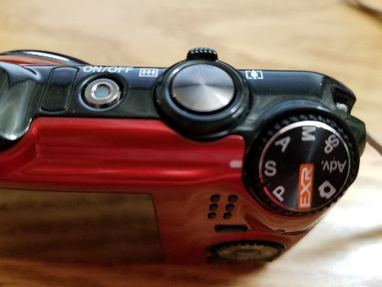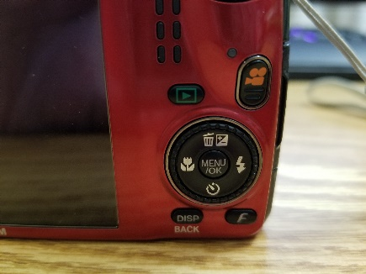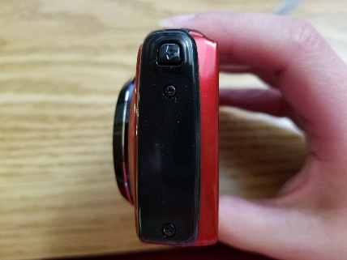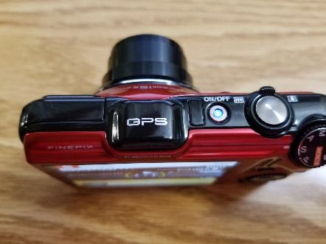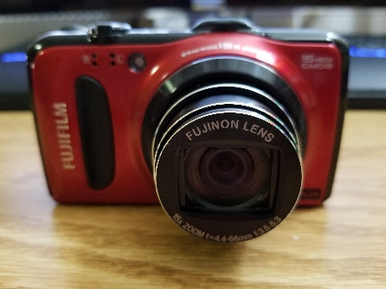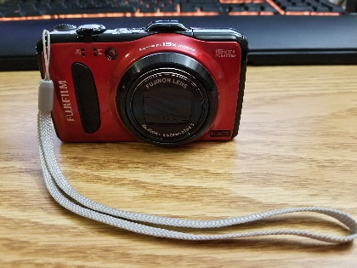

*Match between system and the real world:*

Another good design feature is that each of the buttons are arranged in the order of operations: on/off, zoom, shutter, mode, display, video, and display menu. Though it can also be a bad design as well, because of the placement of the mode dial and shutter button. A suggestion would be if they switched the switched the mode dial with the shutter, it would be in a better order.

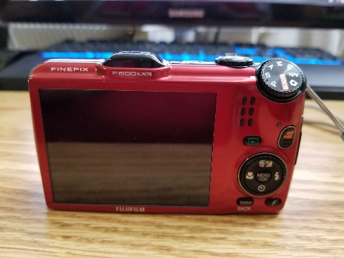*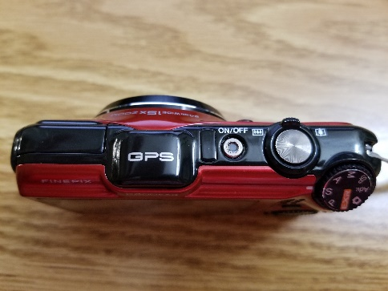*

*User control and freedom:*

The viewer screen states what mode the camera is in, what format they are using, how much battery life there is, and if the flash is on to the user is a good design feature to this interface. While it does keep the user informed, it also gives the user control on how the camera operates. The menu is both a good and bad design feature. It is easy to navigate using the circular dial surrounding the menu buttons, but it uses symbols as the directional buttons. A suggestion for this bad design feature would be to use arrows to better help the user know that it is navigational.

*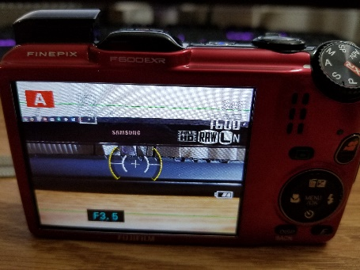*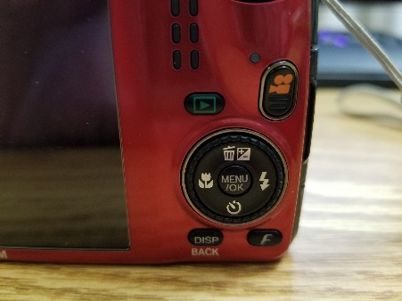

*Consistency and standards:*

A good consistency design feature is that each of the buttons on the camera follows the same color scheme that is used on the interface. However, the bad design feature is that the interface uses abbreviations for the modes. So, a way to fix that design would be to use words instead of abbreviations. Sounds are used when switching between menus to indicate to the user that something is happening on the interface, which is informative and shows good consistency to the user when using the interface.

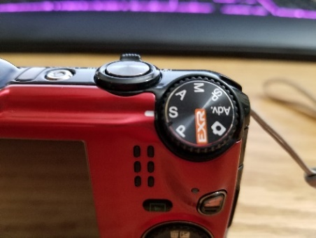

*Error prevention:*

When deleting photos, the user is prompted with a confirmation to select ok if it is okay to delete the photo or cancel to not delete the photo which is also a good design aspect. To make the selection design even better for the user, a suggestion would be to ask them yes or no to confirm their selection instead of “OK” or “CANCEL”. Another great design is that a selection is greyed out in the main menu to prevent a user from selecting it, though offering recommendations to the user when making some of the selections would help the user better understand the modes. A camera icon with an exclamation point displays on the screen to indicate to the user that the camera is not steady can be a bad design feature on the interface, because it can make the user feel like it is their mistake. However, it is meant to inform the user that the picture will be blurry. A suggestion would be to make a more nicer warning sign so as not to make the user feel like it is their fault.

*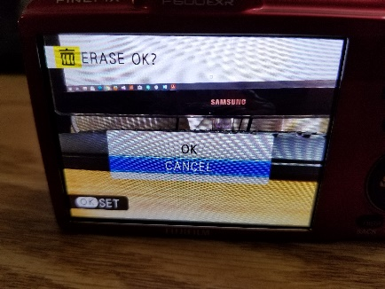*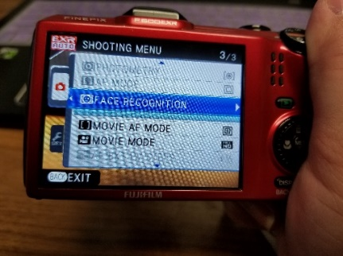

*Recognition rather than recall:*

When rotating between camera modes, a screen displaying the mode and an explanation of the mode is shown, which is a great informative feature to this interface. The camera icon with the exclamation point helps the user to recognize that an error will occur when taking a photo, though it is good to warn the user about an error it is a bad design because it can also seem accusatory. A good design feature is that a battery icon on the viewer screen indicates and informs the user how much battery life is left before they need to change it.

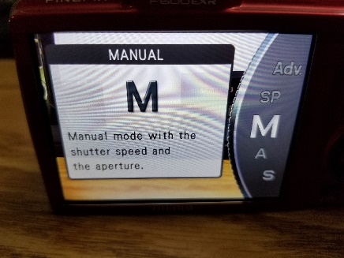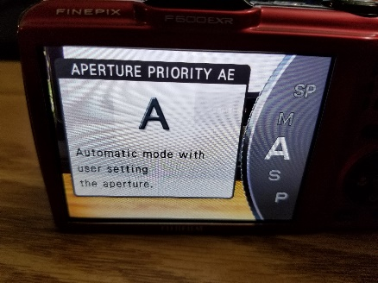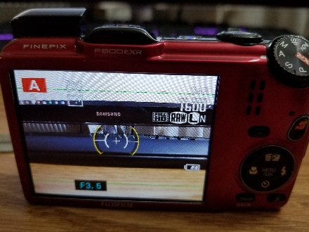

*Flexibility and efficiency of use:*

Another good design is that the camera interface automatically remembers the modes and format the user has used previously, which helps when programming the camera. A suggestion would be having a shortcut to quickly go to these modes, making it more helpful to the experienced user. A bad feature is when viewing the photos in the display mode, it takes up more of the camera’s battery life. Having a prompt display to the user informing of the battery drain would help the user to know not to use the display mode too often, and it will prolong the battery life to allow the user to take more pictures.

*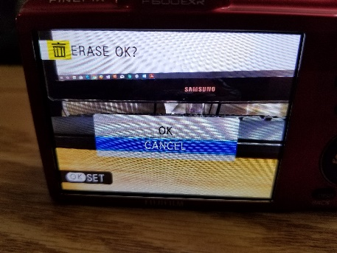*

*Aesthetic and minimalist design:*

The camera uses a good balance of white space. The color scheme is minimized to four colors total: black, white, green, and orange. The white stands out easily to the user on the black background and offers a great contrast on the interface. Though the bad part is that some people who are color blind might not be able to differentiate between the green and orange, so having a label above these colored buttons would be suggested.

*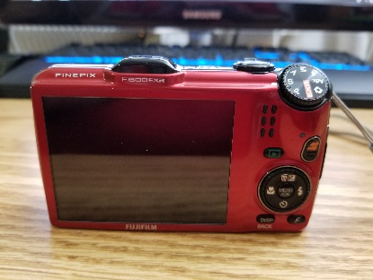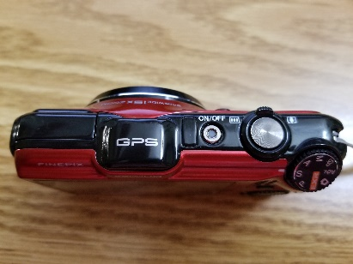*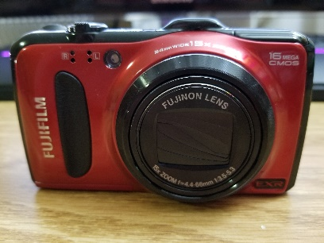

*Help users recognize, diagnose, and recover from errors:*

There are not many error messages given to then user when there is a problem, which is bad because you always want to keep the user informed and let them know when there is going to be an error. Providing a motion error would help the user recognize a stabilization error. Allowing the user to change their mind when going between modes or making suggestions when a photo does not turn out would help the user get a better-quality photo.

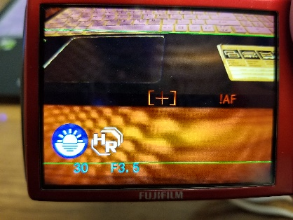

*Help and documentation:*

The best feature and design about this camera are that it is meant to be an easy to use point-and-shoot camera, so that any user can easily pick it up and begin to learn how to use a manual camera. However, having a manual with instructions or a help section in the camera menu would be helpful for explaining modes, how to choose your formats, etc. Currently the camera has no help menu, which would be a suggestion for an additional add-on to the current interface.

