Hands-on Projects

These projects should be completed in the order given. The hands-on projects presented in this chapter should take a total of three hours to complete. The requirements for this lab include:

* A computer with Fedora Linux installed according to Hands-on Project 2-1 and Ubuntu Server Linux installed according to Hands-On Project 6-1.

# Project 13-1

In this hands-on project, you configure and test the DNS daemon on your Fedora Linux virtual machine.

1. Boot your **Fedora** Linux virtual machine. Login to your chosen desktop environment as **user1** using password **LNXrocks!** and open up a terminal window.
2. At the terminal, become **root** by typing **su -** and press enter and provide **LNXrocks!** as the password.
3. At the command prompt, type **yum install system-config-bind** and press Enter to install the graphical BIND configuration utility, which also installs the dependency package BIND (the named daemon). Type y and press Enter when prompted to continue the installation.
4. At the command prompt, type **system-config-bind&** and press Enter to start the BIND configuration GUI program in the background. *You will want to expand this window out to be able to see the fields better.*
5. Highlight **DNS Server** and click **Properties**. Add the **forwarders** option to the Current Options box. In the New List Element section, highlight IPV4 Address and supply **8.8.8.8** for this option and click **OK** when finished. Click **OK** to close the DNS server property window. This configures your DNS server to forward requests Google’s DNS server if it cannot resolve the destination address using the information within its own zone files.
6. Click **New**, **Zone** and accept the default zone scope of **Internet** by clicking **OK** underneath the Class drop-down box. Next, accept the default zone type of **Forward** by clicking **OK** below the Origin Type drop-down box and type the zone name **class.com**. (*taking care to include the trailing . in the zone name*). Accept the default DNS server zone role of **master** by clicking **OK**.
7. Examine the default SOA record parameters. What is the default minimum TTL? **1 hour** Click **OK** to return to the BIND configuration utility window.
8. Expand your **class.com** zone. What default records are created in this new zone? **Zone Authority Information, Name Server localhost**
9. Highlight the **class.com** zone and click **New**, **A IPv4 Address**. Type **gateway.class.com.** in the Domain Name dialog box (*taking care to include the trailing . in the FQDN*) and supply the IPv4 address of your classroom’s default gateway (*obtained by typing* ***ip route*** *the IP address to use is for the default route)*. Click **OK** to create the A record.
10. Highlight the **class.com** zone and click **New**, **A IPv4 Address**. Type **server1.class.com.** in the Domain Name dialog box (*taking care to include the trailing . in the FQDN*) and supply your computer’s IPv4 address (*obtained by typing* ***ip addr*** *and using the inet IPv4 address for your virtual interface)*. Click **OK** to create the A record.
11. Highlight the **class.com** zone and click **New**, **CNAME** **Alias**. Type **alias.class.com.** in the Domain Name dialog box, and type **server1.class.com.** in the Canonical Name dialog box (*taking care to include the trailing . in both FQDNs*). Click OK to create the CNAME record.
12. Highlight the **class.com** zone and click **New**, **MX Mail Exchange**. Note the default domain of class.com. in the Domain Name dialog box and type **server1.class.com.** in the Mail Server Name dialog box (*taking care to include the trailing . in the FQDN*). Click **OK** to create the MX record.
13. Expand your **class.com** zone. Are the new records visible? **Yes**
14. Expand the zone that represents your classroom network. Are PTR records available for reverse lookups? **no**
15. Click **Save**. Click **OK** when prompted to save your changes to the configuration files on the hard drive.
16. Close the BIND configuration utility.
17. At the command prompt, type **systemctl start named.service** and press Enter to start the DNS name daemon.
18. Edit the /etc/resolv.conf file with a text editor and remove any existing nameserver lines. Add the line

nameserver 127.0.0.1

to ensure that your Linux computer uses the local DNS server daemon for name resolution. Save your changes and quit the editor when finished.

1. At the command prompt, type **ping -c 4 gateway.class.com** and press Enter. Was the name resolved successfully? Explain. **Yes, it successfully pinged the gateway address that was provided.**
2. At the command prompt, type **ping -c 4 server1.class.com** and press Enter. Was the name resolved successfully? Explain. **Yes, it successfully pinged from localhost and there was 0% loss.**
3. At the command prompt, type **ping -c 4 alias.class.com** and press Enter. Was the name resolved successfully? Explain. **Yes, it successfully pinged from localhost and there was 0% loss.**
4. At the command prompt, type **ping -c 4 www.google.com** and press Enter. Was the name resolved successfully? Explain. **Yes, it successfully pinged from ord30s26-in-f4.le100.net and there was 0% loss.**
5. At the command prompt, type **dig @localhost class.com ANY** and press Enter. Are your resources records returned successfully? **Yes**
6. At the command prompt, type **less /etc/named.conf** and press Enter. View the entries. Is class.com a Master zone? Do you see a line that forwards unknown requests to your classroom DNS server? Press q when finished. **Yes and yes again.**
7. At the command prompt, type **cat /var/named/class.com.db** and press Enter. View the entries. Are your resource records present? **Yes they are**
8. At the command prompt, type **cat /var/named/network_ID.db** and press Enter *where network_ID is your classroom network ID*. View the entries. Are PTR resource records present? **Yes**
9. At the command prompt, type **less /var/named/named.ca** and press Enter. View the entries. What do these entries represent? **The servers**
10. **Provide screenshot(s) of steps 3 through 27.**

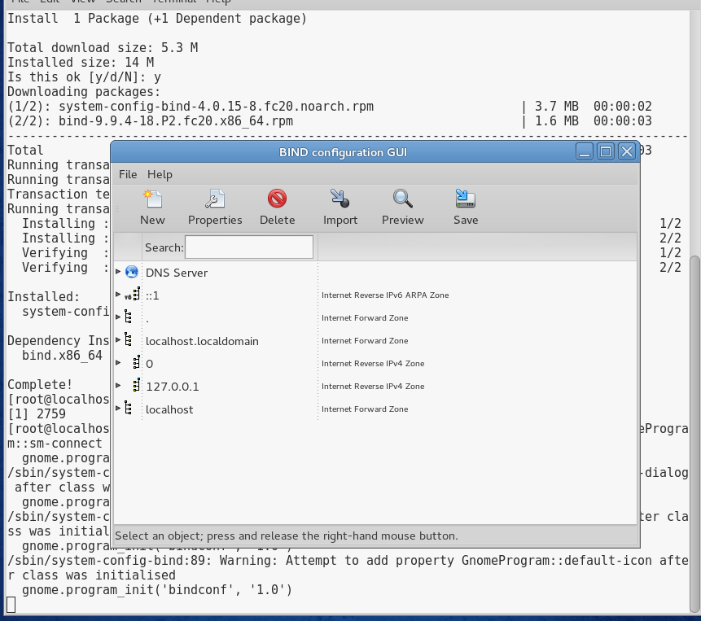

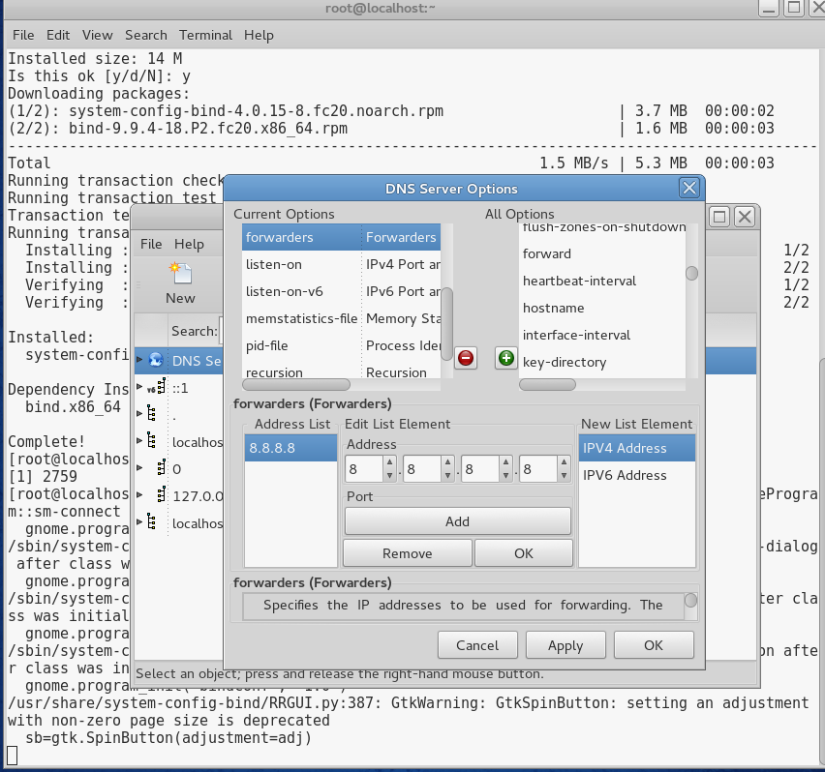

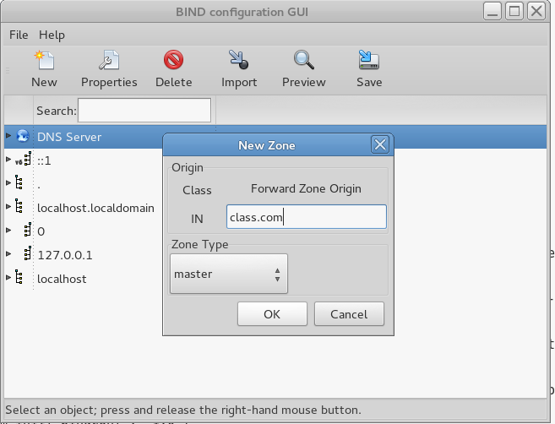

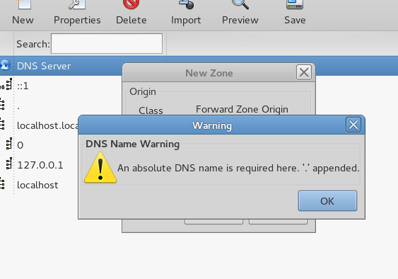

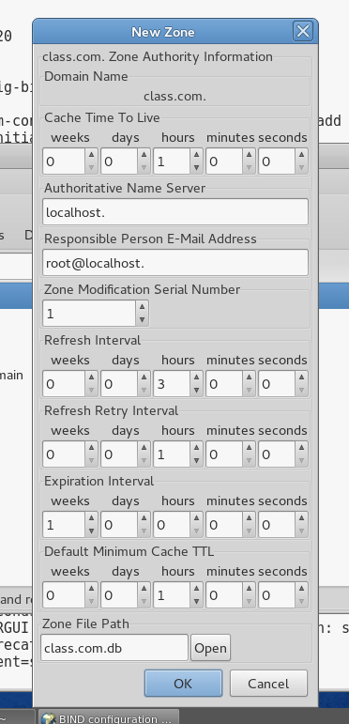

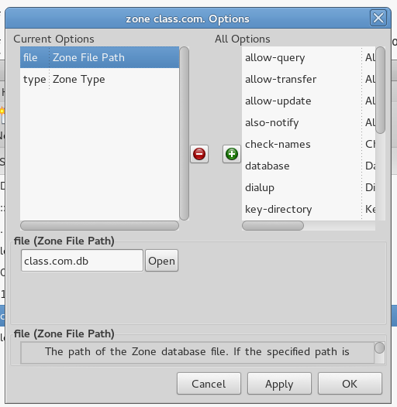

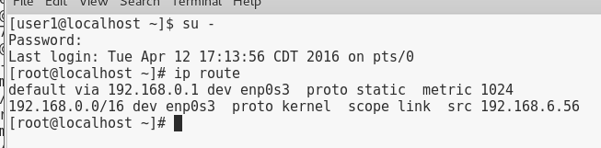

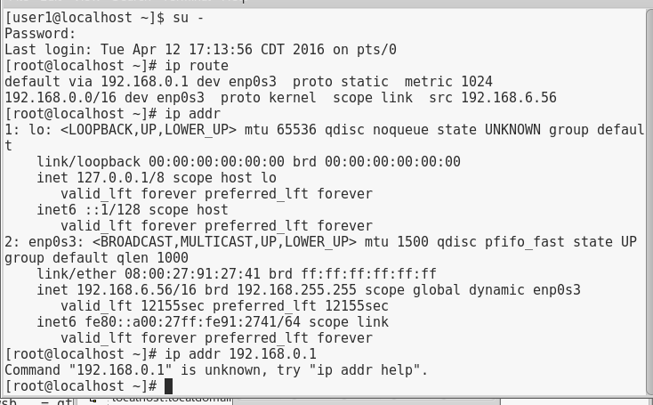

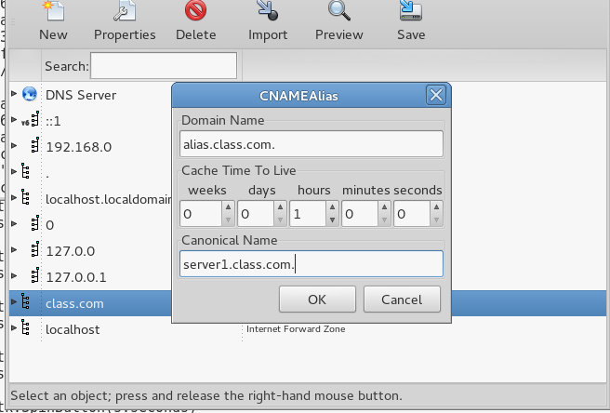

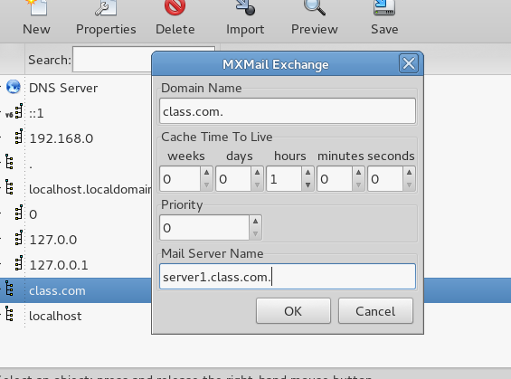

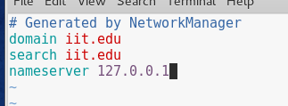

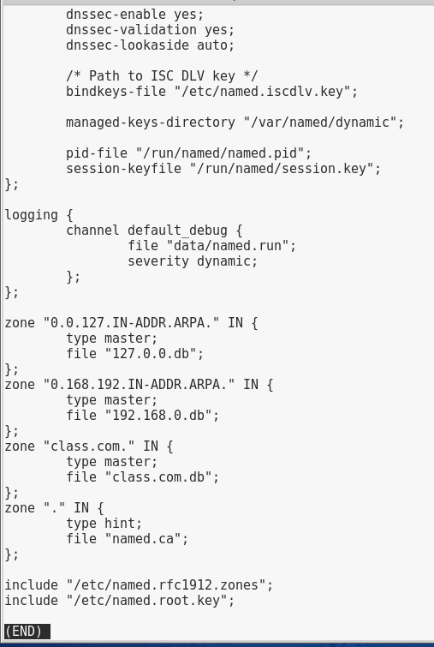

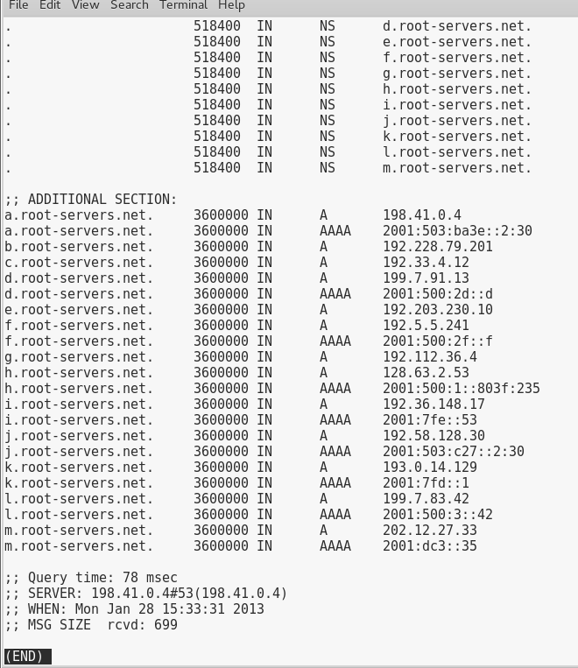

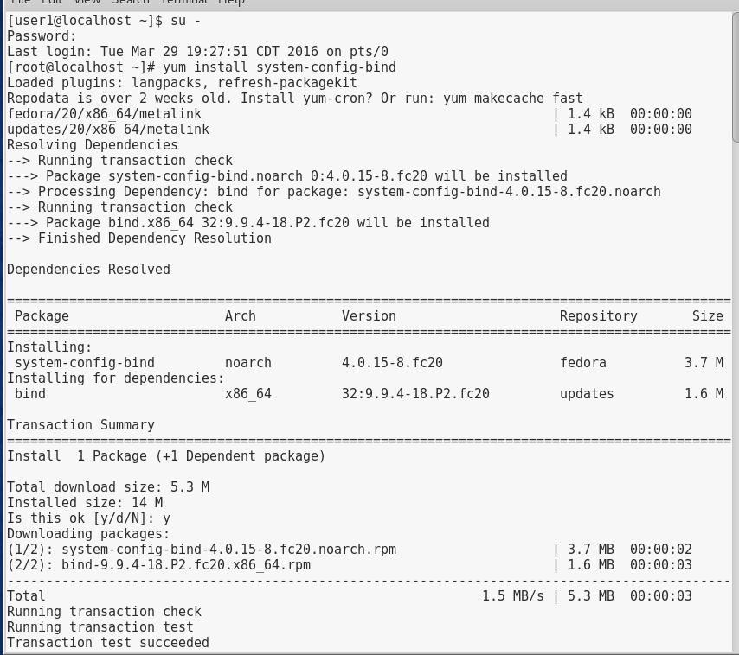

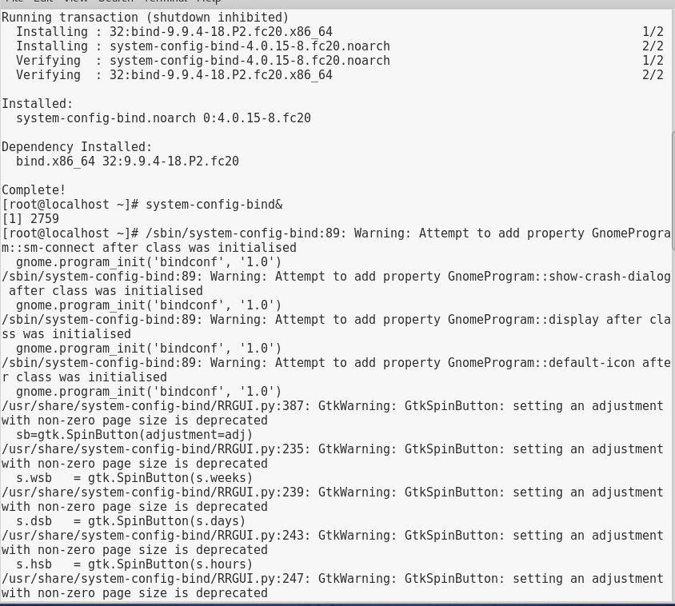

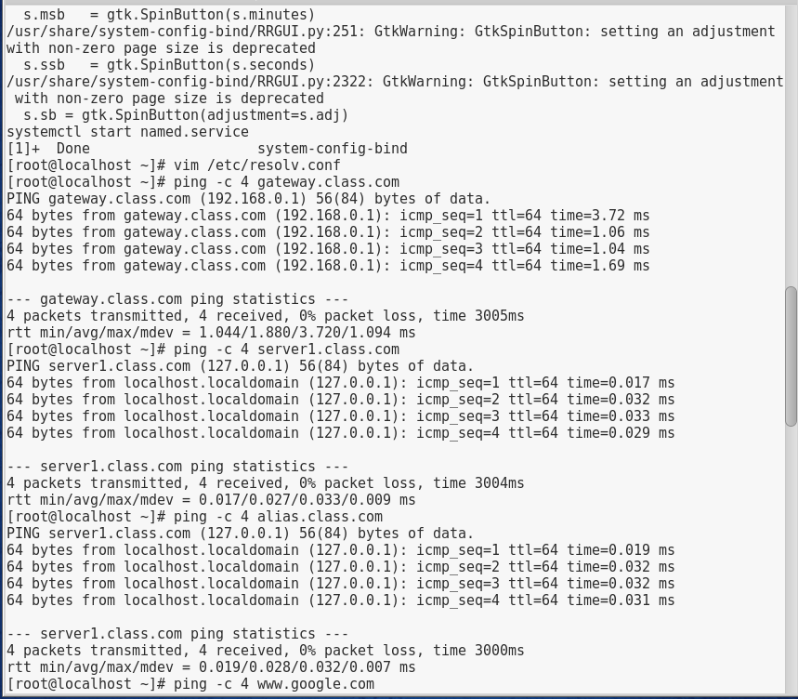

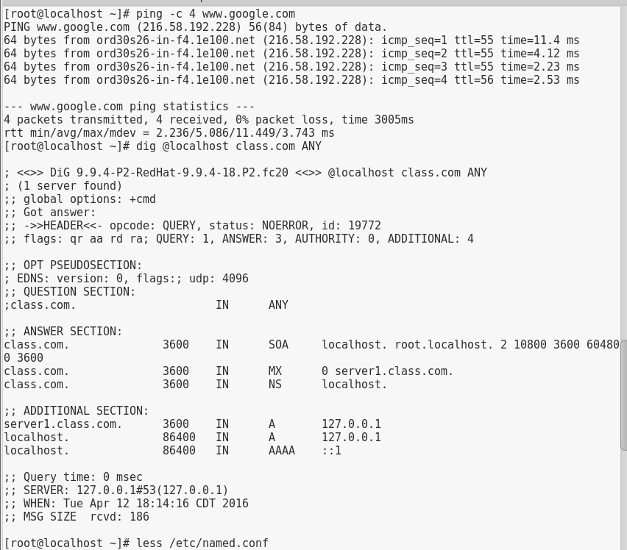

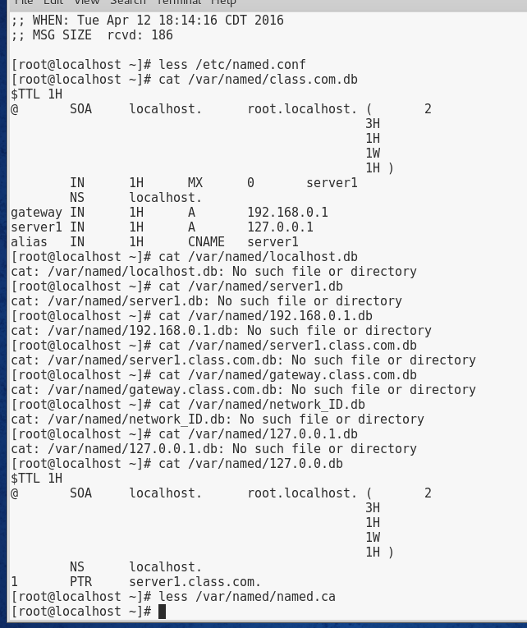

# Project 13-2

In this hands-on project, you install and configure the Very Secure FTP daemon on your Fedora Linux virtual machine.

1. Boot your **Fedora** Linux virtual machine. Login to your chosen desktop environment as **user1** using password **LNXrocks!** and open up a terminal window.
2. At the terminal, become **root** by typing **su -** and press enter and provide **LNXrocks!** as the password.
3. At the command prompt, type **yum -y install vsftpd** and press Enter to install the Very Secure FTP daemon.
4. Next, type **grep anonymous /etc/vsftpd/vsftpd.conf** at the command prompt and press Enter to review the anonymous settings for our FTP server.
5. At the command prompt, type **systemctl start vsftpd** and press Enter to start the server and then type **systemctl enable vsftpd** to allow the service to start upon system boot.
6. At the command prompt, type **yum -y install ftp** and press Enter to install the command line ftp client.
7. At the command prompt, type **ftp localhost** and press Enter. When prompted for name, enter **anonymous** with no password (press enter when prompted for password).
8. At the command prompt, type **ls** and press Enter. You should see the pub directory. Next type **cd pub** to switch to the pub directory. Next type ls again to view the contents of this directory. Currently, no files exist here. Next type **exit** to logout of the ftp server.
9. At the command prompt, type **cp /usr/share/pixmaps/faces/* /var/ftp/pub/** and press Enter to populate the pub directory. Follow steps 7 and 8 to view the files we just copied to the directory.
10. At the command prompt, type **get flower.jpg** and press Enter to download this image to our current directory. At the command prompt, type **quit** to logout of the FTP server. Verify the file was downloaded by typing **ls flower.jpg** and press Enter.
11. **Provide screenshot(s) of steps 3 through 10.**

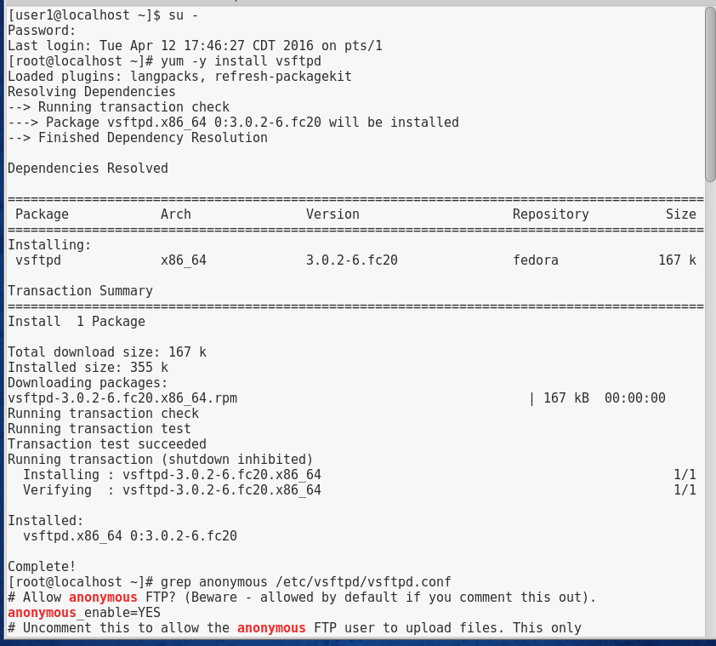

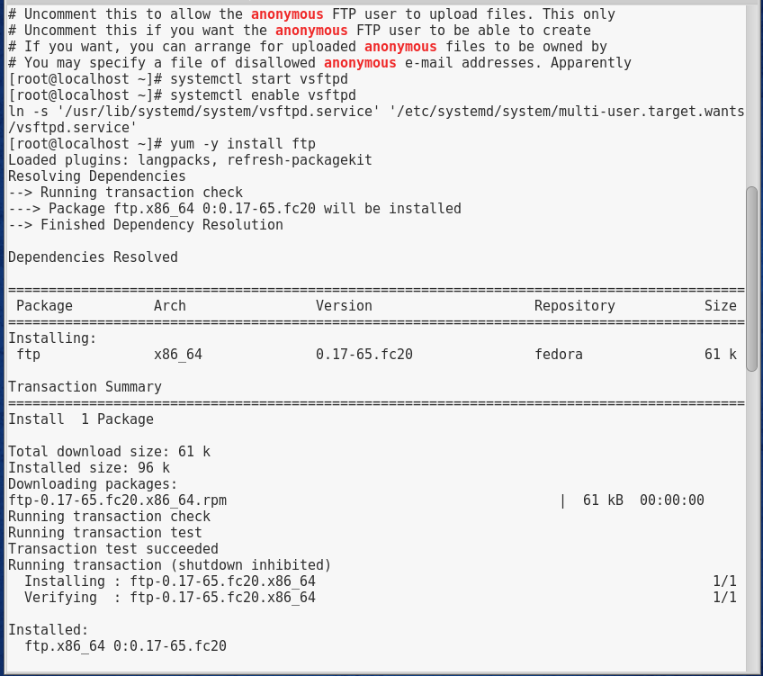

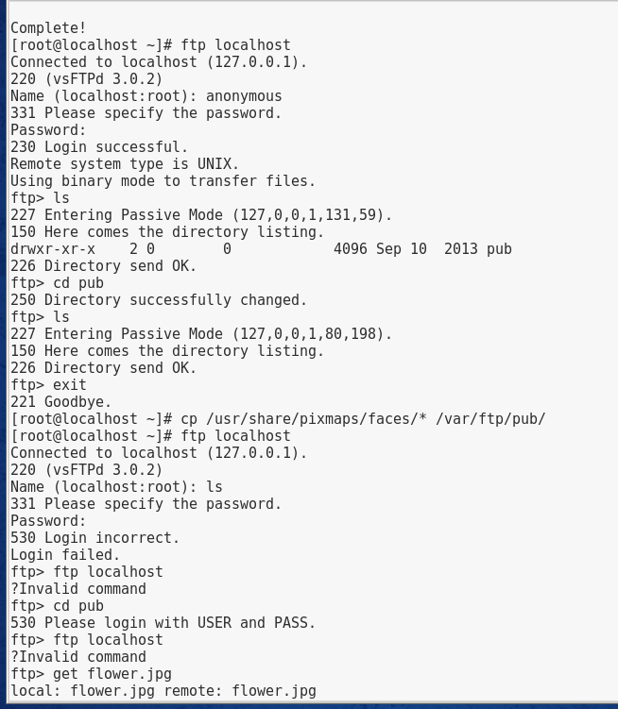

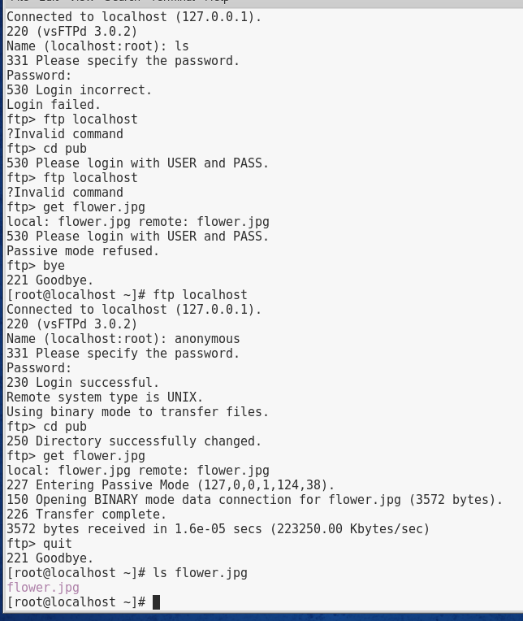

# Project 13-3

In this hands-on project, you install and explore the NTP daemon on your Ubuntu Server Linux virtual machine as well as explore the Chrony NTP daemon on your Fedora Linux virtual machine.

1. Boot your **Ubuntu** Linux virtual machine. Login to your chosen desktop environment as **root** using password **LNXrocks!** and open up a terminal window.
2. At the command prompt, type **apt-get install ntp** and press Enter. Press y when prompted to install the NTP daemon. Next, type **ps -ef | grep ntpd** and press Enter to verify that the NTP daemon is running.
3. At the command prompt, type the **less /etc/ntp.conf** command. Review the contents of the ntp configuration file.
4. At the command prompt, type **service ntp stop** and press Enter to stop the NTP daemon.
5. At the command prompt, type **ntpdate -u 0.ubuntu.pool.ntp.org** and press Enter to synchronize your clock with the first time server listed in /etc/ntp.conf.
6. At the command prompt, type **service ntp start** and press Enter to start the NTP daemon.
7. At the command prompt, type **ntpq -p** and press Enter to view information about the time servers that you are synchronizing with (peers).
8. Boot your **Fedora** Linux virtual machine. Login to your chosen desktop environment as **user1** using password **LNXrocks!** and open up a terminal window.
9. At the terminal, become **root** by typing **su -** and press enter and provide **LNXrocks!** as the password.
10. At the command prompt, type **less /etc/chrony.conf** and press Enter. Review the contents of the chrony configuration file.
11. At the command prompt, type **chronyc sources -v** and press Enter to view information about the time servers that you are synchronizing with (peers).
12. **Provide screenshot(s) of steps 2 through 11.**

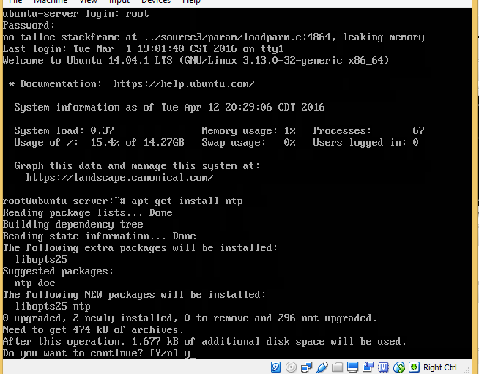

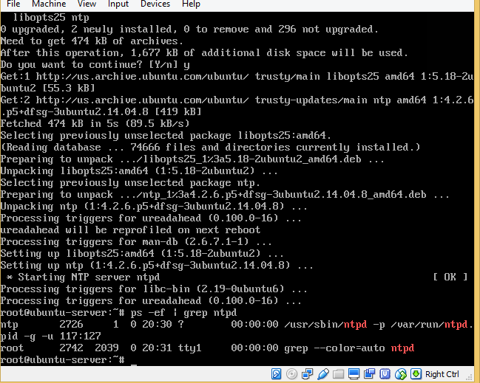

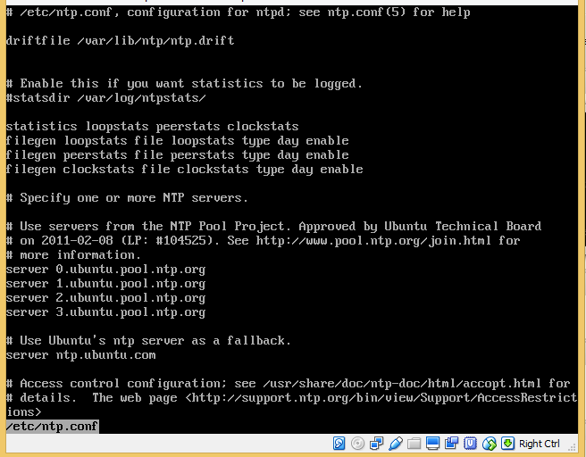

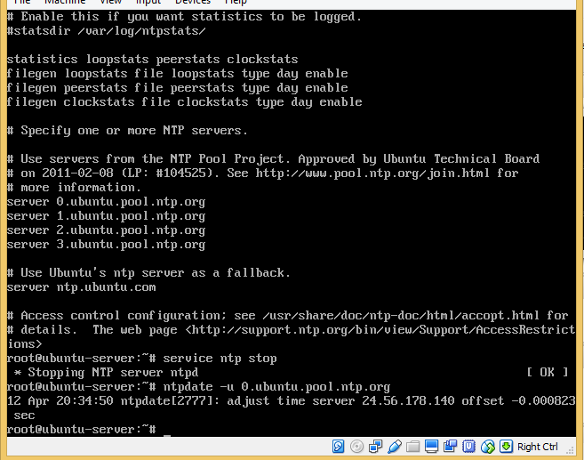

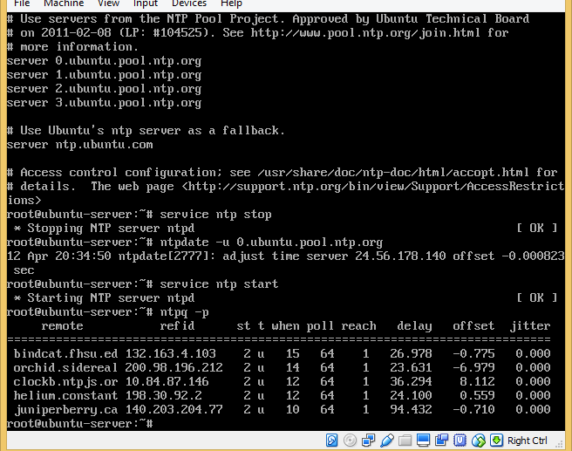

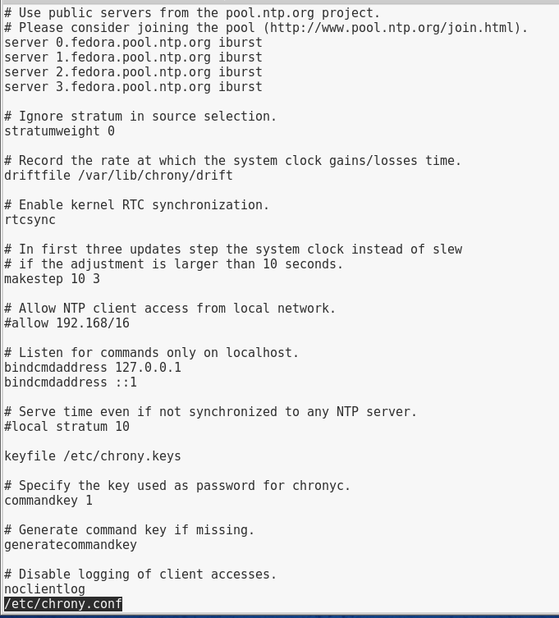

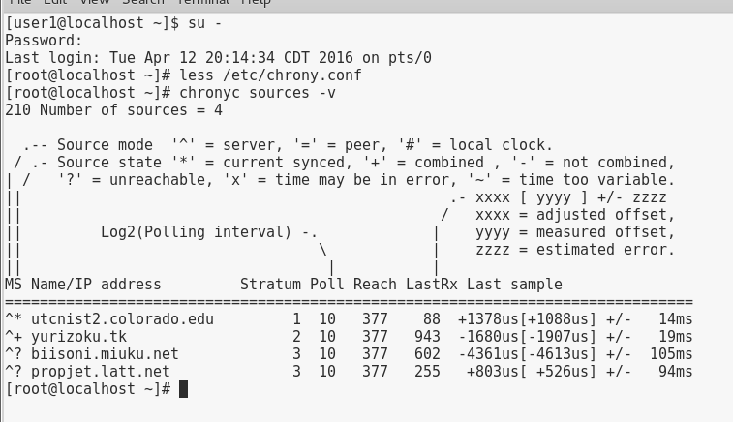

# Project 13-4

In this hands-on project, you configure the Apache Web server on your Fedora Linux virtual machine and test daemon permissions to files on the system.

1. Boot your **Fedora** Linux virtual machine. Login to your chosen desktop environment as **user1** using password **LNXrocks!** and open up a terminal window.
2. At the terminal, become **root** by typing **su -** and press enter and provide **LNXrocks!** as the password.
3. At the command prompt, type **yum install httpd** and press Enter to install the Apache web server.
4. At the command prompt, type **grep DocumentRoot /etc/httpd/conf/httpd.conf** and press Enter. What is the document root directory? **/var/www/html**
5. At the command prompt, type **grep DirectoryIndex /etc/httpd/conf/httpd.conf** and press Enter. What file(s) will automatically be handed out by the Apache daemon from the document root directory? **DirectoryIndex index.html**
6. At the command prompt, type **grep "User " /etc/httpd/conf/httpd.conf** and press Enter. What user does the Apache daemon run as locally? **apache**
7. At the command prompt, type **grep "Group " /etc/httpd/conf/httpd.conf** and press Enter. What user does the Apache daemon run as locally? **apache**
8. At the command prompt, type **apachectl configtest** and press Enter. Are there any syntax errors within your /etc/httpd/conf/httpd.conf file? **no**
9. At the command prompt, type **systemctl start httpd.service** and press Enter to start the Apache Web server. At the command prompt, type **systemctl enable httpd.service** and press Enter to start the Apache Web server on system boot.
10. Open up a web browser (most likely firefox) and got to **http://localhost** to access the Fedora test page.
11. Next attempt to access **http://localhost/manual** to view the documentation for the Apache HTTP server. Note that you are unable to find this page. At the command prompt, type **yum -y install httpd-manual** and press Enter to install the manuals for Apache.
12. At the command prompt, type **apachectl reload** and press Enter. Now refresh your web browser to access the manual pages.
13. At the command prompt, type **vim /var/www/html/index.html** file with a text editor such as vi. Add the following lines:

<html>

<body>

<h1>My sample website</h1>

</body>

</html>

When finished, save your changes and quit the editor.

1. At the command prompt, type **chmod 640 /var/www/html/index.html** and press Enter.
2. Open up a web browser (most likely firefox) and got to **http://localhost** to access our index.html file. Notice that you are unable to access the page since we removed the read permission from the others group.
3. At the command prompt, type **chmod 644 /var/www/html/index.html** and press Enter.
4. Open up a web browser (most likely firefox) and got to **http://localhost** to access our index.html file.
5. At the command prompt, type **curl http://127.0.0.1/** and press Enter to display the HTML to standard out. At the command prompt, type **curl -o index.html http://127.0.0.1/** and press Enter to download the HTML to index.html.
6. **Provide screenshot(s) of steps 3 through 18.**

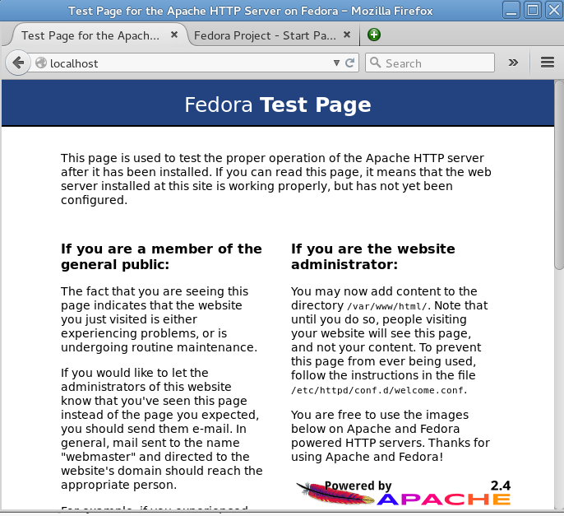

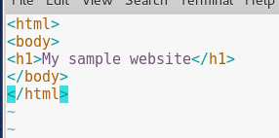

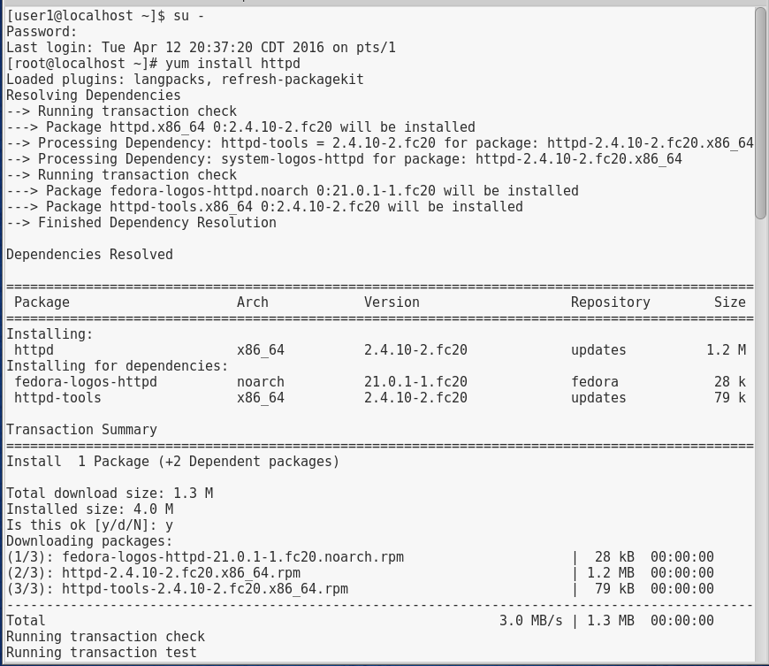

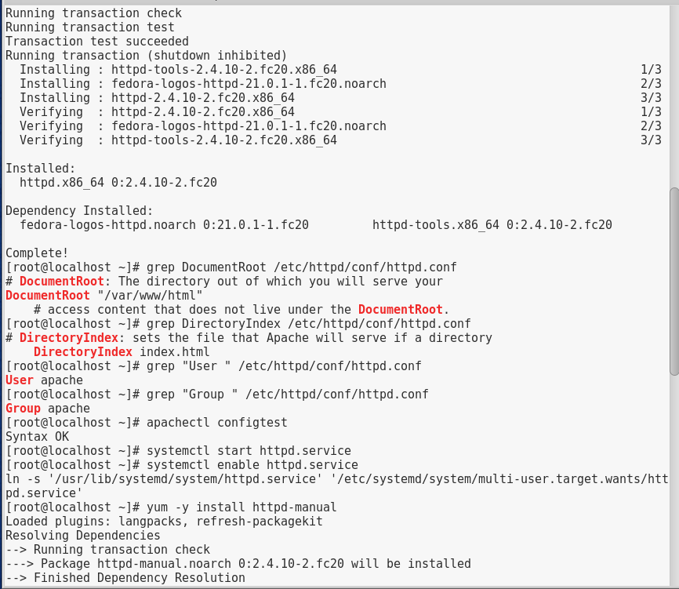

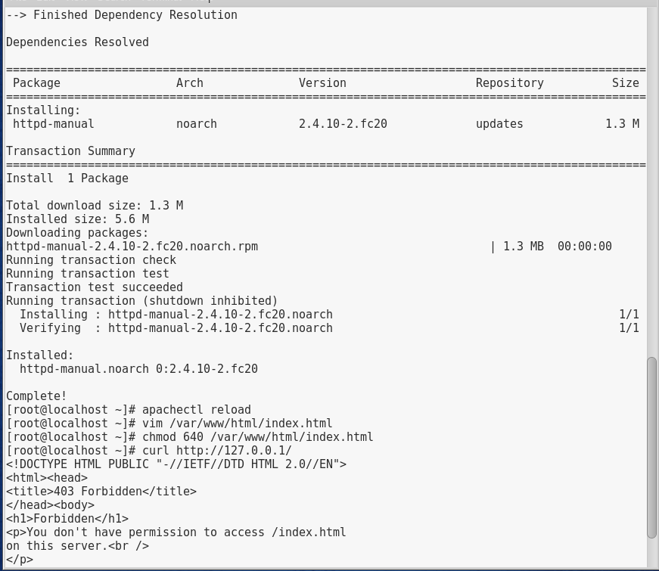

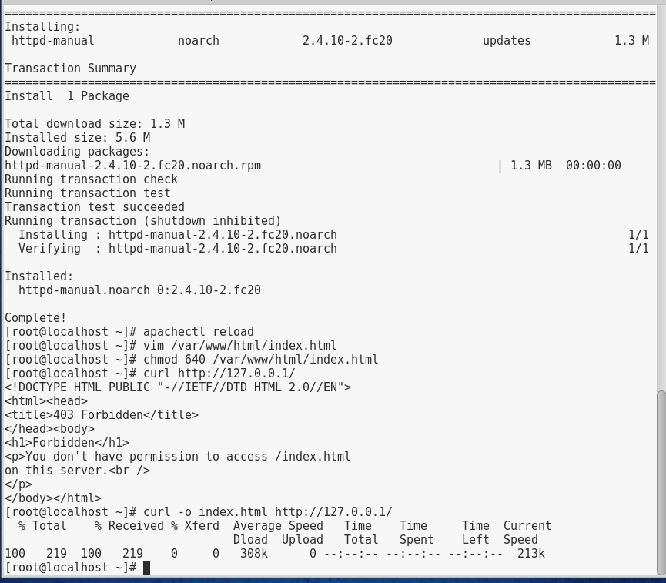

1. At the command prompt, type **yum -y install elinks** and press Enter to install a terminal based web browser. Once installed type **elinks http://localhost/manual** to access the manuals in the terminal. Type q to exit elinks.
2. At the command prompt, type **curl http://127.0.0.1/** and press Enter to display the HTML to standard out.
3. At the command prompt, type **ab -n 10000 http://127.0.0.1/** and press Enter to use the Apache benchmarking tool against your web server.
4. At the command prompt, type **ln -s /var/ftp/pub/ /var/www/html/pub** and press Enter to link the contents of the FTP pub directory for use with Apache.
5. At the command prompt, type **vim /var/www/html/index.html** file with a text editor such as vi. Append the file to look like the following:

<html>

<body>

<h1>My sample website</h1>

See additional files in the <a href="pub">pub</a> directory.

</body>

</html>

1. Open up a web browser (most likely firefox) and got to **http://localhost** to access your index.html. Click on the link to pub to view the image files in the directory.
2. At the command prompt, type **yum -y install mod_ssl** and press Enter to install TLS/SSL support for Apache.
3. At the command prompt, type **apachectl restart**and press Enter to restart the Apache server.
4. Open up a web browser (most likely firefox) and got to **https://localhost** to access your site securely. When you see the This Connection is Untrusted page, click I Understand the Risks, then click Add Exception. From this page you can view the certificate. We will want to click on Confirm Security Exception to access our page encrypting the traffic.
5. **Provide screenshot(s) of steps 20 through 28.**

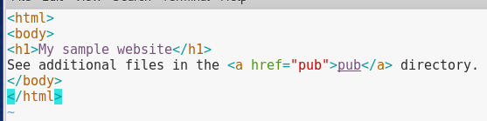

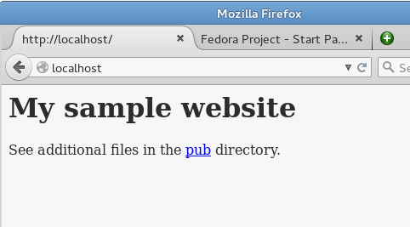

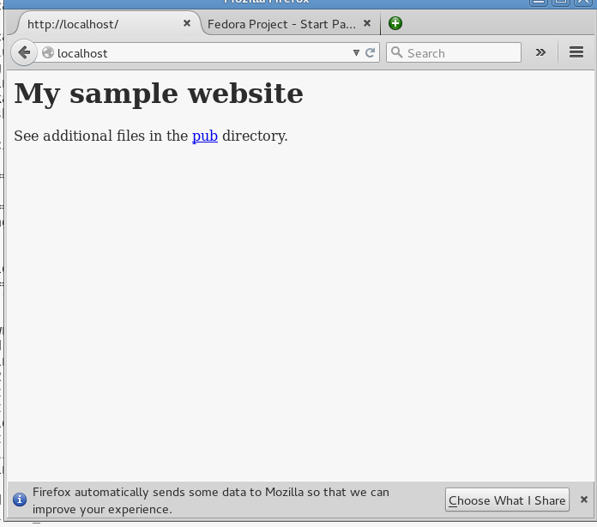

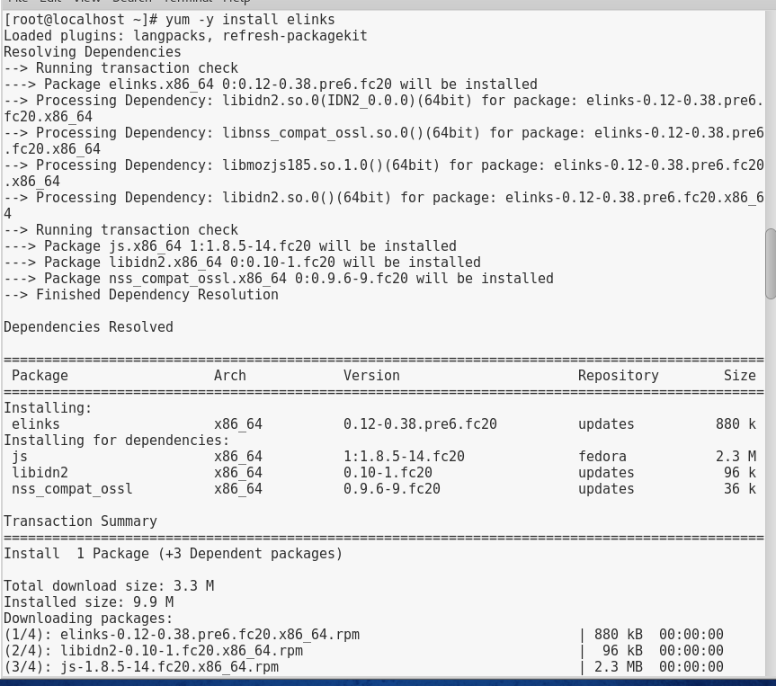

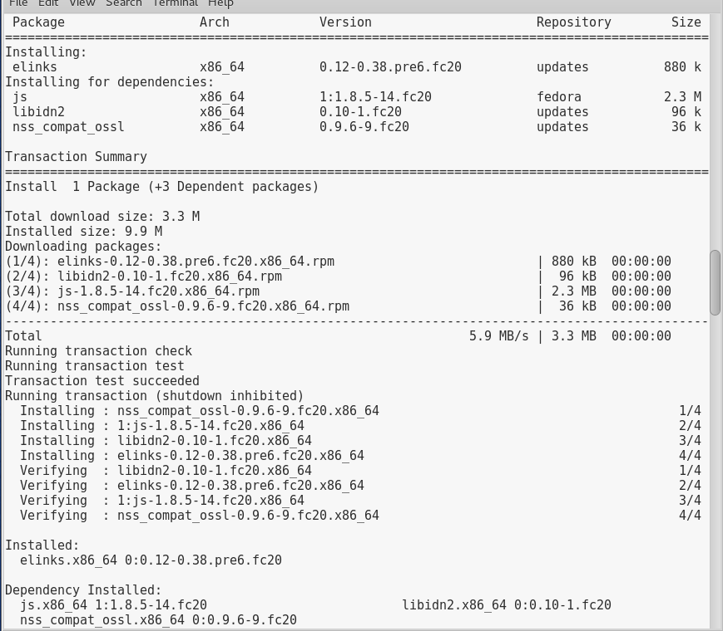

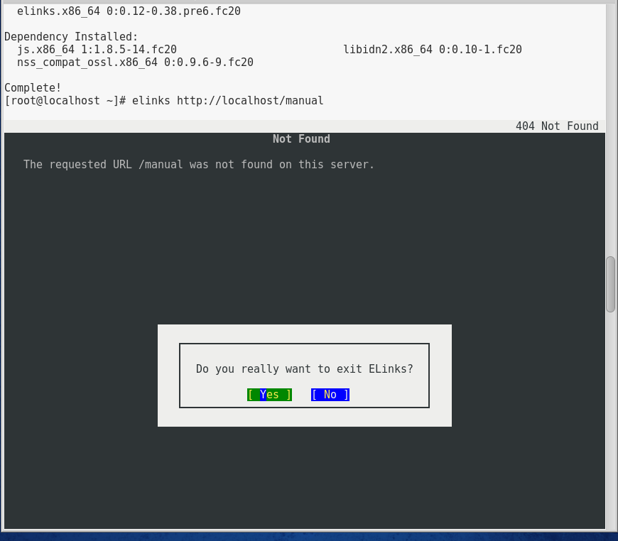

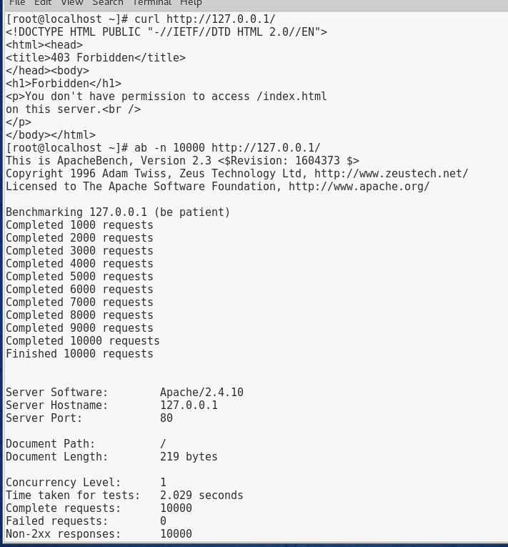

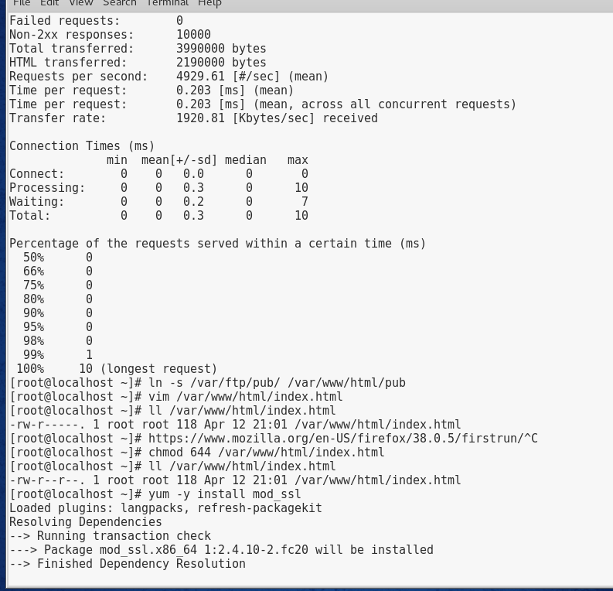

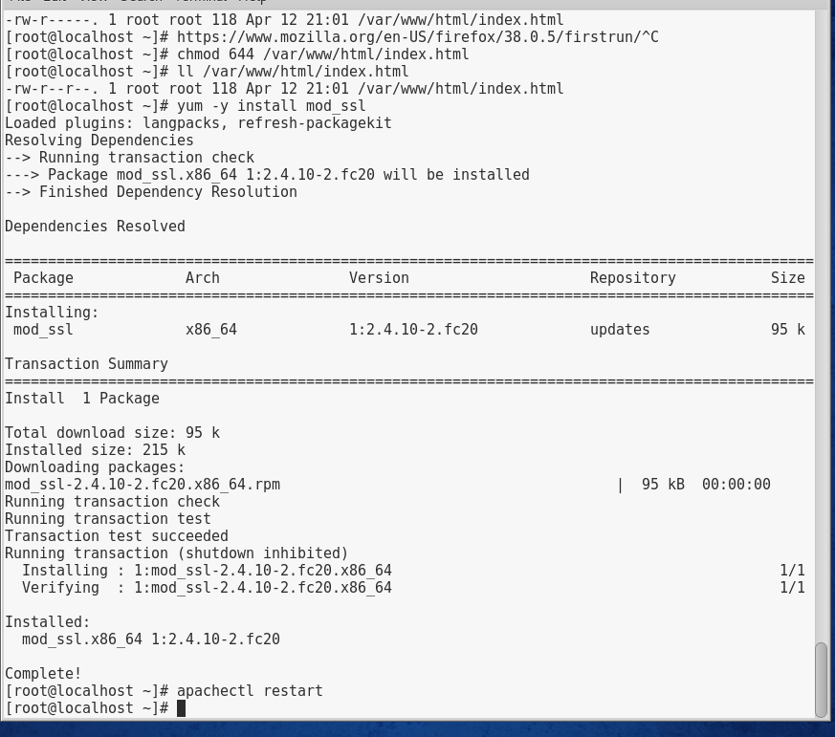

# Project 13-5

In this hands-on project, you configure and test Samba file sharing on your Ubuntu Server Linux virtual machine.

1. Boot your **Ubuntu** Linux virtual machine. Login to your chosen desktop environment as **root** using password **LNXrocks!** and open up a terminal window.
2. At the command prompt, type **ps –ef |grep mbd** and press Enter. Are the Samba daemons installed and started by default.
3. At the command prompt, type **vi /etc/samba/smb.conf** file with the vi text editor. Spend a few minutes examining the comments within this file to understand the available Samba configuration options. Under the Share Definitions section, notice that the only two shares configured by default are the [printers] share (which shares all printers to Windows hosts) and the hidden [print$] share (which shares print drivers to Windows hosts).
4. Add the following line underneath the [global] line in this file, *where hostname is the host name configured on your Ubuntu Server Linux virtual machine*:

netbios name = *hostname*

1. Uncomment/modify the following section that shares out all home directories to users who authenticate successfully:

[homes]

comment = Home Directories

browseable = no

read only = no

1. Next, add the following share definition to the bottom of the file to share out the /etc directory to all users as read-only:

[etc]

comment = The etc directory

path = /etc

guest ok = yes

read only = yes

1. When finished, save your changes and quit the editor.
2. At the command prompt, type **testparm** and press Enter. Were any syntax errors reported within /etc/samba/smb.conf? **No.** Press Enter to view your Samba configuration.
3. At the command prompt, type **service samba restart** and press Enter to restart the Samba daemons.
4. At the command prompt, type **smbpasswd -a root** and press Enter. When prompted, supply the password LNXrocks!. Repeat the same password when prompted a second time.
5. At the command prompt, type **smbclient -L 127.0.0.1** and press Enter. Supply your Samba password of LNXrocks! when prompted. Do you see your shared home directory? Do you see any printer shares? **Yes and yes.**
6. At the command prompt, type **smbclient //127.0.0.1/root** and press Enter. Supply your Samba password of LNXrocks! when prompted.
7. At the smb:\> prompt, type **ls** and press Enter. Are you in your home directory? **Yes**
8. At the smb:\> prompt, type **lcd /etc** and press Enter to change your local directory to /etc.
9. At the smb:\> prompt, type **put issue** and press Enter to copy the /etc/issue file to our home directory via SMB.
10. At the smb:\> prompt, type **ls** and press Enter and ensure the issue file is in your home directory.
11. At the smb:\> prompt, type **get issue** and press Enter to download the issue file.
12. At the smb:\> prompt, type exit and press Enter.
13. **Provide screenshot(s) of steps 2 through 18.**

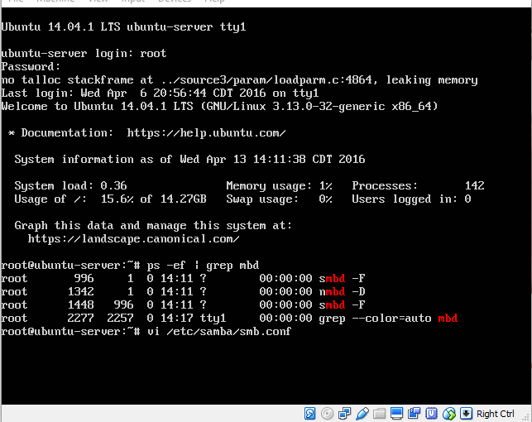

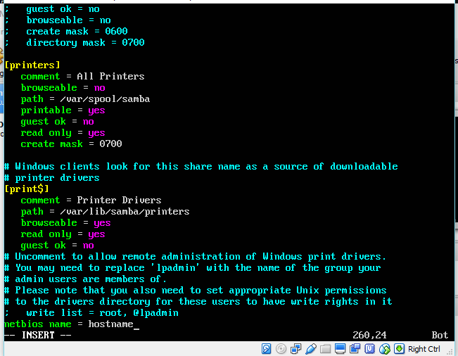

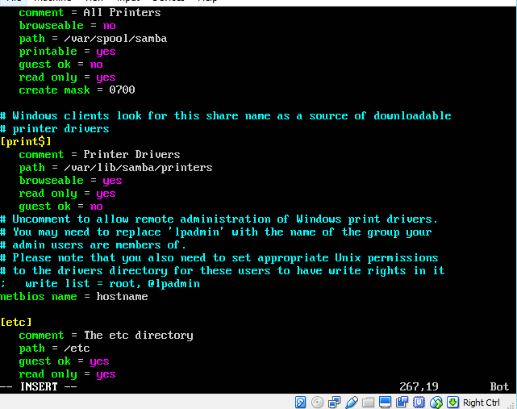

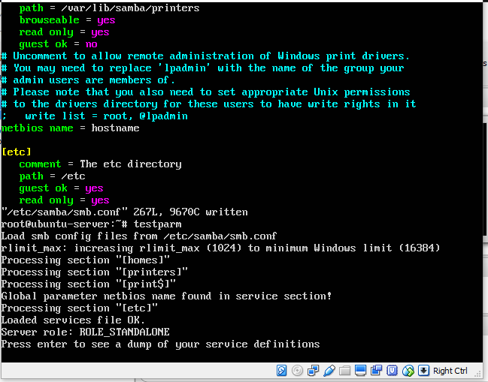

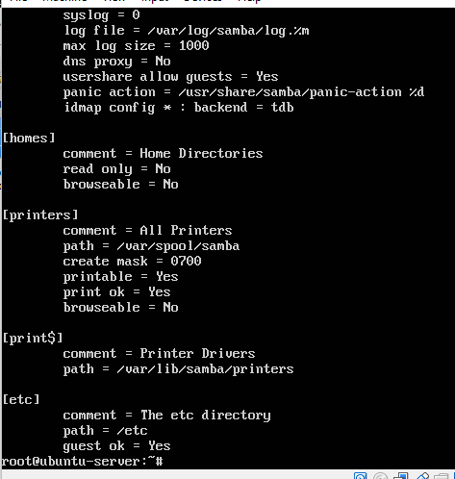

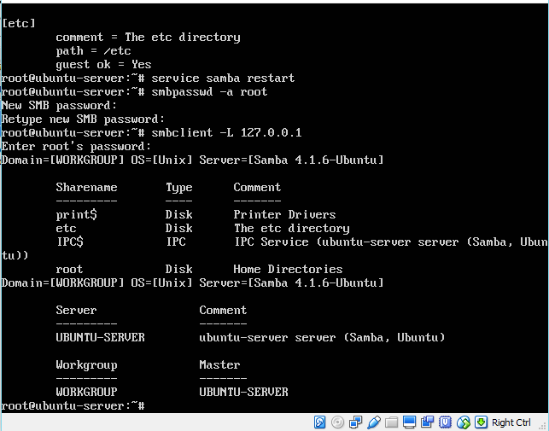

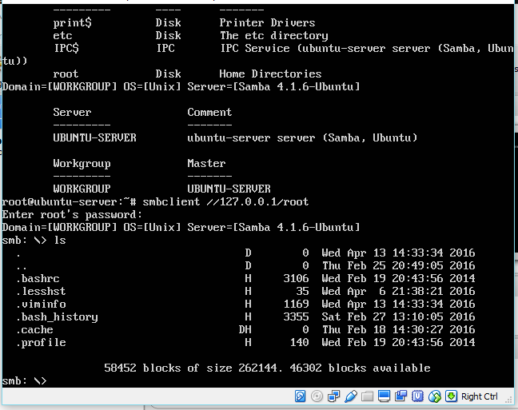

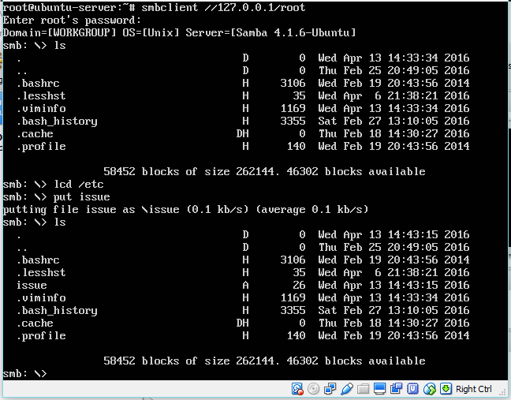

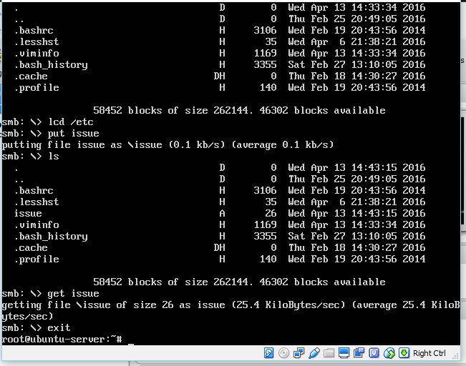

# Project 13-6

In this hands-on project, you explore the Postfix e-mail daemon on your Ubuntu Server Linux virtual machine.

1. Boot your **Ubuntu** Linux virtual machine. Login to your chosen desktop environment as **root** using password **LNXrocks!** and open up a terminal window.
2. At the command prompt, type **ps –ef | grep** postfix and press Enter. Is the Postfix daemon running? **Yes**
3. Edit the /etc/aliases file with a text editor and add the following line:

webmaster: user1

When finished, save your changes and quit the editor.

1. At the command prompt, type **newaliases** and press Enter to update the aliases database using the information within the /etc/aliases file.
2. At the command prompt, type **mail webmaster** and press Enter to compose a new e-mail to the webmaster. When prompted for a subject, type **Test email** and press Enter. Next, type **This is a test email that will be delivered using the Postfix daemon** and press Enter. Next, type **.** (a period) and press Enter. Press Enter again to complete and send the e-mail.
3. At the command prompt, type **su - user1** to switch to a new shell as user1.
4. At the command prompt, type **mail** to check your mailbox for e-mail messages. Press Enter to view the body of the message. The last e-mail should have a subject line of Test e-mail. If you don’t see this message, type z to advance to the next screen of messages. Note the number of the e-mail message that has the subject line of Test e-mail and type this number at the & prompt to read your e-mail message. Type q when finished to exit the mail program.
5. At the command prompt, type **exit** and press Enter to return to your root shell.
6. At the command prompt, type **telnet localhost 25** and press Enter. Can you tell that you are interacting with the Postfix daemon? **Yes**
7. Type **EHLO localhost** and press Enter. Does your Postfix daemon support 8-bit MIME? **Yes it does.** Type quit and press Enter to quit the telnet session.
8. **Provide screenshot(s) of steps 2 through 10.**

