Hands-on Projects

These projects should be completed in the order given. The hands-on projects presented in this chapter should take a total of three hours to complete. The requirements for this lab include:

* A computer with Fedora Linux installed according to Hands-on Project 2-1

# Project 7-1

In this hands-on project, you use the shell to redirect the Standard Output and Standard Error to a file and take Standard Input from a file.

1. Boot your Fedora Linux virtual machine. Login to your chosen desktop environment as **user1** using password **LNXrocks!** and open up a terminal window.
2. At the terminal, become **root** by typing **su -** and press enter and provide **LNXrocks!** as the password.
3. At the command prompt, type **touch sample1 sample2** and press Enter to create two new files named sample1 and sample2 in your home directory. Verify their creation by typing **ll** at the command prompt, and press Enter.
4. At the command prompt, type **ll sample1 sample2 sample3** and press Enter. Review the standard out and standard error displayed to the terminal. Note that not having sample3 is expected, do not create this file.
5. At the command prompt, type **ll sample1 sample2 sample3 > file** and press Enter. Observer that standard error is displayed on the terminal.
6. At the command prompt, type **cat file** and press Enter. In the previous step, we redirected standard out to this file.
7. At the command prompt, type **ll sample1 sample2 sample3 2>file** and press Enter. You will see standard out displayed on the terminal.
8. At the command prompt, type **cat file** and press Enter. Standard error was redirected to this file in the previous step.
9. At the command prompt, type **ll sample1 sample2 sample3 > file 2>file2** and press Enter. Standard out and standard error have been redirected to file and file2.
10. At the command prompt, type **cat file** and press Enter.
11. At the command prompt, type **cat file2** and press Enter.
12. **Provide screenshot(s) of steps 3 through 11.**

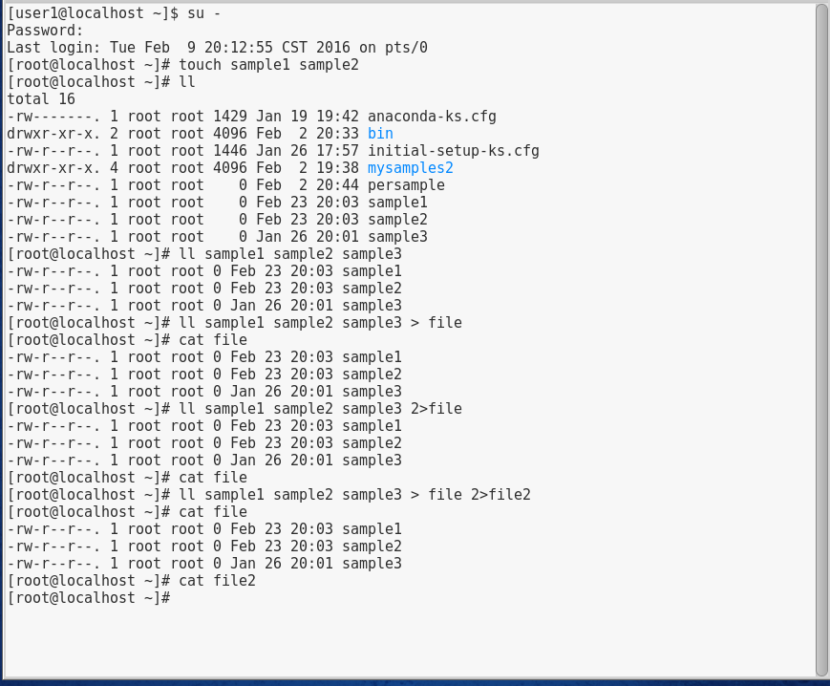

1. At the command prompt, type **ll sample1 sample2 sample3 > file 2>&1** and press Enter. We have now redirected both standard out and standard error to the same file.
2. At the command prompt, type **cat file** and press Enter.
3. At the command prompt, type **ll sample1 sample2 sample3 &> file** and press Enter. Notice we have accomplished the same as the previous step.
4. At the command prompt, type **cat file** and press Enter.
5. At the command prompt, type **date >> file** and press Enter.
6. At the command prompt, type **cat file** and press Enter.
7. At the command prompt, type **tr o O /etc/hosts** and press Enter. Notice the error message. We need to redirect the contents of /etc/hosts to the tr command.
8. At the command prompt, type **tr o O </etc/hosts**
9. **Provide screenshot(s) of steps 13 through 20.**

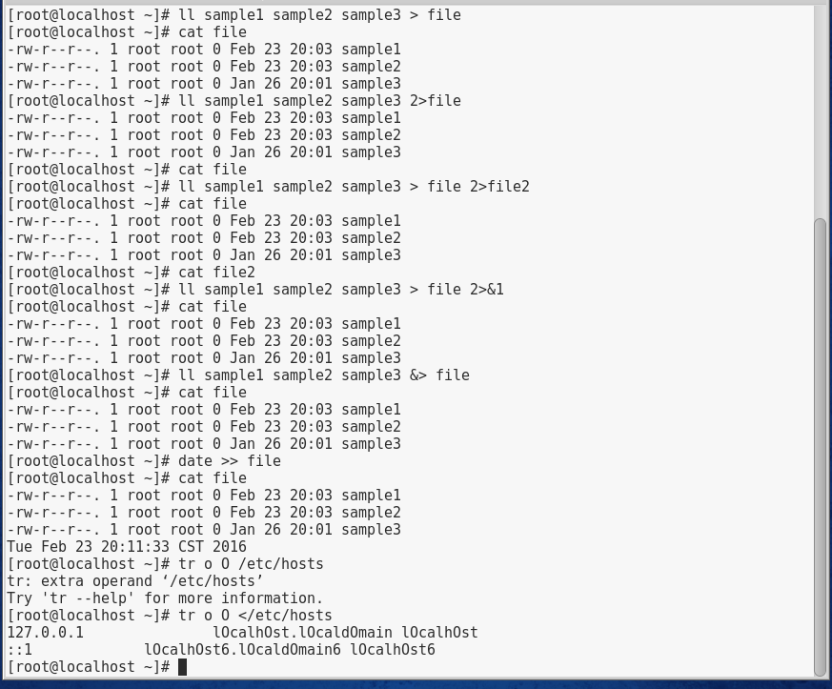

# Project 7-2

In this hands-on project, you redirect Standard Output and Standard Input using pipe metacharacters.

1. Boot your Fedora Linux virtual machine. Login to your chosen desktop environment as **user1** using password **LNXrocks!** and open up a terminal window.
2. At the terminal, become **root** by typing **su -** and press enter and provide **LNXrocks!** as the password.
3. At the command prompt, type **cat /etc/nsswitch.conf** and press Enter to view the /etc/ nsswitch.conf file. Next, type **cat /etc/nsswitch.conf | less** at the command prompt and press Enter to perform the same task page-by-page. Type q to quit out of less. Understand that you can also just type less /etc/nsswitch.conf without the need of the cat command.
4. At the command prompt, type **cat /etc/nsswitch.conf | grep nisplus** and press Enter.
5. At the command prompt, type **cat /etc/nsswitch.conf | grep nisplus | tr n N** and press Enter. At the command prompt, type **cat /etc/nsswitch.conf | grep nisplus | tr n N | sort -r** and press Enter.
6. At the command prompt, type **cat /etc/nsswitch.conf | grep nisplus | tr n N | sort -r | tee file** and press Enter. Next, type **cat file** at the command prompt and press Enter.
7. At the command prompt, type **cat /etc/nsswitch.conf | grep nisplus | tr n N | sort -r | tee file | wc -l** and press Enter. Explain the output on the terminal screen. Next, type **cat file** at the command prompt and press Enter.
8. At the command prompt, type **cat /etc/nsswitch.conf | grep nisplus | sed /#/d | sed /public/s/nisplus/NISPLUS/** and press Enter.
9. At the command prompt, type **cat /etc/hosts**. Next, type **cat /etc/hosts | awk ‘/localhost/ {print $1, $3}’** and press Enter.
10. **Provide screenshot(s) of steps 3 through 9.**

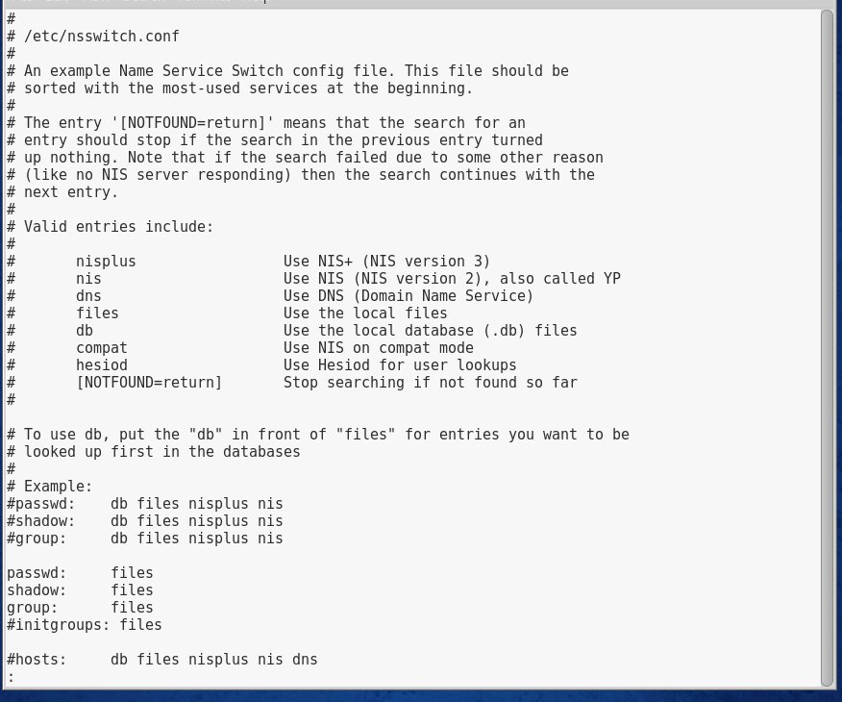

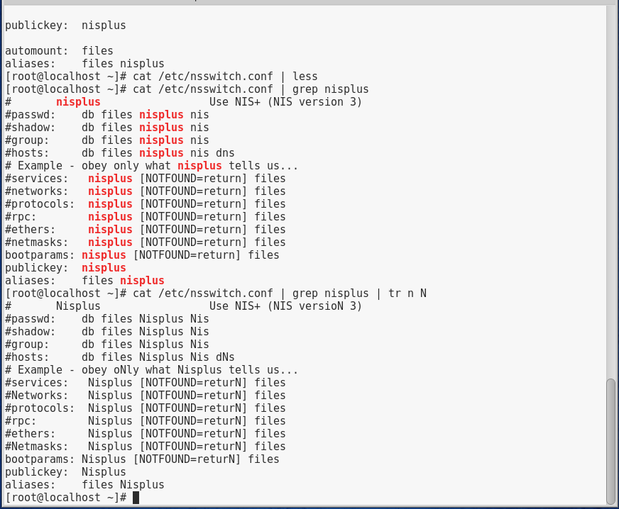

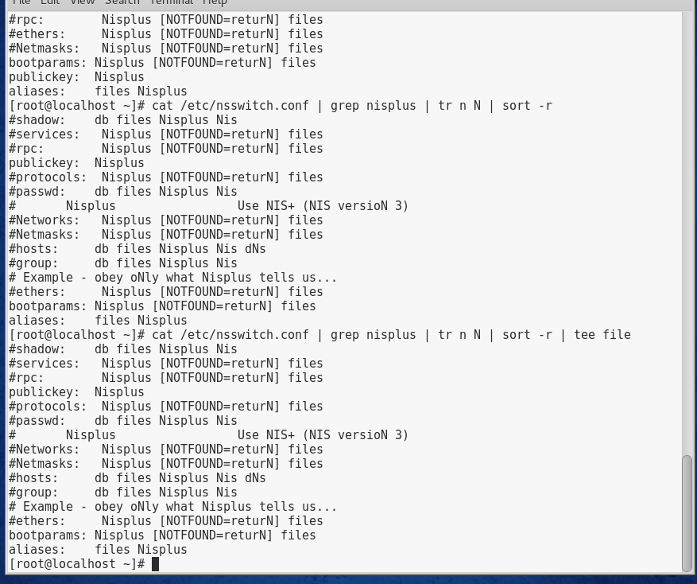

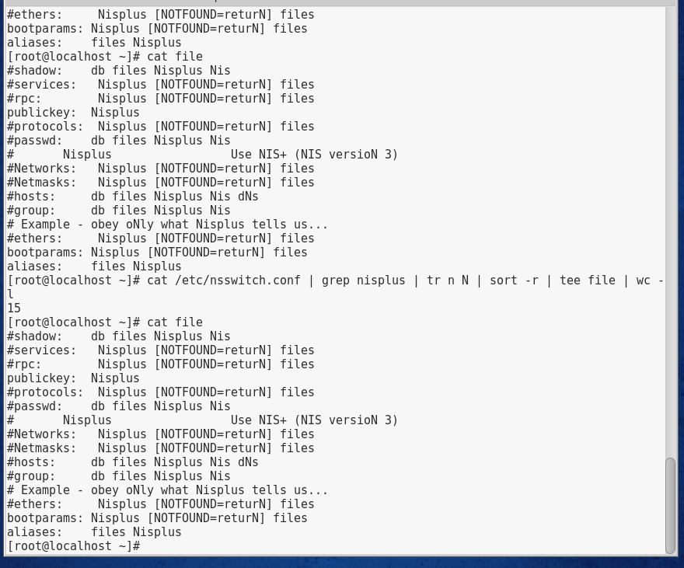

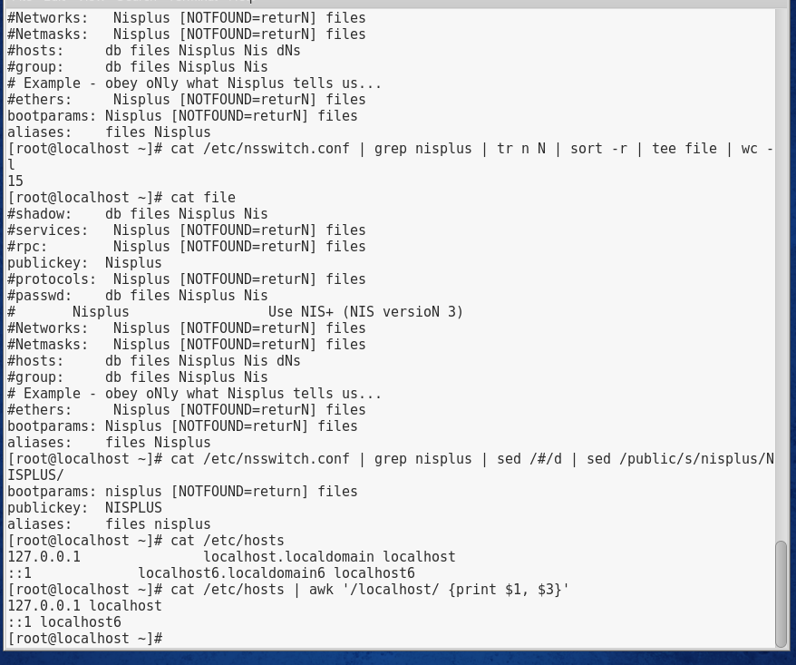

# Project 7-3

In this hands-on project, you create and use an alias, as well as view and change existing shell variables. In addition to this, you export user-defined variables and load variables automatically upon shell startup.

1. Boot your Fedora Linux virtual machine. Login to your chosen desktop environment as **user1** using password **LNXrocks!** and open up a terminal window.
2. At the terminal, become **root** by typing **su -** and press enter and provide **LNXrocks!** as the password.
3. At the command prompt, type **set | less** and press Enter to view the BASH shell environment variables currently loaded into memory. Scroll through this list using the cursor keys on the keyboard. When finished, press q to quit the less utility.
4. At the command prompt, type **env | less** and press Enter to view the exported BASH shell environment variables currently loaded into memory. Scroll through this list using the cursor keys on the keyboard. Compare this output to the previous output. When finished, press q to quit the less utility.
5. At the command prompt, type **PS1="Hello There: "** and press Enter. Next, type **echo $PS1** at the command prompt and press Enter to verify the new value of the PS1 variable.
6. Open a new terminal/tab and compare your PS1 to your new one. You will notice that when you open a new terminal, the PS1 is not replicated to this terminal.
7. At the command prompt, type **vi .bash_profile** and press Enter. At the bottom of the file, add the following lines. When finished, save and quit the vi editor.

**echo -e "Would you like a hello prompt? (y/n) -->\c"**

**read ANSWER**

**if [ $ANSWER = "y" ]**

**then**

**PS1="Hello There: "**

**fi**

1. Open a new terminal/tab and you should be prompted for the new prompt. Type **y** to receive the new prompt.
2. At the command prompt, type **MYVAR="My sample variable"** and press Enter to create a variable called MYVAR. Verify its creation by typing **echo $MYVAR** at the command prompt, and press Enter.
3. At the command prompt, type **set | grep MYVAR** and press Enter.
4. At the command prompt, type **env | grep MYVAR** and press Enter.
5. At the command prompt, type **export MYVAR** and press Enter. Next, type **env | grep MYVAR** at the command prompt and press Enter.
6. Open a new terminal/tab and at the command prompt, type **echo $MYVAR** and press Enter to view the contents of the MYVAR variable. What is listed and why?
7. At the command prompt, type **vi .bash_profile** and press Enter. At the bottom of the file, add the following line. When finished, save and quit the vi editor.

**export MYVAR="My sample variable"**

1. Open a new terminal/tab.
2. At the command prompt, type **echo $MYVAR** and press Enter to list the contents of the MYVAR variable.
3. At the command prompt, type **alias** and press Enter.
4. At the command prompt, type **alias** **asample="cd /etc; cat hosts; cd ~; ls –F"** and press Enter.
5. At the command prompt, type **asample** and press Enter.
6. **Provide screenshot(s) of steps 3 through 19.**

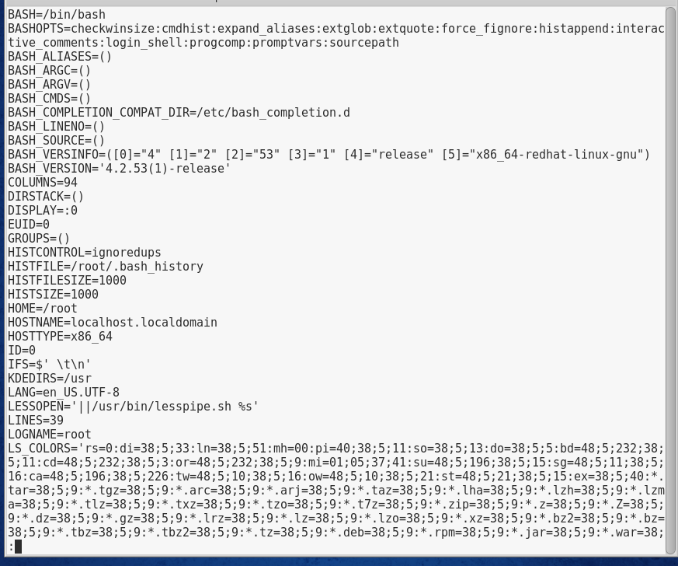

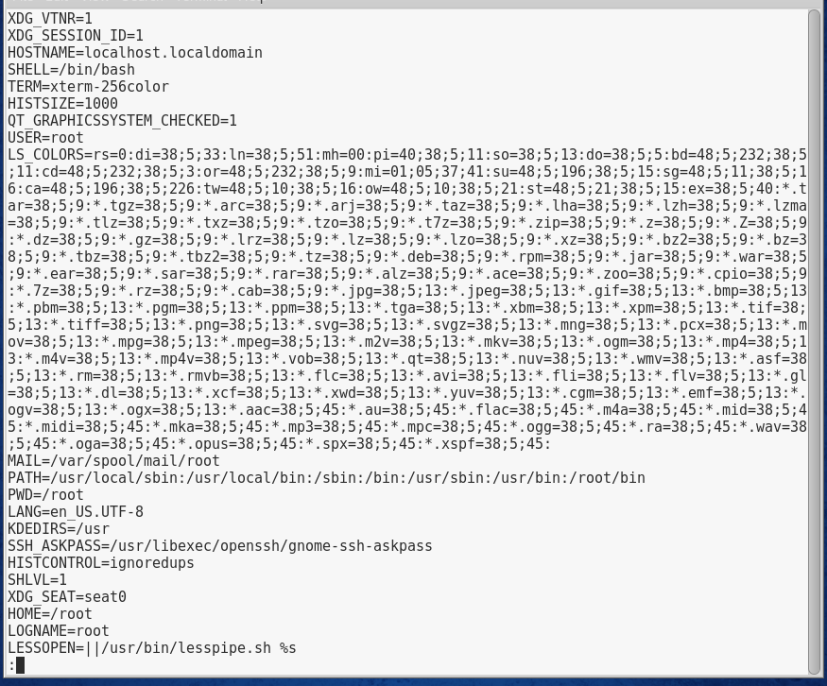

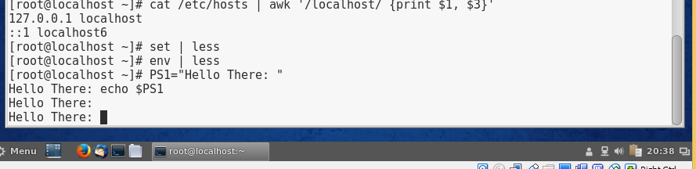

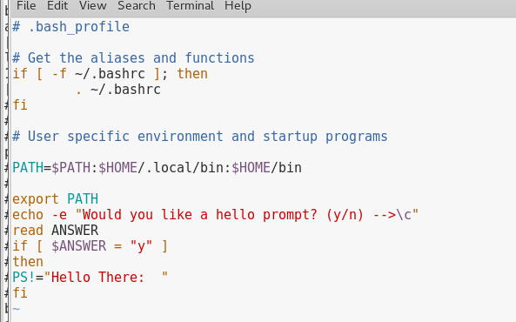

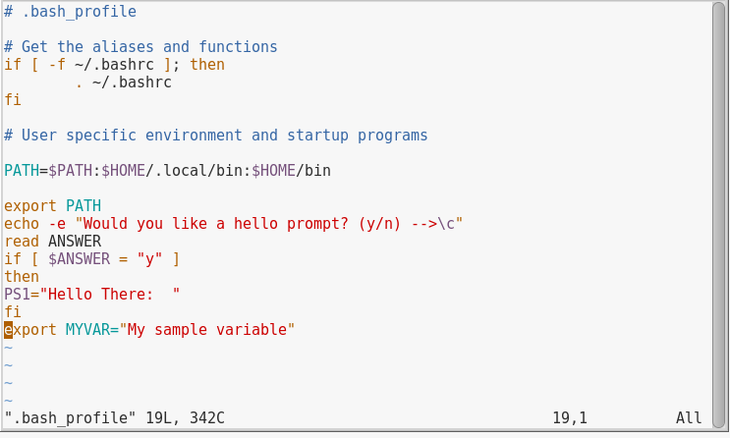

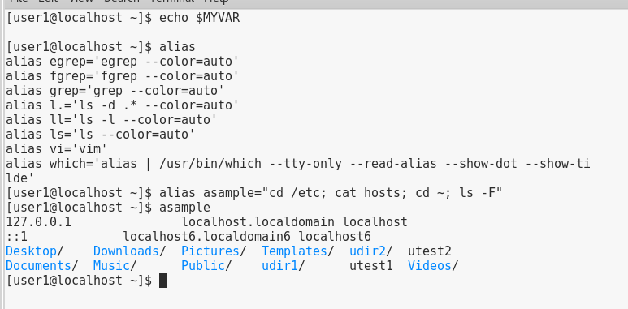

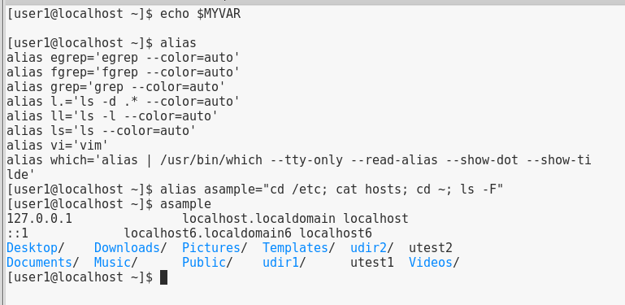

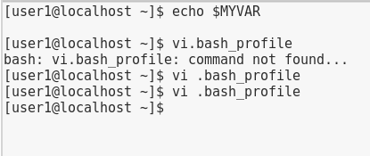

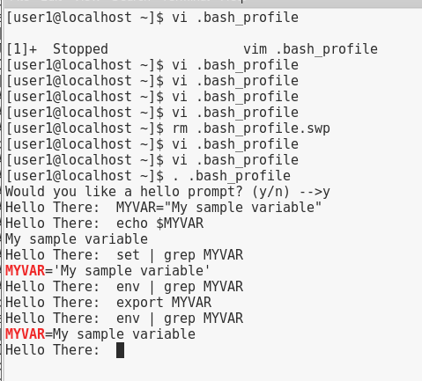

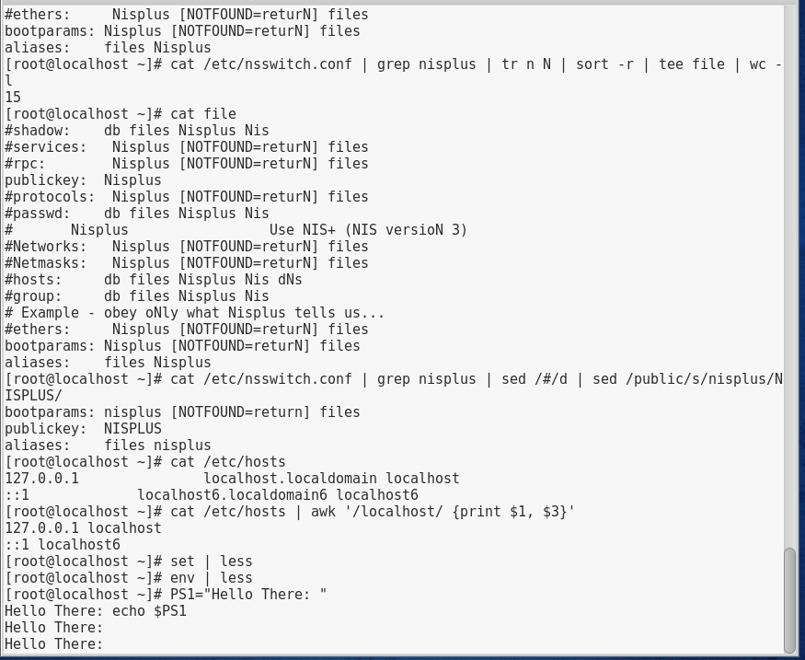

# Project 7-4

In this hands-on project, you create a basic shell script and execute it on the system.

1. Boot your Fedora Linux virtual machine. Login to your chosen desktop environment as **user1** using password **LNXrocks!** and open up a terminal window.
2. At the terminal, become **root** by typing **su -** and press enter and provide **LNXrocks!** as the password.
3. At the command prompt, type **vi myscript** and press Enter to open a new file for editing called myscript in your home directory.
4. Enter the following text into the myscript file. When finished, save and quit the vi editor.

**#!/bin/bash**

**echo -e "This is a sample shell script. \t It displays mounted**

**filesystems \a"**

**mount**

1. At the command prompt, type **ll myscript** and press Enter.
2. Next, type **bash myscript** at the command prompt and press Enter.
3. Next, type **./myscript** at the command prompt and press Enter. Note the error message you received.
4. At the command prompt, type **chmod u+x myscript** and press Enter. Next, type **./myscript** at the command prompt and press Enter. The script now executes.
5. **Provide screenshot(s) of steps 3 through 8.**

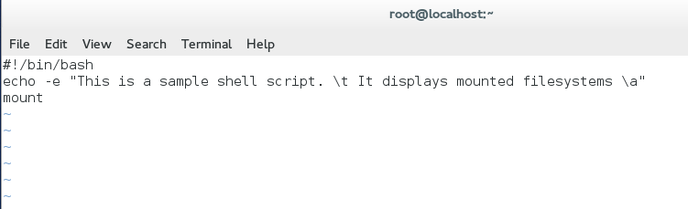

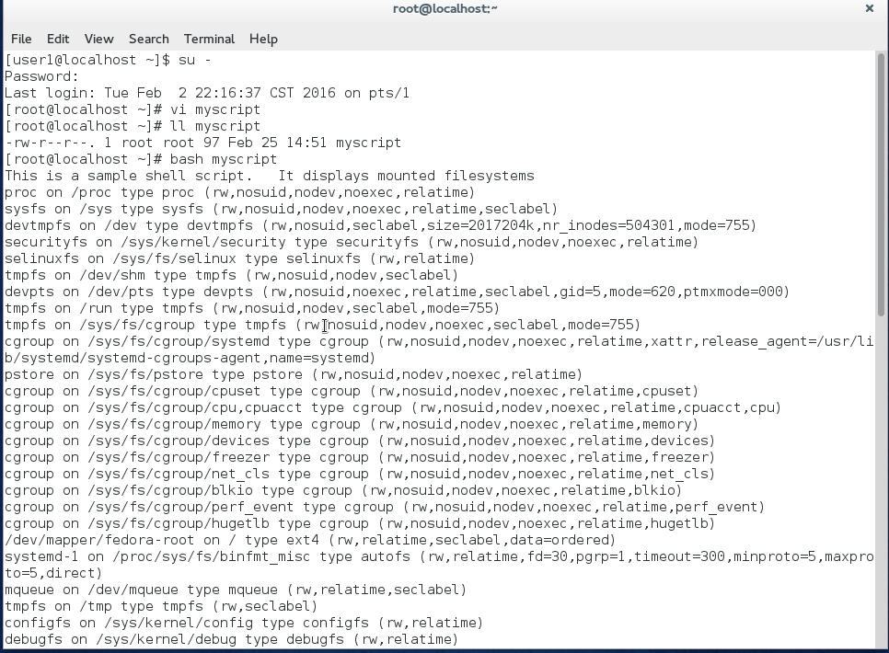

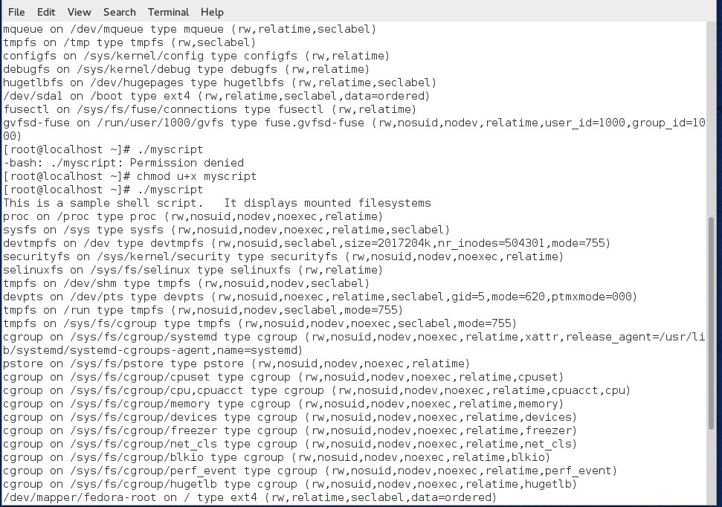

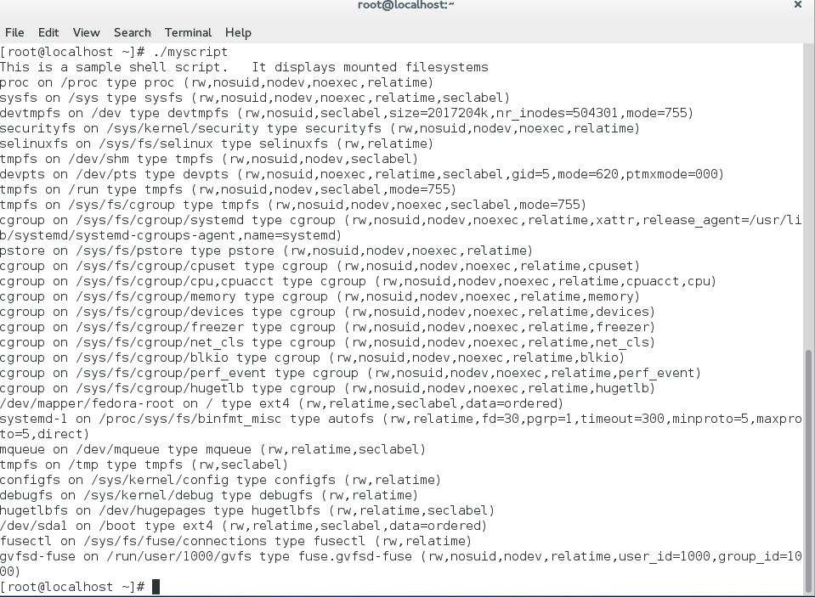

# Project 7-5

In this hands-on project, you create a shell script that uses decision and loop constructs to analyze user input.

1. Boot your Fedora Linux virtual machine. Login to your chosen desktop environment as **user1** using password **LNXrocks!** and open up a terminal window.
2. At the terminal, become **root** by typing **su -** and press enter and provide **LNXrocks!** as the password.
3. Enter the following text into the **myscript2** file. When finished, save and quit the vi editor.

**#!/bin/bash**

**echo -e "This program adds entries to a family database file.\n"**

**echo -e "Please enter the name of the family member -->\c"**

**read NAME**

**echo -e "Please enter the family member’s relation to you (i.e. mother) -->\c"**

**read RELATION**

**echo -e "Please enter the family member’s telephone number -->\c"**

**read PHONE**

**echo -e "$NAME\t$RELATION\t$PHONE" >> database**

1. At the command prompt, type **chmod u+x myscript2** and press Enter. Next, type **./myscript2** at the command prompt and press Enter. Answer the questions with information regarding one of your family members.
2. At the command prompt, type **cat database** and press Enter.
3. Perform Step 4 several times to populate the database file with entries.
4. **Provide screenshot(s) of steps 3 through 6.**

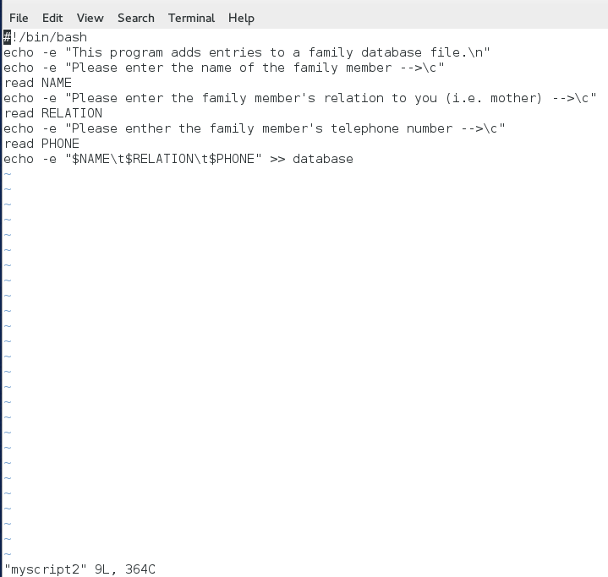

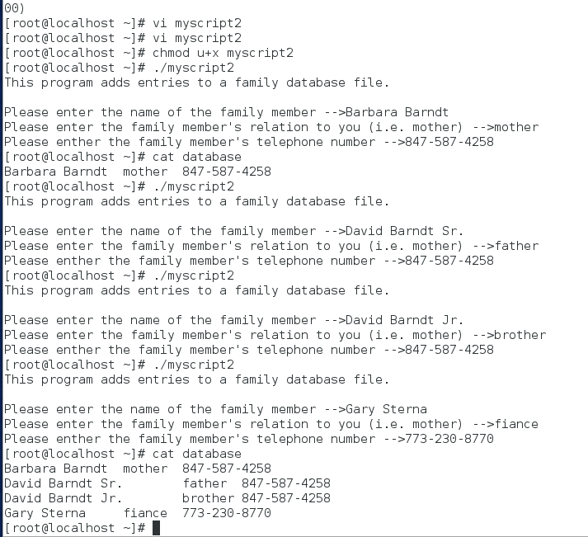

1. At the command prompt, type **vi myscript2** and press Enter. Edit the text inside the myscript2 shell script such that it reads:

**#!/bin/bash**

**echo -e "Would you like to add an entry to the family database file?\n"**

**read ANSWER1**

**if [ $ANSWER1 = "y" -o $ANSWER1 = "Y" ]**

**then**

**echo -e "Please enter the name of the family member -->\c"**

**read NAME**

**echo -e "Please enter the family member’s relation to you (i.e. mother)-->\c"**

**read RELATION**

**echo -e "Please enter the family member’s telephone number -->\c"**

**read PHONE**

**echo -e "$NAME\t$RELATION\t$PHONE" >> database**

**fi**

**echo -e "Would you like to search an entry in the family database file?\n"**

**read ANSWER2**

**if [ $ANSWER2 = "y" -o $ANSWER2 = "Y" ]**

**then**

**echo -e "What word would you like to look for? -->\c"**

**read WORD**

**grep "$WORD" database**

**fi**

1. At the command prompt, type **./myscript2** and press Enter. When prompted to enter an entry into the database, choose y and press Enter. Answer the questions with information regarding one of your family members. Next, when prompted to search the database, answer y and press Enter. Search for the name that you just entered a few seconds ago.
2. At the command prompt, type **./myscript2** and press Enter. When prompted to enter an entry into the database, choose **n** and press Enter. Next, when prompted to search the database, answer **y** and press Enter. Search for a name that you entered earlier in Step 6.
3. **Provide screenshot(s) of steps 8 through 10.**

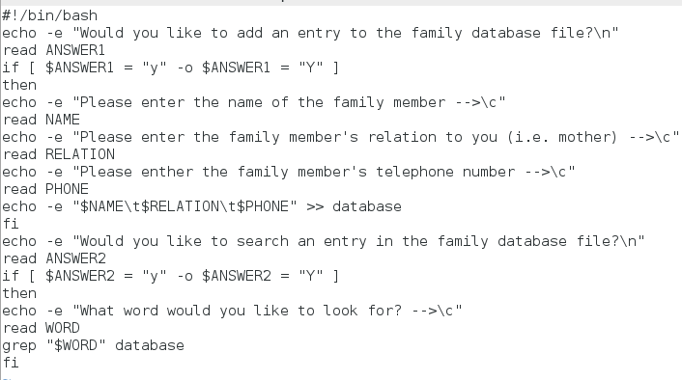

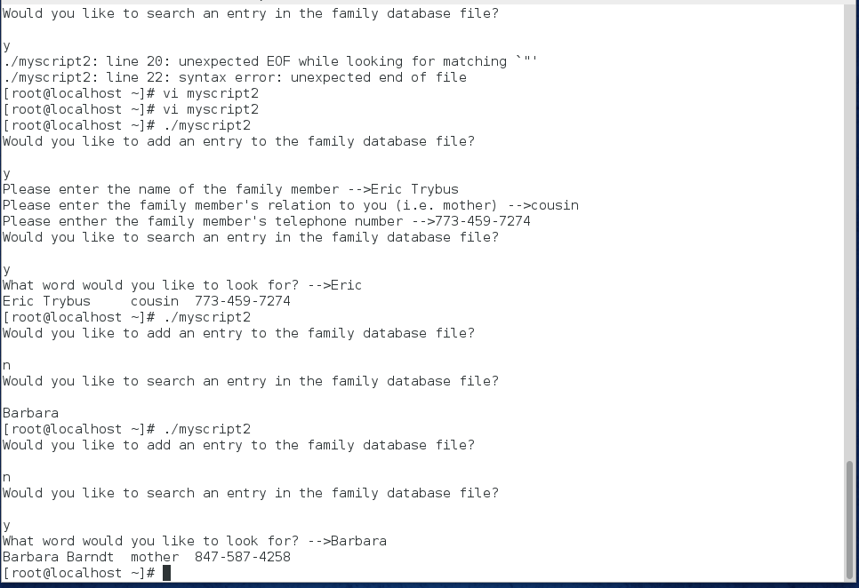

1. At the command prompt, type **vi myscript2** and press Enter. Edit the text inside the myscript2 shell script such that it reads:

**#!/bin/bash**

**echo -e "What would you like to do?**

**Add an entry (a)**

**Search an entry (s)**

**Enter your choice (a/s)-->\c"**

**read ANSWER**

**case $ANSWER in**

**a|A ) echo -e "Please enter the name of the family member -->\c"**

**read NAME**

**echo -e "Please enter the family member’s relation to you (i.e. mother)-->\c"**

**read RELATION**

**echo -e "Please enter the family member’s telephone number -->\c"**

**read PHONE**

**echo -e "$NAME\t$RELATION\t$PHONE" >> database**

**;;**

**s|S ) echo -e "What word would you like to look for? -->\c"**

**read WORD**

**grep "$WORD" database**

**;;**

**\*) echo "You must enter either the letter a or s."**

**;;**

**esac**

1. At the command prompt, type **./myscript2** and press Enter. Choose y and press Enter.
2. At the command prompt, type **./myscript2** and press Enter. Choose a and press Enter. Enter information about another family member.
3. At the command prompt, type **./myscript2** and press Enter. Choose s and press Enter. Search for the family member entered in Step 12.
4. **Provide screenshot(s) of steps 12 through 15.**

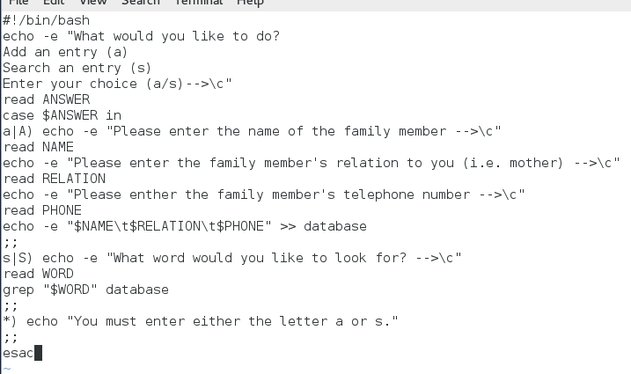

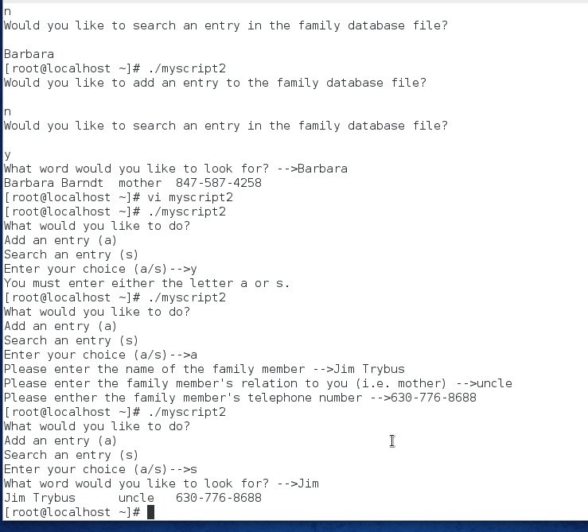

**esa**

1. At the command prompt, type vi myscript2 and press Enter. Edit the text inside the myscript2 shell script such that it reads:

**#!/bin/bash**

**while true**

**do**

**clear**

**echo -e "What would you like to do?**

**Add an entry (a)**

**Search an entry (s)**

**Quit (q)**

**Enter your choice (a/s/q)-->\c"**

**read ANSWER**

**case $ANSWER in**

**a|A ) echo -e "Please enter the name of the family member -->\c"**

**read NAME**

**echo -e "Please enter the family member’s relation to you (i.e. mother)-->\c"**

**read RELATION**

**echo -e "Please enter the family member’s telephone number -->\c"**

**read PHONE**

**echo -e "$NAME\t$RELATION\t$PHONE" >> database**

**;;**

**s|S ) echo -e "What word would you like to look for? -->\c"**

**read WORD**

**grep "$WORD" database**

**sleep 4**

**;;**

**q|Q ) exit**

**;;**

**\*) echo -e "You must enter either the letter a or s."**

**sleep 4**

**;;**

**esac**

**done**

1. At the command prompt, type **./myscript2** and press Enter. Choose **a** and press Enter. Enter information about another family member. Choose s and press Enter. Search for the family member that you just entered. Choose q to quit the shell script.
2. At the command prompt, type **vi myscript3** and press Enter to edit a new file called myscript3 in your home directory.
3. **Provide screenshot(s) of steps 17 through 19.**

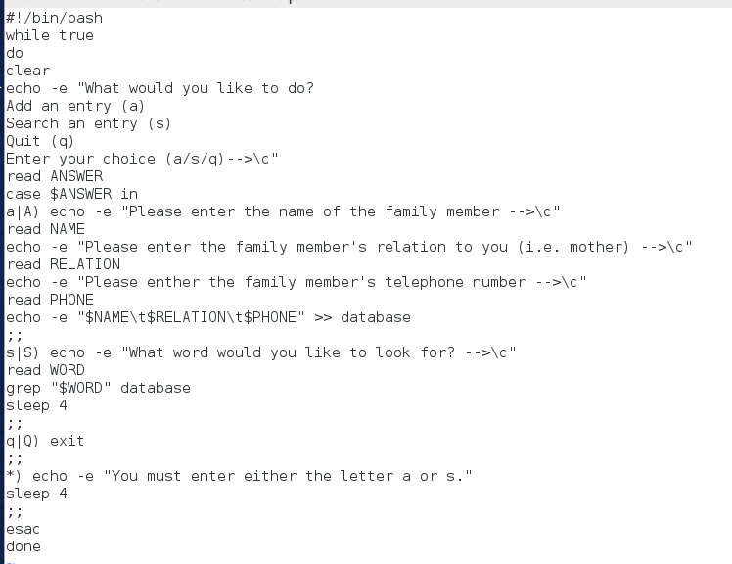

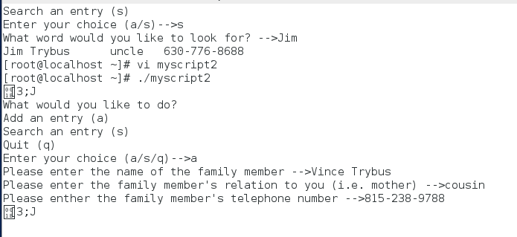

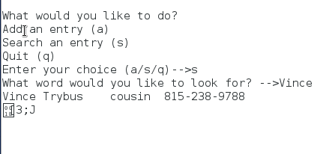

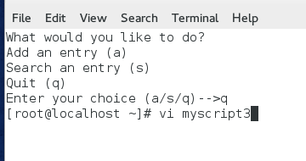

1. Enter the following text into the myscript3 file. When finished, save and quit the vi editor

**#!/bin/bash**

**echo -e "This program copies a file to the /stuff directory.\n"**

**echo -e "Which file would you like to copy? -->\c"**

**read FILENAME**

**mkdir /stuff || echo "The /stuff directory could not be created."**

**cp -f $FILENAME /stuff && echo "$FILENAME was successfully copied to stuff/"**

1. At the command prompt, type **chmod u+x myscript3** and press Enter. Next, type **./myscript3** at the command prompt and press Enter. When prompted for a filename, type **/etc/hosts** and press Enter. The directory should be created that contains /etc/hosts.
2. Type **./myscript3** at the command prompt and press Enter. When prompted for a filename, type **/etc/inittab** and press Enter.
3. At the command prompt, type **vi myscript4** and press Enter to edit a new file called myscript4 in your home directory.
4. **Provide screenshot(s) of steps 21 through 24.**

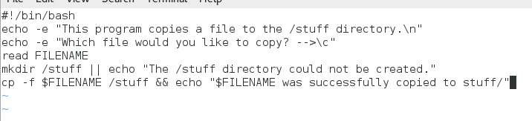

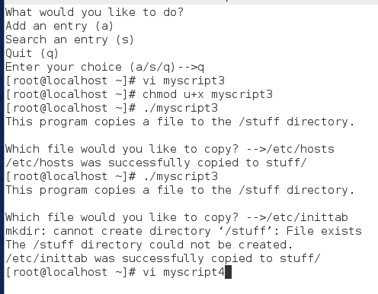

1. Enter the following text into the myscript4 file. When finished, save and quit the vi editor.

**#!/bin/bash**

**echo "These are the scripts that you have created previously:"**

**ls -l myscript myscript2 myscript3**

**sleep 2**

**echo "This script will now change the permissions on each script such that the root user has exclusive rights only."**

**sleep 3**

**for FILE in myscript myscript2 myscript3**

**do chmod 700 $FILE**

**done**

**echo "The new permissions are listed below:"**

**ls -l myscript myscript2 myscript3**

1. At the command prompt, type **chmod u+x myscript4** and press Enter. Next, type ./myscript4 at the command prompt and press Enter. Were the permissions changed to rwx- - - - - - for myscript, myscript2, and myscript3?
2. **Provide screenshot(s) of steps 26 through 27.**

