/**
* Deborah Barndt
* 9-6-16
* AccountHolder.java
* Lab 1
* This program will similate a bank account. It will prompt users for options for creating an initial balance, entering deposits or withdrawals, and it will
* allow for the printing of account information including interest at various interest rates.
* Written by Deborah Barndt. */

package BankofIIT;

import javax.swing.JOptionPane;
import java.text.DecimalFormat;

public class AccountHolder
{
static double balance, // account balance
annualInterestRate = .04; // interest rate

//Print 2 decimal places.
DecimalFormat mydf = new DecimalFormat("0.00");

// Constructor sets the balance to 0.00.
public AccountHolder()
{
balance = 0.00;
}

// Constructor sets the starting balance of the account to the value passed.
public AccountHolder(double newbalance)
{
balance = newbalance;

// Check for a positive balance
if (balance < 0)
{
JOptionPane.showMessageDialog(null, "Error: You can not start off with a negative balance.");
}

this.balance = balance >= 0 ? balance: 0;
}

// Constructor sets the balance of the account to the value as a string.
public AccountHolder(String balstr)
{
balance = Double.parseDouble(balstr);
}

// Method to make a deposit money into the account.
public void deposit(double amount)
{
balance += amount;
}

// Method to make a deposit money into the account as a string.
public void deposit(String depstr)
{
balance += Double.parseDouble(depstr);
}

// Method to withdraw money from the account.
public void withdrawal(double amount)
{
if (balance <= 100)
{
JOptionPane.showMessageDialog(null, "Insufficient Funds for Withdrawal.");
amount = 0;
}

else
{
// Check if the user's balance goes below $500, and add a transaction fee.
if (balance - amount < 500)
{
// Check if the user's balance is below $100.
if (balance - amount < 100)
{
amount = balance - 100;
JOptionPane.showMessageDialog(null, "Your balance cannot go below $100.\n"
+ "Your withdrawal is now the maximum amount of $" + mydf.format(amount) + ".");
balance -= amount;
amount = 0;
}

balance -= 50;
JOptionPane.showMessageDialog(null, "Your account is below $500.\n"
+ "A $50 transaction fee has been deducted from your account.\n");
}

balance -= amount;
}

}

// Method to withdraw money from the account as a string.
public void withdrawal(String withstr)
{
balance -= Double.parseDouble(withstr);
}

// Method to calculate the monthly interest rate to the account.
public void monthlyInterest()
{
balance += balance * (annualInterestRate / 12.0);
}

// Method to modify the monthly interest rate to the account.
public void modifyMonthlyInterest(double interestRateUpdate)
{
if (interestRateUpdate >= 0 && interestRateUpdate <= 1.0)
{
annualInterestRate = interestRateUpdate;
}
}

// Setter method to set the account balance.
public void setBalance(double newbalance)
{
balance = newbalance;
}

// Setter method that sets the account balance as a string.
public void setBalance(String balstr)
{
balance = Double.parseDouble(balstr);
}

// Getter method to return the account balance.
public double getBalance()
{
return balance;
}

// Getter method to return the annual interest rate.
public static double getAnnualInterestRate()
{
return annualInterestRate;
}

// Getter method to return the accounts current balance in a string.
@Override
public String toString()
{
return String.format("$%.2f", balance);
}

}

package BankofIIT;

import java.awt.Color;
import java.net.MalformedURLException;
import java.net.URL;
import java.text.DecimalFormat;
import javax.swing.ImageIcon;
import javax.swing.JOptionPane;
import java.text.DecimalFormat;
import javax.swing.JTextArea;
import java.text.SimpleDateFormat;
import java.util.Calendar;
import javax.swing.UIManager;

/**
* Deborah Barndt
* 9-6-16
* AccountHolderTest.java
* Lab 1
* This programs tests the AccountHolder class.
* Written by Deborah Barndt. */

public class AccountHolderTest
{
public static void main(String[] args) throws MalformedURLException
{
double balance, // balance of the account
annualamount; // the annual amount added to the user's account

int selection = 0; // menu selection made by the user

//Print 2 decimal places.
DecimalFormat mydf = new DecimalFormat("0.00");

// Change the color of the background of the dialog box
UIManager UI = new UIManager();
UI.put ("OptionPane.background", Color.lightGray);
UI.put ("Panel.background", Color.lightGray);

// Print a time stamp for program.
String timeStamp = new SimpleDateFormat("yyyy/MM/dd HH:mm:ss").format(Calendar.getInstance().getTime());

// Prompt the user for the initial balance.
balance = Double.parseDouble(JOptionPane.showInputDialog("Please enter your starting balance: "));

// Create an AccountHolder object.
AccountHolder account = new AccountHolder(balance);

// Change icon inside dialog box.
final ImageIcon icon = new ImageIcon(new URL("http://iconshow.me/media/images/Business/e-commerce-icon/png/32/bank.png"));

do
{
selection = Integer.parseInt(JOptionPane.showInputDialog("Welcome to the Bank of IIT!\n"
+ "How many I help you today?\n\n"
+ "1: Check your current balance.\n2: Make a deposit.\n"
+ "3: Make a withdraw.\n4: Update your interest.\n"
+ "5: Check your 12 month annual interest.\n6: Exit\n\n"
+ "Please make a selection: "));

// Switch statement containing the Bank of IIT Service Menu.
switch (selection)
{
case 1:
// Display the user's current balance.

JOptionPane.showMessageDialog(null, "Your current balance is $" + mydf.format(account.getBalance()) + ".\n\n"
+ "Cur dt = " + timeStamp + "\nProgrammed by Deborah Barndt\n", "Account Balance",
JOptionPane.INFORMATION_MESSAGE, icon);
break;

case 2:
// Prompt the user for the amount they would like to deposit.
balance = Double.parseDouble(JOptionPane.showInputDialog("Please enter the amount you would like to deposit: "));
account.deposit(balance);
JOptionPane.showMessageDialog(null, "Your current balance is $" + mydf.format(account.getBalance()) + ".\n\n"
+ "Cur dt = " + timeStamp + "\nProgrammed by Deborah Barndt\n", "Deposit",
JOptionPane.INFORMATION_MESSAGE, icon);
break;

case 3:
// Prompt the user for the amount they would like to withdrawal.
balance = Double.parseDouble(JOptionPane.showInputDialog("Please enter the amount you would like the withdraw: "));
account.withdrawal(balance);
JOptionPane.showMessageDialog(null, "Your current balance is $" + mydf.format(account.getBalance()) + ".\n\n"
+ "Cur dt = " + timeStamp + "\nProgrammed by Deborah Barndt\n", "Withdraw",
JOptionPane.INFORMATION_MESSAGE, icon);
break;

case 4:
// Check your current interest rate, and update the amount of interest added to the account.
account.modifyMonthlyInterest(Double.parseDouble(JOptionPane.showInputDialog("Your current interest rate is " +
mydf.format(account.getAnnualInterestRate()) + "\n"
+ "Input the new interest rate in decimal format: ")));
break;

case 5:
// Display a 12 month print out showing the interest being added to the user's account. Showing a text area containing the headers for columns,
// the current balance, and the 12 month print out showing the interest for each of the 12 months.
String output = "Your current balance is $" + mydf.format(account.getBalance()) + ".\n\n"
+ "Your monthly balances for one year at " + mydf.format(account.getAnnualInterestRate() * 100) + "% interest rate.\n\n"
+ "Month\tBalance with Interest\n";

Double monthBal = account.getBalance();

// Loop to calculate the 12 month print out.
for (int monthNum = 1; monthNum <= 12; monthNum++)
{
output += monthNum + ":\t" + "$" + mydf.format((monthBal += monthBal * (account.getAnnualInterestRate()/12))) + "\n" ;
}

output += "\n\n" + "Cur dt = " + timeStamp + "\nProgrammed by Deborah Barndt\n";

// Display the results.
JOptionPane.showMessageDialog(null, new JTextArea(output), "12 Month Interest Rate Print Out",
JOptionPane.INFORMATION_MESSAGE, icon);

break;

case 6:
// Exit the program.
System.exit(0);
}
}

while (selection != 6); // Ends the loop.
}
}

Intial starting balance:
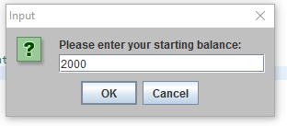
Welcome to Bank of IIT Menu:
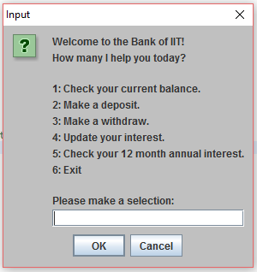
Trying to put in a negative balance:
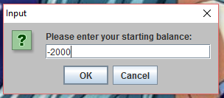
Error message for negative balance:
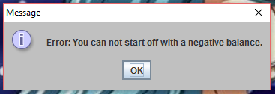
Display of current balance:
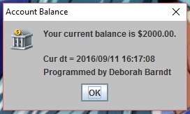
Making a deposit:
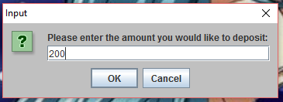
Current balance after deposit:
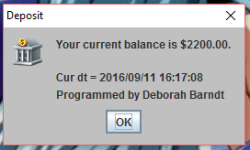
Withdrawing from account:
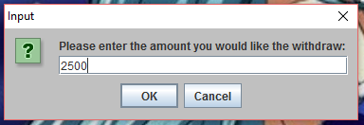
Trying to put account below 100 but does the maximum withdrawal:
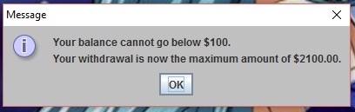
Account below 500 message:
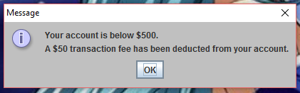
Balance after transaction fee:
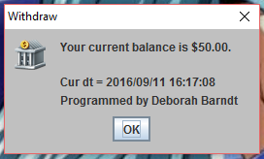

Interest rate being updated from current interest rate:
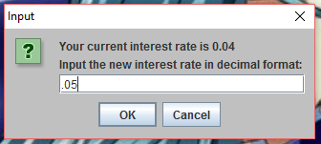

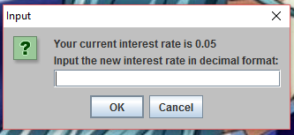
Display of updated interest rate:

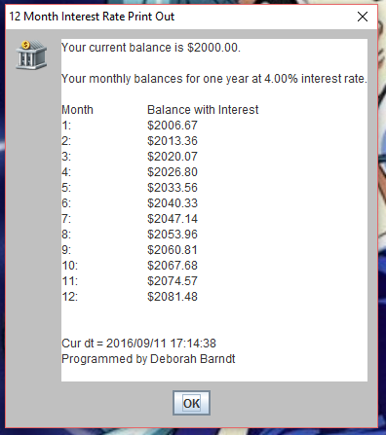
Print out of the 4% interest rate print out:

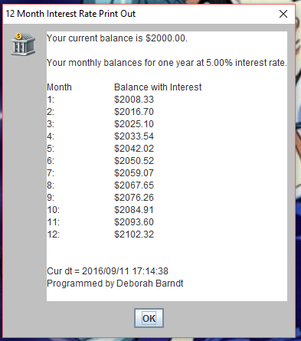
Print out of the 5% interest rate print out:

