/**
* Deborah Barndt
* 10-31-16
* LoanProcessing.java
* Lab 4
* This program will act as a driver file to call the database CRUD methods and create
* some resulting output.
* Written by Deborah Barndt. */

package bankofiit;

import java.awt.BorderLayout;
import java.awt.Container;
import java.awt.Font;
import java.net.MalformedURLException;
import java.sql.DriverManager;
import java.sql.ResultSet;
import java.sql.ResultSetMetaData;
import java.sql.SQLException;
import java.util.Vector;

import javax.swing.JFrame;
import javax.swing.JPanel;
import javax.swing.JScrollPane;
import javax.swing.JTable;
import javax.swing.UIManager;
import javax.swing.plaf.ColorUIResource;
import javax.swing.plaf.FontUIResource;
import javax.swing.table.TableColumnModel;
import javax.swing.table.TableModel;

import com.mysql.jdbc.Connection;
import com.mysql.jdbc.Statement;

public class LoanProcessing extends BankRecords
{

private static final int EXIT_ON_CLOSE = 0;

public LoanProcessing()
{
// TODO Auto-generated constructor stub
}

public static void main(String[] args) throws MalformedURLException
{
// Change the color of the background of the dialog box
UIManager UI = new UIManager();
UI.put ("OptionPane.background", new ColorUIResource(36, 154, 32));

// Change the color of the panel background of the dialog box
UIManager.put ("Panel.background", new ColorUIResource(138, 201, 136));

// Change the color of the scroll bar background of the dialog box
UIManager.put ("ScrollBar.background", new ColorUIResource(138, 201, 136));

// Change the color of the text area background of the dialog box
UIManager.put ("TextArea.background", new ColorUIResource(138, 201, 136));

// Change the color of the table headers background of the dialog box
UIManager.put ("TableHeader.background", new ColorUIResource(36, 154, 32));

// Change the color of the table background of the dialog box
UIManager.put ("Table.background", new ColorUIResource(138, 201, 136));

// Change the font in the dialog box
UIManager.put ("OptionPane.messageFont", new FontUIResource(new Font("Rockwell", Font.PLAIN, 14)));

// Change the font in the dialog box
UIManager.put ("TextArea.font", new FontUIResource(new Font("Rockwell", Font.PLAIN, 14)));

// Change the font in the button
UIManager.put("OptionPane.buttonFont", new Font("Rockwell", Font.BOLD, 14));

// Change the font in the dialog box
UIManager.put ("OptionPane.messageFont", new FontUIResource(new Font("Rockwell", Font.PLAIN, 14)));

// Change the font in the table
UIManager.put("TableHeader.font", new Font("Rockwell", Font.BOLD, 14));

// Change the font in the table box
UIManager.put ("Table.font", new FontUIResource(new Font("Rockwell", Font.PLAIN, 14)));

// Instantiate a Dao object.
Dao dao = new Dao();

// Create objects for BankRecords.
BankRecords client = new BankRecords();

// Call readData method.
client.readData();

// Call createTable method.
dao.createTable();

// Call insertRecords method.
dao.insertRecords(clientInfo);

// Call retrieveRecords method.
//dao.retrieveRecords();

// Call LoanTable.
new LoanTable();
}

}

createTable Screenshot
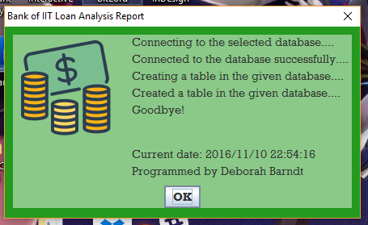

insertRecords Screenshot
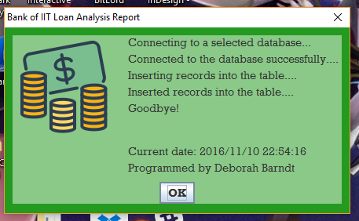
retrieveRecords Screenshot 1
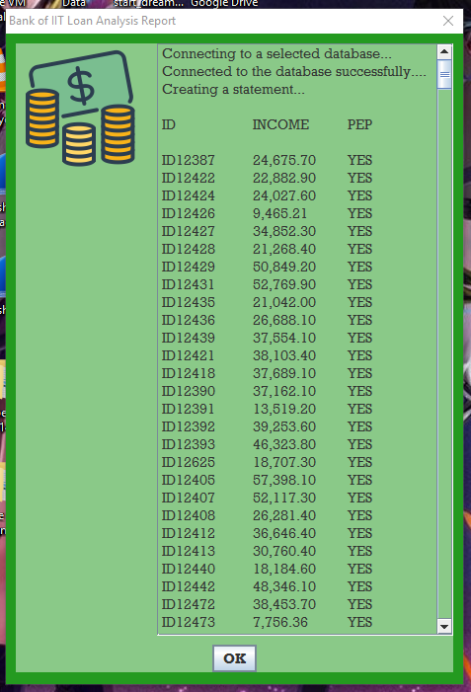

retrieveRecords Screenshot 2
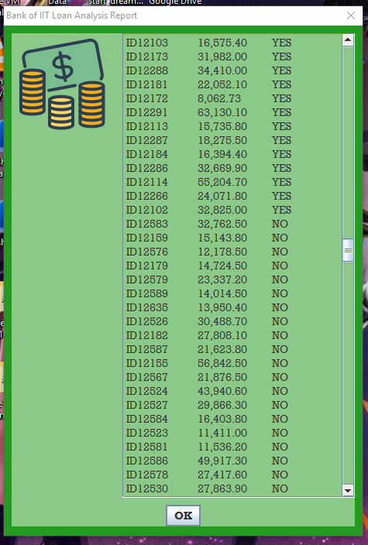

retrieveRecords Screenshot 3
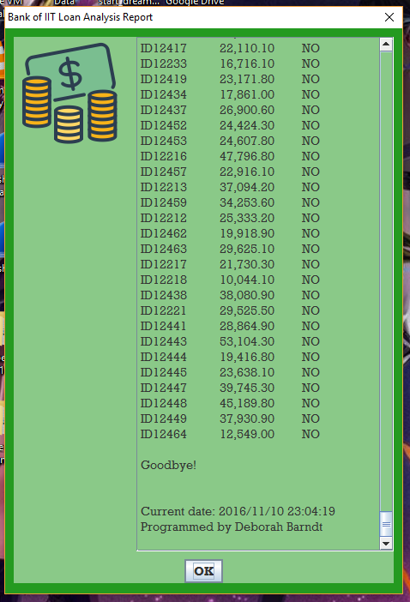

new retrieveRecords Screenshot with the JTable after
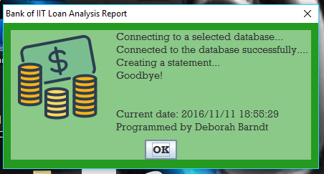
LoanTable Screenshot 1
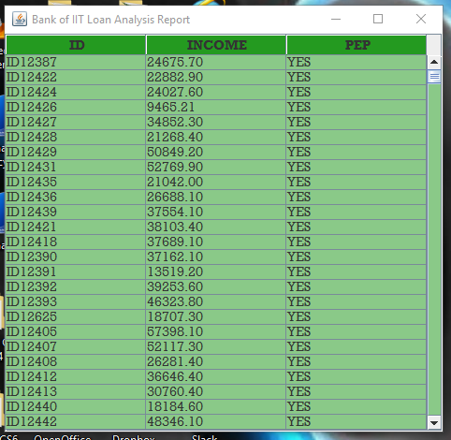

LoanTable Screenshot 2
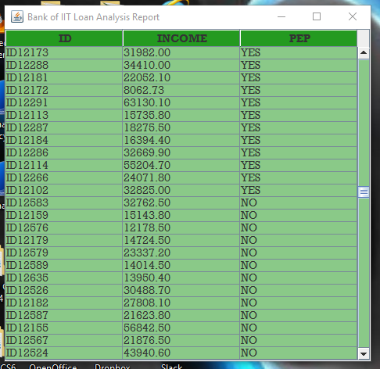

MySQL Database Screenshot
