Hands-on Projects
These projects should be completed in the order given. The hands-on projects presented in this chapter should take a total of three hours to complete. The requirements for this lab include:
- A computer with Fedora Linux installed according to Hands-on Project 2-1
- The ISO image for Ubuntu Server 14.04 installation media (ubuntu-14.04.1-serveramd64.iso)

Project 6-1
In this hands-on project, you install Ubuntu Server 14.04 Linux within a virtual machine on a Windows computer and examine the LVM partition configuration afterwards.
- 1. In your virtualization software, create a new virtual machine called Ubuntu Server Linux that has the following characteristics:
  - 4GB of memory (4096 MB)
  - An Internet connection via your PC’s network card (preferably using bridged mode)
  - A 20GB virtual hard disk
  - The virtual machine DVD drive attached to the ISO file for the Ubuntu Server 14.04 installation media (ubuntu-14.04.1-server-amd64.iso)
- Start and then connect to your Ubuntu Server Linux virtual machine using your virtualization software.
  - The Ubuntu Server Linux installation program does not use a graphical desktop. As a result, you must switch between buttons shown on the screen using the Tab key and press Enter to make your selections.
- At the Language screen, ensure that English is selected and press Enter.
- At the Ubuntu welcome screen, ensure that Install Ubuntu Server is selected and press Enter.
- At the Select a language page, ensure that English is selected and press Enter.
- At the Select your location screen, ensure that United States is selected and press Enter.
- At the Configure the keyboard screen, select Yes and press Enter. Follow the prompts to complete the detection. When the detection process finds a “us” keyboard layout, select Continue and press Enter.
- At the Configure the network screen, type a hostname of ubuntu-server, select Continue, and press Enter.
- At the Set up users and passwords page, type user1 as the full user name, select Continue, and press Enter. When prompted for the simple user name, ensure that user1 is displayed, select Continue, and press Enter. When prompted for a password for user1, type LNXrocks!, select Continue, and press Enter. When prompted to repeat the password, enter LNXrocks! again, select Continue, and press Enter. When prompted to encrypt user1’s home directory, ensure that No is selected and press Enter.
- At the Configure the clock screen, ensure that the correct time zone is displayed, select Yes and press Enter. Alternatively, if an incorrect time zone is displayed, select No, press Enter, select your time zone, and press Enter.
- At the Partition disks screen, note that the default selection is Guided – use entire disk and set up LVM and press Enter. Press Enter again to select your disk (sda or hda), and then select Yes and press Enter to write your partition changes to the disk. Note that the full size (approx. 20GB) is used for the volume group, select Continue, and press Enter.
- At the summary screen, note that Ubuntu will create an LV for the root filesystem with an ext4 filesystem and an LV for swap as well. Select Yes and press Enter to write the changes to the disk and start the installation of the core system packages.
- At the Configure the package manager screen, select Continue, and press Enter.
- At the Configuring tasksel, ensure that No automatic updates are selected and press Enter.
- At the Software selection screen, use the spacebar to individually choose all packages (except for Manual package selection), select Continue, and press Enter.
- At the Configuring mysql-server-5.5 screen, supply a password of LNXrocks!, select Continue, and press Enter. When prompted to confirm the password, type LNXrocks!, select Continue, and press Enter.
- At the Postfix Configuration screen, ensure that Internet Site is selected and press Enter. When prompted for a system mail name, ensure that ubuntu-server is listed, select Continue, and press Enter.
- At the configuring dovecot-core screen, ensure that Yes is selected and press Enter to create an SSL encryption certificate. When prompted for the host name used in the certificate, type ubuntu-server in place of localhost, select Continue, and press Enter.
- At the Install the GRUB boot loader on a hard disk screen, ensure that Yes is selected and press Enter.
- At the Finish the installation screen, ensure that Continue is selected and press Enter to reboot into the new system.
- After the system has booted, note that a graphical login is not available. Log in as user1 with the password LNXrocks!. At the command prompt, type who and press Enter.
- The root user password is not set during an Ubuntu Server installation. Instead, the user configured during the installation process (user1) has the ability to configure the root user password following installation. At the command prompt, type sudo passwd root and press Enter. Supply user1’s password of LNXrocks! when prompted and press Enter. Supply a password of LNXrocks! for the root user when prompted and press Enter. Confirm the root user password by typing LNXrocks! and press Enter.
- At the command prompt, type su - and supply a password of LNXrocks! to switch to the root user.
- At the command prompt, type df -h and press Enter. Examine the output of the df command.
- At the command prompt, type fdisk -l and press Enter.
- At the command prompt, type lvdisplay and press Enter. Note the logical volumes created for the root filesystem and swap partition within the ubuntu-server-vg volume group.
- Provide screenshot(s) of steps 22 through 26.
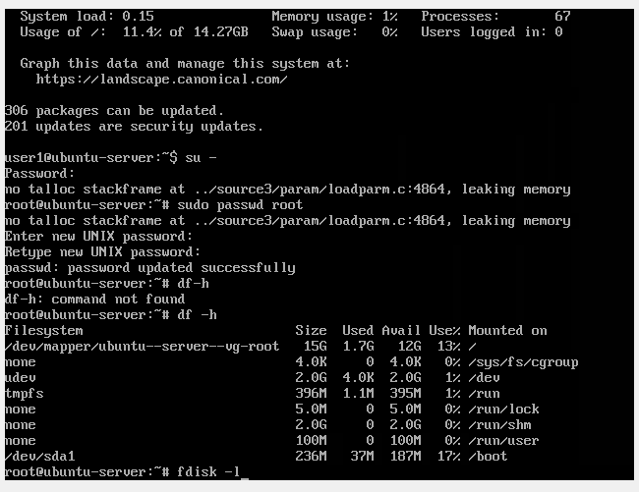
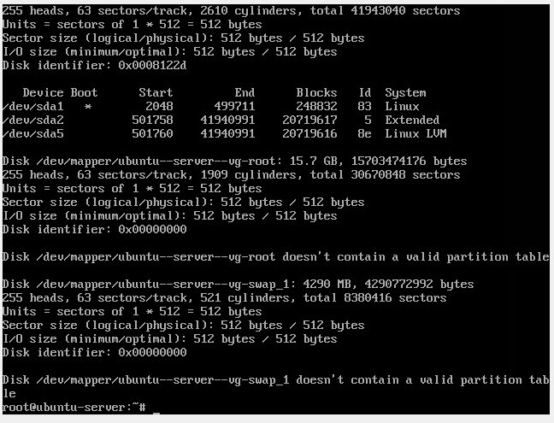
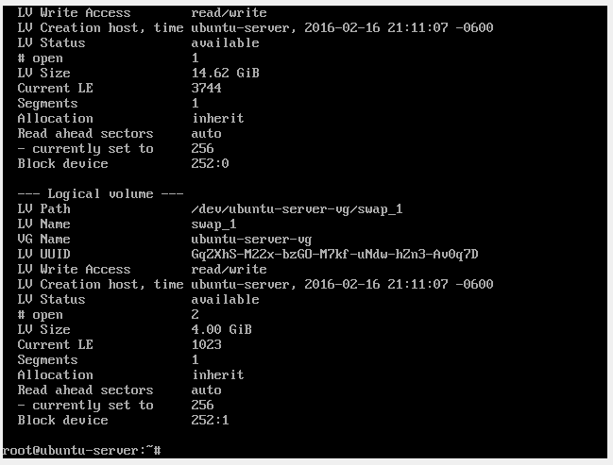

Project 6-2
In this hands-on project, you examine installation log files and system information on Fedora Linux and Ubuntu Server Linux.
- On your Ubuntu Server Linux virtual machine, log into the command-line terminal (tty1) using the user name of root and the password of LNXrocks!.
- At the command prompt, type ls /var/log/installer and press Enter. Notice the installation logs created.
- At the command prompt, type egrep –i “(error|warn)” /var/log/ installer/syslog and press Enter, view any warnings or errors that occurred during your installation.
- At the command prompt, type ls –F /proc and press Enter to view the file and directory contents of the proc filesystem.
- At the command prompt, type less /proc/cpuinfo and press Enter. Review the CPU info provided. Type q to quit the less utility.
- At the command prompt, type less /proc/modules and press Enter. Review the loaded modules. Type q to quit the less utility.
- At the command prompt, type less /proc/meminfo and press Enter. Review the memory info. Type q to quit the less utility.
- At the command prompt, type dmesg | less and press Enter. Observe the entries. How do they correspond with the hardware information that you saw in the previous three steps? Type q to quit the less utility.
- At the command prompt, type less /var/log/boot.log and press Enter. Review each entry in the file. Type q to quit the less utility.
- At the command prompt, type less /var/log/syslog and press Enter. Review the output from syslog. Type q to quit the less utility.
- Provide screenshot(s) of steps 2 through 10.
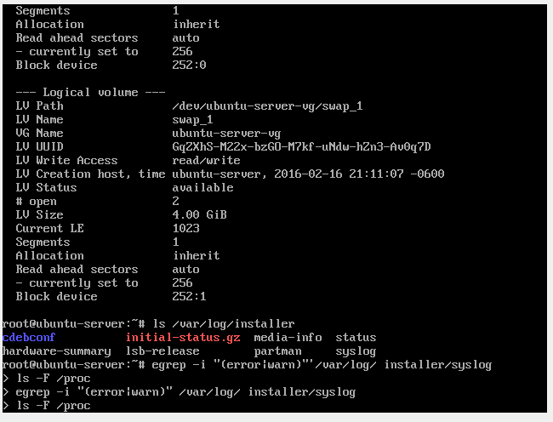
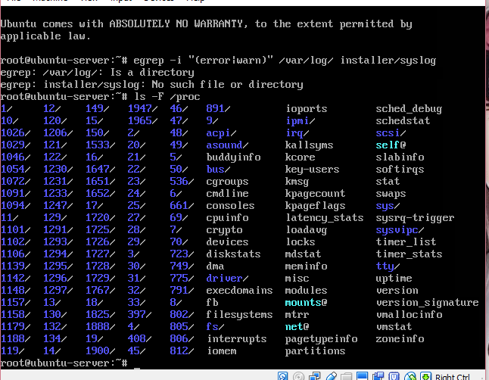
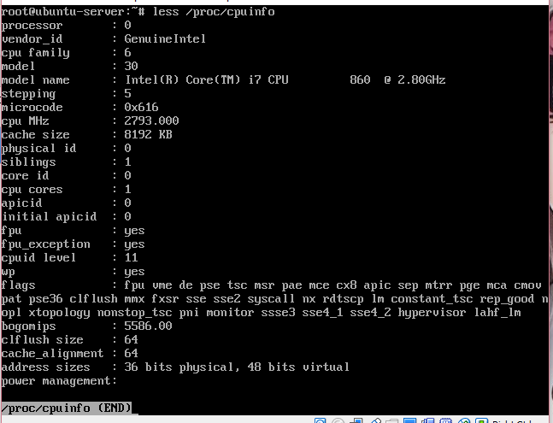
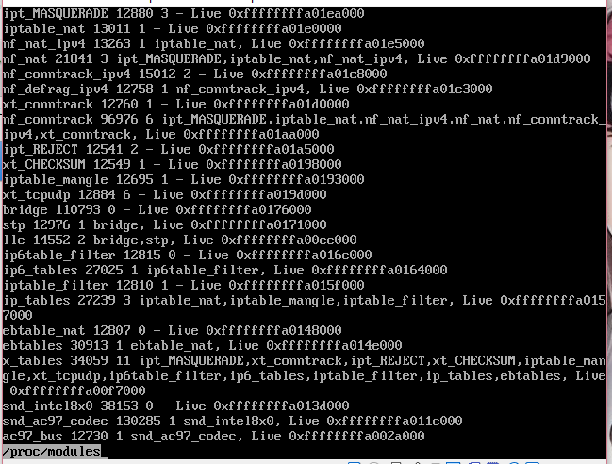
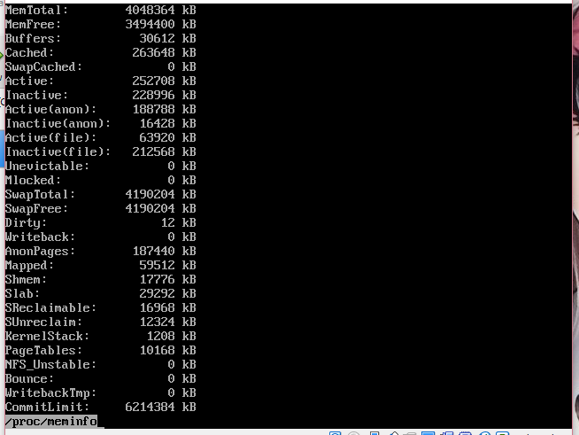
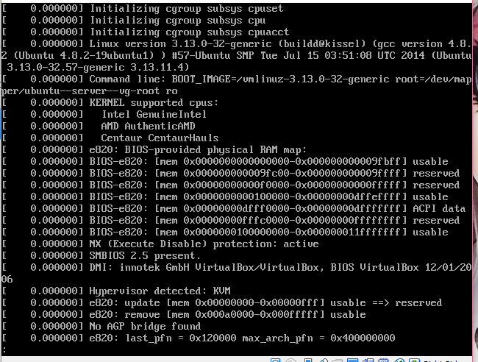
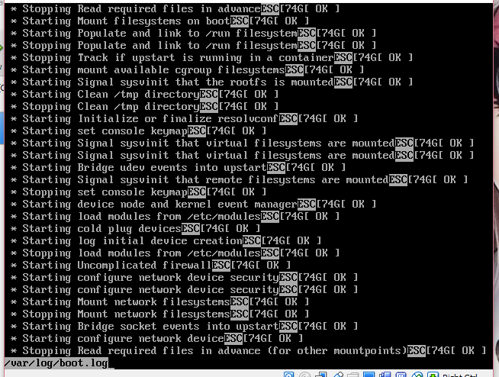
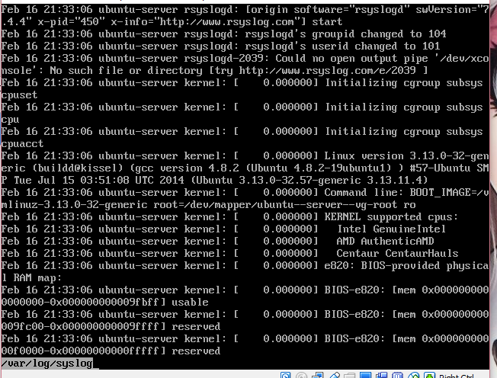

- At the command prompt, type poweroff and press Enter to shut down your Ubuntu Server Linux virtual machine.
- Boot your Fedora Linux virtual machine. After your Linux system has loaded, open the graphical terminal of your choice. Log in to the terminal using the user name of root and the password of LNXrocks!.
- At the command prompt, type ls /var/log/ and press Enter.
- At the command prompt, type egrep –iR “(error|warn)” /var/log/anaconda/ and press Enter. View any warnings or errors that occurred during your installation.
- At the command prompt, type ls –F /proc and press Enter to view the file and directory contents of the proc filesystem. Do the contents look similar to those from Ubuntu Server Linux? Next, type less /proc/cpuinfo and press Enter. Do the contents of this file look similar to the contents you saw in Step 5? Why? Type q to quit the less utility.
- At the command prompt, type dmesg | less and press Enter. Observe the entries. Type q to quit the less utility.
- At the command prompt, type journalctl –b | less and press Enter. Review each entry. Type q to quit the less utility.
- Provide screenshot(s) of steps 14 through 18.
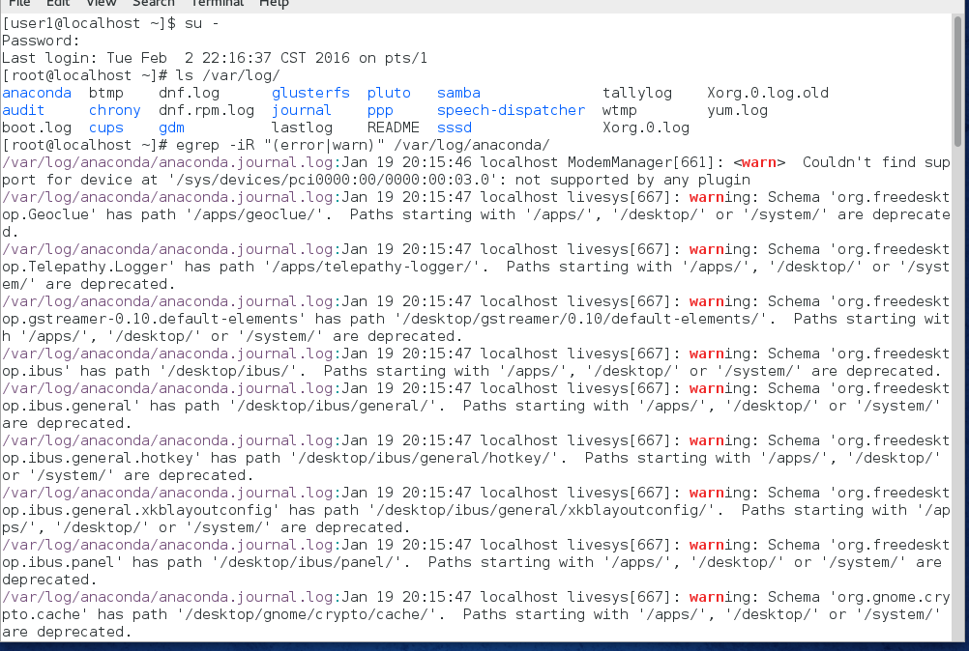
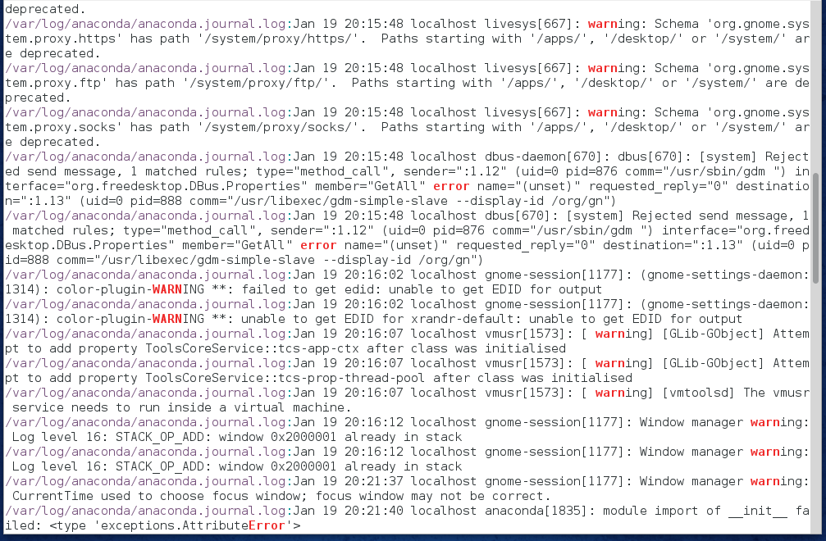
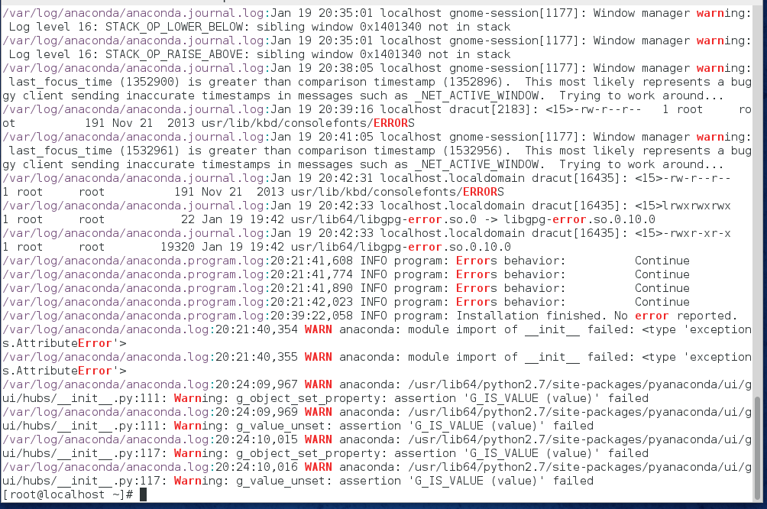
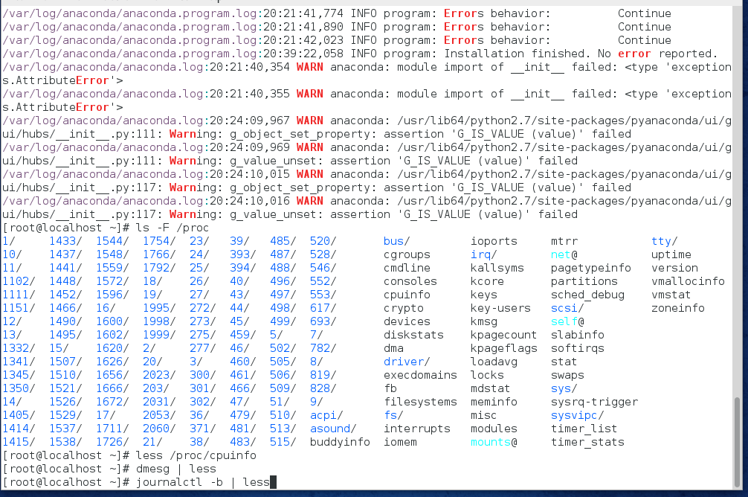
- At the command prompt, type poweroff and press Enter to shut down your Fedora Linux virtual machine.

Project 6-3
In this hands-on project, you install ZFS support on Ubuntu Server and configure the ZFS filesystem.
- Boot your Ubuntu Server Linux virtual machine. After your Linux system has loaded, log into the command-line terminal (tty1) using the user name of root and the password of LNXrocks!.
- At the command prompt, type apt-get -y install build-essential gawk zlib1g-dev uuid-dev vim-nox python-software-properties and press Enter to download and install ZFS prerequisite packages. Ubuntu Server Linux uses a different package manager than Fedora Linux. The apt-get command is functionally equivalent to the yum command that you used in previous chapters to download and install software from Internet repositories. Both apt-get and yum are discussed in Chapter 11.
- At the command prompt, type add-apt-repository ppa:zfs-native/stable and press Enter, and then press Enter again to add the location of the online ZFS software repository on the Internet to the Ubuntu installer. Next, type apt-get update and press Enter to update the Ubuntu installer with the new repository information.
- At the command prompt, type apt-get install ubuntu-zfs and press Enter to install ZFS on your Ubuntu Server Linux system.
- Edit the /etc/modules file (vi /etc/modules) and add the following lines to the end of the file. When finished, save your changes and quit the vi editor.
spl
zavl
znvpair
zunicode
zcommon
zfs
- At the command prompt, type update-initramfs -u and press Enter to update the disk and module support for the image used to load kernel modules at boot time.
- Provide screenshot(s) of steps 2 through 6.
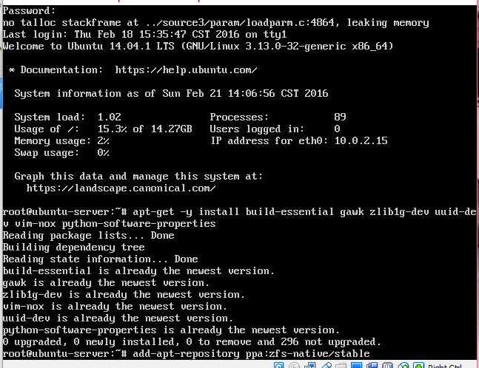
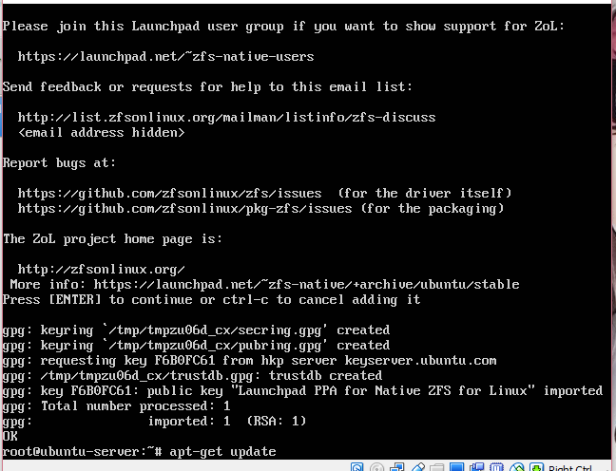
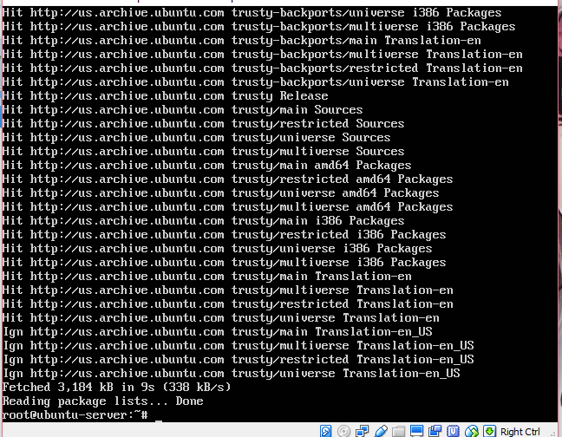

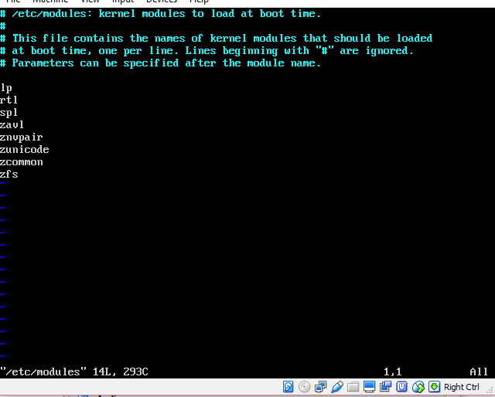
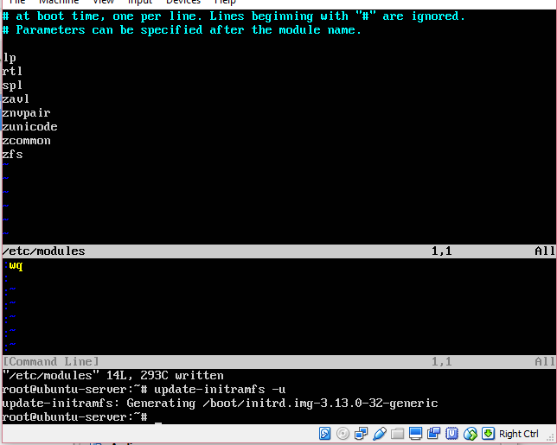
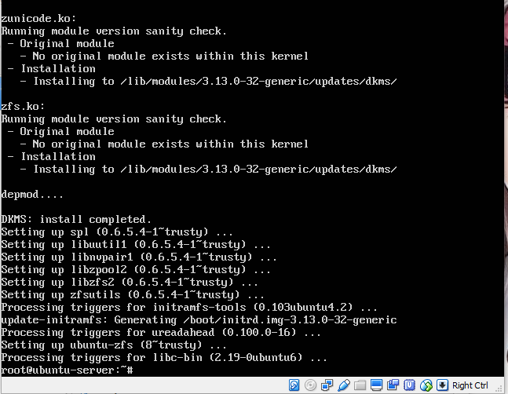
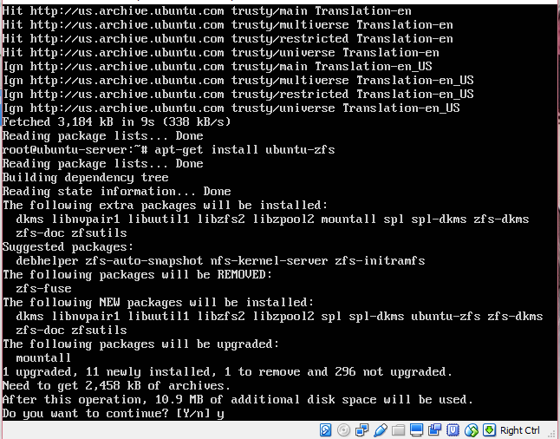

- Although ZFS normally works with device files for additional disk devices (/dev/sdb1, / dev/sdc1, /dev/sdd1, and so on), ZFS can work with nearly any device or file that can be used to store data. As a result, we’ll create four empty files using the dd command that we’ll treat as four separate disks to practice ZFS commands. Run the following commands to create four 128MB files called /disk1, /disk2, /disk3, and /disk4:
dd if=/dev/zero of=/disk1 bs=1024k count=128
dd if=/dev/zero of=/disk2 bs=1024k count=128
dd if=/dev/zero of=/disk3 bs=1024k count=128
dd if=/dev/zero of=/disk4 bs=1024k count=128
- At the command prompt, type zpool create webstorage /disk1 and press Enter to create a simple ZFS volume called webstorage from the space on /disk1. Next, type zpool list at the command prompt and press Enter to view your configuration.
- At the command prompt, type cp /etc/hosts /webstorage and press Enter to copy the /etc/hosts file to the new ZFS filesystem . Next, type ll /webstorage at the command prompt and press Enter to view the contents of the filesystem. The /etc/hosts file should have been copied successfully.
- At the command prompt, type zpool destroy webstorage and press Enter to remove the webstorage volume.
- At the command prompt, type zpool create webstorage mirror /disk1 /disk2 and press Enter to create a mirrored ZFS volume called webstorage from the space on /disk1 and /disk2. Next, type zpool list at the command prompt and press Enter to view your configuration. Following this, type zpool status webstorage at the command prompt and press Enter. Does you mirror have any problems listed?
- At the command prompt, type dd if=/dev/random of=/disk1 bs=512 count=1 and press Enter to overwrite a portion of /disk1 using the dd command, simulating disk corruption. Next, type zpool scrub webstorage at the command prompt and press Enter to update the status of the ZFS filesystem, and then type zpool status webstorage at the command prompt and press Enter. Does you mirror have any problems listed?
- At the command prompt, type zpool detach webstorage /disk1 and press Enter to remove the bad disk (/disk1) from the mirror, and then type zpool status webstorage at the command prompt and press Enter to verify that it is no longer listed.
- Provide screenshot(s) of steps 8 through 14.

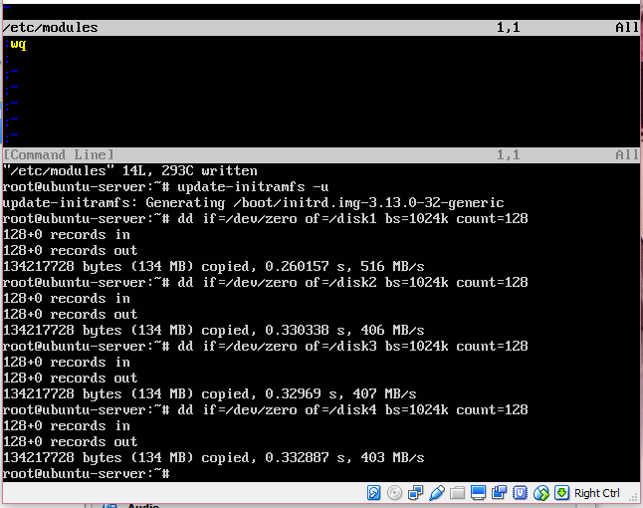
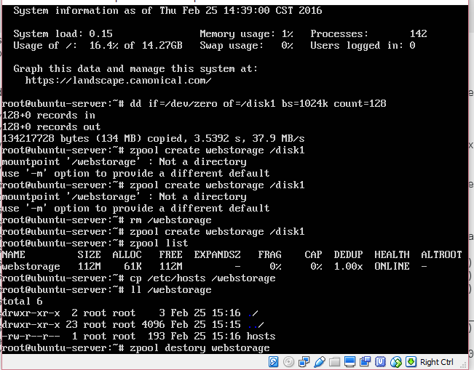
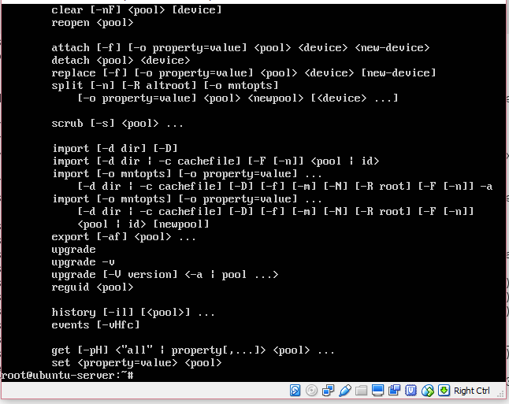
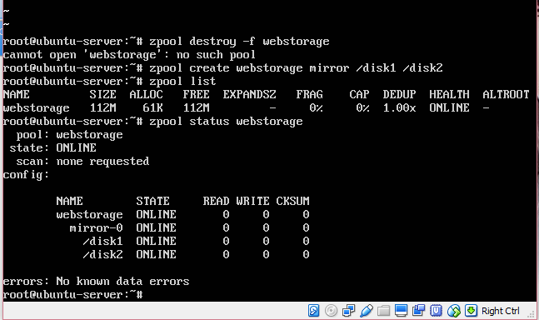
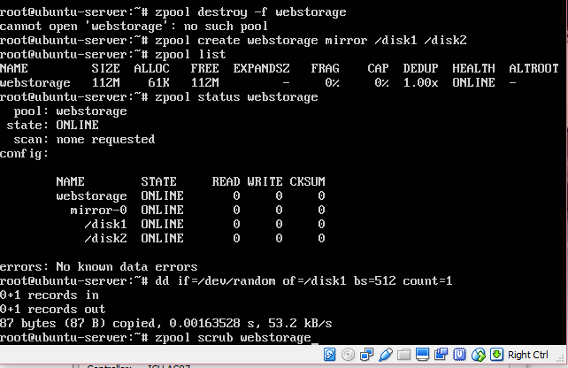
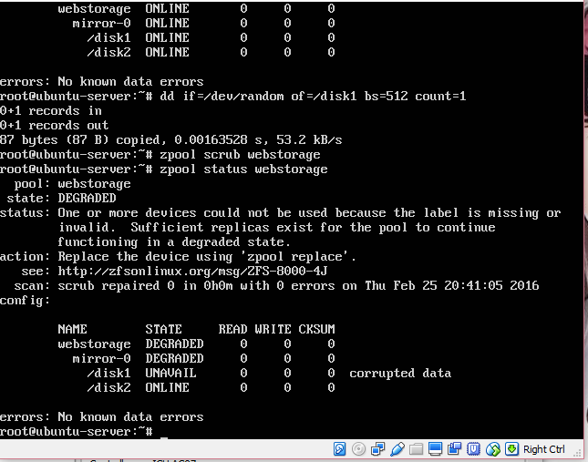
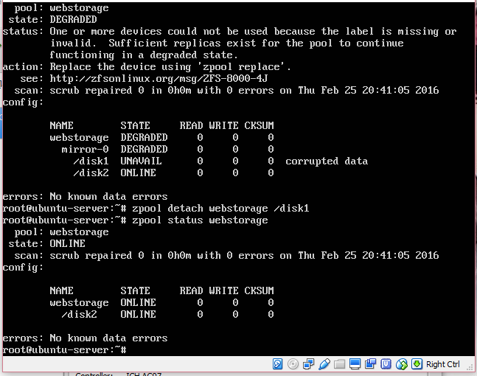
- At the command prompt, type zpool attach webstorage /disk2 /disk3 and press Enter to mirror the data on /disk2 to a new disk (/disk3), and then type zpool status webstorage at the command prompt and press Enter. Is the mirror fully functional using /disk2 and /disk3?
- At the command prompt, type zpool iostat -v webstorage and press Enter to view the input and output statistics for your mirror. Next, type zpool destroy webstorage and press Enter to remove the webstorage mirror.
- At the command prompt, type zpool create webstorage raidz /disk2 /disk3 /disk4 and press Enter to create a RAID-Z volume called webstorage using /disk2, /disk3 and /disk4, and then type zpool status webstorage at the command prompt and press Enter to verify the results. Next, type zpool iostat -v webstorage and press Enter to view the input and output statistics for your RAID-Z volume.
- At the command prompt, type each of the following commands in turn and press Enter to create three subdirectories under /webstorage:
mkdir /webstorage/site1
mkdir /webstorage/site2
mkdir /webstorage/site3
- At the command prompt, type zfs list and press Enter. Are the site1, site2, and site3 directories listed? Next, type each of the following commands in turn and press Enter to create three subfilesystems for site1, site2, and site3:
zfs create webstorage/site1
zfs create webstorage/site2
zfs create webstorage/site3
- At the command prompt, type zfs list and press Enter. Are the site1, site2, and site3 directories listed?
- At the command prompt, type zfs get all webstorage/site1 and press Enter to view the available options for the site1 subfilesystem. Next, type zfs set quota=10G webstorage/site1 at the command prompt and press Enter to set a quota of 10GB for the subfilesystem. Next, type zfs get all webstorage/site1 and press Enter. Was your quota listed? Why will this quota never be applied to the webstorage/site1 subfilesystem? (Hint: Think of the total size of the webstorage volume)
- Provide screenshot(s) of steps 16 through 22.
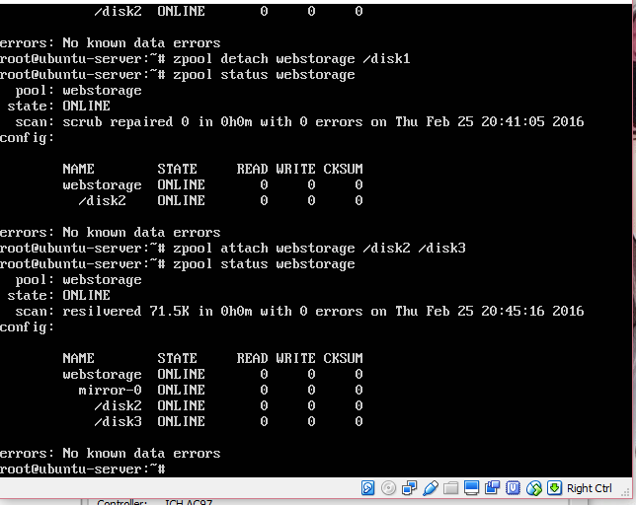
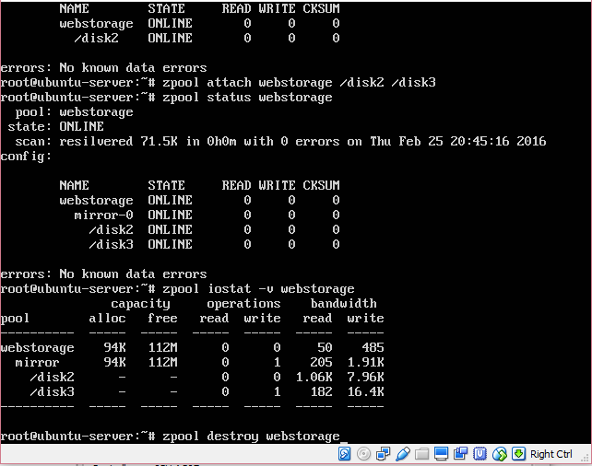

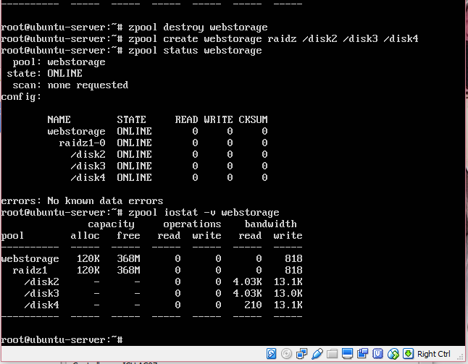
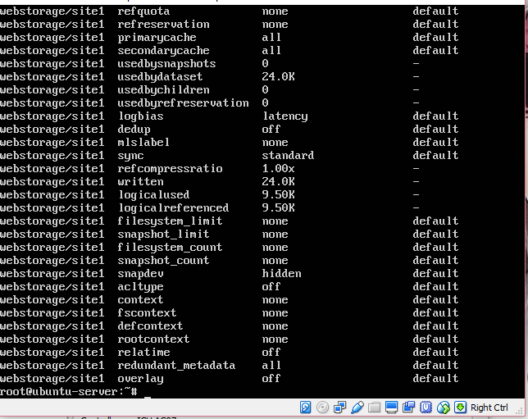

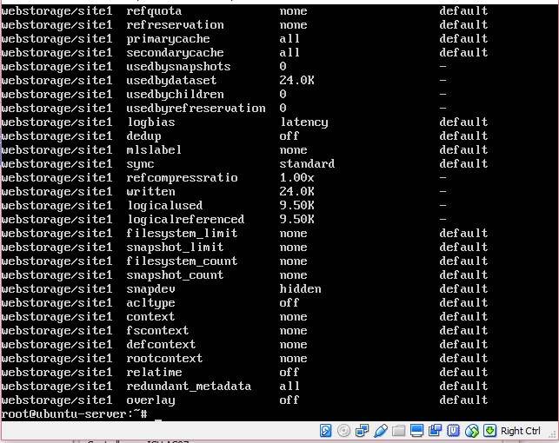
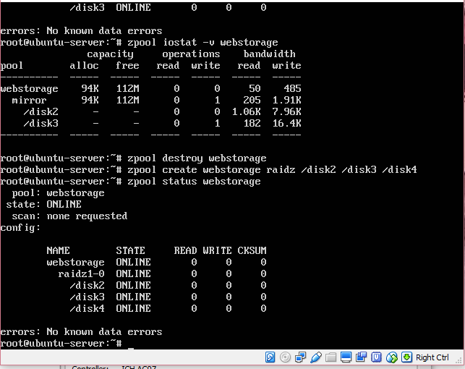
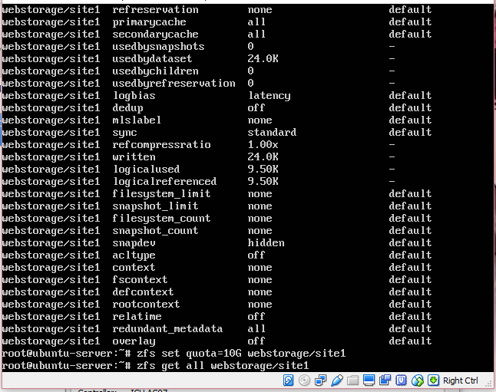
- At the command prompt, type poweroff and press Enter to shut down your Ubuntu Server Linux virtual 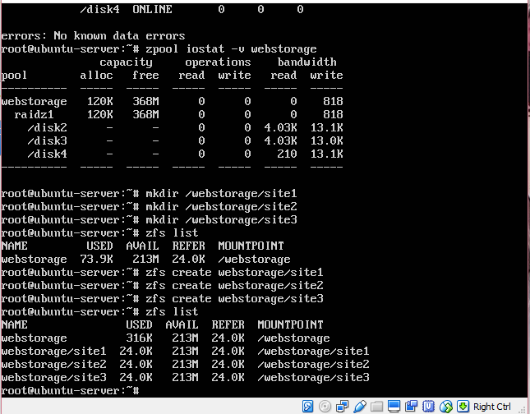machine.

Project 6-4
In this hands-on project, you use system rescue on both Fedora Linux and Ubuntu Server Linux to check your root filesystem for errors and change the root user’s password.
- In your virtualization software, ensure that the DVD for your Fedora Linux virtual machine is attached to the ISO image for Fedora 20 Live (Fedora-Live-Desktop-x86_64- 20-1.iso). Next, start and then connect to your Fedora Linux virtual machine using your virtualization software.
- At the Fedora Live welcome screen, press Enter to boot Fedora Live.
- Once the graphical desktop and Welcome to Fedora screen have loaded, select the option Try Fedora and click Close when prompted.
- Navigate to Activities, Show Applications, Utilities, Terminal within the GNOME desktop to open a BASH terminal.
- At the command prompt, type su - root and press Enter to switch to the root user.
- At the command prompt, type df -h and press Enter to view the mounted filesystems. Is the root filesystem on your hard disk mounted?
- At the command prompt, type fsck -f /dev/sda3 (or fsck -f /dev/hda3) and press Enter to check your (/) root filesystem for errors.
- At the command prompt, type mount /dev/sda3 /mnt (or mount /dev/hda3 /mnt) and press Enter to mount the (/) root filesystem on your hard disk to the /mnt directory on the Fedora live system. Next, type mount /dev/sda1 /mnt /boot (or mount /dev/hda1 /mnt/boot) and press Enter to mount the /boot filesystem on your hard disk to the /mnt/boot directory on the Fedora live system.
- At the command prompt, type chroot /mnt and press Enter to switch from the root filesystem on your Live Fedora system to the root filesystem on your hard disk. Next, type ls /root and press Enter. Do you recognize the files?
- At the command prompt, type passwd root and press Enter. Supply a new root user password of Secret123 and press Enter when prompted (twice).
- Click the power icon in the upper-right corner, select the power icon that appears, and click Power Off to shut down your Fedora Live installation image.
- In the Settings for your virtual machine in your virtualization software, ensure that the DVD drive is no longer attached to the Fedora ISO image.
- Finally, start your Fedora Linux virtual machine using your virtualization software. After the system has loaded, switch to a command-line terminal (tty2) by pressing Ctrl+Alt+F2 and log in to the terminal using the user name of root and the password of Secret123. Were you successful?
- At the command prompt, type passwd root and press Enter. Supply a new root user password of LNXrocks! and press Enter when prompted (twice).
- Provide screenshot(s) of steps 5 through 14.

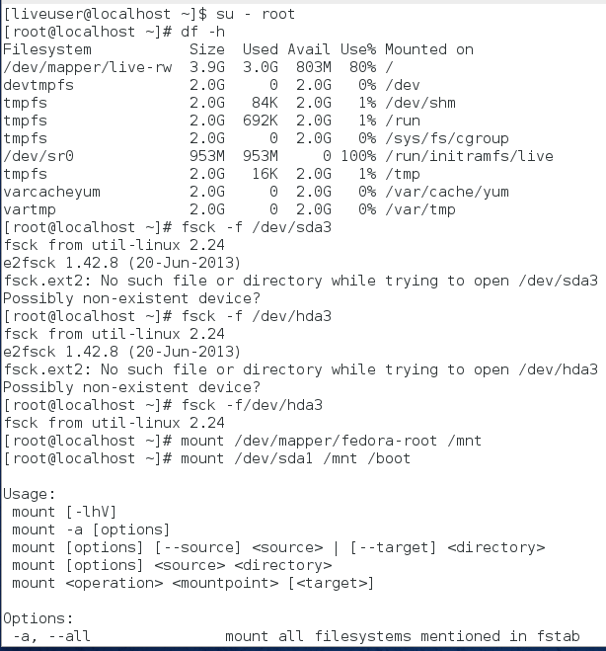
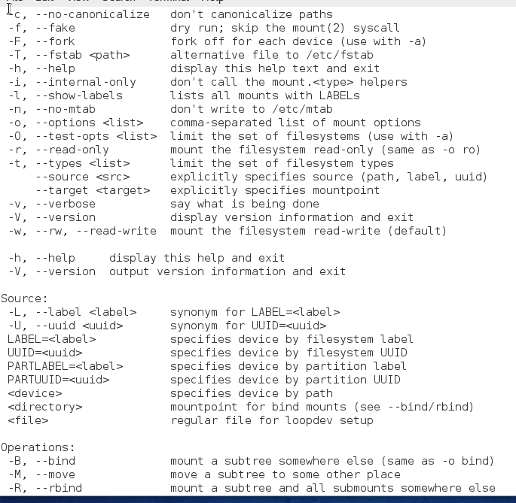

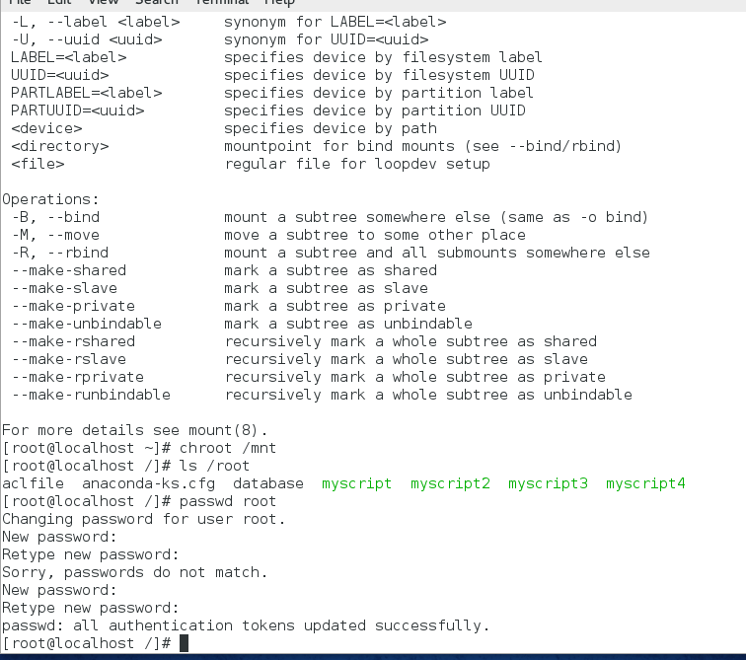
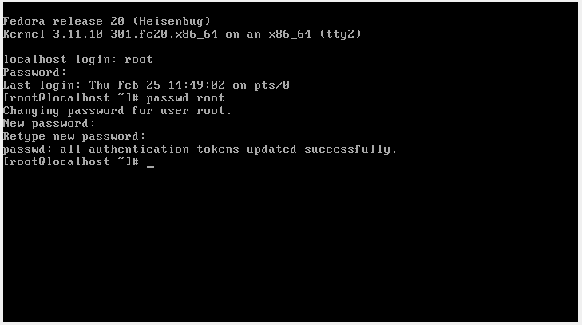

- At the command prompt, type poweroff and press Enter to shut down your Fedora Linux virtual machine.
- In your virtualization software, ensure that the DVD for your Ubuntu Server Linux virtual machine is attached to the ISO image for Ubuntu Server 14.04 (ubuntu-14.04.1- server-amd64.iso). Next, start and then connect to your Ubuntu Server Linux virtual machine using your virtualization software.
- At the language screen, ensure that English is selected and press Enter.
- At the Ubuntu welcome screen, navigate to the Rescue a broken system option and press Enter.
- At the Select a language page, ensure that English is selected and press Enter.
- At the Select your location screen, ensure that United States is selected and press Enter.
- At the Configure the keyboard screen, select Yes and press Enter. Follow the prompts to complete the detection. When the detection process finds a “us” keyboard layout, select Continue and press Enter.
- At the Configure the network screen, view the default hostname supplied, select Continue, and press Enter.
- At the Configure the clock screen, ensure that the correct time zone is displayed, select Yes, and press Enter. Alternatively, if an incorrect time zone is displayed, select No, press Enter, select your time zone, and press Enter.
- At the Enter rescue mode screen, select /dev/Ubuntu-server-vg/root and press Enter. When prompted to also mount the /boot partition, ensure that Yes is selected and press Enter.
- At the Enter rescue mode screen, view the options. Select Execute a shell in /dev/Ubuntu-server-vg/root and press Enter. Ensure that Continue is selected and press Enter when prompted. This will change the root to the mounted / (root) filesystem on your hard disk with the chroot command.
- At the command prompt, type df and press Enter to view the mounted filesystems. Is the root filesystem on your hard disk mounted?
- At the command prompt, type passwd root and press Enter. Supply a new root user password of Secret123 and press Enter when prompted (twice).
- At the command prompt, type exit and press Enter.
- At the Enter rescue mode screen, select Reboot the system and press Enter.
- In the Settings for your virtual machine in your virtualization software, ensure that the DVD drive is no longer attached to the Ubuntu Server ISO image.
- After the system has loaded, log into the command-line terminal (tty1) using the user name of root and the password of Secret123.
- At the command prompt, type passwd root and press Enter. Supply a new root user password of LNXrocks! and press Enter when prompted (twice).
- Provide screenshot(s) of steps 18 through 33.
