Hands-on Projects
These projects should be completed in the order given. The hands-on projects presented in this chapter should take a total of three hours to complete. The requirements for this lab include:
- A computer with Fedora Linux installed according to Hands-on Project 2-1 and Ubuntu Server Linux installed according to Hands-On Project 6-1.

Project 12-1
In this hands-on project, you view and modify the TCP/IP configuration of the network interface on your Fedora Linux and Ubuntu Server Linux virtual machines.
- Boot your Fedora Linux virtual machine. Login to your chosen desktop environment as user1 using password LNXrocks! and open up a terminal window.
- At the terminal, become root by typing su - and press enter and provide LNXrocks! as the password.
- At the command prompt, type ifconfig and press Enter. What IPv4 and IPv6 configuration do you see? IPv4: 10.0.2.15 & IPv6: fe80::a00:27ff:fe6b:40cd
- At the command prompt, type cat /etc/sysconfig/network-scripts/ifcfg-INTERFACE where INTERFACE is what was displayed from ifconfig and press Enter. Is your configuration listed? yes
- At the command prompt, type ifdown INTERFACE (from ifconfig) and press Enter. Next, type ifconfig at the command prompt and press Enter.
- At the command prompt, type ifup INTERFACE (from ifconfig) and press Enter.
- At the command prompt, type ping interfaceIP and press Enter, where interfaceIP is the IPv4 address of the output of ifconfig. Do you receive ping responses from your network interface? Yes. Press Ctrl+c when finished to quit the ping command.
- At the command prompt, type netstat -i and press Enter. View the statistics for your network interfaces. If necessary, consult the netstat manual page to determine the meaning of each column displayed.
- Boot your Ubuntu Server Linux virtual machine. After your Linux system has been loaded, log into tty1 using the user name of root and the password of LNXrocks!.
- At the command prompt, type ifconfig and press Enter. What IPv4 and IPv6 configuration do you see for eth0? IPv4: 10.0.2.15 & IPv6: fe80::a00:27ff:fe87:cd7a/64
- At the command prompt, type cat /etc/network/interfaces and press Enter. Is IP information obtained automatically for eth0? Yes. What lines could you modify and add to this file to set a static IP configuration? You would add static to the line dhcp.
- At the command prompt, type ifdown eth0 ; ifup eth0 and press Enter. Did the command probe for a DHCP server? Yes.
- Provide screenshot(s) of steps 3 through 12.
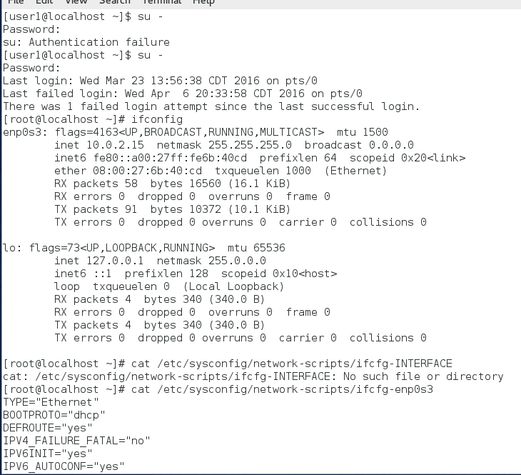
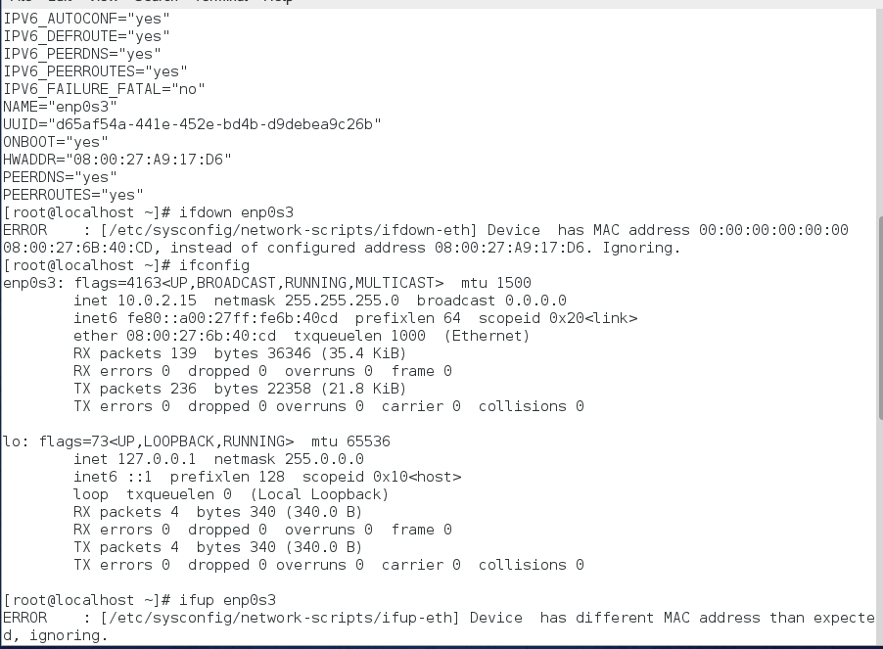

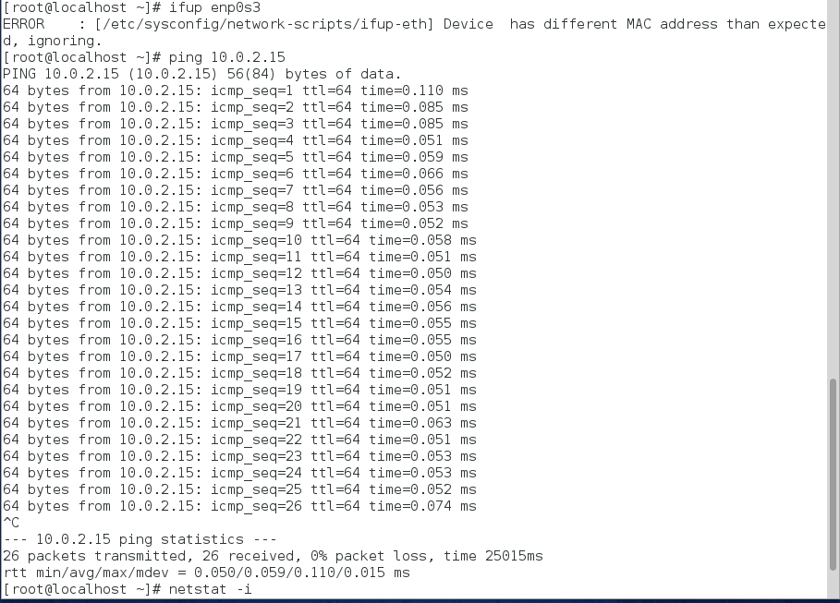

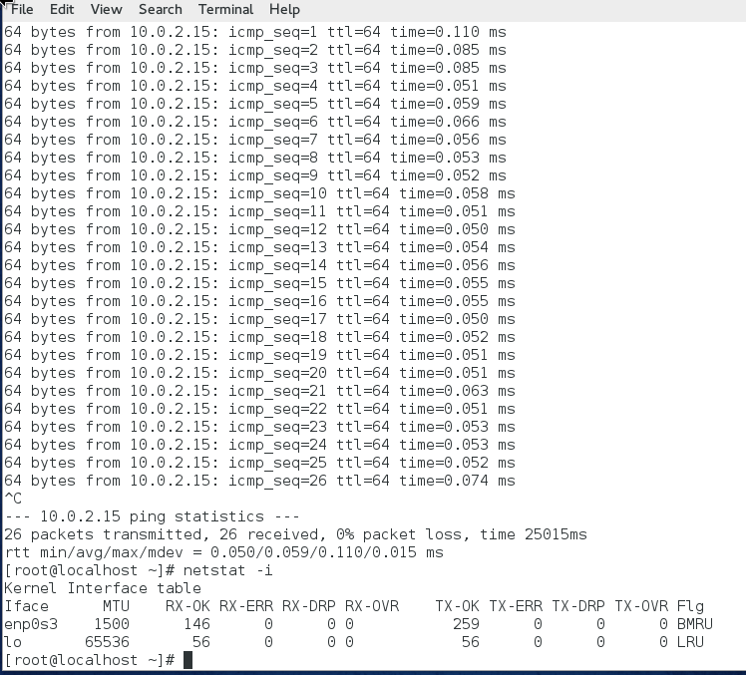

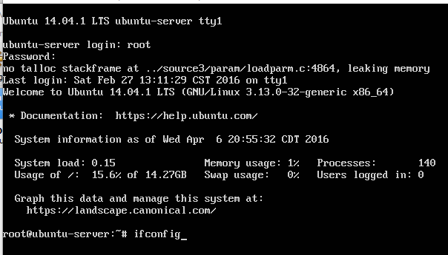

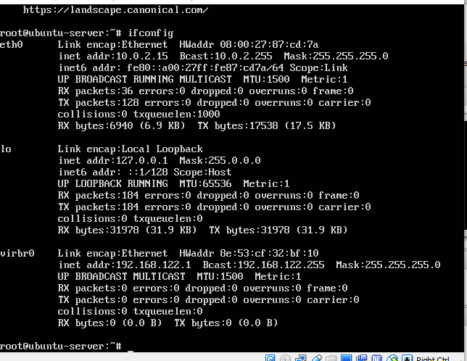

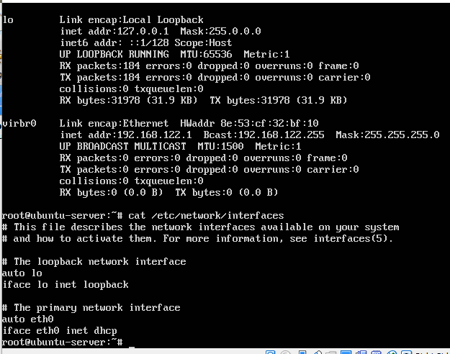

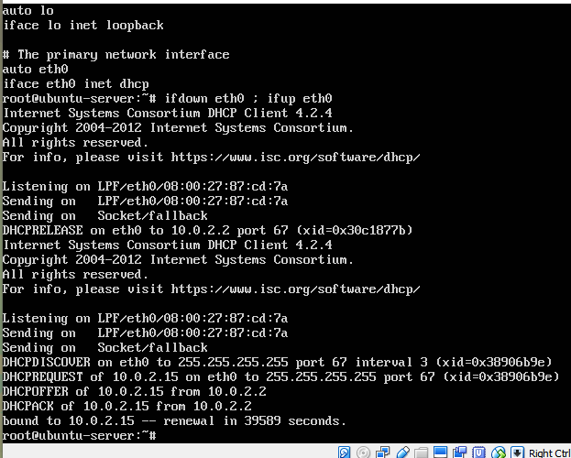

Project 12-2
In this hands-on project, you view your host name as well as resolve host names and configure host name resolution.
- Boot your Fedora Linux virtual machine. Login to your chosen desktop environment as user1 using password LNXrocks! and open up a terminal window.
- At the terminal, become root by typing su - and press enter and provide LNXrocks! as the password.
- At the command prompt, type hostname and press Enter. What is your host name? localhost.localdomain
- Next, type cat /etc/hostname at the command prompt and press Enter. What host name is listed here? Localhost.localdomain
- At the command prompt, type cat /etc/resolv.conf and press Enter. Do you have a DNS server configured? Yes.
- At the command prompt, type less /etc/nsswitch.conf and press Enter. Will files such as /etc/hosts be used for name resolution before DNS? Yes. Press q to quit the less utility.
- Edit the /etc/hosts file with a text editor such as vim. Add a line to the bottom of the file that reads:
1.2.3.4 fakehost.fakedomain.com sample
When finished, save your changes and quit the editor.
- At the command prompt, type ping -c 5 localhost and press Enter. Was the name resolved correctly? Yes.
- At the command prompt, type ping -c 5 fakehost.fakedomain.com and press Enter. Was the name resolved correctly? Was the ping command able to contact the host? No and no.
- At the command prompt, type ping -c 5 sample and press Enter. Was the name resolved correctly? Was the ping command able to contact the host? No and no.
- On your Ubuntu Server Linux virtual machine, log into tty1 using the user name of root and the password of LNXrocks!. Perform Steps 2 through 9 and note any differences.
- Provide screenshot(s) of steps 3 through 11 for both Fedora and Ubuntu.
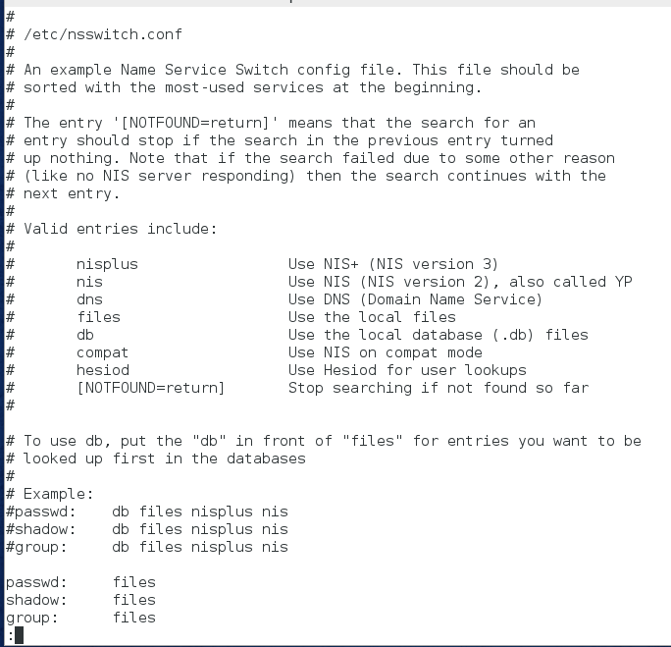

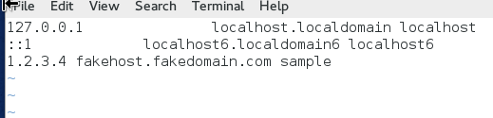
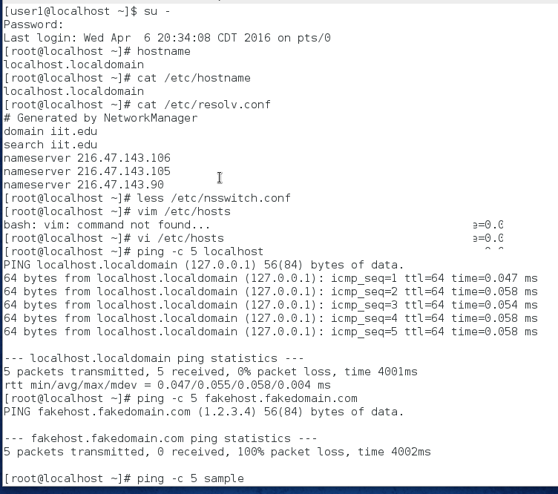

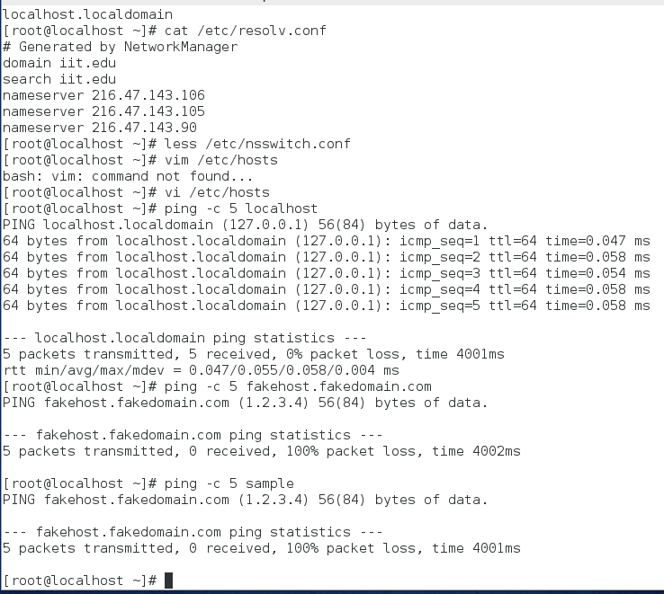
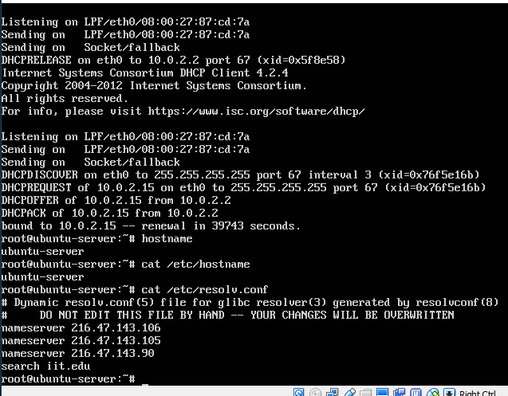
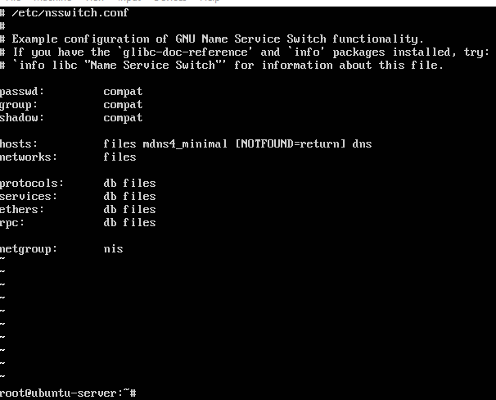

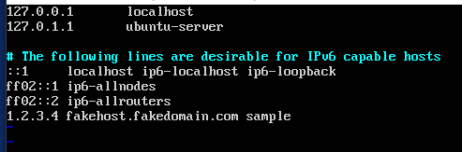

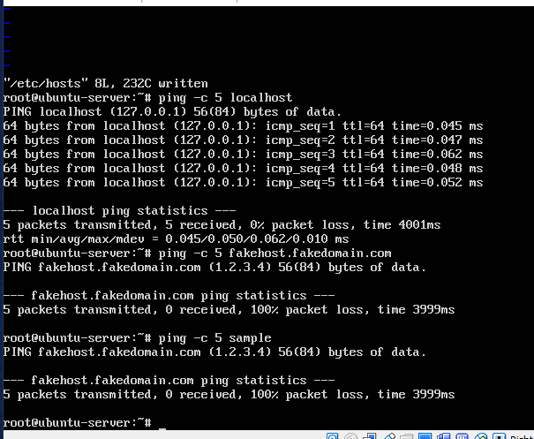

Project 12-3
In this hands-on project, you test name resolution using your ISP’s DNS server on your Ubuntu Server Linux virtual machine.
- Boot your Fedora Linux virtual machine. Login to your chosen desktop environment as user1 using password LNXrocks! and open up a terminal window.
- At the terminal, become root by typing su - and press enter and provide LNXrocks! as the password.
- At the command prompt, type host ftp.kernel.org and press Enter. What IP address was returned for ftp.kernel.org? Is there another name for ftp.kernel.org? The IP addresses are 199.204.44.194, 149.20.4.69, and 198.145.20.140. The other name for ftp.kernel.org is ftp.all.kernel.org.
- At the command prompt, type nslookup ftp.kernel.org and press Enter. How do you know that this information came from your ISP’s DNS server? Because it lists the same IP addresses that were provided previously.
- At the command prompt, type the command dig ftp.kernel.org and press Enter. What additional information does dig provide compared to the nslookup and host utilities? It gives the version, global options, pseudosection, question section, and answer section.
- Provide screenshot(s) of steps 3 through 5.
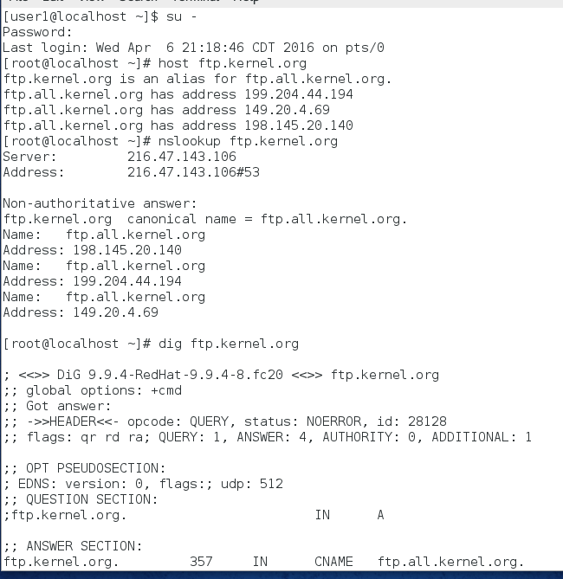

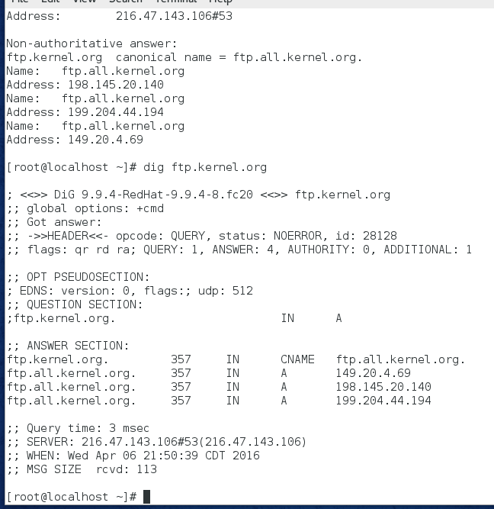

Project 12-4
In this hands-on project, you view and configure the route table on your Fedora Linux virtual machine as well as view and test your routing configuration.
- Boot your Fedora Linux virtual machine. Login to your chosen desktop environment as user1 using password LNXrocks! and open up a terminal window.
- At the terminal, become root by typing su - and press enter and provide LNXrocks! as the password.
- At the command prompt, type route and press Enter. What entries are listed? What does each entry represent? What IPv4 address is listed as your default gateway? The entries that are listed are destination, gateway, genmask, flags, metric, ref, use, and iface. The destination represents where the destination address is. Gateway represents the IP addres on a router. Genmask represents the netmask for the destination. Flags represents the status of the route. Metric represents the distance to the target, Ref is the number of references to this route, Use is the count of lookups for the route, and Iface is the interface to which packets for this route will be sent. The IPv4 address that is listed in my default is 10.0.2.2.
- At the command prompt, type ip route add 1.0.0.0/8 via gwIP and press Enter, where gwIP is the IPv4 address of your default gateway.
- At the command prompt, type route and press Enter. Is the route added in Step 3 visible? Will this route interfere with traffic that is sent to the 1.0.0.0 network? Explain. Yes it is visible. No it will not interfere, because it has a different netmask destination.
- At the command prompt, type traceroute ftp.kernel.org and press Enter. How many routers are used to pass your packet to the ftp.kernel.org computer? I don’t know, because while it pops up 30 it also posts *** for all of them.
- At the command prompt, type tracepath ftp.kernel.org and press Enter. Is the same path taken? If not, explain why. I would say no, because all 31 responded with no reply.
- At the command prompt, type the command cat /proc/sys/net/ipv4/ip_ forward and press Enter. Is your system configured as an IPv4 router? Yes. Next, type the command cat /proc/sys/net/ipv6/conf/all/forwarding and press Enter. Is your system configured as an IPv6 router? No.
- Provide screenshot(s) of steps 3 through 8.
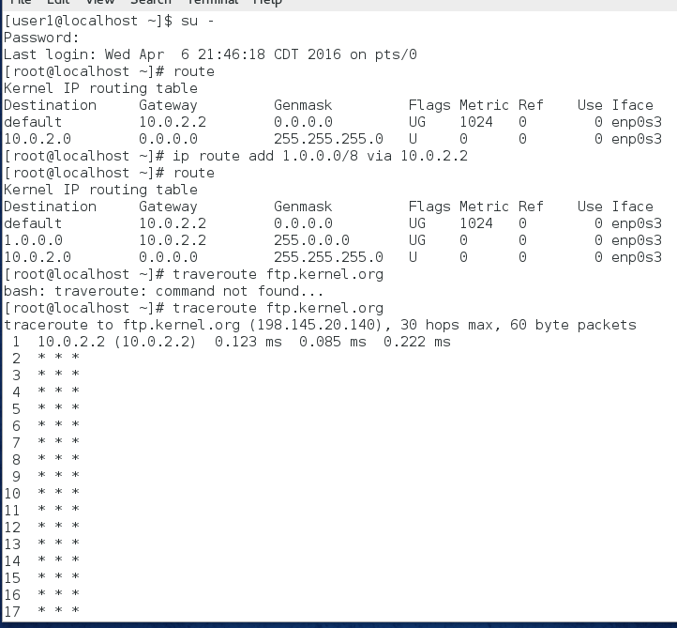
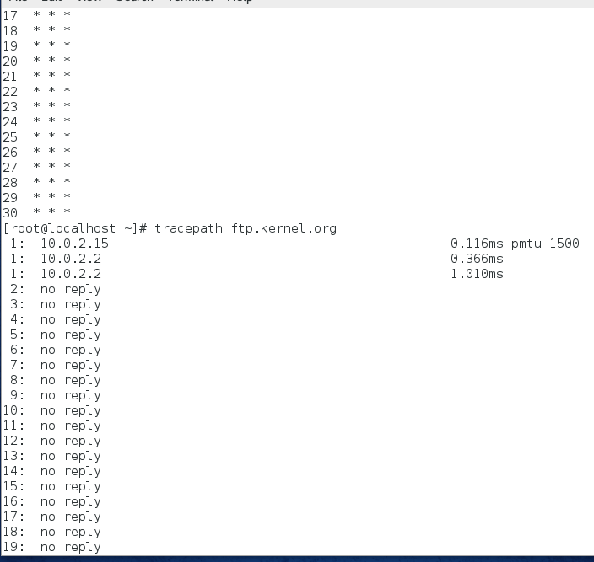
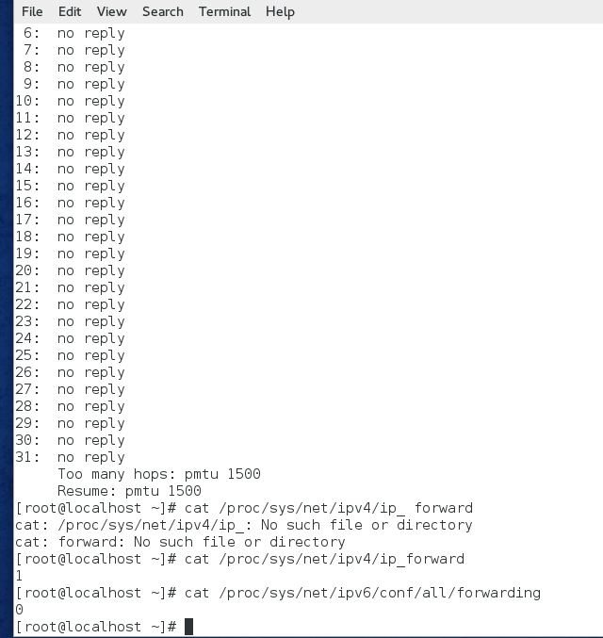

Project 12-5
In this hands-on project, you configure SSH on your Ubuntu Server Linux and Fedora Linux virtual machines. Additionally, you perform remote administration of your Ubuntu Server Linux and Fedora Linux virtual machines using SSH.
- Boot your Fedora Linux virtual machine. Login to your chosen desktop environment as user1 using password LNXrocks! and open up a terminal window.
- At the terminal, become root by typing su - and press enter and provide LNXrocks! as the password.
- At the command prompt, type ps –ef | grep sshd and press Enter. Is the SSH daemon started by default? Yes.
- At the command prompt, type systemctl enable sshd.service; systemctl start sshd.service and press Enter to start the SSH daemon and ensure that it is started at boot time.
- At the command prompt, type ssh root@localhost and press Enter. When prompted to connect to the remote system, type yes and press Enter. Next, supply the root user’s password of LNXrocks! and press Enter.
- At the command prompt, type who and press Enter. Type exit and press Enter to log out of your remote shell.
- At the command prompt, type ssh -X root@localhost and press Enter. Supply the root user’s password of LNXrocks! and press Enter when prompted.
- At the command prompt, type system-config-abrt and press Enter. Note that this command starts the remote Problem Reporting Utility in a graphical window. Close the Problem Reporting Utility, type exit, and press Enter to close your remote shell.
- At the command prompt, type ssh user1@IP where IP is the IP address of your Ubuntu Server Linux virtual machine. When prompted to connect to the remote system, type yes and press Enter. Supply the user1 password of LNXrocks! when prompted.
- At the command prompt, type su - and press Enter. Supply the root user password of LNXrocks! when prompted to obtain a root shell.
- At the command prompt, type vim /etc/ssh/sshd_config and press Enter. Modify the PermitRootLogin without-password line such that it reads PermitRootLogin yes, save your changes, and quit the vi editor.
- At the command prompt, type service ssh reload and press Enter to force the SSH daemon to reload its configuration file.
- Type exit and press Enter to log out of your remote shell.
- At the command prompt, type ssh root@IP where IP is the IP address of your Ubuntu Server Linux virtual machine, and supply the root user password of LNXrocks! when prompted. Next, type exit and press Enter to log out of your remote shell.
- At the command prompt, type ssh root@IP cat /etc/issue > /root/partner_issue and press Enter, where IP is the IP address of your Ubuntu Server. Next, supply the root user’s password of LNXrocks! and press Enter.
- At the command prompt, type cat partner_issue and press Enter. The file should have transferred successfully.
- At the command prompt, type less /etc/ssh/ssh_config and press Enter. Examine the SSH client options available. Note the encryption algorithms supported in the commented Ciphers line. Press q when finished.
- At the command prompt, type less /etc/ssh/sshd_config and press Enter. Examine the SSH daemon options available. What line would allow root connections to the SSH daemon if they were not allowed by default? Press q when finished. PermitRootLogin
- At the command prompt, type cat /root/.ssh/known_hosts and press Enter. What two hosts are listed in this file and why? The localhost and 127.0.0.1, which is the Fedora and Ubuntu that is running on the server.
- 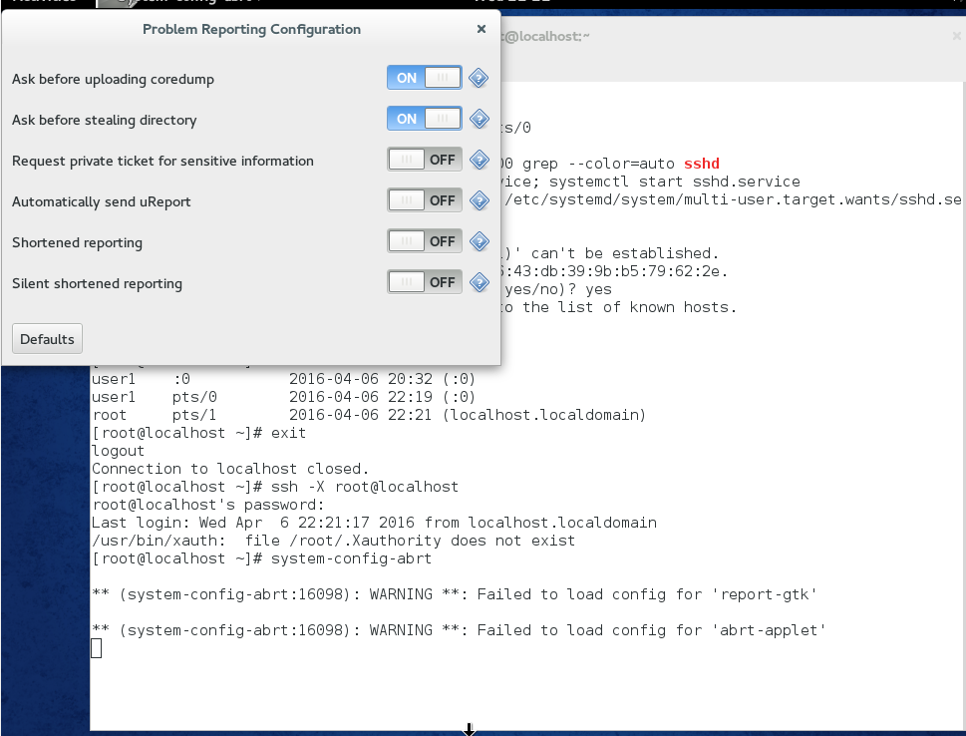
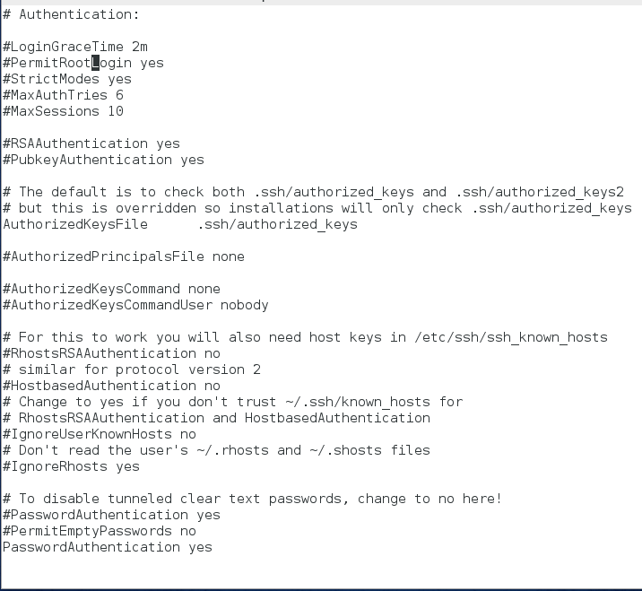
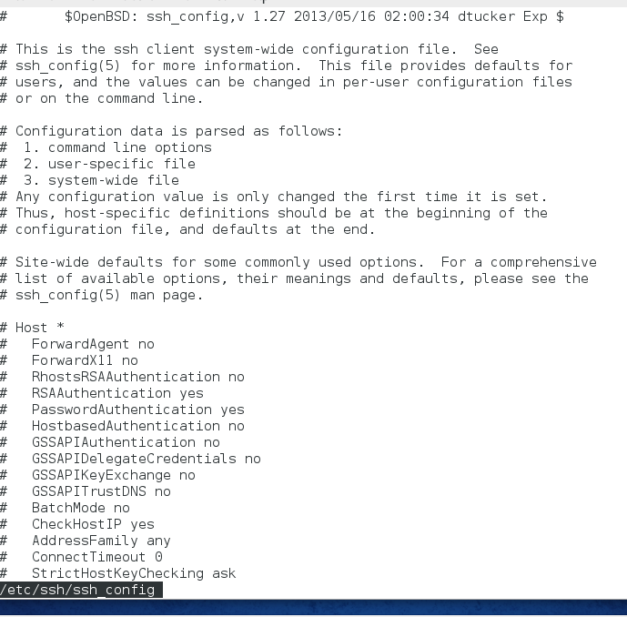
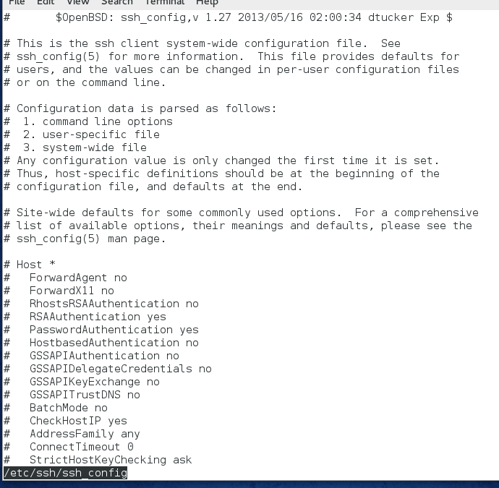
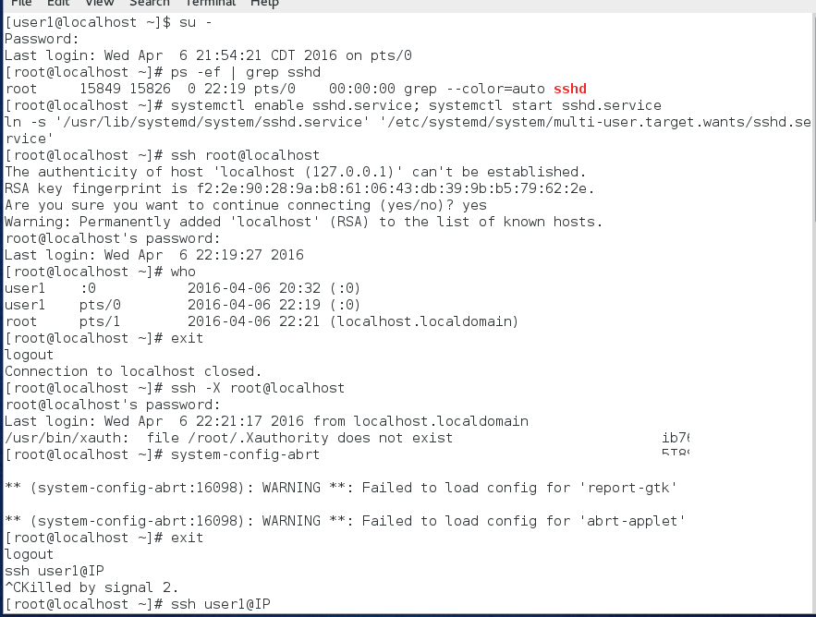
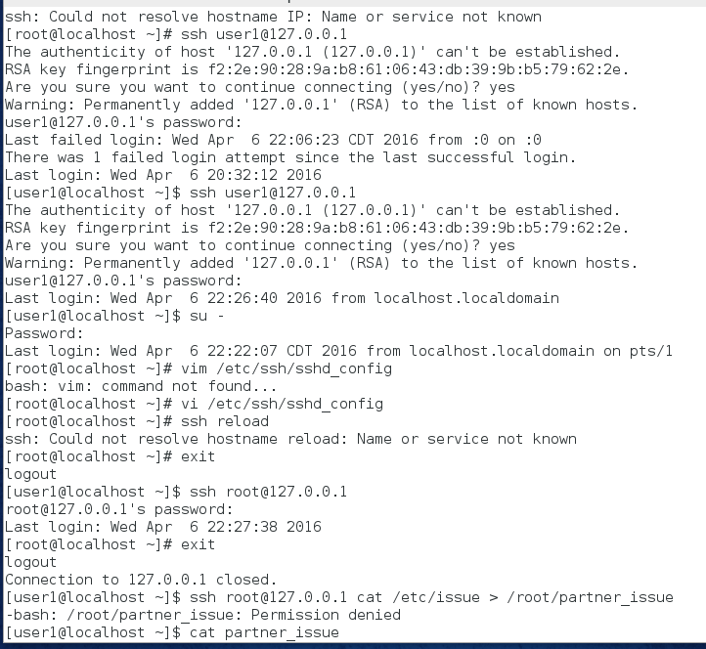
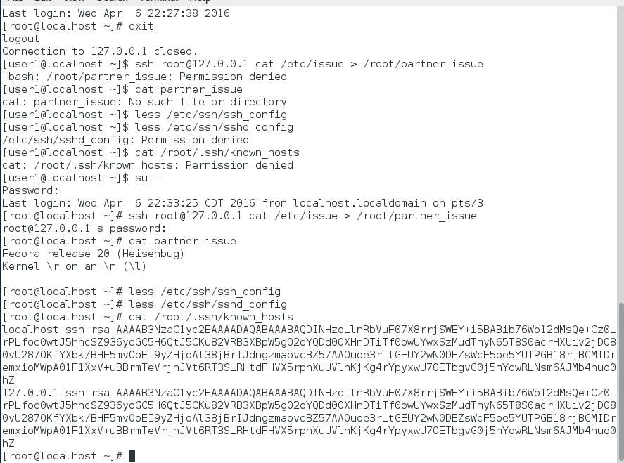

- Provide screenshot(s) of steps 3 through 19.

