lsHands-on Projects
These projects should be completed in the order given. The hands-on projects presented in this chapter should take a total of three hours to complete. The requirements for this lab include:
- A computer with Fedora Linux installed according to Hands-on Project 2-1.
Project 3-1
In this hands-on project, you log in to the computer and navigate the file structure.
- Boot your Fedora Linux virtual machine. Login to your chosen desktop environment as user1 using password LNXrocks! and open up a terminal window.
- At the terminal, become root by typing su - and press enter and provide LNXrocks! as the password.
- At the command prompt, type clear and press Enter to clear your terminal window.
- At the command prompt, type pwd and press Enter to view the current working directory. You should be in the root users home directory.
- At the command prompt, type cd and press Enter. At the command prompt, type pwd and press Enter to view the current working directory. Notice that it did not change.
- At the command prompt, type cd . and press Enter. At the command prompt, type pwd and press Enter to view the current working directory. Recall that . (period) is a relative path for current directory.
- At the command prompt, type cd .. and press Enter. At the command prompt, type pwd and press Enter to view the current working directory. Recall that .. is a relative path for parent directory.
- Provide a screenshot that shows steps 3 through 6.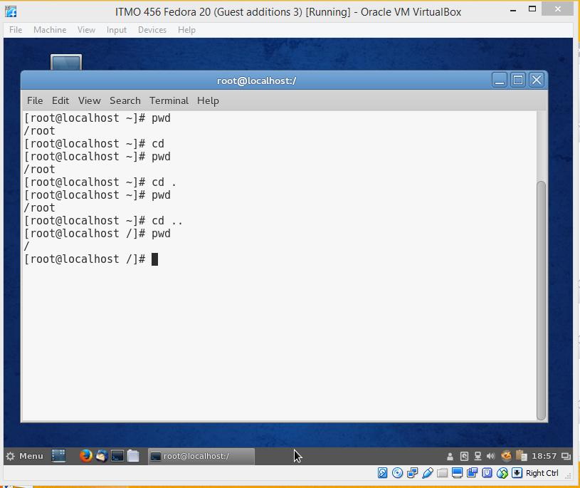
- At the command prompt, type ll (two lowercase L – alias to ls -l) and press Enter. Notice the root directory. At the command prompt, type cd root and press Enter. At the command prompt, type pwd and press Enter to view the current working directory. Notice that your directory changes back to /root by utilizing the relative path for root’s home directory. You are able to utilize the relative path for root since you were in the / (root) directory.
- At the command prompt, type ll and press Enter. At the command prompt, type cd etc and press Enter. Notice that you receive an error. This is due to the fact that you are using a relative path for the etc directory. As you can see from your previous ll output, there is no etc directory in /root.
- At the command prompt, type cd /etc and press Enter. At the command prompt, type pwd and press Enter to view the current working directory. Now that we specified an absolute path, we are able to change to the /etc directory.
- At the command prompt, type cd / and press Enter. At the command prompt, type pwd and press Enter to view the current working directory. We have successfully used the absolute path to the root directory.
- Provide a screenshot that shows steps 8 through 11.
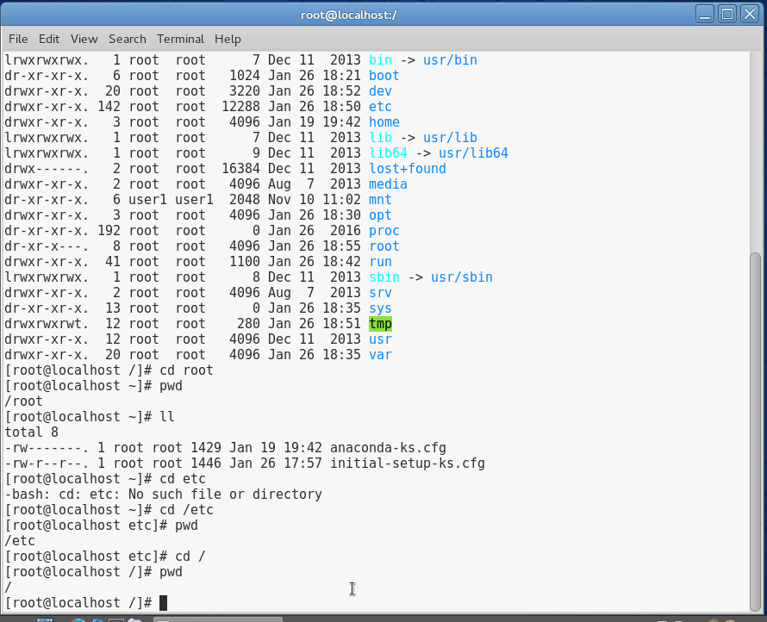
- At the command prompt, type cd ~user1 (replace user1 if you are using a different username) and then press Enter. At the command prompt, type pwd and press Enter to view the current working directory. We utilized ~ which is an absolute path and the same as typing cd /home/user1
- At the command prompt, type echo ~ and press Enter. At the command prompt, type echo ~user1. Notice that when using ~ alone, it references your current users home directory (in this case /root since we are logged in as root but could also be /home/user1 if logged in as user1) but when you append a username it references the /home directory.
- At the command prompt, type cd Desktop and press Enter (be certain to use a capital D – case sensitive!). At the command prompt, type pwd and press Enter to view the current working directory. You should now be in user1’s Desktop directory.
- Currently, you are in a subdirectory of user1’s home folder, three levels below the root. You want to change directory to /etc/samba but using the absolute path would be too easy. To go up three parent directories to the / directory, then down 2 directories using relative paths, type cd ../../../etc/samba and press Enter at the command prompt. Next, type pwd and press Enter to ensure that you are in the /etc/samba directory.
- At the command prompt, type cd ../sysconfig at the command prompt and press Enter. Type pwd and press Enter to view your current location. Again, we are utilizing .. which is a relative path to the parent directory. Now that we are up one directory level, we can now change directory to sysconfig.
- At the command prompt, type cd ~ and press Enter. Type pwd and press Enter to view your current location. Notice that we changed directory using the ~ which is an absolute path for your home directory. At the command prompt, type cd / and press enter. Type pwd and press Enter to view your current location. At the command prompt, type cd and press Enter. Type pwd and press Enter to view your current location. Notice that we do not need to specify ~ to change directory to our home directory as this is the default behavior of the command when no argument is passed.
- At the command prompt, type echo $HOME and press Enter. Notice that a variable exists that contains your current user’s home directory.
- Provide a screenshot of steps 13 through 19.
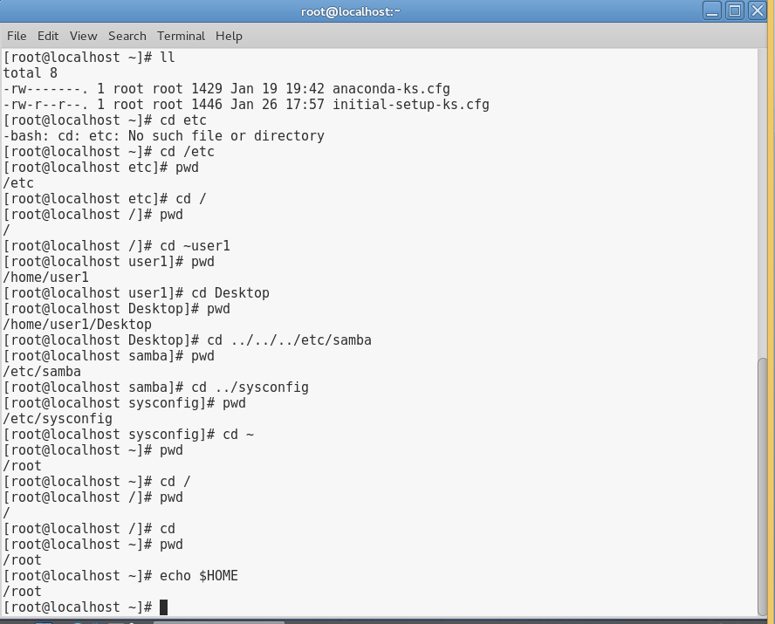
Project 3-2
In this hands-on project, you navigate the Linux filesystem using the Tab-completion feature of the BASH shell.
- Boot your Fedora Linux virtual machine. Login to your chosen desktop environment as user1 using password LNXrocks! and open up a terminal window.
- At the terminal, become root by typing su - and press enter and provide LNXrocks! as the password.
- At the command prompt, type cd / and press Enter.
- Next, type cd ro at the command prompt and press Tab. Notice that the shell completes root/ since it was a unique name.
- Press the Ctrl and c keys simultaneously to cancel the command and return to an empty command prompt.
- At the command prompt, type cd b and press Tab. Notice nothing happened.
- Press the Tab key again. We needed to press tab twice in order to show us the directories that start with b.
- Type the letter i. Notice that the command now reads “cd bi.” Press the Tab key again. The shell expanded to bin since it was a unique name.
- Press the Ctrl and c keys simultaneously to cancel the command and return to an empty command prompt
- At the command prompt, type cd m and press Tab. Press Tab a second time.
- Type the letter e. Notice that the command now reads “cd me” Press Tab.
- Press Enter to execute the command at the command prompt. Next, type the pwd command and press Enter to verify that you are in the /media directory.
- Provide a screenshot of steps 3 through 11.
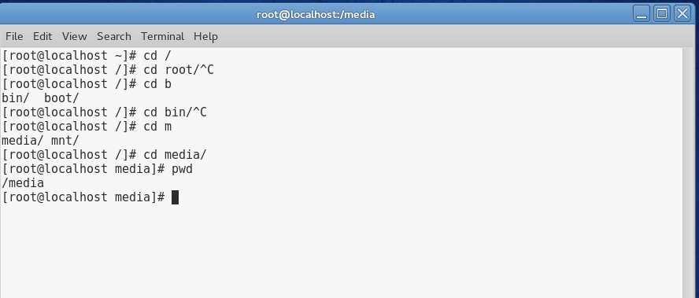

Project 3-3
In this hands-on project, you examine files and file types using the ls and file commands.
- Boot your Fedora Linux virtual machine. Login to your chosen desktop environment as user1 using password LNXrocks! and open up a terminal window.
- At the terminal, become root by typing su - and press enter and provide LNXrocks! as the password.
- At the command prompt, type cd /etc and press Enter. Verify that you are in the /etc directory by typing pwd at the command prompt and press Enter
- At the command prompt, type ls and press Enter. Scroll up in your terminal window and review the different files and directories.
- At the command prompt, type ls | less and then press Enter. Notice the : at the bottom of the screen. Press Enter. Press Enter again. Press Enter once more. Notice that each time you press Enter, you advance one line further into the file. Now press the spacebar. Press the spacebar again. Notice that with each press of the spacebar, you advance one full page into the displayed directory contents. Now press the arrow keys up/down and you can scroll line by line. Press the h key to get a help screen. Examine the command options, and then press q to return to the command output.
- At the command prompt, press the up arrow key. Keep pressing the up arrow a few times and notice that each time you press the up key, you go up one line in the file display toward the beginning of the file. Now, press the down arrow key. Press down again. Press down once more. Notice that each time you press the down key, you move forward into the file display.
- At the command prompt, type ls /etc/skel and press Enter. No output is returned. At the command prompt, type ls -a /etc/skel and press Enter. Recall that hidden files start with a period. The first two entries in the list ( . and .. ) represent the current directory and parent directory.
- At the command prompt, type ls -aF /etc/skel and press Enter. Notice that directories now have a forward slash appended to them.
- At the command prompt, type ls /bin and press Enter. Did you see a listing of any files? At the command prompt, type ls -F /bin and press Enter. We can see executable files have an * and symbolic links have an @ appended to the name.
- At the command prompt, type type ls -l /boot and press Enter. At the command prompt, type ll /boot and press Enter. Notice the output is no different as ll is an alias to ls -l.
- At the command prompt, type file /etc and press Enter. Note the file type.
- At the command prompt, type file /etc/inittab and press Enter. Note the file type.
- At the command prompt, type file /boot/* to see the types of files in the /boot directory. Not the file types.
- Provide a screenshot of step 7 through 13.
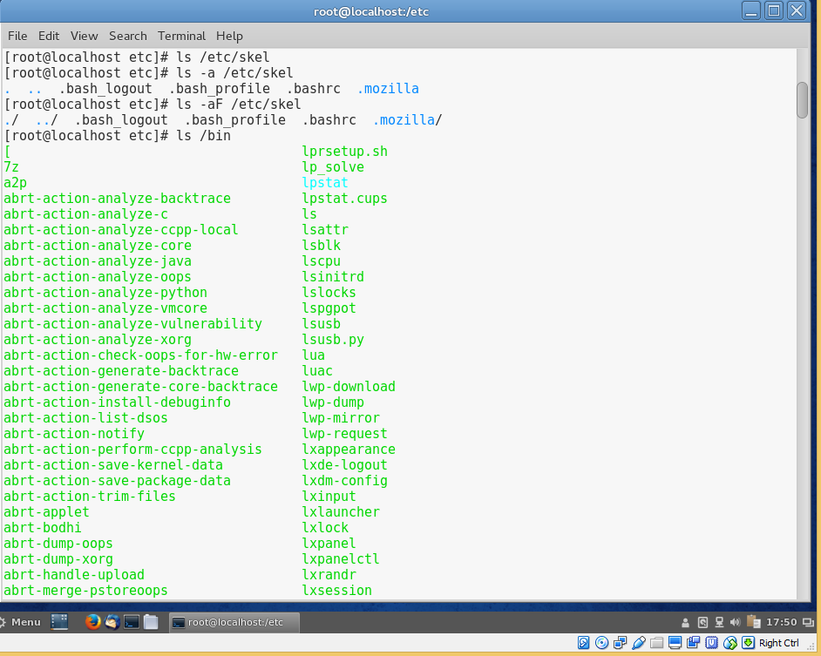
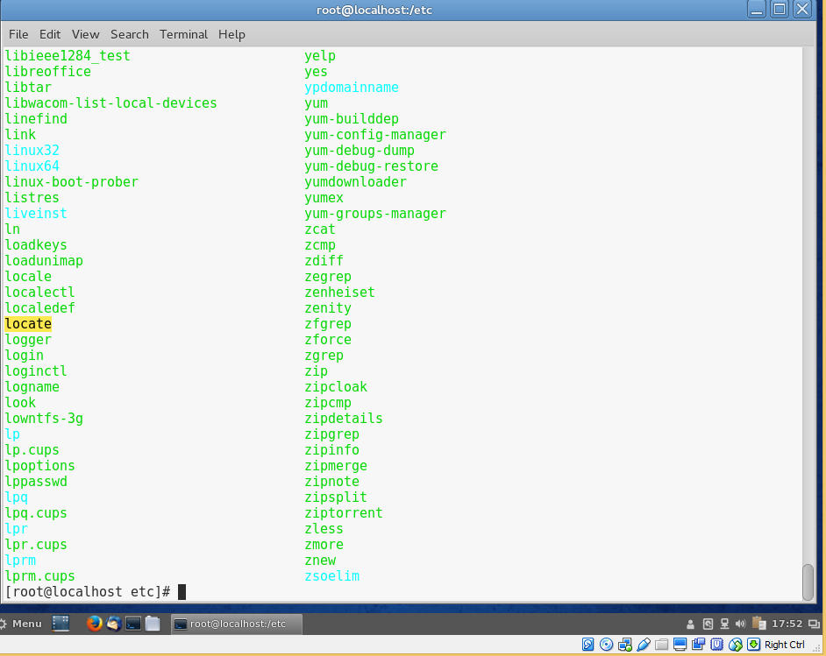
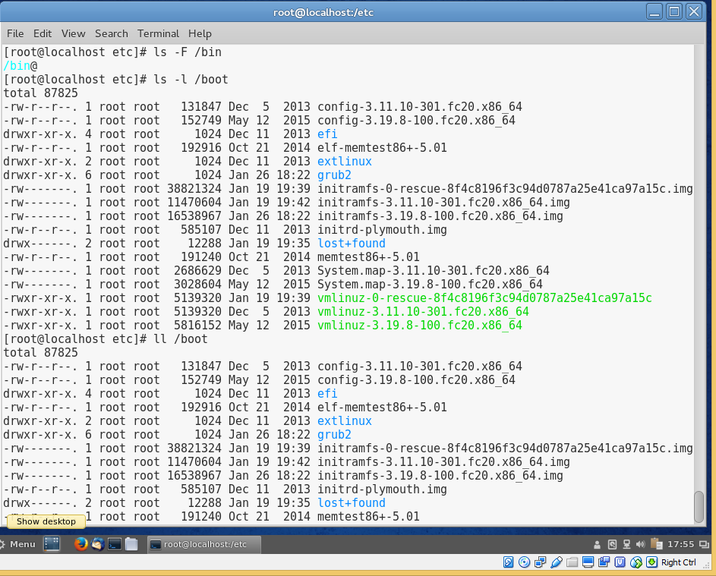
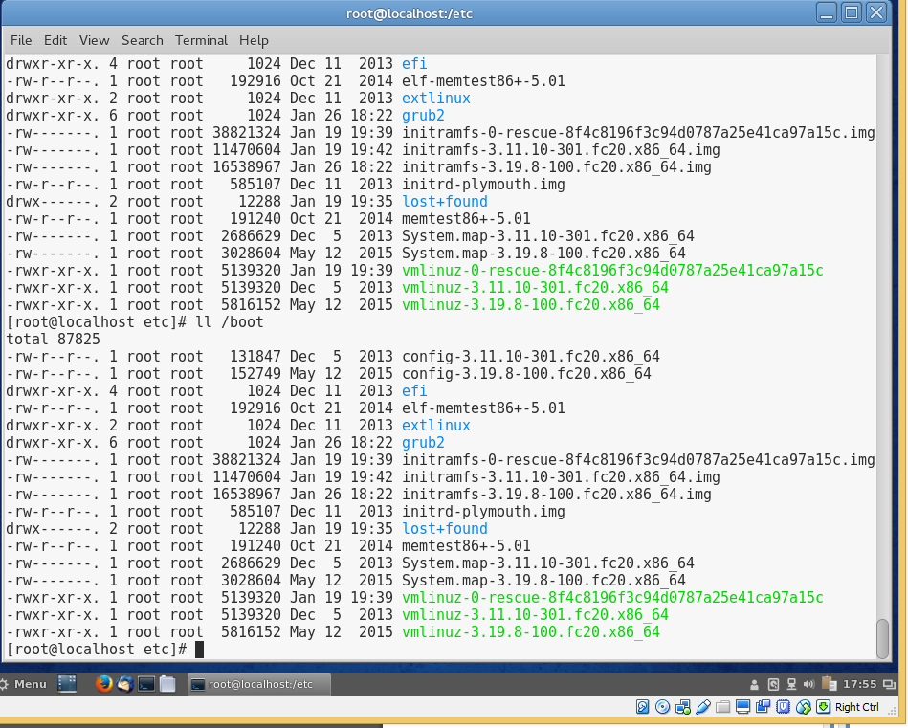
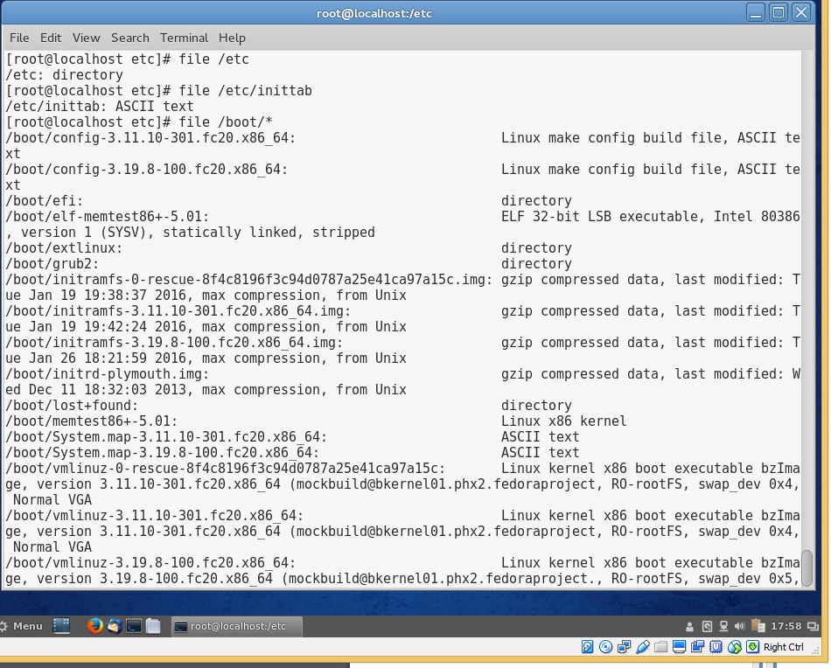
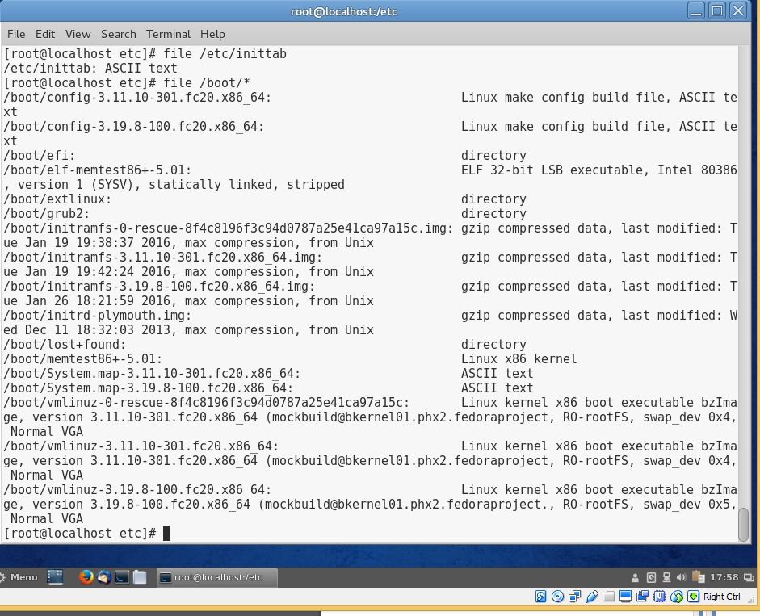

Project 3-4
In this hands-on project, you display file contents using the cat, tac, head, tail, strings, and od commands.
- Boot your Fedora Linux virtual machine. Login to your chosen desktop environment as user1 using password LNXrocks! and open up a terminal window.
- At the terminal, become root by typing su - and press enter and provide LNXrocks! as the password.
- At the command prompt, type cat /etc/hosts and press Enter to view the contents of the file hosts, which reside in the directory /etc. Next, type cat -n /etc/hosts and press Enter. At the command prompt, type tac /etc/hosts and press Enter to view the same file in reverse order. The output of both commands should be visible on the same screen for your review.
- To see the contents of the same file in octal format instead of ASCII text, type od /etc/hosts at the command prompt and press Enter.
- At the command prompt, type cat /etc/inittab and press Enter.
- At the command prompt, type head /etc/inittab and press Enter. Notice the difference in output of the two commands.
- At the command prompt, type head -5 /etc/inittab and press Enter. Next, type head -3 /etc/inittab and press Enter.
- At the command prompt, type tail /etc/inittab and press Enter.
- At the command prompt, type tail -5 /etc/inittab and press Enter. Type the cat –n /etc/inittab command at a command prompt and press Enter.
- At the command prompt, type file /bin/nice and press Enter. Review the file type.
- At the command prompt, type strings /bin/nice and press Enter. Notice that you are able to see some text within this binary file. Next, type strings /bin/nice | less to view the content using the arrow keys or page up/down keys. When finished, press q to quit the less command.
- Provide screenshot of steps 3 through 11.
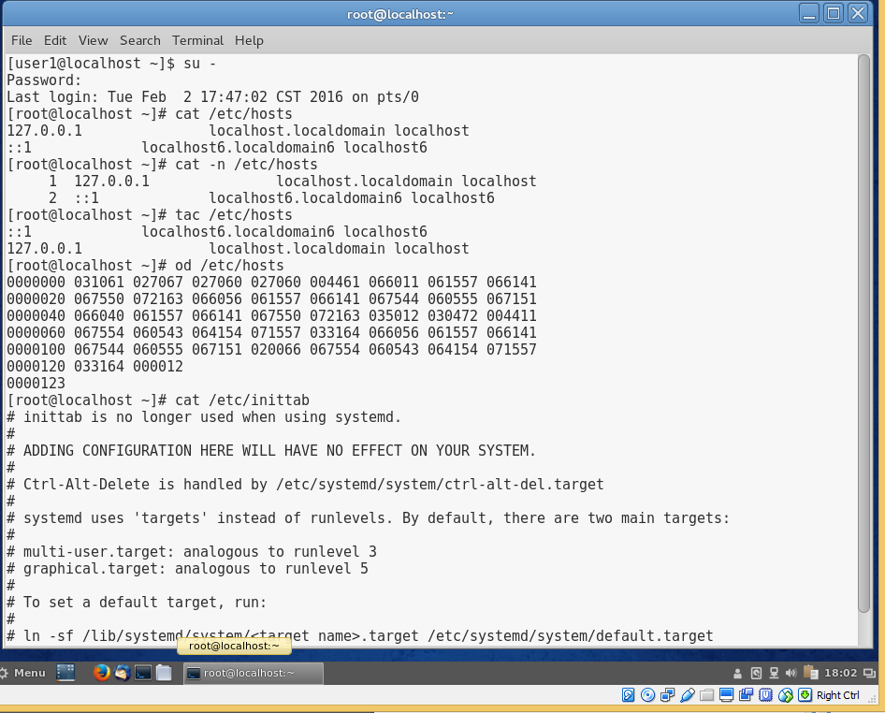

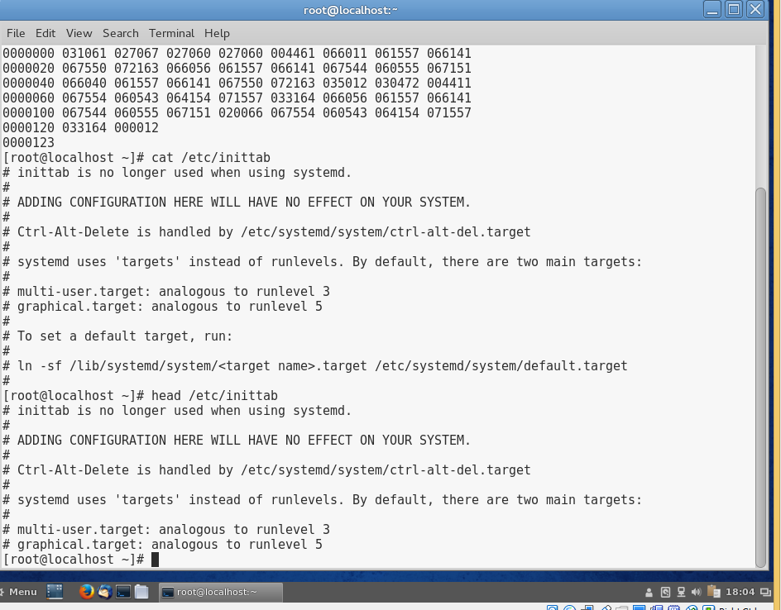
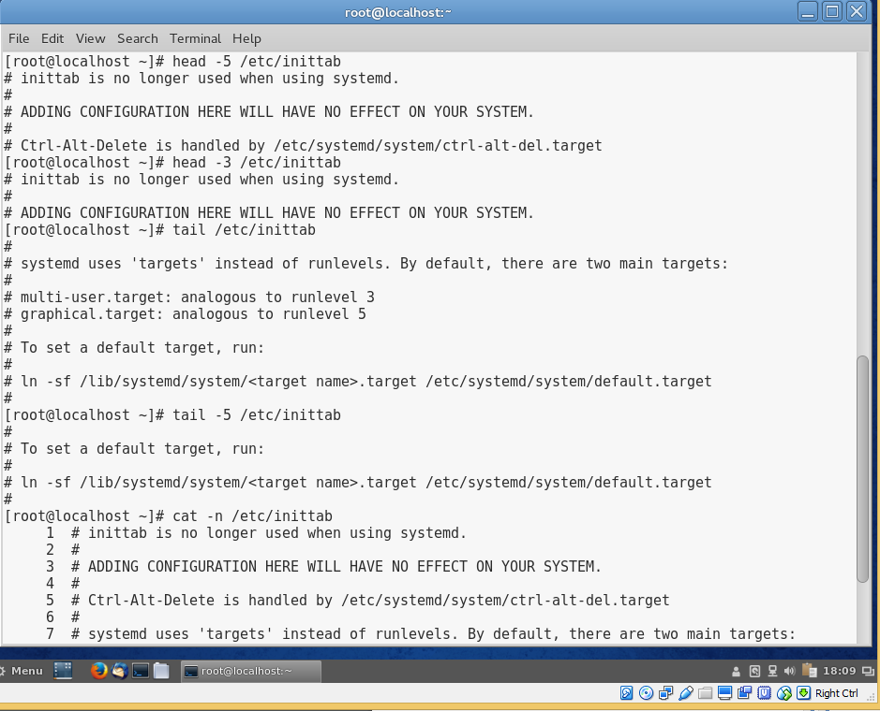
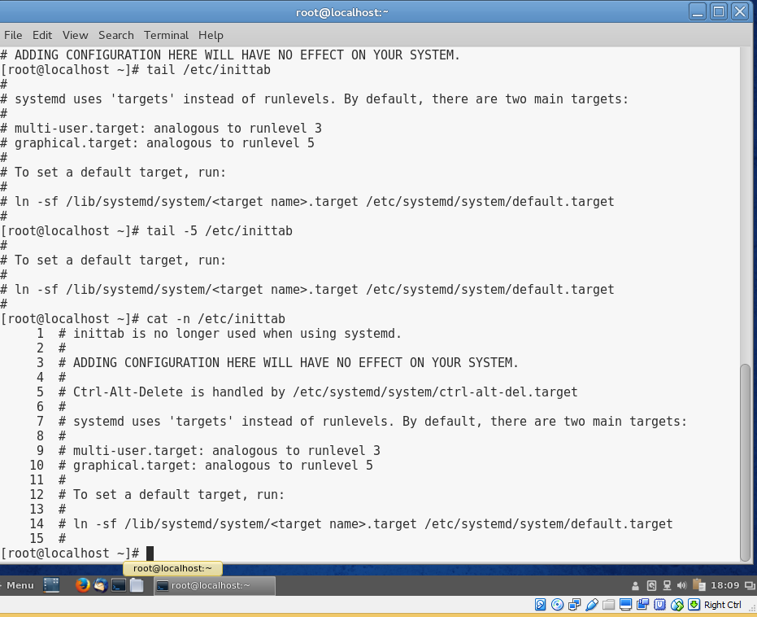
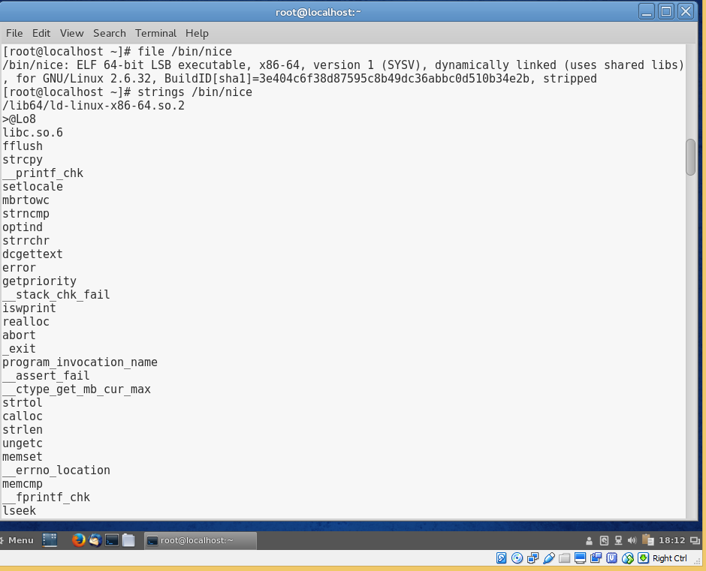
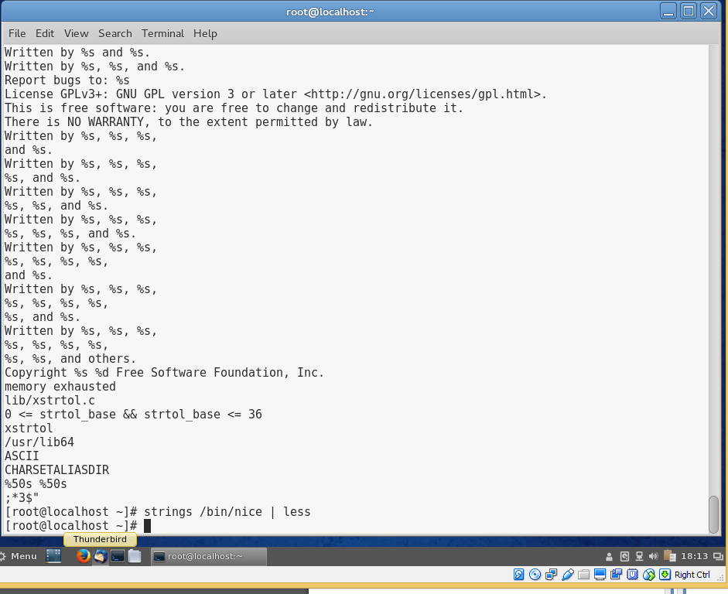

Project 3-4
In this hands-on project, you will learn how to use the command line text editing tool vim by using vimtutor.
- Boot your Fedora Linux virtual machine. Login to your chosen desktop environment as user1 using password LNXrocks! and open up a terminal window.
- At the terminal, become root by typing su - and press enter and provide LNXrocks! as the password.
- Some of you may have vim already installed. Let’s double check by running yum install vim at the command prompt. If yum states that vim is already installed, you can proceed to step 3. Otherwise, yum will show several packages it wants to install. Type y when prompted to download those packages. If you receive a transaction check error, enter yum -y remove vim-minimal and press enter. Once yum removes the package, re-run the yum command to install vim.
- At the command prompt, type vimtutor and press Enter. Take the time to learn how to use vim as this will be very valuable for future labs and is a core text command line text editing tool.
- Take the 30 minutes that it will take to learn vim. If you have used vim before, you may skip past the portions you already know. If you have never used vim before, I strongly recommend taking your time and understanding what you are doing.
Project 3-5
In this hands-on project, you use the ls command alongside wildcard metacharacters in your shell to explore the contents of your home directory.
- Boot your Fedora Linux virtual machine. Login to your chosen desktop environment as user1 using password LNXrocks! and open up a terminal window.
- At the terminal, become root by typing su - and press enter and provide LNXrocks! as the password.
- At the command prompt, type touch sample{1..3} and press Enter. At the command prompt, type ll and notice the 3 sample files created.
- At the command prompt, type ls sample* and press Enter.
- At the command prompt, type ls sample and press Enter. Review the error output.
- At the command prompt, type ls sample? and press Enter. Recall what the ? metacharacter does
- At the command prompt, type ls sample?? and press Enter. Does the error make sense to you?
- At the command prompt, type ls sample[13] and press Enter.
- At the command prompt, type ls sample[!13] and press Enter.
- At the command prompt, type ls sample[1-3] and press Enter.
- At the command prompt, type ls sample[!1-3] and press Enter.
- Provide a screenshot of steps 3 through 11.
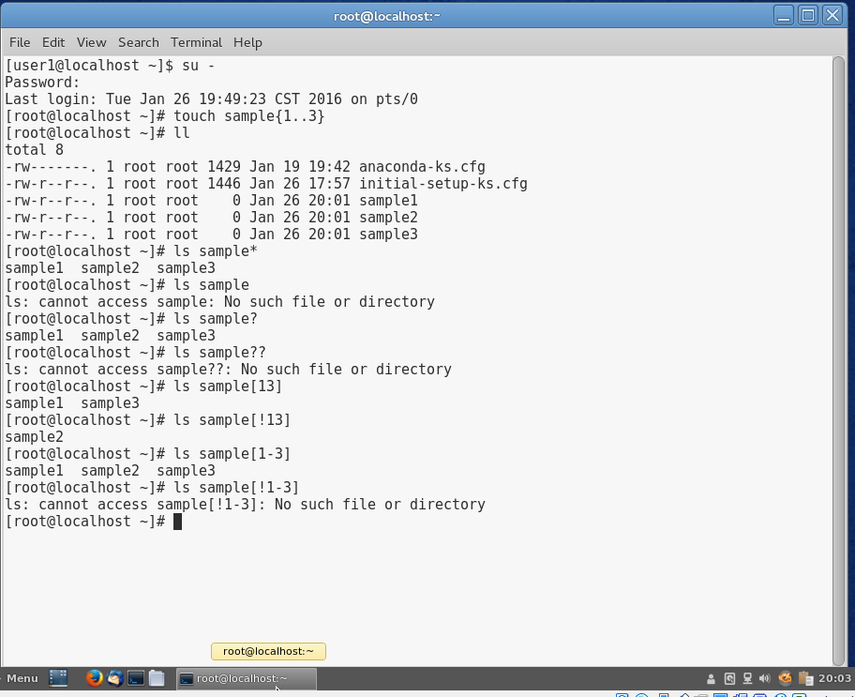

Project 3-6
In this hands-on project, you use the grep and egrep commands alongside regular expression metacharacters to explore the contents of text files.
- Boot your Fedora Linux virtual machine. Login to your chosen desktop environment as user1 using password LNXrocks! and open up a terminal window.
- At the terminal, become root by typing su - and press enter and provide LNXrocks! as the password.
- At the command prompt, type grep SELINUX /etc/sysconfig/selinux and press Enter. Review the output.
- At the command prompt, type grep -i selinux /etc/sysconfig/selinux and press Enter. Since -i is the option for case insensitivity, we match more patterns than before.
- At the command prompt, type grep -vi selinux /etc/sysconfig/selinux and press Enter. Notice that we invert the matching criteria.
- At the command prompt, type grep “w..e” /etc/services and press Enter. Review the output in the terminal.
- At the command prompt, type grep “t.e” /etc/services and press Enter. Review the output in the terminal.
- At the command prompt, type grep ssh /etc/services and press Enter. Review the output in the terminal.
- At the command prompt, type grep ^ssh /etc/services and press Enter. Review the output in the terminal.
- At the command prompt, type grep “(ssh|telnet)” /etc/services and press Enter. Notice that nothing is returned.
- At the command prompt, type egrep “(ssh|telnet)” /etc/services and press Enter. Review the output in the terminal.
- At the command prompt, type grep SSH$ /etc/services and press Enter. Review the output in the terminal.
- Provide a screenshot of steps 3 through 12.
