Hands-on Projects
These projects should be completed in the order given. The hands-on projects presented in this chapter should take a total of three hours to complete. The requirements for this lab include:
- A computer with Fedora Linux installed according to Hands-on Project 2-1.
Project 4-1
In this hands-on project, you log in to the computer and create new directories.
- Boot your Fedora Linux virtual machine. Login to your chosen desktop environment as user1 using password LNXrocks! and open up a terminal window.
- At the terminal, become root by typing su - and press enter and provide LNXrocks! as the password.
- At the command prompt, type ll (long listing) and press Enter. Note the contents of your home folder.
- At the command prompt, type mkdir mysamples and press Enter. Next type ll at the command prompt, and press Enter. You should now see the newly created mysamples directory.
- At the command prompt, type cd mysamples and press Enter. Next, type ll at the command prompt and press Enter. We will now create some sub-directories in mysamples.
- At the command prompt, type mkdir undermysamples and press Enter. Next, type ll at the command prompt and press Enter. You should see the newly created directory undermysamples.
- At the command prompt, type mkdir todelete and press Enter. Next, type ll at the command prompt and press Enter. We should now have 2 directories created.
- At the command prompt, type cd .. and press Enter. Next, type ls -R and press Enter. Notice that the subdirectory mysamples and its subdirectory undermysamples are both displayed. You have used the recursive option with the ls command.
- At the command prompt, type cd .. and press Enter. At the command prompt, type pwd and press Enter. Recall what the purpose of the double period is. You should now be in the / directory.
- At the command prompt, type mkdir foruser1 and press Enter. At the command prompt, type ll and press Enter. You should now see the new directory.
- Provide screenshot(s) of steps 3 through 10.
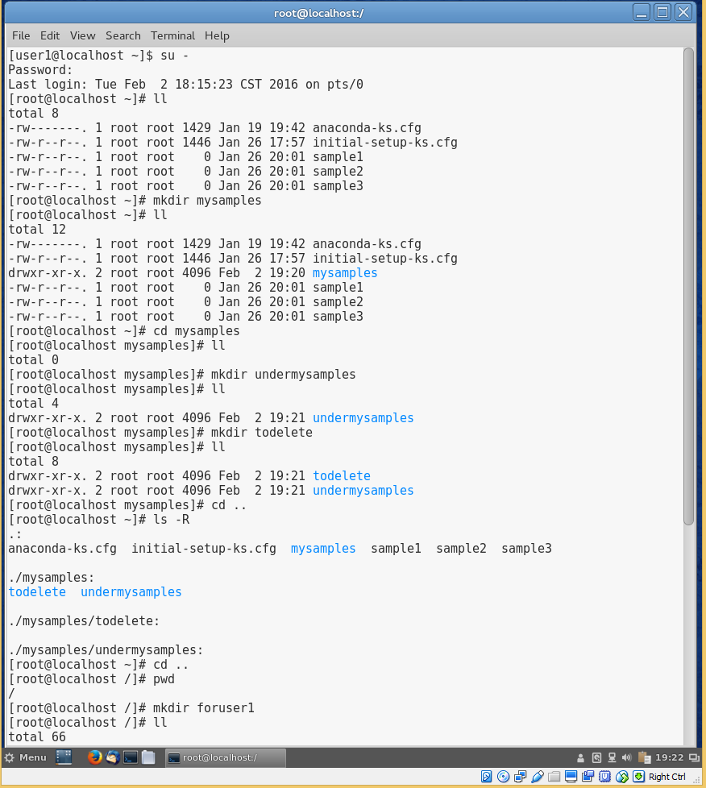
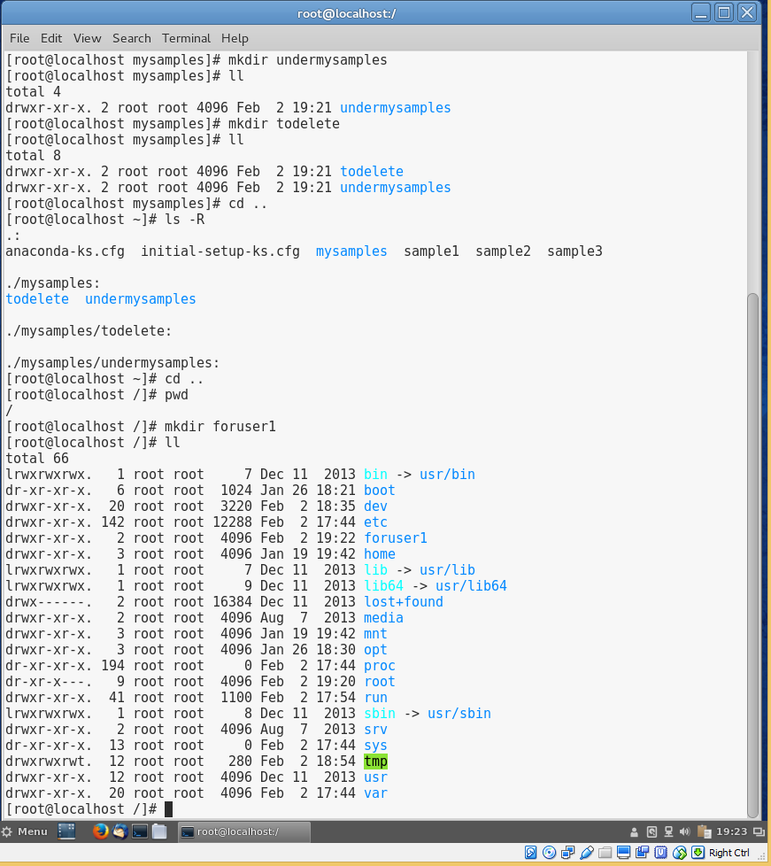
Project 4-2
In this hands-on project, you copy files using the cp command.
- Boot your Fedora Linux virtual machine. Login to your chosen desktop environment as user1 using password LNXrocks! and open up a terminal window.
- At the terminal, become root by typing su - and press enter and provide LNXrocks! as the password.
- At the command prompt, type cd and press Enter to ensure you are in the root users home directory. Next, type ll at the command prompt and press Enter. Note the contents of your home directory.
- At the command prompt, type cp sample1 and press Enter. Note the error message that is displayed. This is because we did not provide the necessary arguments to utilize the cp command.
- At the command prompt, type cp sample1 sample1A and press Enter. Next, type ll at the command prompt and press Enter. Notice the newly copied file.
- At the command prompt, type cp sample1 mysamples/sample1B and press Enter. Next, type ll at the command prompt and press Enter.
- At the command prompt, type cd mysamples and press Enter. Next, type ll at the command prompt and press Enter. You should see sample1B in the output.
- At the command prompt, type cp /root/sample2 . and press Enter. Next, type ll at the command prompt and press Enter. You should now see sample2 in the output as we copied it to our current directory.
- At the command prompt, type cp sample1B .. and press Enter. Next, type cd .. at the command prompt and press Enter. At the command prompt, type ll and press Enter. You should see sample1B in your output.
- At the command prompt, type cp sample1 sample2 sample3 mysamples and press Enter. You should be prompted to overwrite sample2. Choose y and press Enter. Next, type cd mysamples at the command prompt and press Enter. At the command prompt, type ll and press Enter. You should see 4 files in your output.
- At the command prompt, type cd .. and press Enter. Next, type cp mysamples mysamples2 at the command prompt and press Enter. Review the error message you receive.
- At the command prompt, type cp -R mysamples mysamples2 and press Enter. Next, type ll at the command prompt, and press Enter. You should now see the mysamples2 directory in your output. Type ll mysamples2 at the command prompt and press Enter. You should see the recursively copied files and directories.
- Provide screenshot(s) of steps 3 through 12.
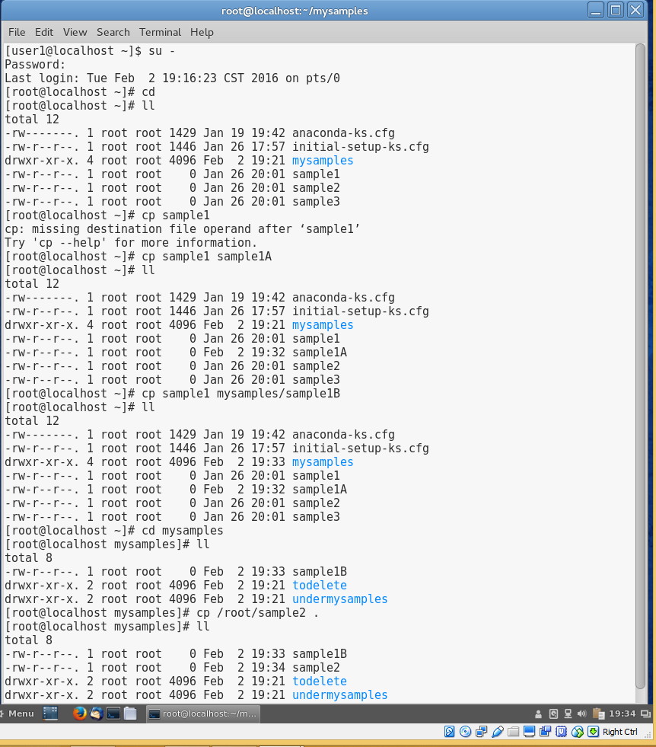
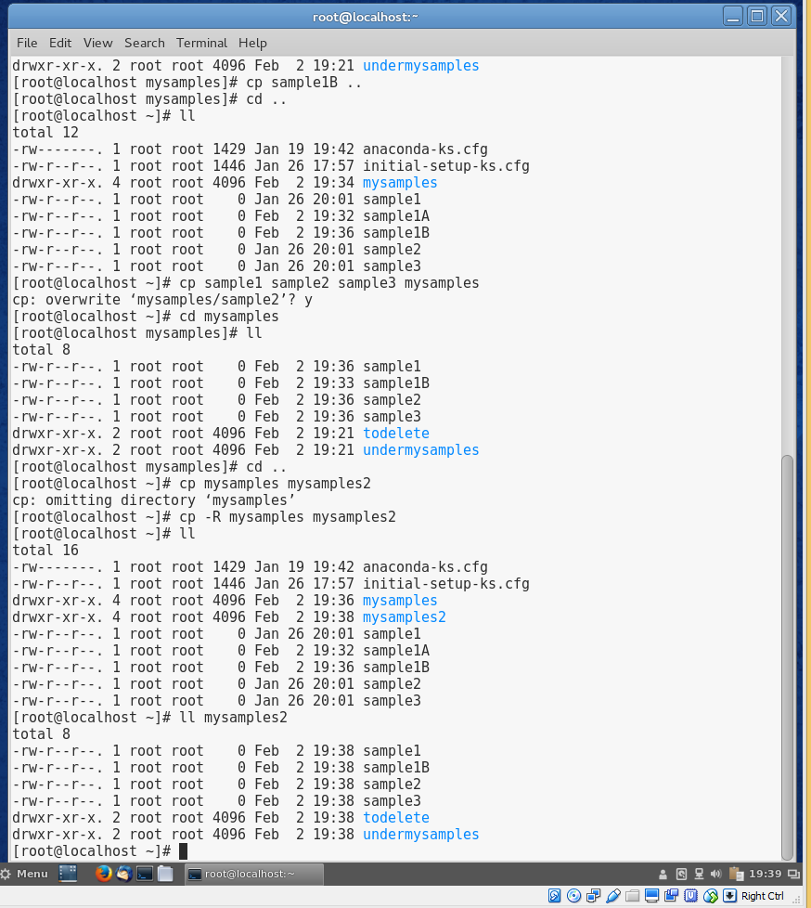
Project 4-3
In this hands-on project, you use the mv command to rename files and directories.
- Boot your Fedora Linux virtual machine. Login to your chosen desktop environment as user1 using password LNXrocks! and open up a terminal window.
- At the terminal, become root by typing su - and press enter and provide LNXrocks! as the password.
- At the command prompt, type cd and press Enter to ensure you are in the root users home directory. Next, type ll at the command prompt and press Enter. Note the contents of your home directory.
- At the command prompt, type mv sample1 and press Enter. Recall that the mv command requires two arguments at a minimum.
- At the command prompt, type mv sample1 sample4 and press Enter. Next, type ll at the command prompt and press Enter. You should notice that sample1 is no longer displayed as we renamed it sample4.
- At the command prompt, type mv sample4 mysamples and press Enter. Next, type ll at the command prompt and press Enter. Sample4 has been moved to the mysamples directory and should not be displayed in the output.
- At the command prompt, type cd mysamples and press Enter. Next, type ll at the command prompt and press Enter. Notice that the sample4 file you moved in Step 6 was moved here.
- At the command prompt, type mv sample4 .. and press Enter. Next, type ll at the command prompt and press Enter. Sample4 should have been moved to the parent directory and not in the output.
- At the command prompt, type cd .. and press Enter. Next, type ll at the command prompt and press Enter to view the new location of sample4.
- At the command prompt, type mv sample4 mysamples/sample2 and press Enter. Review the message displayed on the terminal.
- Type y and press Enter to confirm you want to overwrite the file in the destination folder.\
- Provide screenshot(s) of steps 4 through 11.
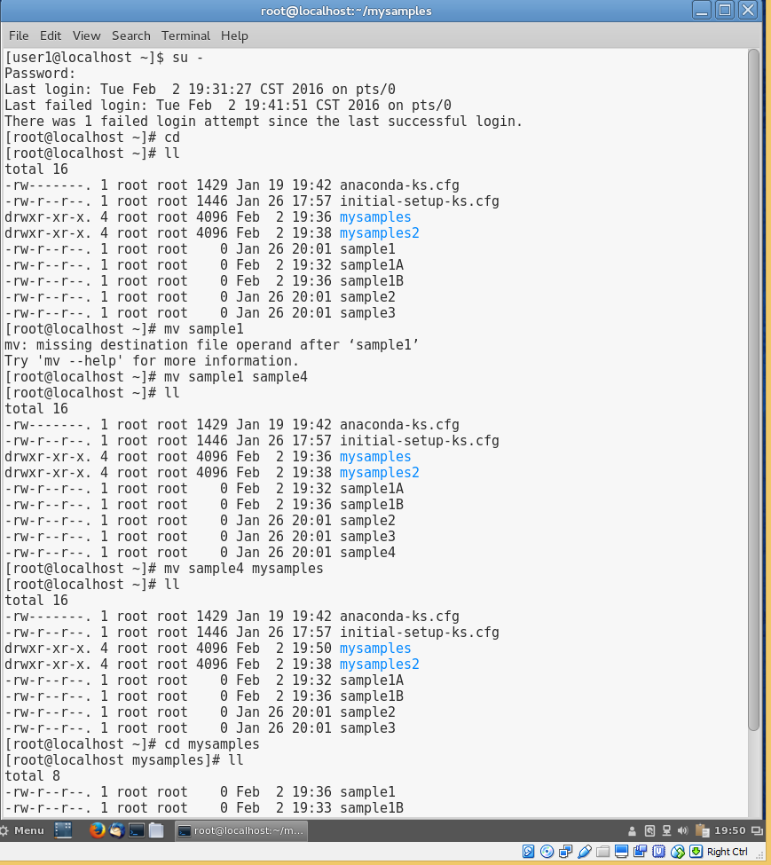
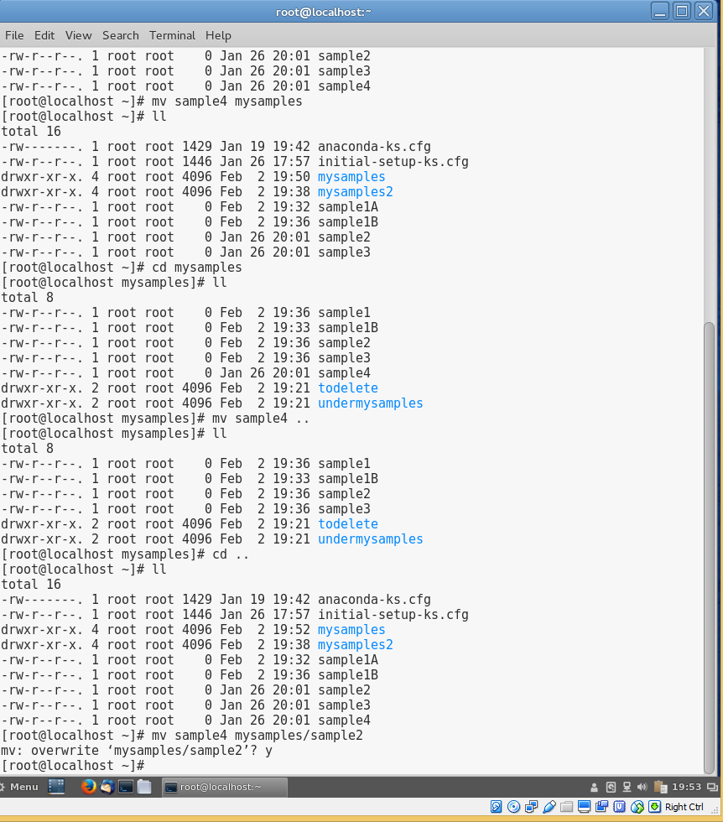
- At the command prompt, type mv sample? mysamples and press Enter. Type y and press Enter to confirm you want to overwrite the file sample2 and sample3 in the destination folder.
- At the command prompt, type ll and press Enter. Review the output of what remains in your home directory.
- At the command prompt, type mv sample1* mysamples and press Enter. Type y and press Enter to confirm you want to overwrite the file sample1B in the destination directory.
- At the command prompt, type ll and press Enter. Notice that there are no sample files in the /root directory.
- At the command prompt, type cd mysamples and press Enter. Next, type ll at the command prompt and press Enter. Notice that all files originally in /root have been moved to this directory.
- At the command prompt, type cd .. and press Enter. Next, type ll at the command prompt and press Enter. Type mv mysamples samples and press Enter. Next, type ll at the command prompt and press Enter. Notice you did not need to specify the recursive option to the mv command to rename the mysamples directory to samples. This is because the directory name is only changed with the mv command and nothing is done to the sub-directories and files. When we used the cp command, we also wanted to copy any file or directory under mysamples. In order to do this, we need to provide the -R for recursive functionality.
- Provide screenshot(s) of steps 13 through 18.
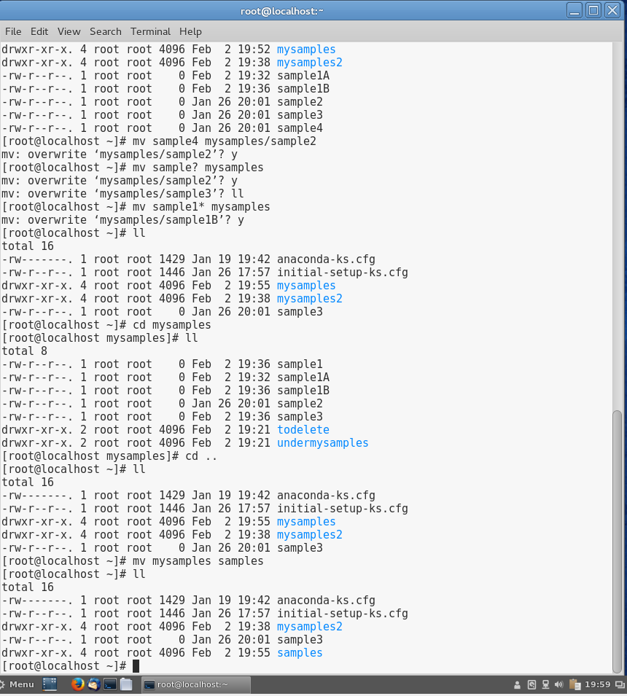
Project 4-4
In this hands-on project, you make and view links to files and directories.
- Boot your Fedora Linux virtual machine. Login to your chosen desktop environment as user1 using password LNXrocks! and open up a terminal window.
- At the terminal, become root by typing su - and press enter and provide LNXrocks! as the password.
- At the command prompt, type cd and press Enter to ensure you are in the root users home directory.
- At the command prompt, type cd samples and press Enter. Next, type ll at the command prompt and press Enter. Review the link count for the sample1 file.
- At the command prompt, type ln sample1 hardlinksample and press Enter. Next, type ll at the command prompt and press Enter. Notice that the link count has increased for the linked files. Next, type ll -i at the command prompt and press Enter to view the inode numbers of each file. You will see the inodes are the same for hard linked files.
- At the command prompt, type ln sample1 hardlinksample2 and press Enter. Next, type ll -i at the command prompt and press Enter. Notice the shared inode and that the link count for sample1 has increased.
- At the command prompt, type vi sample1 and press Enter. Enter a sentence of your choice into the vi editor, and then save your document and quit the vi editor.
- At the command prompt, type cat sample1 and press Enter. Next, type cat hardlinksample at the command prompt and press Enter. Next, type cat hardlinksample2 at the command prompt and press Enter. Notice the output is the same for all the files. This is because they are the same exact files with different names.
- At the command prompt, type ln sample1 /boot/hardlinksample2 and press Enter. Review the error message and recall that hard links cannot cross partitions. At the command prompt, type df -h and press Enter. Notice that /boot is on a different filesystem than /.
- Provide screenshot(s) of steps 4 through 9.
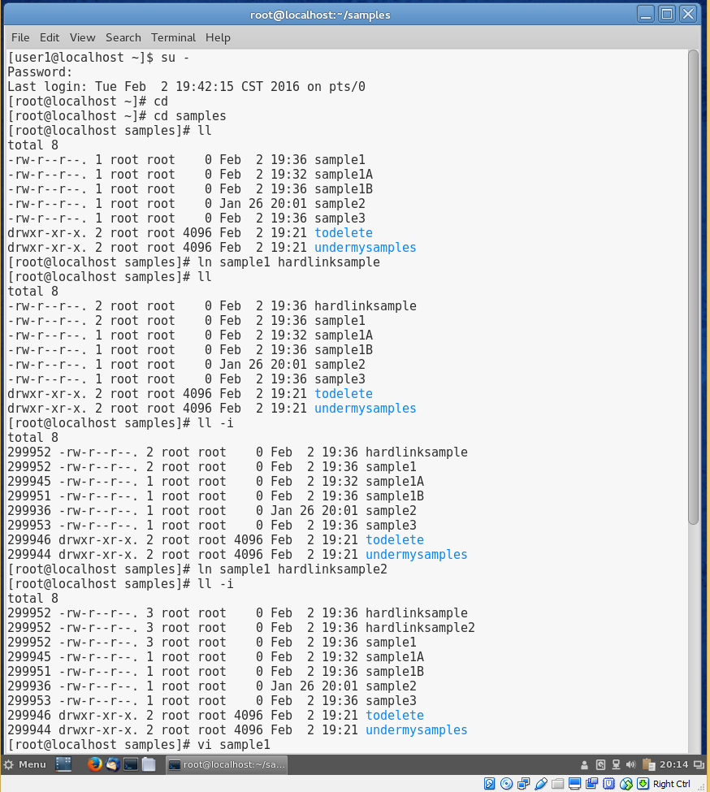
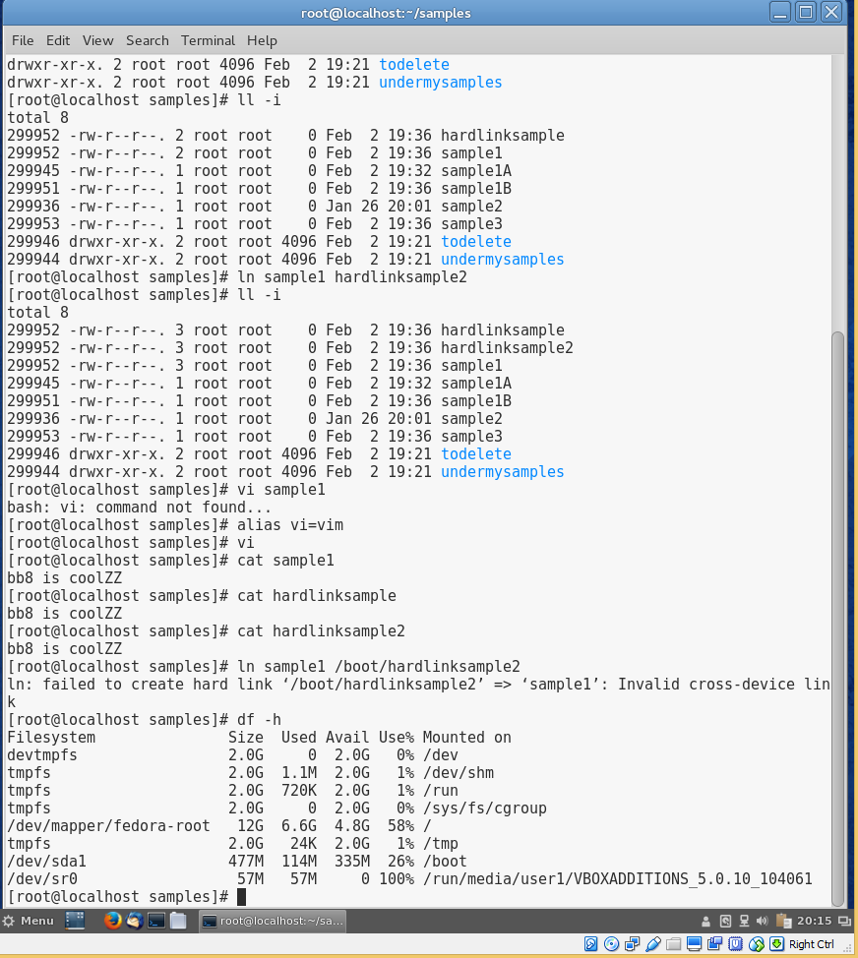

- At the command prompt, type ln -s sample2 /boot/sample2symlink and press Enter. Next, type ll /boot/sample2symlink at the command prompt and press Enter. You should notice 2 things: the l at the left of the terminal screen signifying this is a symbolic link and also that it is red. This means the link is a broken link and will not work as expected. This is because when we created the symlink, we did not use the absolute path for the sample2 file. To fix this, type ln -sf /root/samples/sample2 /boot/sample2symlink and press Enter. The -f option will overwrite the existing link in /boot instead of providing and error message that it already exists. Next, type ll /boot/sample2symlink at the command prompt and press Enter. The link should now point back to the absolute path for sample2.
- At the command prompt, type ll -i sample2 /boot/sample2symlink and press Enter. Notice the different inode numbers for each file. At the command prompt, type vi /boot/sample2symlink and press Enter. Enter a sentence of your choice into the vi editor, and then save your document and quit the vi editor. Next, type cat sample2 at the command prompt and press Enter. The contents will be the same.
- At the command prompt, type ln -s /etc/sysconfig/network-scripts netscripts and press Enter. Next, type ll at the command prompt and press Enter. Note the file type at the left of the terminal output. Next, type cd netscripts at the command prompt and press Enter. Type pwd at the command prompt and press Enter to view your current directory. Next, type ll at the command prompt and press Enter. Next, type ll /etc/sysconfig/network-scripts at the command prompt and press Enter. Compare the output and notice that they will be the same for both the linked directory and the actual directory.
- Provide screenshot(s) of steps 11 through 13.
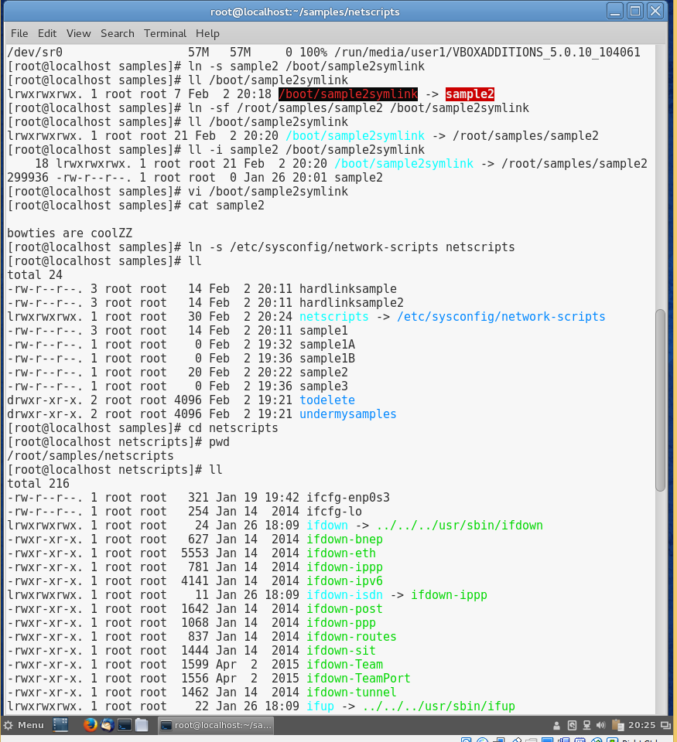
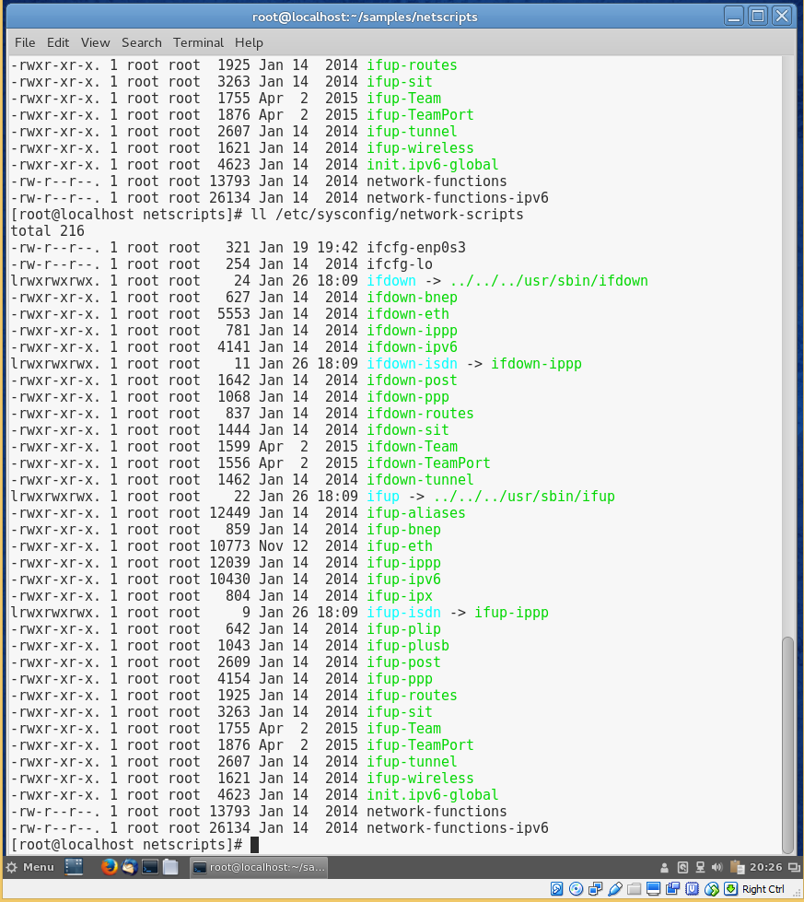
Project 4-5
In this hands-on project, you find files on the filesystem using the find, locate, and which commands.
- Boot your Fedora Linux virtual machine. Login to your chosen desktop environment as user1 using password LNXrocks! and open up a terminal window.
- At the terminal, become root by typing su - and press enter and provide LNXrocks! as the password.
- At the command prompt, type cd and press Enter to ensure you are in the root users home directory.
- At the command prompt, type touch newfile and press Enter. Next, type locate newfile at the command prompt and press Enter. Locate should not be able to find the newly created file. This is because the database has not been updated with this new file.
- At the command prompt, type updatedb (must be root) and press Enter. When the command is finished, type locate newfile at the command prompt and press Enter. Locate should have been able to find the file rather quickly.
- At the command prompt, type find / -name "newfile" and press Enter. Since the file is in the root users home directory, find will not take that long to find the file. However, locate is much faster than find but find is more feature rich but will usually yield a slower search.
- At the command prompt, type find /root -name "newfile" and press Enter. This search should find the file much faster since we narrowed down the directories to search.
- Provide screenshot(s) of steps 4 through 7.
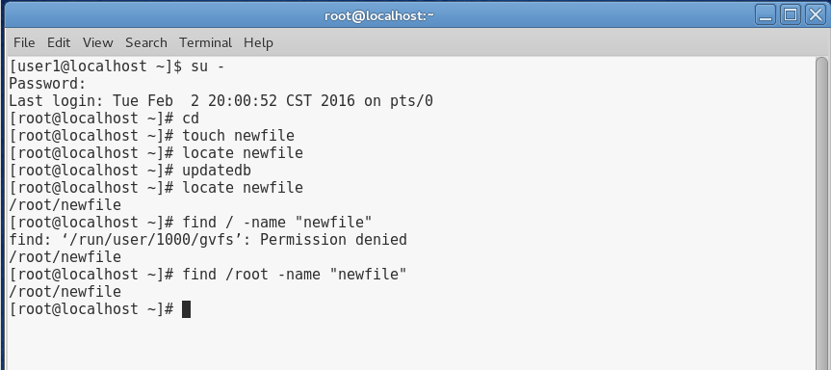
- At the command prompt, type which newfile and press Enter. Review the error message displayed to the terminal. This is because the /root directory is not in the path. Type echo $PATH at the command prompt and press Enter. Notice that at the end we see that /root/bin is in our root users path. Next, type mkdir bin at the command prompt and press Enter. Next, type mv newfile bin at the command prompt and press Enter. Next, type which newfile at the command prompt and press Enter. Notice that we still receive the same error. This is because the file needs to have the executable mode set. Next, type chmod +x bin/newfile at the command prompt and press Enter. Next, type which newfile at the command prompt and press Enter. Notice that we are now able to locate where the file is located as it is in our path and has the executable permission.
- At the command prompt, type which grep and press Enter.
- At the command prompt, type find /root -type l and press Enter. This will display all the symlinked files/directories in /root.
- At the command prompt, type find /root -size 0 and press Enter. This will display all the files that have 0 file size.
- Provide screenshot(s) of steps 9 through 12.
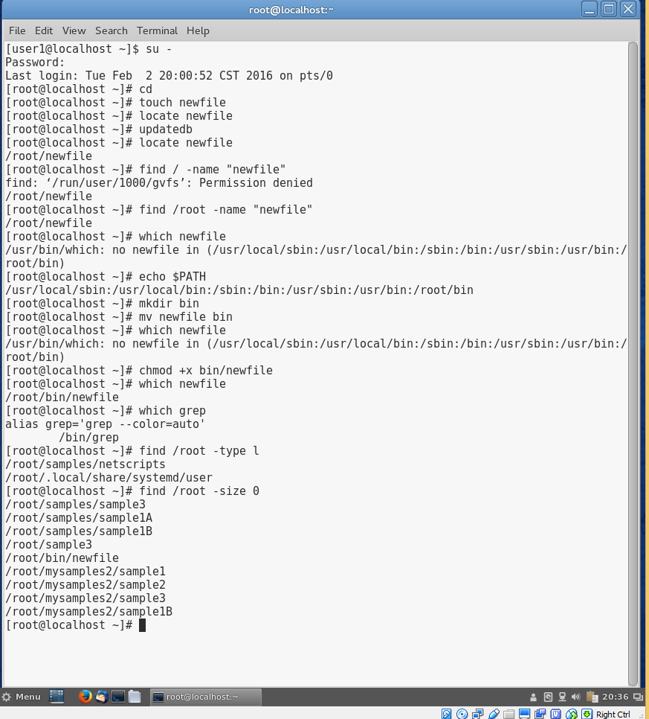
Project 4-6
In this hands-on project, you delete files and directories using the rmdir and rm commands.
- Boot your Fedora Linux virtual machine. Login to your chosen desktop environment as user1 using password LNXrocks! and open up a terminal window.
- At the terminal, become root by typing su - and press enter and provide LNXrocks! as the password.
- At the command prompt, type cd and press Enter to ensure you are in the root users home directory.
- At the command prompt, type cd samples and press Enter. At the command prompt, type ls -R and press Enter. Note the two empty directories todelete and undermysamples.
- At the command prompt, type rmdir undermysamples todelete and press Enter. Next, type ll at the command prompt and press Enter. Both directories should be deleted.
- At the command prompt, type rm sample1* and press Enter. Notice the shell asks you if you are sure you want to delete these files. Recall that rm has an alias to rm -i for interactive mod. Answer n to all three questions.
- At the command prompt, type rm -f sample1* and press Enter. Notice you are not prompted if you are sure you want to delete these files. Next, type ll at the command prompt and press Enter. You should no longer see the 3 files in the output.
- At the command prompt, type cd .. and press Enter. Next, type rmdir samples at the command prompt and press Enter. Read the error message returned by the shell.
- At the command prompt, type rm -Rf samples and press Enter. Next, type ll at the command prompt and press Enter. We successfully deleted the samples directory and the contents of the directory by using the recursive option and the force option to not prompt us to delete each file.
- Provide screenshot(s) of steps 4 through 9.
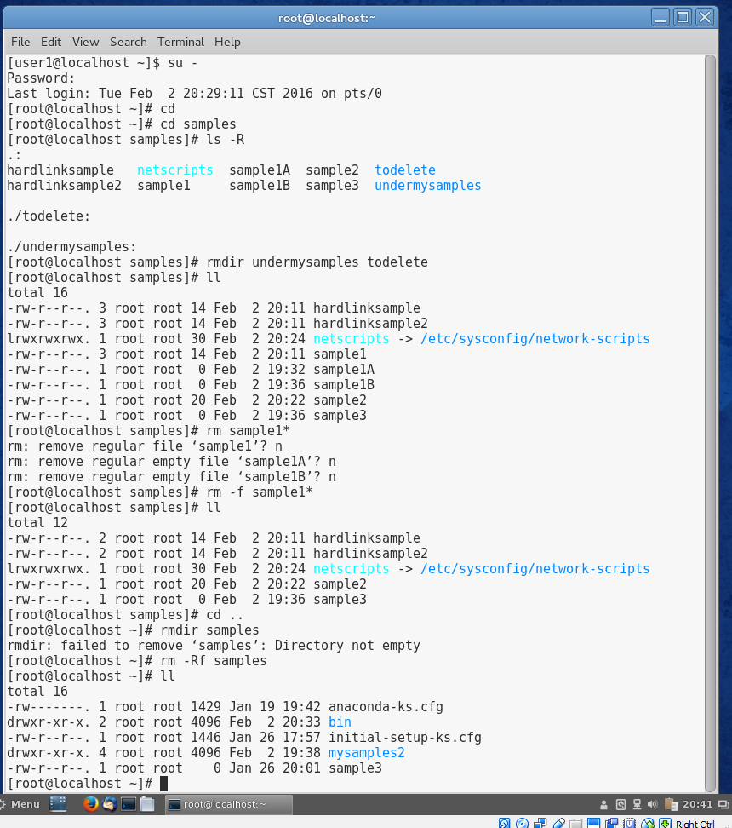
Project 4-7
In this hands-on project, you apply and modify access permissions on files and directories and test their effects.
- Boot your Fedora Linux virtual machine. Login to your chosen desktop environment as user1 using password LNXrocks! and open up a terminal window.
- At the terminal, become root by typing su - and press enter and provide LNXrocks! as the password.
- At the command prompt, type cd and press Enter to ensure you are in the root users home directory.
- At the command prompt, type touch permsample and press Enter. Next, type chmod 777 permsample at the command prompt and press Enter.
- At the command prompt, type ll and press Enter. Notice that we gave the owner, group owner, and others (anyone not the owner or in the group) full permission to read, write, and execute the file.
- At the command prompt, type chmod 000 permsample and press Enter. Next, type ll at the command prompt and press Enter. We have changed the mode of the file by removing all permissions from the owner, group owner, and others.
- At the command prompt, type rm -f permsample and press Enter. You are able to delete the file since you are the owner.
- At the command prompt, type cd / and press Enter. Next, type pwd at the command prompt and press Enter.
- At the command prompt, type ll and press Enter to view the owner, group owner, and permissions on the foruser1 directory created in Hands-on Project 4-1.
- At the command prompt, type cd /foruser1 and press Enter to enter the foruser1 directory. Type cp /etc/hosts . at the command prompt and press Enter. Next, type ll at the command prompt and press Enter to ensure that a copy of the hosts file was made in your current directory.
- Provide screenshot(s) of steps 4 through 10.
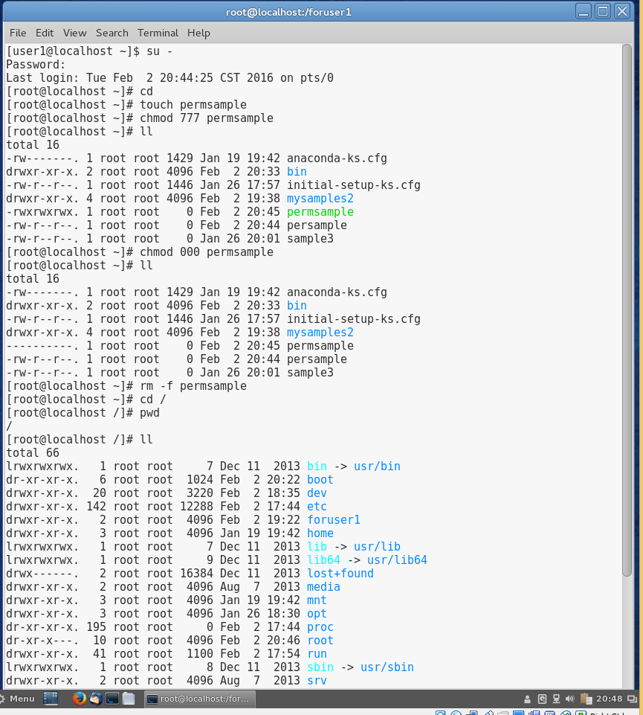
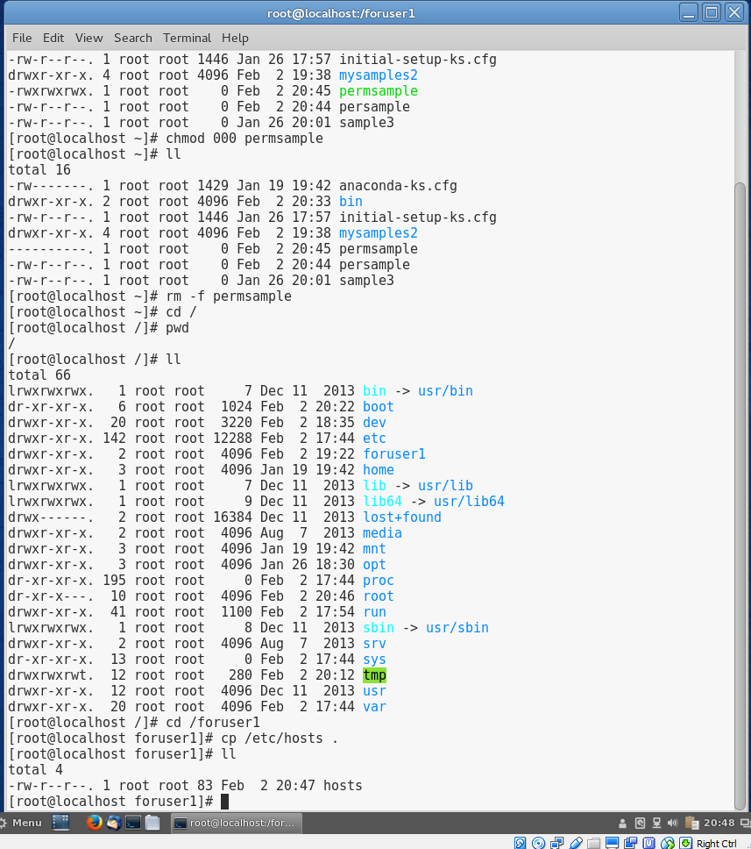
- Open up a new terminal window or tab by going to File -> Open Terminal/Tab.
- At the new terminal command prompt, type cd /foruser1 and press Enter. Next, type ll at the command prompt and press Enter. Next, type rm -f hosts at the command prompt and press Enter. Review the error the shell returns.
- Switch back to your previous terminal where you are the root user.
- At the command prompt, type ll -d /foruser1 and press Enter to view the owner, group owner, and permissions on the foruser1 directory. At the command prompt, type chmod 757 /foruser1 and press Enter. At the command prompt, type ll -d /foruser1 and press Enter to review the addition of the write permission for the others.
- Switch back to your other terminal where you are user1.
- You should still be in the /foruser1 directory. Next, type rm -f hosts at the command prompt and press Enter. You are now able to delete the file even though you are not the owner of the file. This is because we provided the write permission to the directory for others which your user falls under. You need to be careful with giving directories the writer permission.
- Switch back to your previous terminal where you are the root user.
- You should still be in the /foruser1 directory. Type cp /etc/hosts . at the command prompt and press Enter to place another copy of the hosts file in your current directory.
- Provide screenshot(s) of steps 12 through 19.
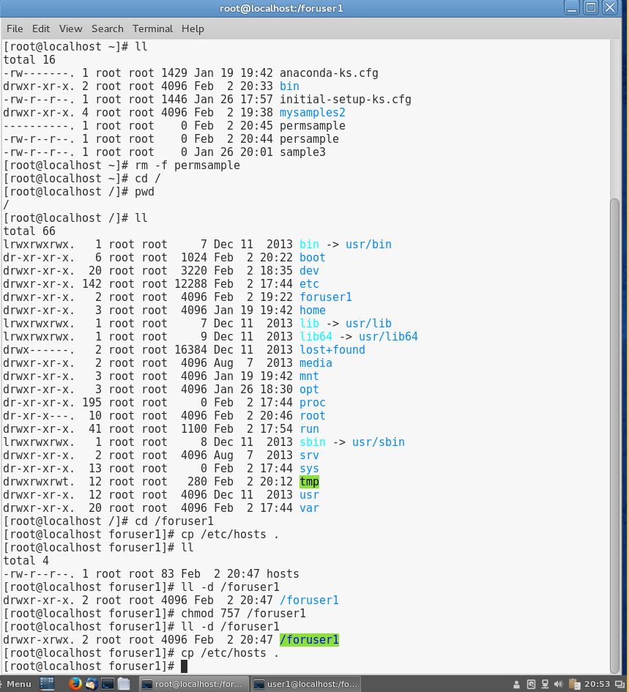
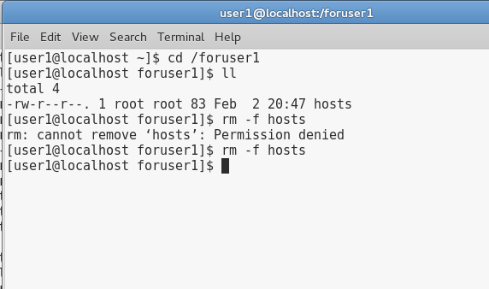
- At the command prompt, type ll and press Enter. Review the permissions of the hosts file.
- Switch back to your other terminal where you are user1.
- You should still be in the /foruser1 directory. Type cat hosts at the command prompt and press Enter. You can view the contents of the file since others have the ability to read the file.
- At the command prompt, type echo test >> hosts and press Enter. Review the error message the shell returns.
- Switch back to your previous terminal where you are the root user.
- You should still be in the /foruser1 directory. Type chmod 646 hosts at the command prompt and press Enter. At the command prompt, type ll and press Enter. Notice we have provided others with the write permission.
- Switch back to your other terminal where you are user1.
- At the command prompt, type echo test >> hosts and press Enter. At the command prompt, type cat hosts and press Enter. You should see test appended to the bottom of the file.
- Provide screenshot(s) of steps 21 through 28.
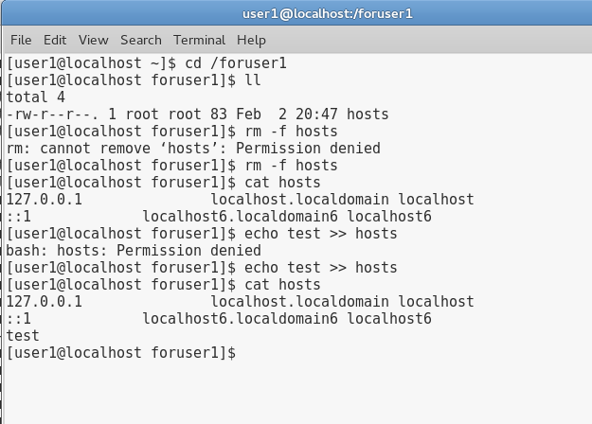
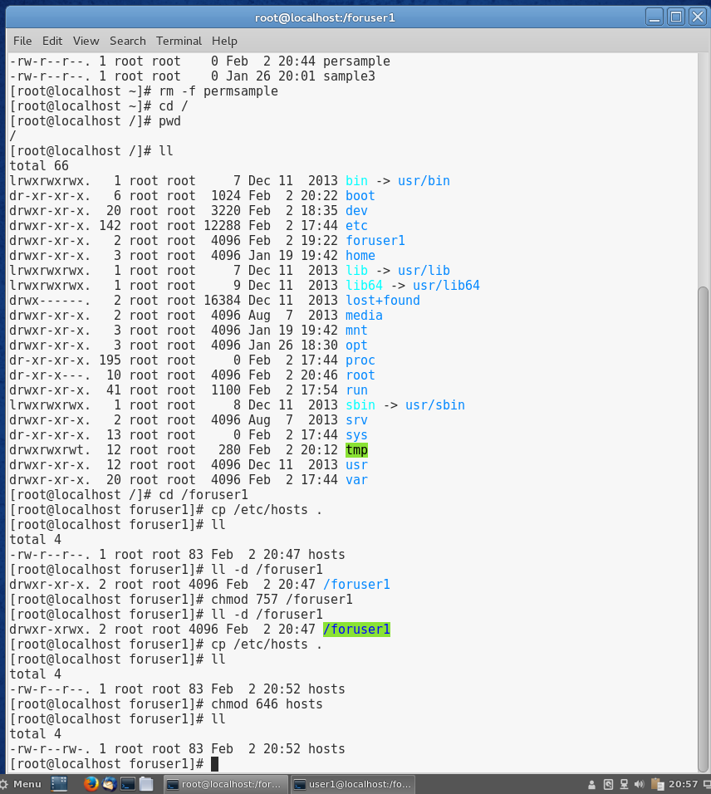
Project 4-8
In this hands-on project, you view and manipulate the default file and directory permissions using the umask variable.
- Boot your Fedora Linux virtual machine. Login to your chosen desktop environment as user1 using password LNXrocks! and open up a terminal window.
- At the command prompt, type ll and press Enter. At the command prompt, type cd and press Enter to ensure you are in user1 home directory.
- At the command prompt, type umask and press Enter. Review the default umask value.
- At the command prompt, type touch utest1 and press Enter. Next, type ll at the command prompt and press Enter. Recall the default permissions provided to a file. Recall that files are created with the default permissions of -rw-rw-rw-. You will see that the write permission is removed from the others due to the default umask value. Create a new directory by typing the command mkdir udir1 at the command prompt and pressing Enter. Next, type ll at the command prompt and press Enter. Recall the default permissions of directories are drwxrwxrwx. You will see that the write permission is removed from the others due to the default umask value. This is to prevent deletion by other users of the system as demonstrated in 4-7.
- At the command prompt, type umask 007 and press Enter. Next, type umask at the command prompt and press Enter to verify that your umask variable has been changed to 007.
- At the command prompt, type touch utest2 and press Enter. Next, type ll at the command prompt and press Enter. Review the permissions of the utest2 file. Create a new directory by typing the command mkdir udir2 at the command prompt and pressing Enter. Next, type ll at the command prompt and press Enter. Review the permissions of the new directory.
- Provide screenshot(s) of steps 2 through 5.
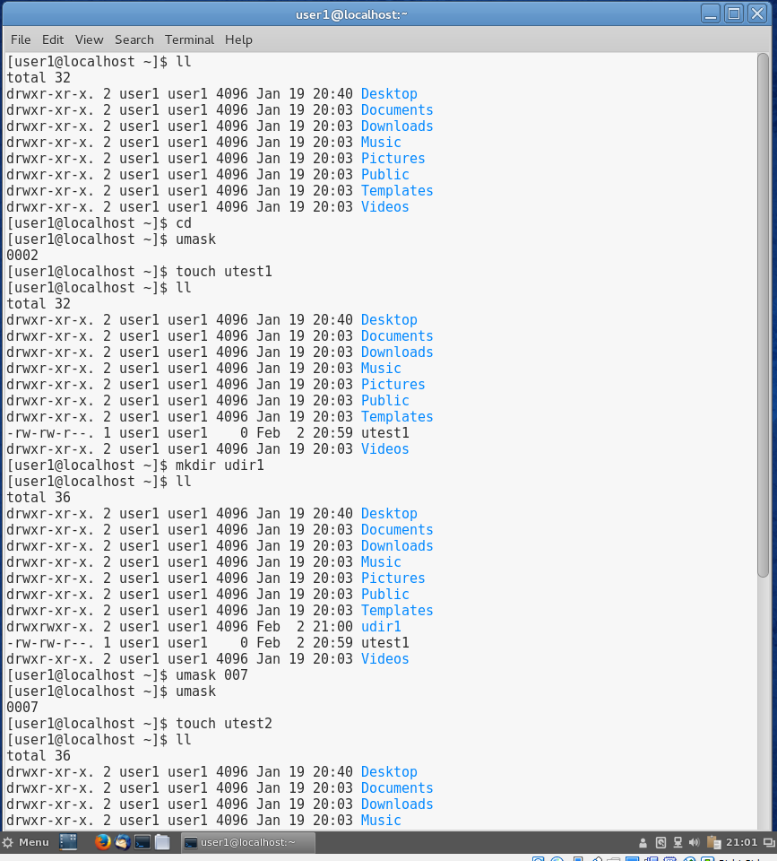
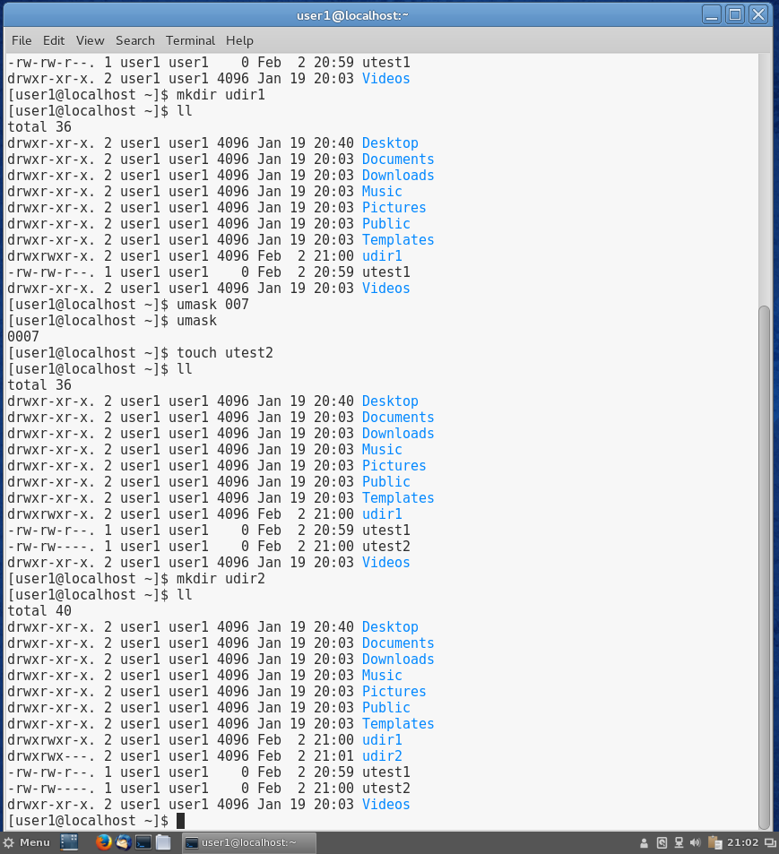
Project 4-9
In this hands-on project, you view and change file and directory ownership using the chown and chgrp commands.
- Boot your Fedora Linux virtual machine. Login to your chosen desktop environment as user1 using password LNXrocks! and open up a terminal window.
- At the terminal, become root by typing su - and press enter and provide LNXrocks! as the password.
- At the command prompt, type cd and press Enter to ensure you are in the root users home directory.
- At the command prompt, type touch ownersample and press Enter. Next, type mkdir ownerdir at the command prompt and press Enter. Next, type ll at the command prompt and press Enter to verify that the file ownersample and directory ownerdir were created and that root is the owner and group owner of each.
- At the command prompt, type chgrp sys owner* and press Enter to change the group ownership to the sys group for both ownersample and ownerdir. Next, type ll at the command prompt and verify the group was changed to sys.
- At the command prompt, type chown user1 owner* and press Enter to change the ownership to user1 for both ownersample and ownerdir. Verify this by typing ll at the command prompt.
- At the command prompt, type chown root.root owner* and press Enter to change the ownership and group ownership back to the root user for both ownersample and ownerdir. Verify this by typing ll at the command prompt.
- At the command prompt, type mv ownersample ownerdir and press Enter. Next, type ll ownerdir at the command prompt and press Enter to note that the ownersample file now exists within the ownerdir directory and that both are owned by root.
- At the command prompt, type chown -R user1 ownerdir and press Enter. Next, type ll at the command prompt and press Enter. Review the owner of the ownerdir directory. Next, type ll ownerdir at the command prompt and press Enter. Review the owner of the ownersample file.
- At the command prompt, type rm -Rf ownerdir and press Enter.
- Provide screenshot(s) of steps 4 through 10.
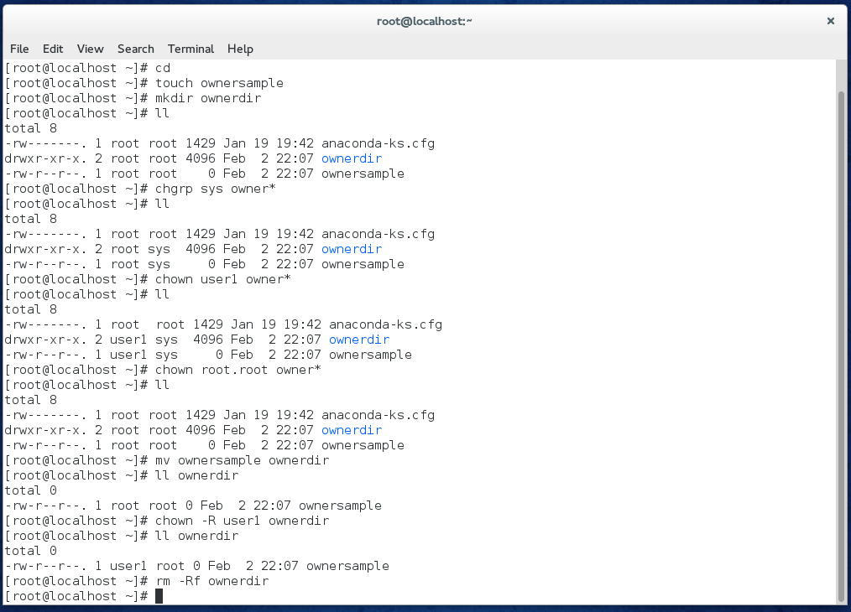
Project 4-10
In this hands-on project, you view and set special permissions on files and directories as well as modify the default ACL on a file.
- Boot your Fedora Linux virtual machine. Login to your chosen desktop environment as user1 using password LNXrocks! and open up a terminal window.
- At the command prompt, type touch specialfile and press Enter. Next, type ll at the command prompt and press Enter to verify that specialfile was created successfully. Review the owner and group owner of the file.
- At the command prompt, type chmod 4777 specialfile and press Enter. Next, type ll at the command prompt and press Enter. We have added the set-user special permission.
- At the command prompt, type chmod 6777 specialfile and press Enter. Next, type ll at the command prompt and press Enter. We have added the set-group special permission along with set-user.
- At the command prompt, type chmod 6444 specialfile and press Enter. Next, type ll at the command prompt and press Enter. You will notice that the special permissions now show up as capital S as we did not provide the file with the execute mode which is required for these special permissions to work.
- Open up a new terminal window or tab by going to File -> Open Terminal/Tab. At the terminal, become root by typing su - and press enter and provide LNXrocks! as the password.
- At the command prompt, type mkdir /public and press Enter. Next, type chmod 1777 /public at the command prompt and press Enter. We have applied the sticky bit to this directory that has full permissions for owner, group owner, and others. Recall what the sticky bity special permission is used for.
- At the command prompt, type touch /public/rootfile and press Enter.
- Switch back to your other terminal where you are user1.
- At the command prompt, type touch /public/user1file and press Enter. Next, type ll /public at the command prompt and press Enter. Review the files displayed in the output.
- At the command prompt, type rm /public/user1file and press Enter. Next, type ll /public at the command prompt and press Enter. Review the files displayed in the output.
- At the command prompt, type rm /public/rootfile and press Enter. Press y when prompted to delete the file. Note the error message that you receive is due to the sticky bit being applied to the directory. If the sticky bit was not applied, user1 would be able to delete the root users file since the permissions on the directory allow this due to the write and execute permissions.
- Provide screenshot(s) of steps 2 through 12.
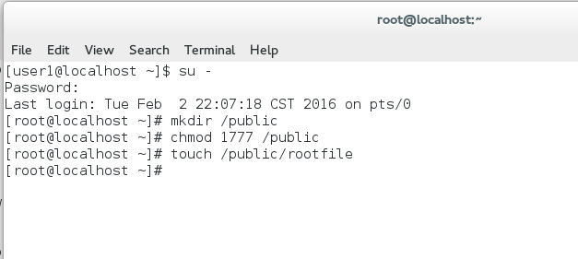
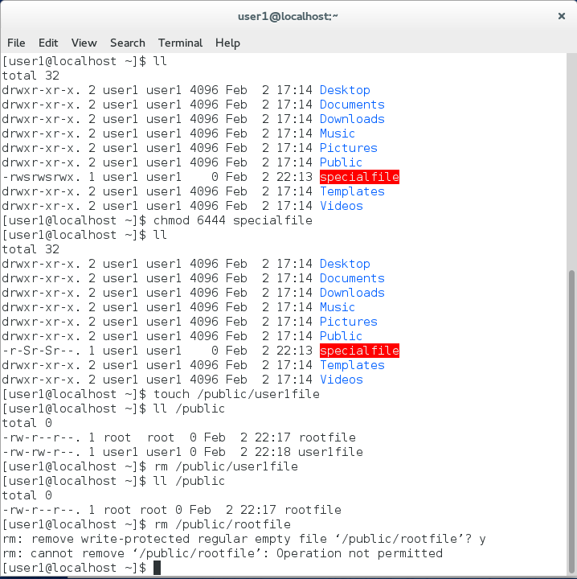
- Switch back to your previous terminal where you are the root user. At the command prompt, type cd and press Enter to ensure you are in the root users home directory.
- At the command prompt, type touch aclfile and press Enter. Next, type getfacl aclfile at the command prompt and press Enter. Note only permissions for the user, group owner, and other are displayed.
- At the command prompt, type setfacl -m u:user1:r-- aclfile and press Enter. Next, type ll aclfile at the command prompt and press Enter. There is now a + symbol following the mode of the file. Next, type getfacl aclfile at the command prompt and press Enter. You will now see the ACL we created for the file that allows user1 to read this file.
- At the command prompt, type setfacl -b aclfile and press Enter. Next, type ll aclfile at the command prompt and press Enter. The + symbol is not displayed as we removed the ACL from the file.
- Provide screenshot(s) of steps 12 through 16.
