# Splunk Core Certified Power User

## What is Splunk? (eLearning)

This is discontinued.

## Intro to Splunk

### What is Splunk?

### Using Splunk web

<https://splunkbase.splunk.com/>

### Using Search

### Exploring events

### Using Search term

### What are commands?

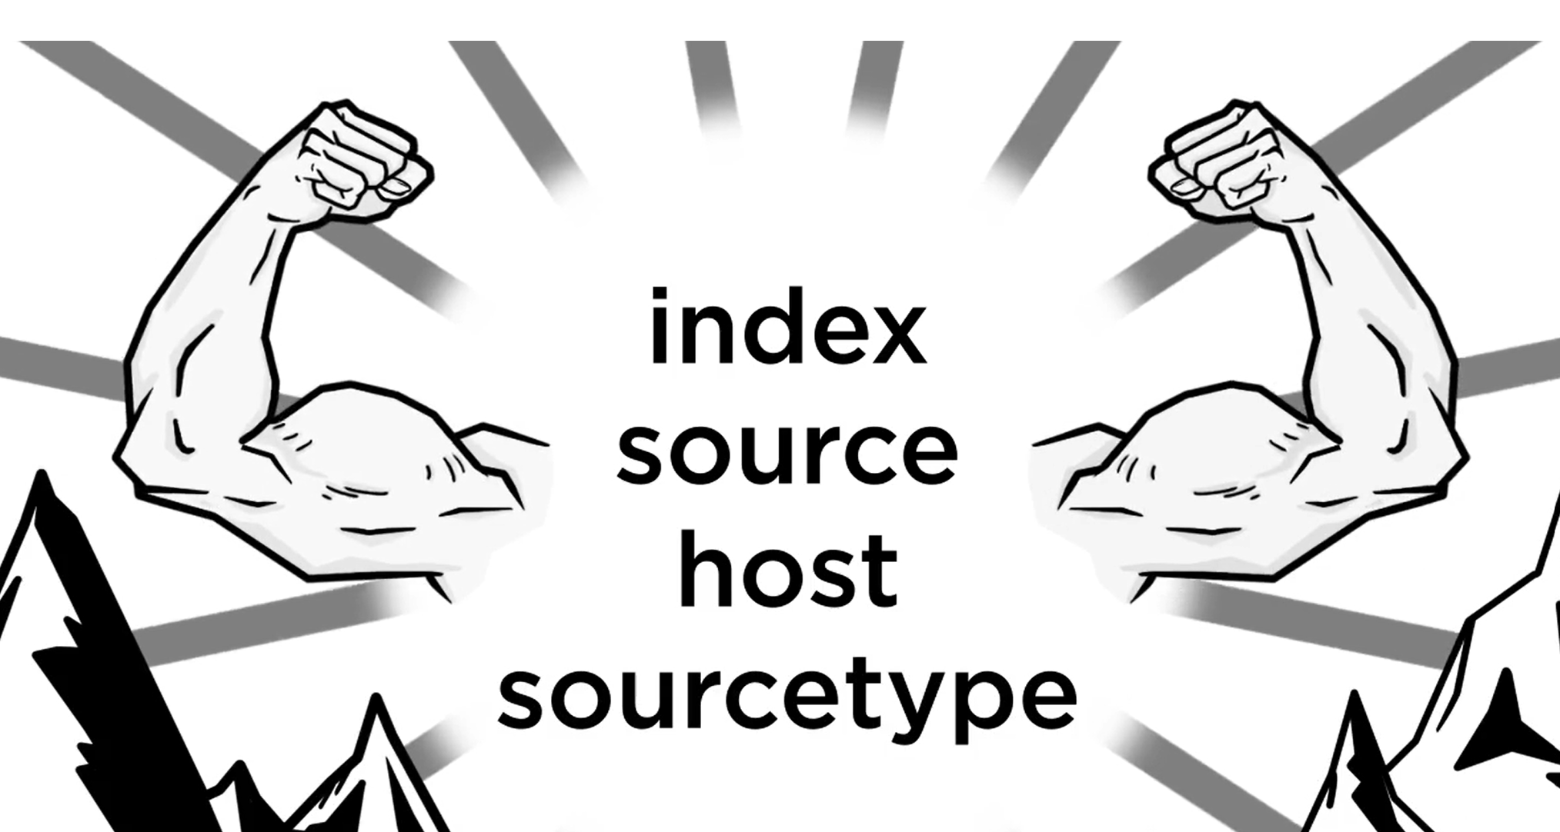

### What are Knowledge objects

### Creating Reports?

### Creating Dashboards

### Dashboard Studio