# Number Theory

## Natural Number

### What are natural Numbers?

The natural numbers include the positive integers (also known as non-negative integers) and a few examples include 1, 2, 3, 4, 5, 6, … ∞.

In other words, natural numbers are a set of all the whole numbers excluding 0.

Example: 23, 56, 78, 999, 100202, etc

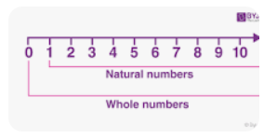

## IMP: Factors

### **IMP:** What are factors of a number?

Factors is a number (or algebraic expression) that divides another number (or expression) evenly—i.e., with no remainder

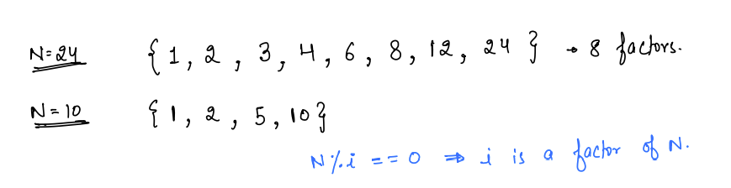

Quote: Optimization comes from observation.

### **IMP: Optimize Finding factors?**

1. If I is a factor of N then I multiplied by some other number is equal to N

I * j = N

In this case if I is a factor then j is also a factor

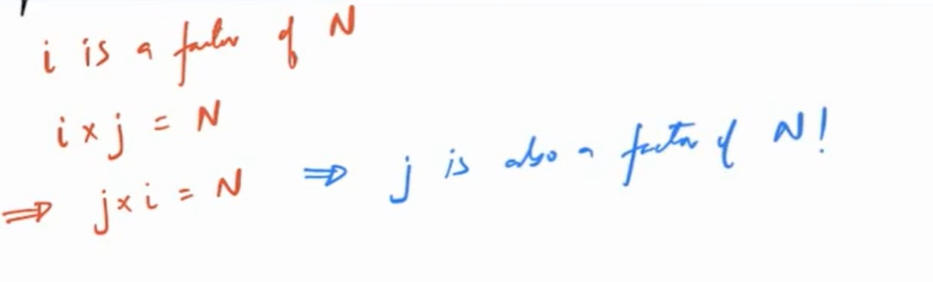

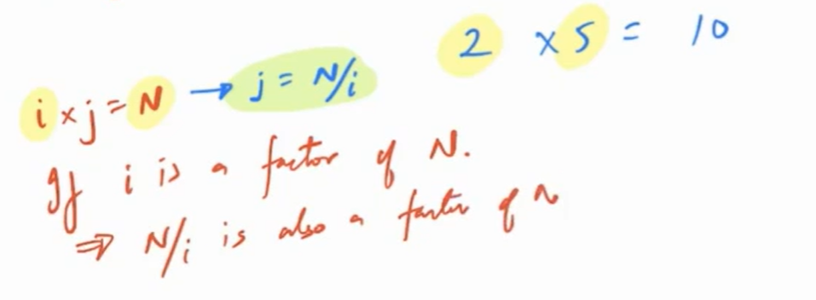

So if “i” is factor of N then “N/i” is also factor of N.

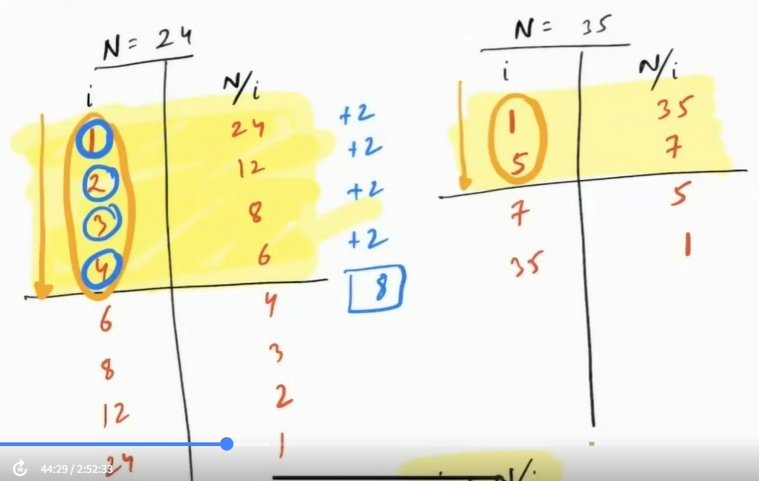

i < N/i

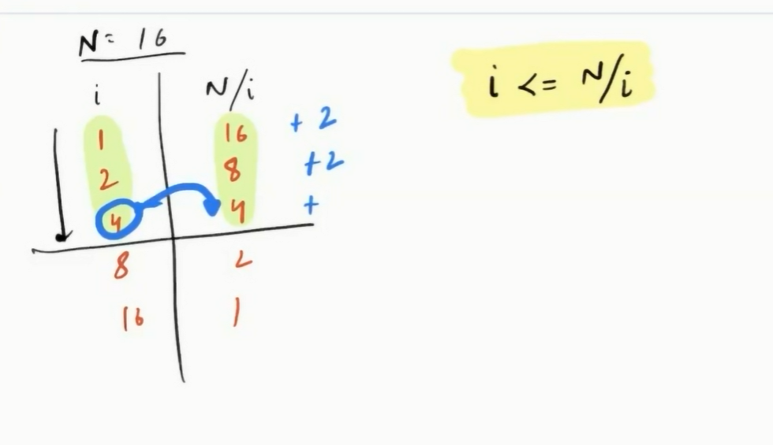

16 is perfect square.

i<=N/I is required for the perfect square.

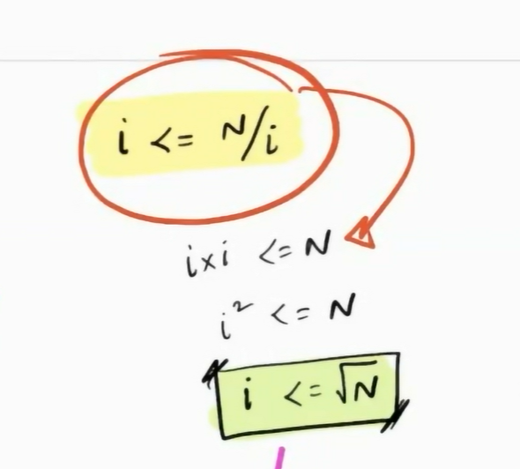

### IMP: Properties of Factors?

Number of factors will be odd for a PERFECT SQUARE.

## **IMP: Prime Number**

### What are prime numbers?

Number which has exactly 2 factors. 1 and itself. (Computer science definition)

a number that is divisible only by 1 and itself.

prime numbers are very useful in cryptography

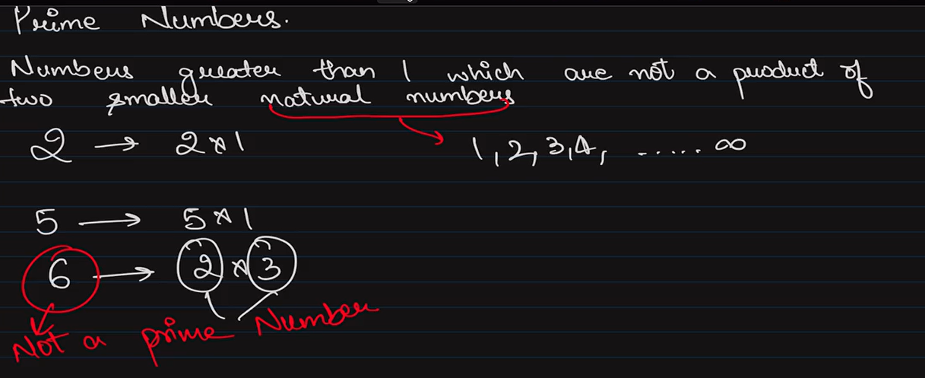

### Properties of Prime number?

1. 1 is neither prime nor composite.
2. Every natural number is either prime or can be formed by using prime numbers. (Prime factorization method.)
3. Even numbers are not prime numbers except 2. All even numbers are composite numbers except 2.
4. Trick 1 : For any number less than 100 we divide the number by rime number. Less than 10 that is 2,3,5,7
5. Trick 2: For any number less than 200 we divide the number by prime number less than 14 that is 2,3,5,7,11, 13
6. 1 is neither prime number not composite number.
7. 2 is the only even number that is prime.

### How to find prime number?

In order to find if the number is prime number or not, we need to find its **factors.**

1. General form

<https://www.youtube.com/watch?v=vyXNThkfiVA>

1. Fastest way

6n+1 or 6n -1

https://www.youtube.com/watch?v=5liC14kBrQ4

### What is co-prime?

Two prime numbers are called co -primes if they do not contain common factors other than 1.

https://www.youtube.com/watch?v=HGfxdr6_gWY

*Best way to find if number are co-prime or not.*: If 2 numbers are co-prime then their LCM is equal to product of the 2 numbers. This is how we can find the prime number.

## Composite Number

### What are composite numbers?

Numbers other than prime numbers are composite numbers.

A number that is divisible by a number other than 1 and the number itself

Note: 1 is neither composite nor prime.

## IMP: Square Root: Perfect square.

### IMP: What is Perfect square?

Number which is **“product of 2 same integers”**

### Properties of perfect square?

1. 1 is smallest perfect square, because 1*1 =1
2. 2 is not perfect square.
3. You can find the square root by using binary Search

### Finding Square root of a given number Mathematical approach?

Below methods are mathematical approaches:

Square root is inverse of square of a number

Square root of a number can be found using three methods.

1. Repeated subtraction method (by odd number). Never use this method

<https://www.youtube.com/watch?v=EggZmJOcKpw>

1. Prime Factorization method

<https://www.youtube.com/watch?v=njh0TwV8zA8>

1. **Best: Long division method**

Quotient will be the square root

https://www.youtube.com/watch?v=ERCwQXhd2gQ

## LCM

### LCM (Least Common multiple)?

Least number which is multiple of all given numbers.

1. Prime factorization method.

<https://www.youtube.com/watch?v=-s06Os761dU>

First find prime factors of both numbers, then find highest occurrence of each prime number in any one of the prime factors and consider that for multiplication. You have to consider all prime numbers.

1. *Best method:* Common Division Method

<https://www.youtube.com/watch?v=Ze7_BhdIBSM>

Once the common division method is done multiply all prime factors.

Note: Properties of LCM : LCM of set of numbers is always greater than or equal to the largest number.

### Finding LCM of 3 Numbers?

1. Common Division Method.

<https://www.youtube.com/watch?v=efd9bYQNDYo>

## GCD/HCF

### GCD (Greatest Common **Divisor**) or HCF (Highest Common **Factor**)?

GCD/ HCF is the greatest factor that 2 numbers have in common with each other

1. Prime Factorization

<https://www.youtube.com/watch?v=eOrJw5u5Mq8>

First find prime factors of both numbers, then find common/matching prime numbers in both the prime factors and consider one number for multiplication.

1. *Best Method:* Long Division

https://www.youtube.com/watch?v=eLX5QRVBHQ0

After this the last divisor is HCF

Note: Properties of HCF/GCD: HCF of set of number is always less then or equal to smallest number.

### GCD/HCF of 3 numbers?

<https://www.youtube.com/watch?v=eljVa2KqOTo>

### Formula for Greatest number that will divide all three numbers leaving same remainder is?

GCD/HCF of ((b-a),( c-b),( c-a))

### Formula for LCM and HCF?

LCM (a,b) × HCF (a,b) = a × b

Note: This holds good only for 2 numbers.

https://www.youtube.com/watch?v=8vZJwWUO8IU

# Assignment:

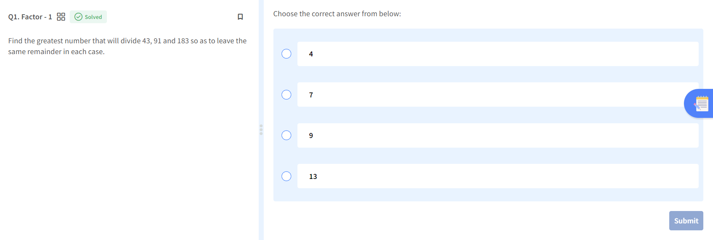

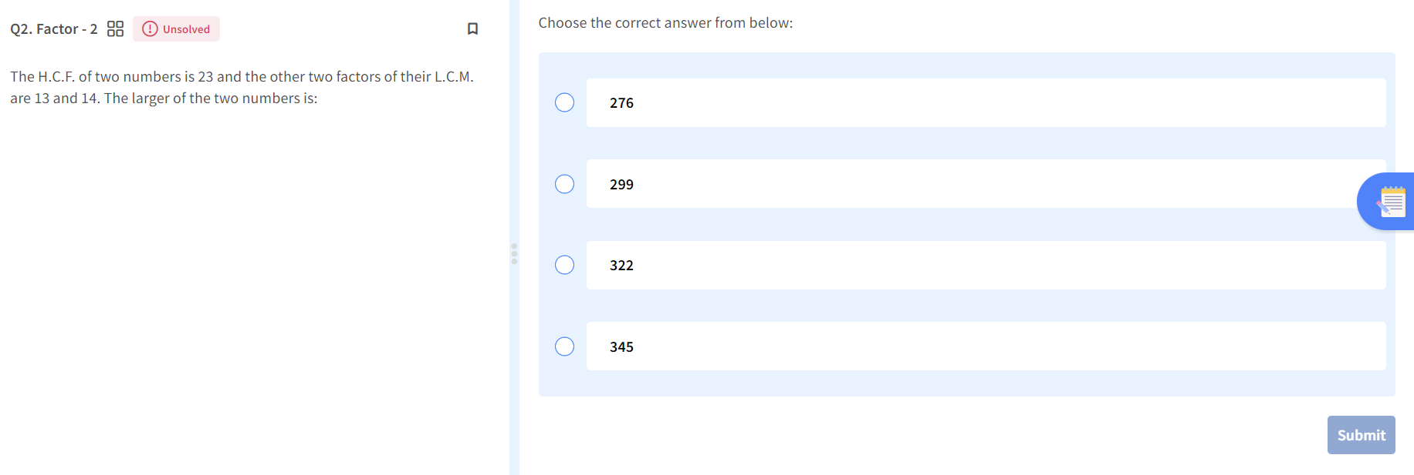

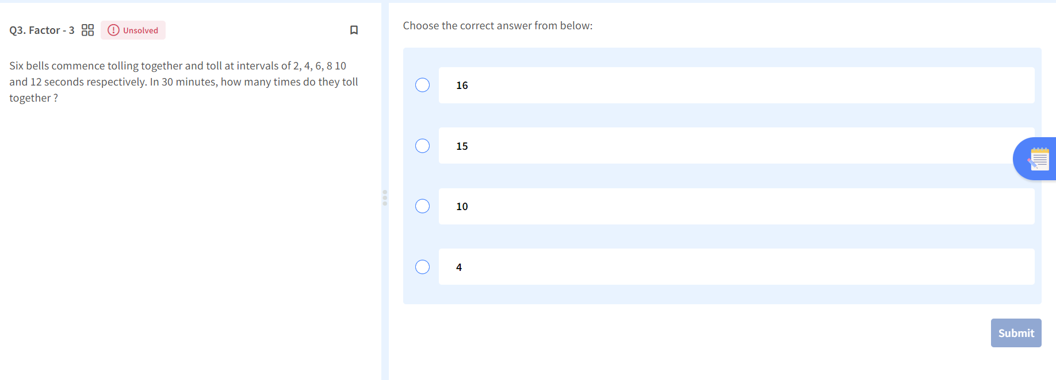

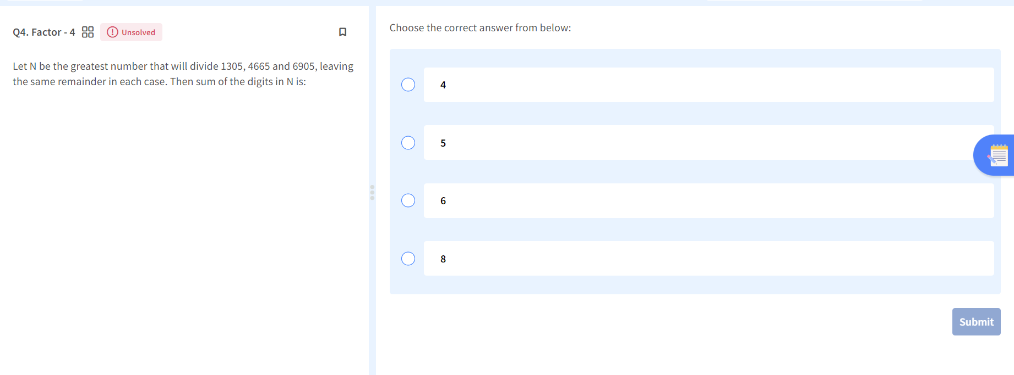

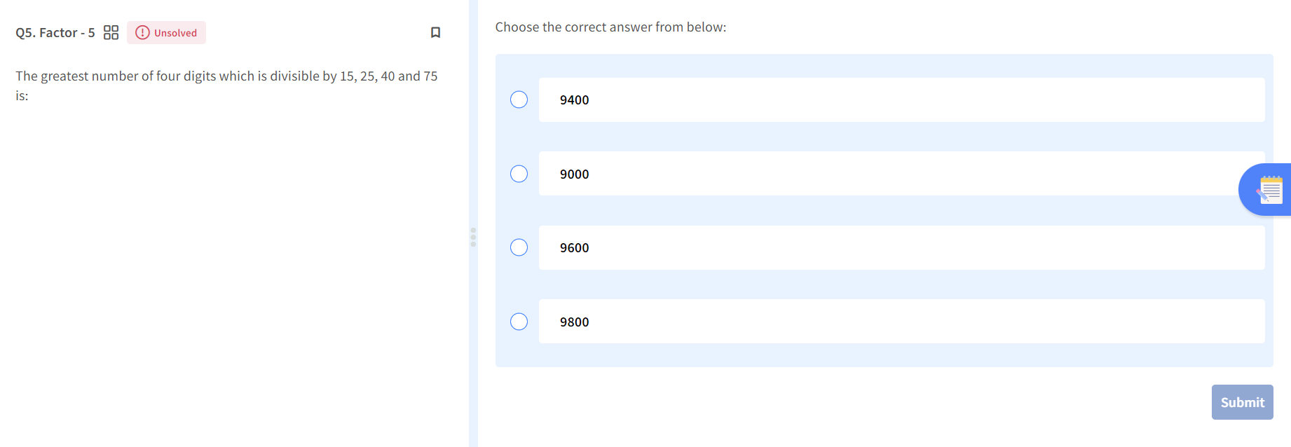

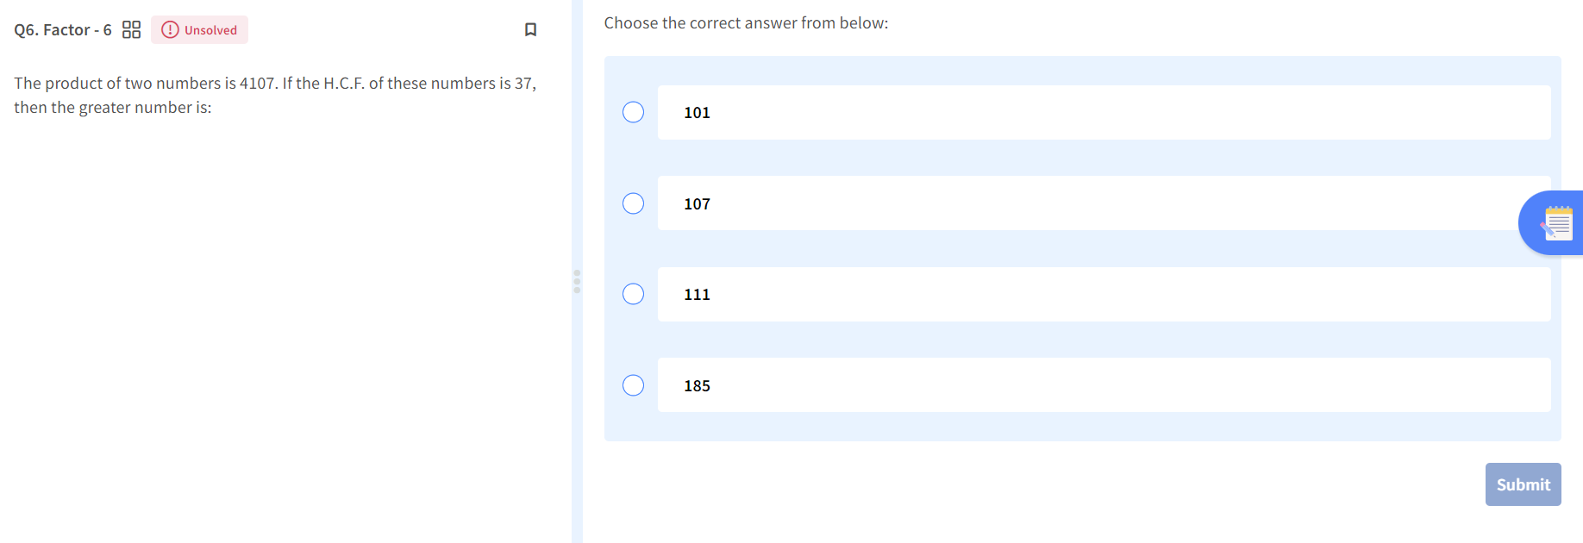

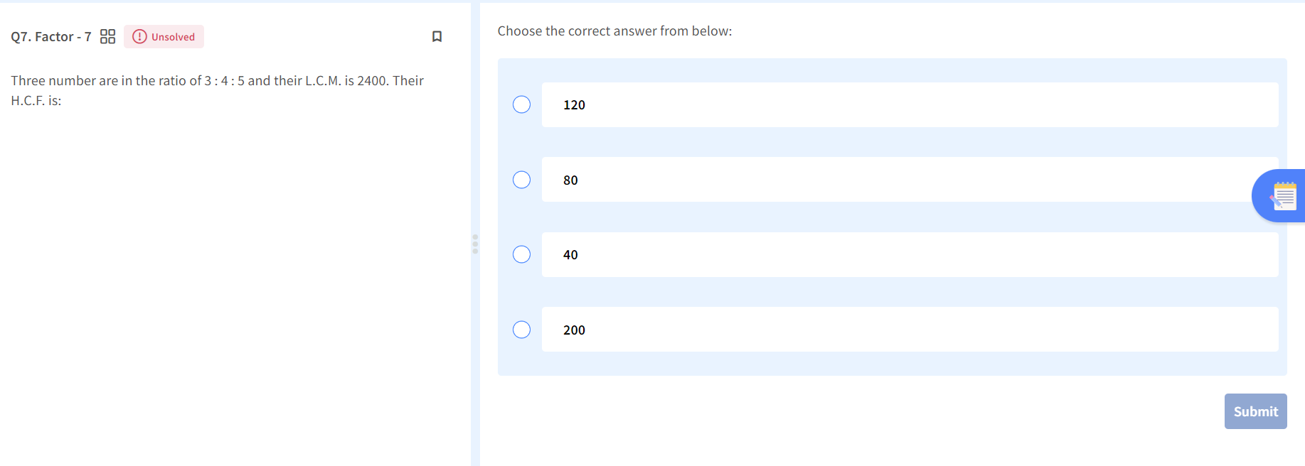

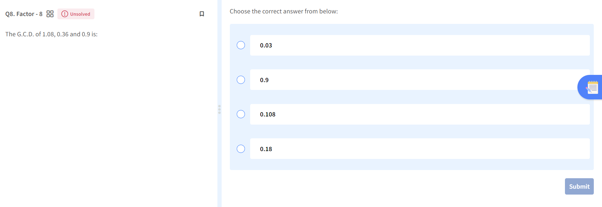

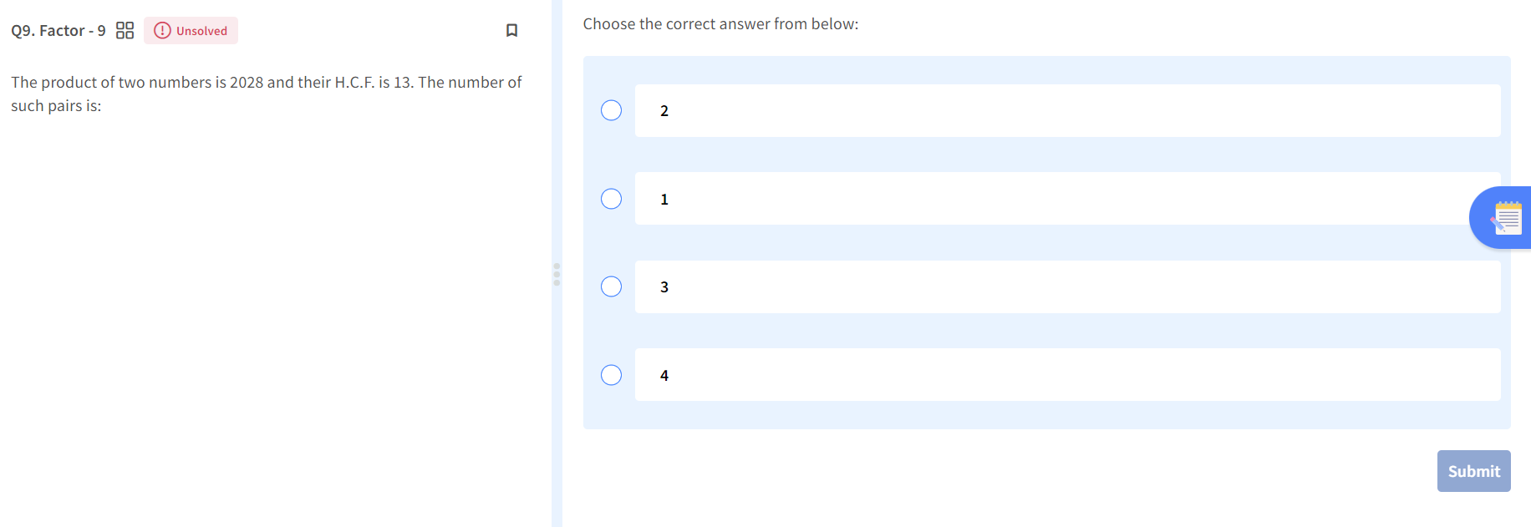

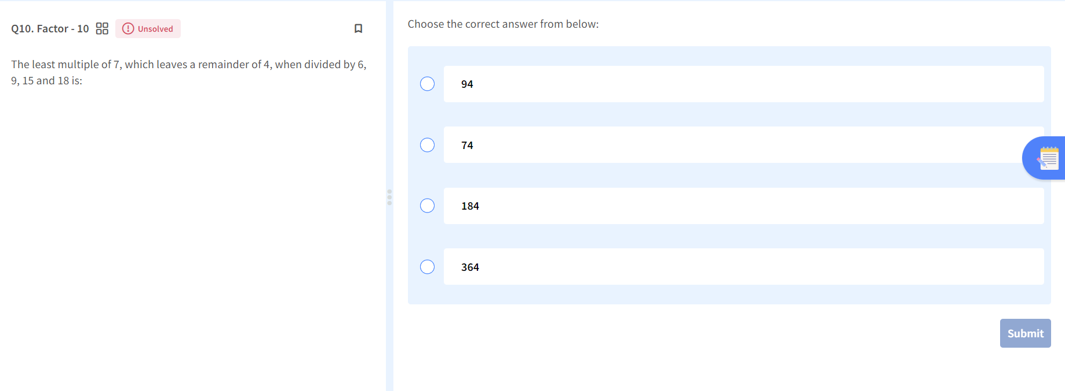

## Practice table till 20?