## Arithmetic progression?

It is a series.

Common difference between adjacent elements remains same.

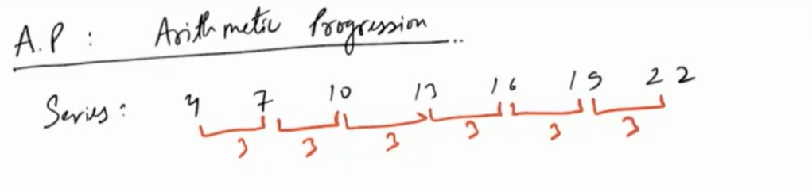

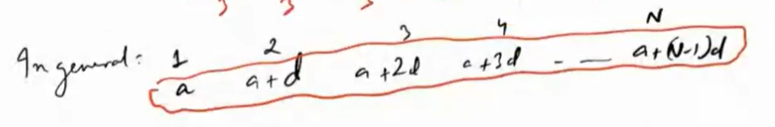

Sum of first N terms is (FT: first term, LT: last term)



