# Time Complexity

## How to analyse the time complexity?

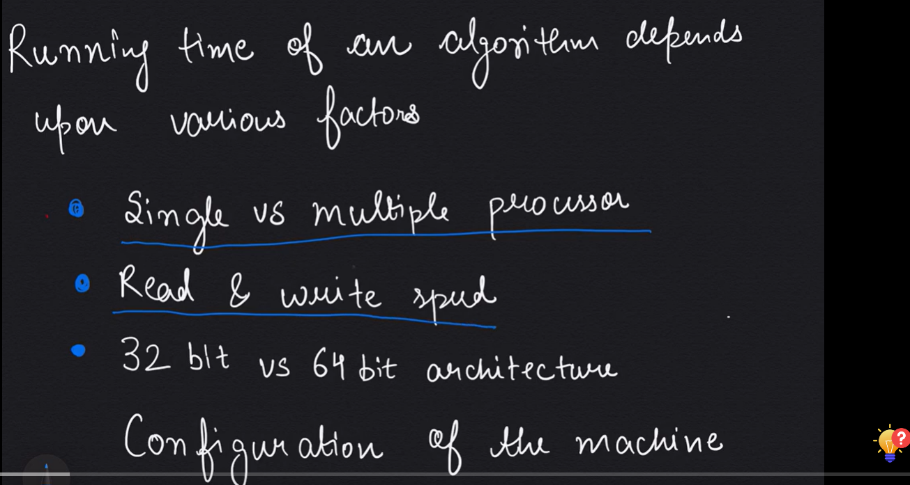



**Input** is the important thing for us.

## Make model machine?

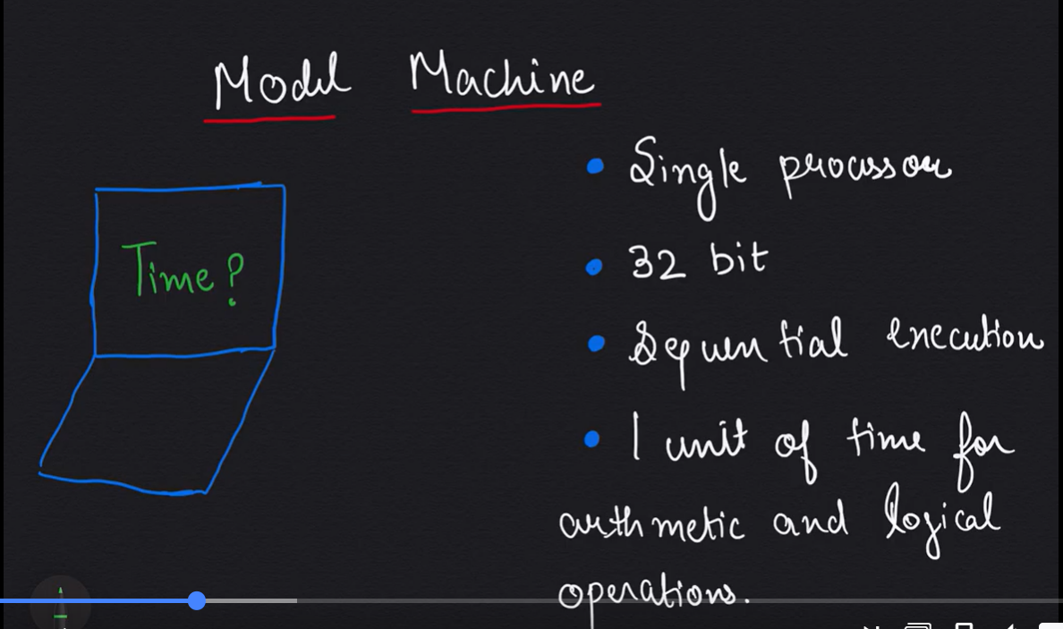

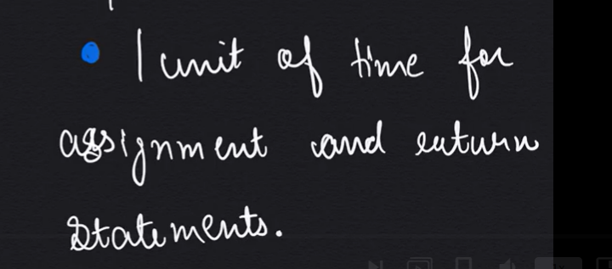

## Arithmetic progression

## Arithmetic progression?

It is a series.

Common difference between adjacent elements remains same.

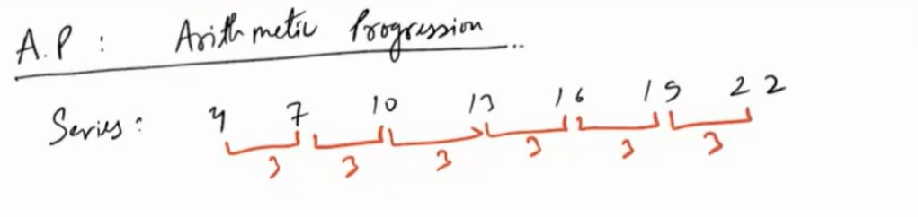

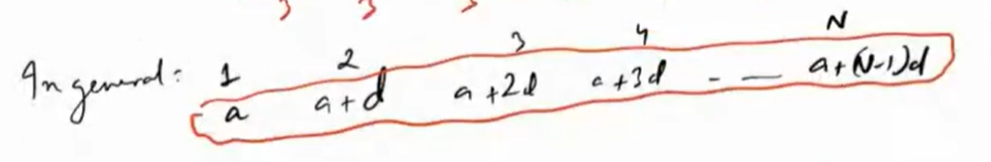

Sum of first N terms is (FT: first term, LT: last term)



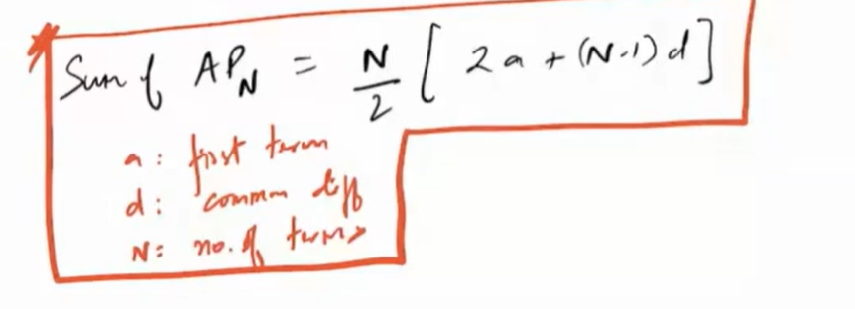

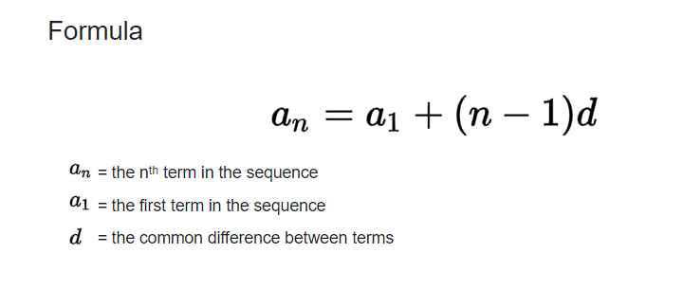

## Geometric Progression?

It is a series.

Common ratio between adjacent elements remains same.

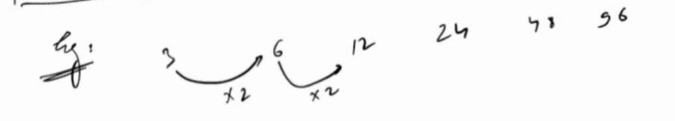

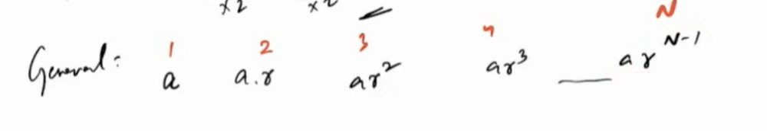

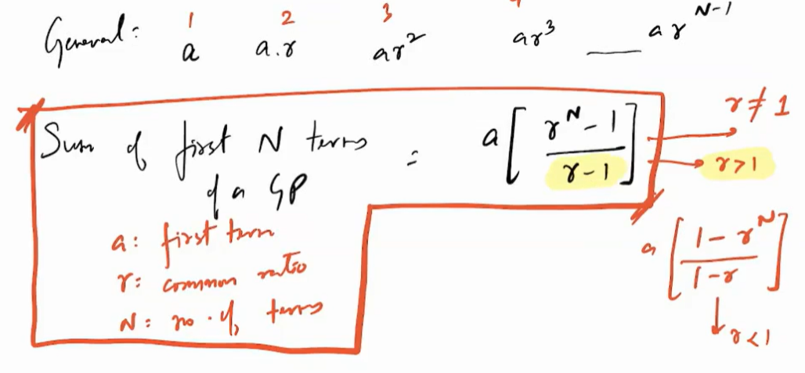

# Assignments