# Scaler

### Overall curriculum

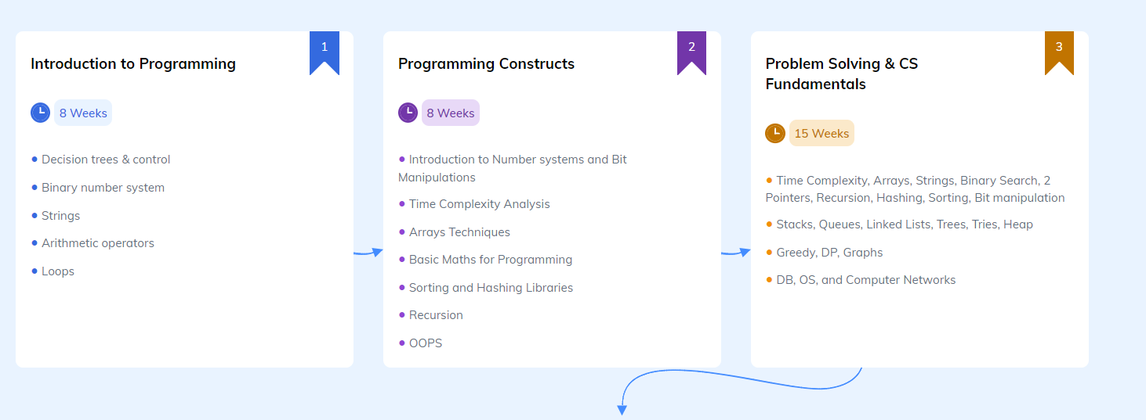

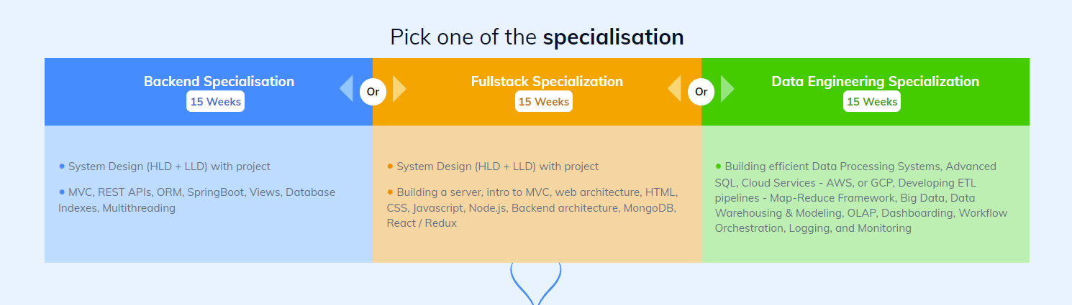

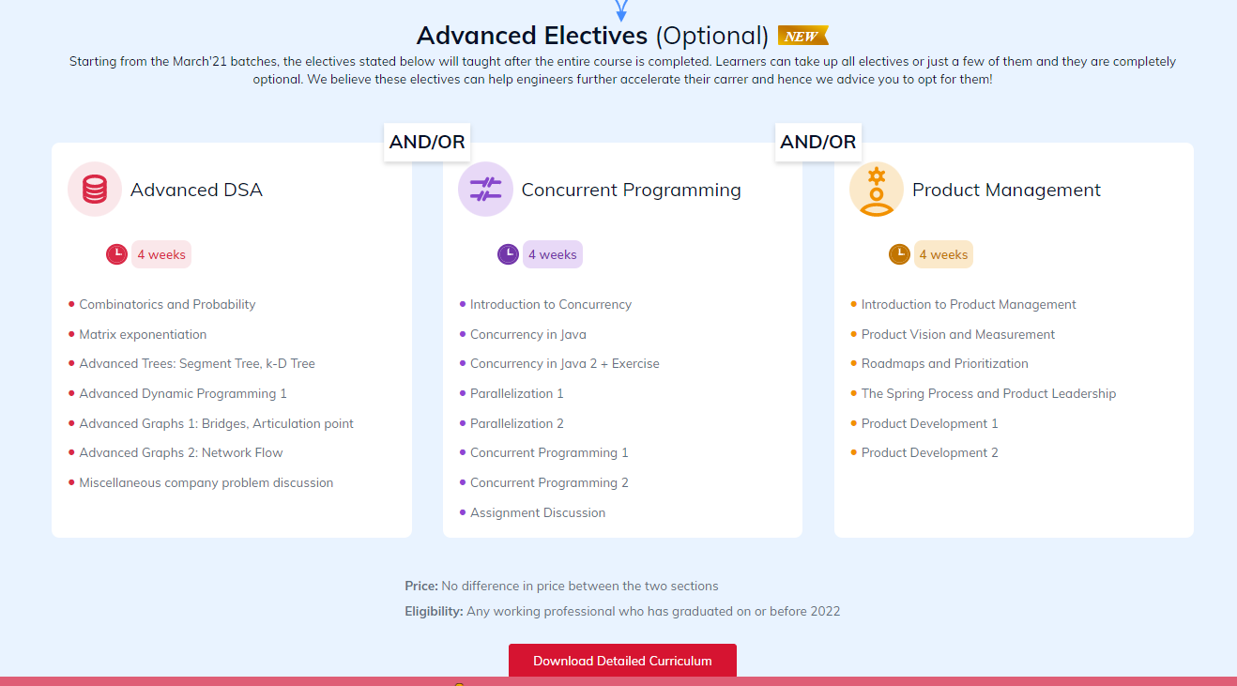

### DSA

#### Maths for programmers

1. Number Theory: Introduction to Number systems and Bit Manipulations
2. Binary number system
3. Modular Arithmetic basic
4. Log Base conversion
5. Probability
6. Permutation and Combination
7. Find any M such That A%M=B%M
8. a ^ b (mod m) [Fast Power In O (log b)]
9. Inverse mod
10. Fermat Theorem
11. Pair sum divisible by M

#### Coding and Logic

1. Recursion
2. Strings
3. Arrays: Arrays Techniques
4. Sorting: Sorting and Hashing Libraries
5. Binary Search
6. 2 Pointers
7. Hashing
8. Time Complexity: Time Complexity Analysis
9. (OOPS)
10. Bit manipulation

#### Data Structure and Algorithm Primer

1. Language fundamentals
2. Introduction to Algorithms
3. Introduction to Data Structure.
4. Stacks, Queues, Linked Lists, Trees, Tries, Heap
5. Greedy, DP, Graphs
6. DB, OS, and Computer Networks

#### Advanced DSA:

Combinatorics and Probability

Matrix exponentiation

Advanced Trees: Segment Tree, k-D Tree

Advanced Dynamic Programming 1

Advanced Graphs 1: Bridges, Articulation point

Advanced Graphs 2: Network Flow

Miscellaneous company problem discussion

# My References

1. I have course in Geeks for Geeks

<https://practice.geeksforgeeks.org/batch/dsa-online-2>

1. <https://leetcode.com/explore/>
2. Refer this Suggestion

https://www.quora.com/How-should-I-plan-for-studying-data-structures-and-algorithms