# Data Base

## What is Database?

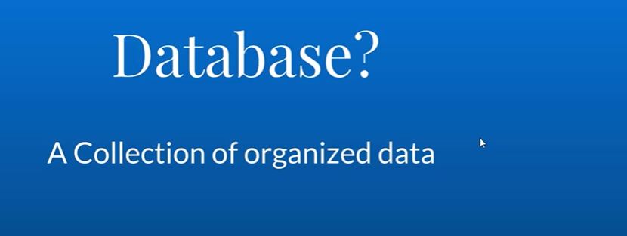

## What is DBMS (Data Base Management System)?

