# Basics

# Resources

1. <https://www.techonthenet.com/sql> : all topics have practice in the end whenever you face some problem you can refer those.

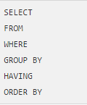

* **SELECT**

Retrieve records from one or more tables in your SQL database.

* **FROM**

List the tables and any joins required for the SQL statement.

* **Comparison Operators**

Used in the WHERE clause to decide which records to select

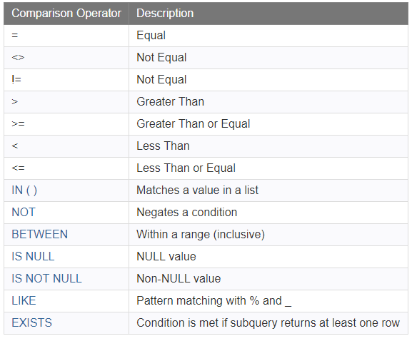

* **WHERE**

Used to filter the results and apply conditions in a SELECT, INSERT, UPDATE, or DELETE statement.

* 1. AND
  2. OR
  3. AND/OR
  4. IN/NOT IN
  5. IS NULL
  6. IS NOT NULL
  7. LIKE/NOT LIKE

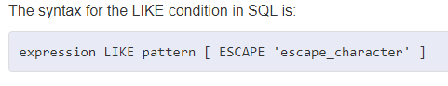

Following wild characters are supported.

%: zero or more character

_: one character

Like condition is not case sensitive ‘J’ and ‘j’ both are same.

Q1. How do you incorporate the Oracle UPPER function with the SQL LIKE condition?

* 1. NOT

Not can be used with IN,IS NULL,LIKE,BETWEEN,EXISTS

* **ORDER BY**

Sort the records in the result set for a SELECT statement.

* **DISTINCT**

Remove duplicates from the result set

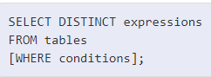

* **ALIASES**

create a temporary name for columns or tables.

* **What are the difference between having and where? IMP**

The WHERE clause places conditions on the selected columns

HAVING clause places conditions on groups created by the GROUP BY.

# JOIN? IMP

Retrieve data from multiple tables.

## INNER JOIN:

Return all rows from multiple tables where the join condition is met.

Visual Illustration

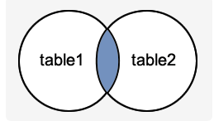

The SQL INNER JOIN would return the records where table1 and table2 intersect.

Syntax

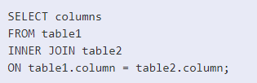

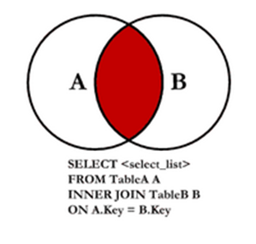

## LEFT OUTER JOIN

Returns all rows from the LEFT-hand table specified in **the ON condition** and only those rows from the other table where join condition is met.

Visual Illustration

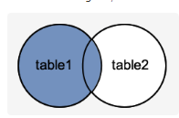

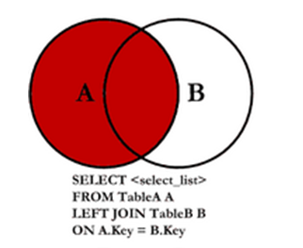

The SQL LEFT OUTER JOIN would return all records from table1 and only those records from table2 that intersect with table1.

Syntax

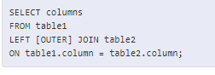

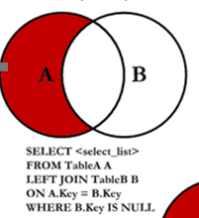

All values from table1 which is not present in table2.

## RIGHT OUTER JOIN

Returns all rows from the RIGHT-hand table specified in **the ON condition** and only those rows from the other table where the join condition is met.

Visual Illustration

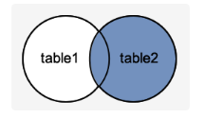

The SQL RIGHT OUTER JOIN would return the all records from table2 and only those records from table1 that intersect with table2.

Syntax

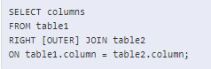

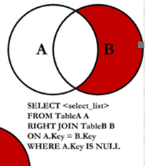

All values from table2 which is not present in table1.

## FULL JOIN

All rows from the LEFT-hand table and RIGHT-hand table if the join condition is not met then NULL values will be returned.

Visual Illustration

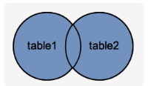

The SQL FULL OUTER JOIN would return the all records from both table1 and table2.

Syntax

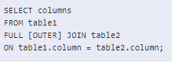

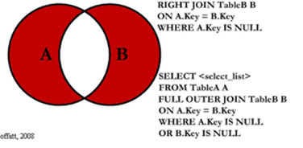

This query will return all of the records in the left table (table A) and all of the records in the right table (table B) that do not match. I have yet to have a need for using this type of Join, but all of the others, I use quite frequently

## SELF JOIN

The SQL SELF JOIN is used to join a table to itself as if the table were two tables; temporarily renaming at least one table in the SQL statement.

<https://www.codeproject.com/Articles/33052/Visual-> vcRepresentation-of-SQL-Joins

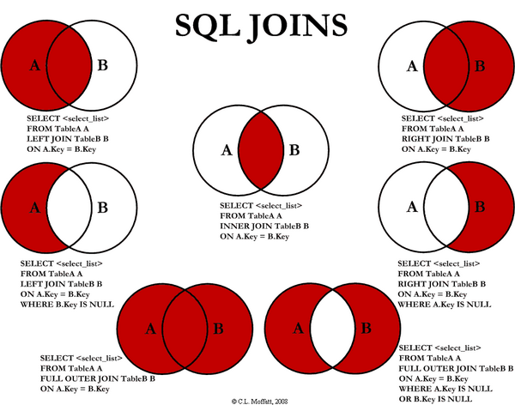

Multiple Joins in SQL?

<https://www.sqlshack.com/sql-multiple-joins-for-beginners-with-examples/>

multiple join is a query that contains the same or different join types, which are used more than once

Pivot in sql?

<https://databricks.com/blog/2018/11/01/sql-pivot-converting-rows-to-columns.html>

https://stackoverflow.com/questions/15745042/efficiently-convert-rows-to-columns-in-sql-server

# Join Sample queries?

# Important points about Order by?

By default, order by is ascending, if you want descending then you have to manually mention it

* **Views? IMP**

View is a virtual table based on the result-set of an SQL statement.

A view contains rows and columns, just like a real table. The fields in a view are fields from one or more real tables in the database.

View can be created from one or many tables.

https://www.tutorialspoint.com/sql/sql-using-views.htm

* **Triggers? IMP**

Triggers are stored programs, which are automatically executed or fired when some events occur.

Triggers can be called in following situations.

A database manipulation (DML) statement (DELETE, INSERT, or UPDATE)

A database definition (DDL) statement (CREATE, ALTER, or DROP).

A database operation (SERVERERROR, LOGON, LOGOFF, STARTUP, or SHUTDOWN).

**Benefits of Triggers**

Auditing

Preventing invalid transactions

https://www.tutorialspoint.com/plsql/plsql_triggers.htm

* **Difference between procedures and functions?** **IMP**

**Functions:**

Return a single value; mainly used to compute and return a value.

Functions can be called in select statements.

Function cannot call procedure.

Functions are normally used for computations.

Functions are not pre compiled.

**Procedures:e**

Do not return a value directly; mainly used to perform an action.

Procedures cannot be called in select statements.

Procedure can call function.

Procedures are used to execute business logic.

Stored procedures are pre compiled execution plan.

# Queries

1. We have four columns employee name, department, city and salary

I want average salary for each department for a given city.

<https://livesql.oracle.com/apex/f?p=590:1:17456339374794::NO:RP>::

HR.EMPLOYEES has data

# Oracle functions

## Datediff

The DATEDIFF() function returns the number of days between two date values.