# What is MySQL?

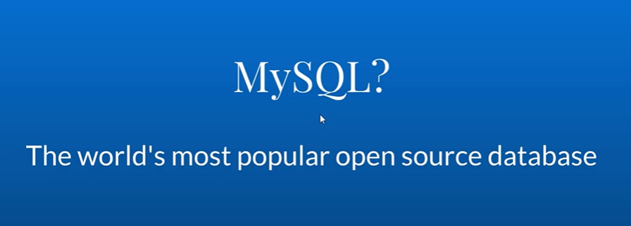

# How to Use MySQL?

<https://www.udemy.com/course/complete-mysql-bootcamp/learn/lecture/12555136#overview>

# Tooling and installing MYSQL?

<https://www.udemy.com/course/complete-mysql-bootcamp/learn/lecture/12555170#overview>

# Running First Query?

<https://www.udemy.com/course/complete-mysql-bootcamp/learn/lecture/12555186#overview>