## What is git lab CI/CD?

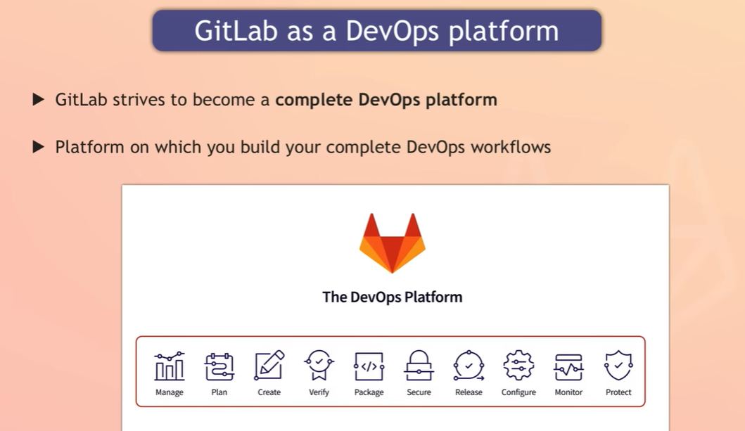

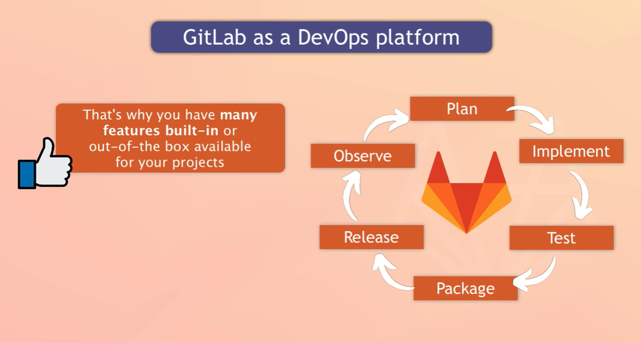

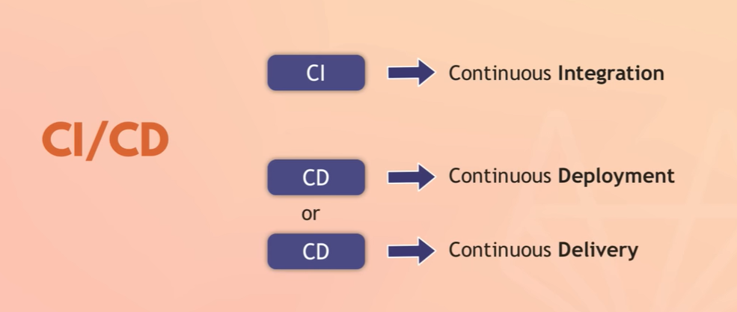

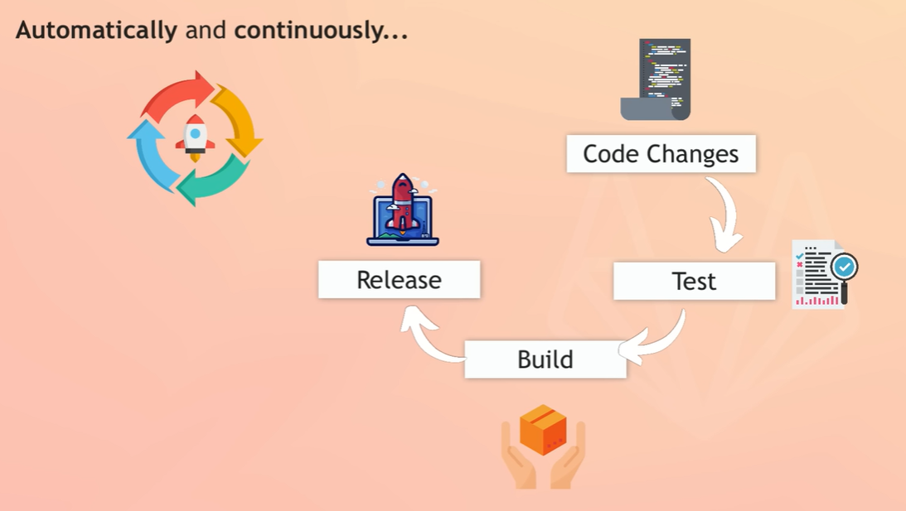

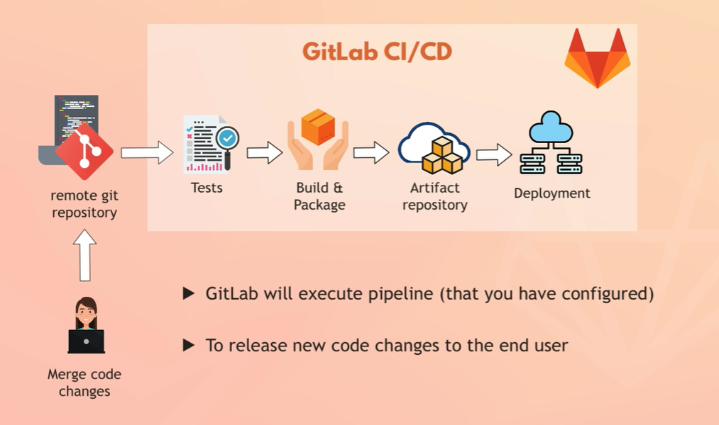

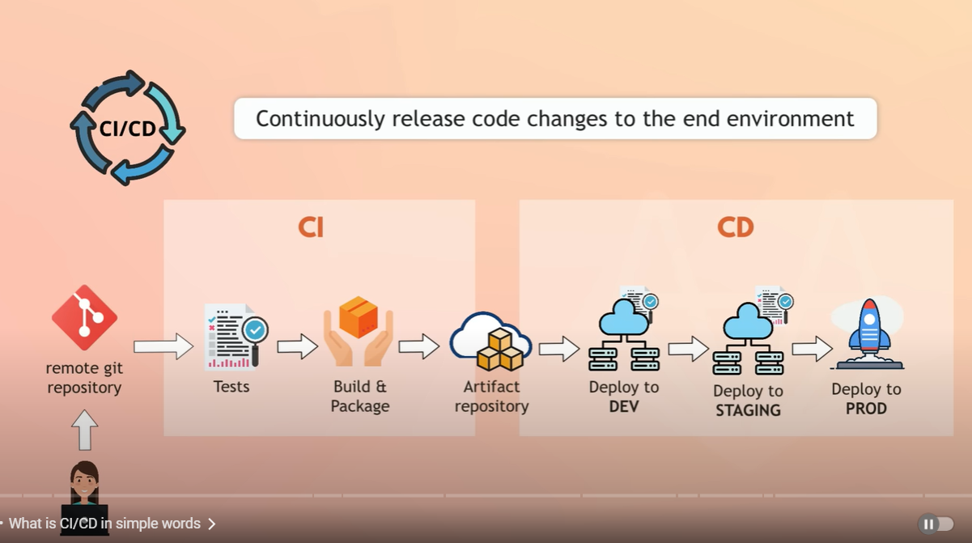

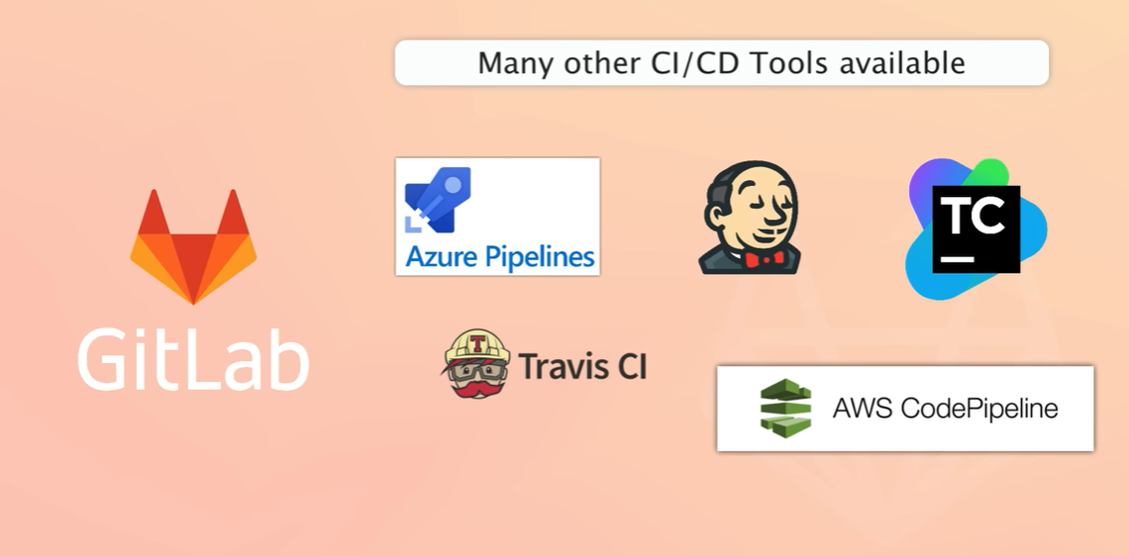

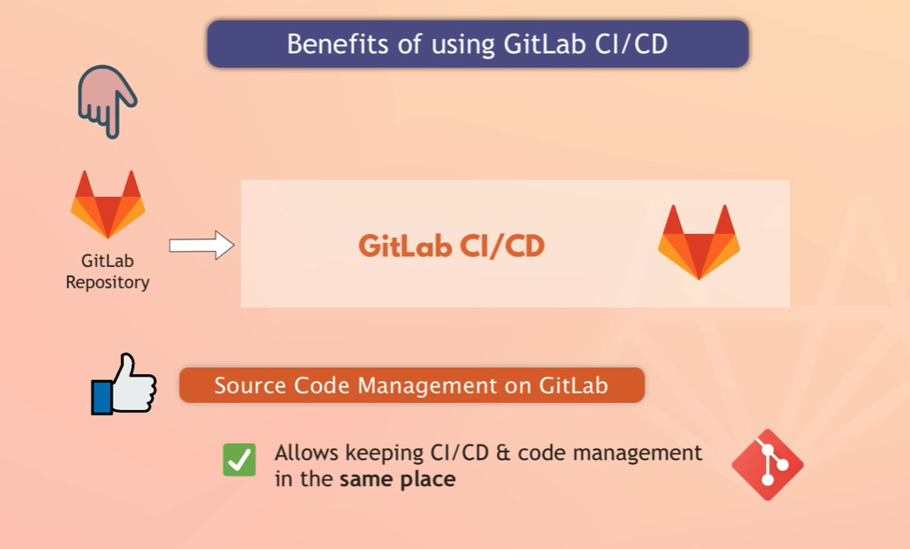

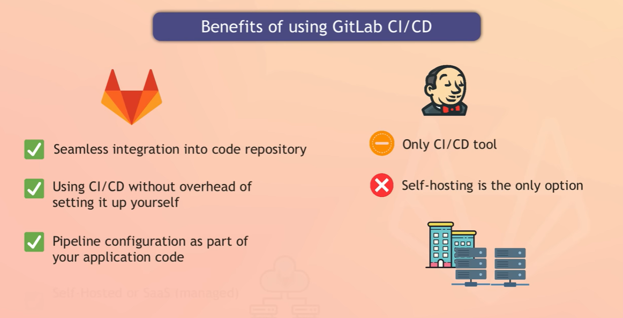

## Git lab architecture in CI/CD?

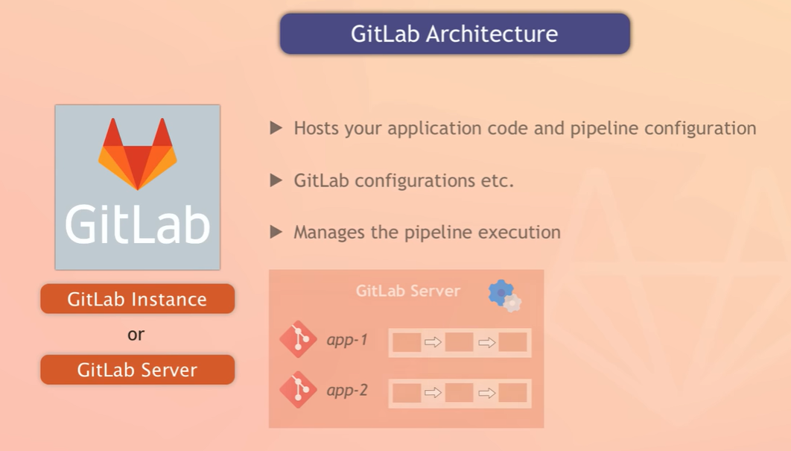

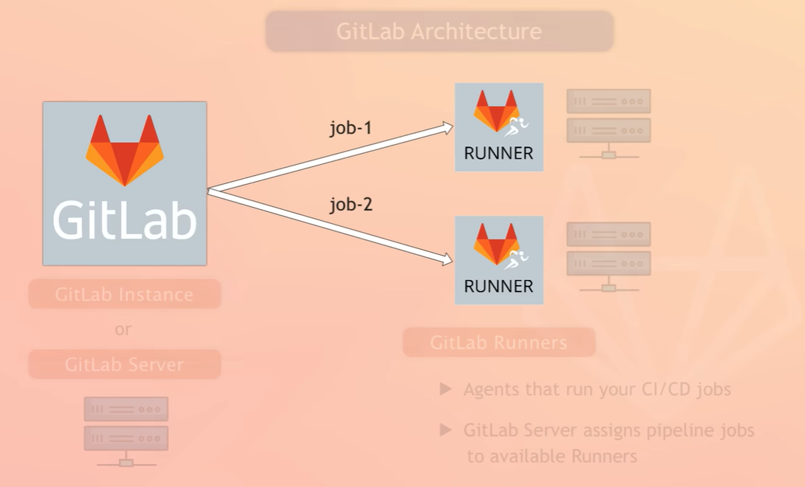

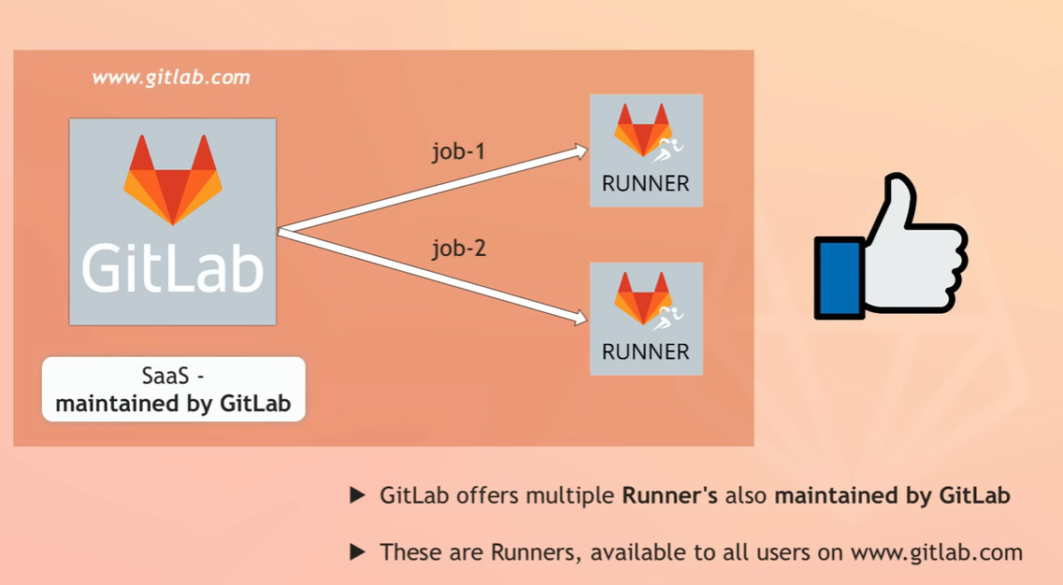



## Jobs in git lab?

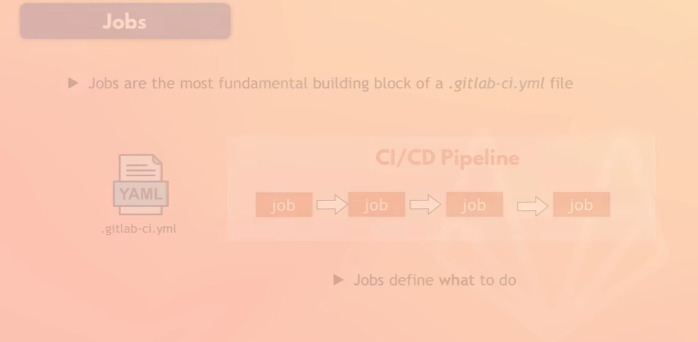

# References:

[**https://www.youtube.com/watch?v=qP8kir2GUgo**](https://www.youtube.com/watch?v=qP8kir2GUgo)

[**https://www.techworld-with-nana.com/gitlab-cicd-course?utm_source=youtube&utm_medium=gitlab-in-1-hour&utm_campaign=gitlab-full-course**](https://www.techworld-with-nana.com/gitlab-cicd-course?utm_source=youtube&utm_medium=gitlab-in-1-hour&utm_campaign=gitlab-full-course)