* **Hive key interview questions**

**Explain Hive Architecture**

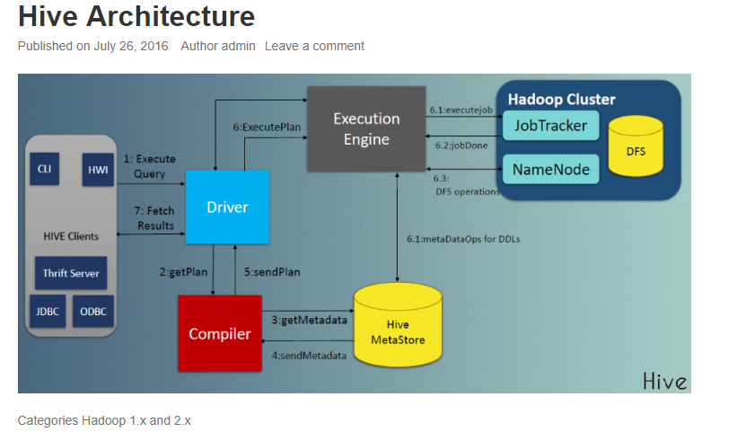

1. **What is the difference between internal table and external table in Hive?**
2. **Explain Partitioning and bucketing in hive?**

How to write an UDF?

<http://www.bmc.com/blogs/how-to-write-a-hive-user-defined-function-udf-in-java/>

1. Need to create a class which extends org.apache.hadoop.hive.ql.exec.UDF

Ex: public class PersonaDataDeserializeUDF extends UDF

1. Need to implement a method with name evaluate refer link for more details.

**public** String evaluate(String inputStr)

{

//Logic here

}

1. Build a this file as a jar files
2. Upload built jar to an hdfs path

*hdfs dfs -put persona-udf.jar /AppData/UDF/*

1. Create Hive UDF function using this jar

For this user should have admin permissions

*set role admin*

Then create udf function

*create function biads.persona_byte_to_json AS ‘fully qualified class name’ USING JAR ‘hdfs://hacluster/AppData/UDF/persona-udf.jar’;*

*create function biads.persona AS ‘fully qualified class name’ USING JAR ‘hdfs://hacluster/AppData/UDF/persona-udf-1.jar’;*