# Foods to Avoid

## Mutton

# Daily Food routine

1. Drink warm water: Before starting your daily routine
2. Drink lemon honey water
3. Have one garlic before breakfast
4. 1 Arjuna after breakfast
5. Breakfast
6. Green/tea
7. Lunch
8. Green Tea
9. Dinner
10. One Arjuna after Dinner
11. One Brahmi after dinner with milk.
12. Lemon Honey water before sleep

# Arjuna: Cardiac wellness

1. Buy Himalaya Arjuna cardiac wellness tablets
2. Take 1 tablet Daily after breakfast and after dinner.
3. Do not consume it when you have alcohol

# KALIDAS HEALTH CHURNA

## Consumption Info:

Have Daily 2 times

1. Morning when you wake up
2. After dinner Before sleeping

Following churna which I have been taking for over 20 years will cleanse your belly and mind.

**Dosage** =: Daily twice, once tsp (teaspoon) in early hours 30 minutes before morning breakfast or tea, and at night, 15 minutes before going to bed. Seven days a week. Take for one month for effectiveness. If one feels good, continue for one year with occasional break of a week, every two months.

**Contents:** All in powder form

Yellow ginger 50 gm (dry powder) -- 150 gram 125

Cinnamon 20 gm -- 50 gram 50

Black Pepper. 20 gm -- 100 gram 50

Cloves. 10 gm -- 100 gram 30

Triphala 10 gm (optional) -- 340 gram 25

TOTAL 100 gm

If you do not have Triphala, omit it and replace with 5 gm each of Cinnamon and Black Pepper.

:

How to take it?

Take a large beer glass or tall glass. Add 1 tsp or 1 1/2 tsp of above mixture. Add 1 table spoon full of lemon juice (bottled or fresh) and 2 table spoon of raw honey, add water to brim, put it in microwave for 1 1/2 minutes, stir and keep for 2 minutes. Drink slowly while warm

ADVANTAGES:

Ginger and Triphala remove constipation, restores taste, and clean up stomach. As result, it also removes gas and bloating. Use preferably yellow ginger powder ( raw or unwashed powder). It is more effective than washed one (white in color)

The Cinnamon, Black Pepper and Clove (Lavang) powder remove cough from your system. They clean up anything above your neck. They give kick to your mind/brain and also clean up the nasal passage (cough).

Honey smoothens stomach, intestine and kidney linings. The semi-solid food or liquid in the system flow smoothly. Also provide energy due to sugar content. The use of warm water soften the stool. It also removes constipation.

Lemon juice or water with honey melt the belly fat, act as an Vitamin C supplement, and anti cough or flu medicine.

Honey when taken with warm milk gains you weight, and when taken with warm lemon juice or water loses weight. It is a 4 season medicine.

VISIBLE SIGNS OF IMPROVEMENT

Your eyes become clear in the morning when you wake up. It is no longer foggy. Constant use controls or improves eye power. (numbers)

When you look yourself in mirror in the morning on waking up, you feel your facial skins shiny and look handsome or beautiful without even make up

Your nasal passage and chest are cleared of cough, you respirate efficiently, no obstructions noticed, no more coughing (acts as cough suppressant)

Mind become focused (due to removal of gas from the system, and almost every joint pain disappears after 2 months of practice.

Bones are usually hollow. The air infiltrate the hollow space which vitiate into unacceptable gas in the joints causing pain. When the gas is removed from the system, basic cause of pain is also removed.

**ADD to above usage (optional), 1 tbsp of Isapgul or Metamucil every fortnight to clean up your bowels. This content being highly fibrous, without any nutritional value, clean up your bowel dirt, obstruction and wastage from the belly, kidney and intestines.**

The above practice clears up bowels and also mind. You feel afresh, spending only few cents per month to keep you healthy, wealthy and wise.

No more vitamins or supplements are necessary. The above ‘churna’ is non addictive - discontinue at any time. No side effects ever.

This is Ayurvedic treatment.

Compliments from Kalidasji

[kalidasji@gmail.com](mailto:kalidasji@gmail.com)

# phlegm or Kapha issue

## Foods to Avoid

Breads

Milk/milk products

sugar, candy,

Eggs

Corn

Cheese

Foods high in sodium

Processed meat

Fast foods

Soda

Candy

## Food to Eat

Honey

Chilli peppers

Carrots

Pine apple

Salmon: any sea fish

Black berries

Bell peppers

Pumpkin seeds

Ginger

kale

Increase foods high with vitamin A

Garlic

# High cholesterol.

* 1. What I should not eat
     1. Do not eat mutton and fried chicken. Eat only barbecue or grilled. Eat only fish with less oil.
  2. What I should eat.
     1. Dry fruit: Walnut, flaxseed
     2. Fish: Salmon, mackerel, herring
     3. Soluble fibers: apple, pear, sprouts, Brussels, kidney beans, oatmeal
  3. Exercise regularly, at least 8 to 10k steps a day, 3 days a week badminton.

# Vitamin B12 Deficiency

## Impact for this issue

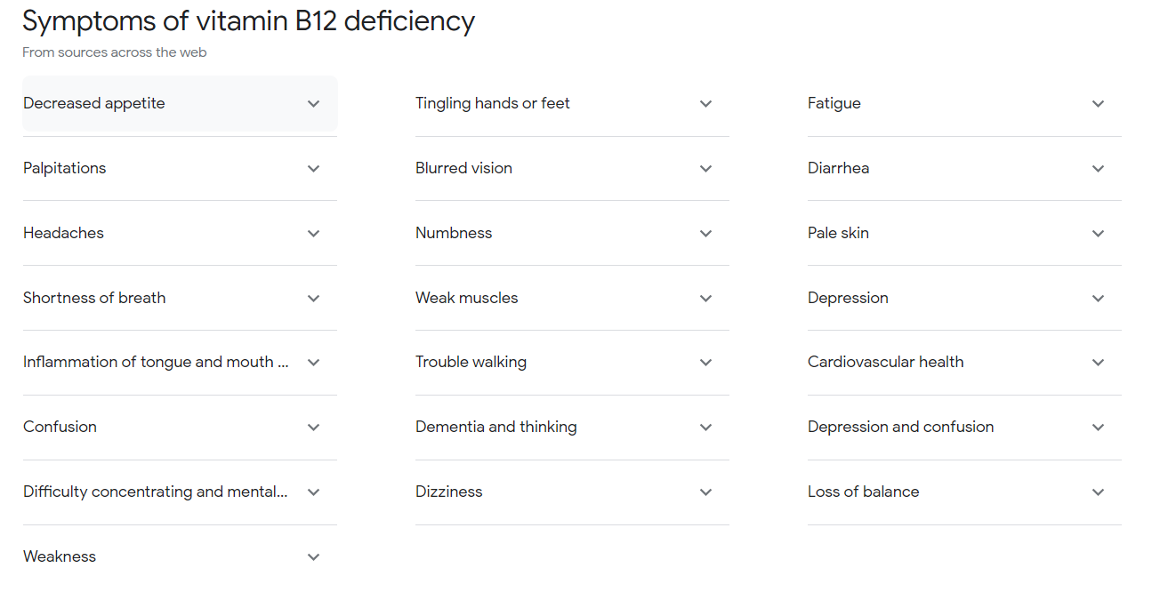

# Foods to eat to increase Vitamin B12

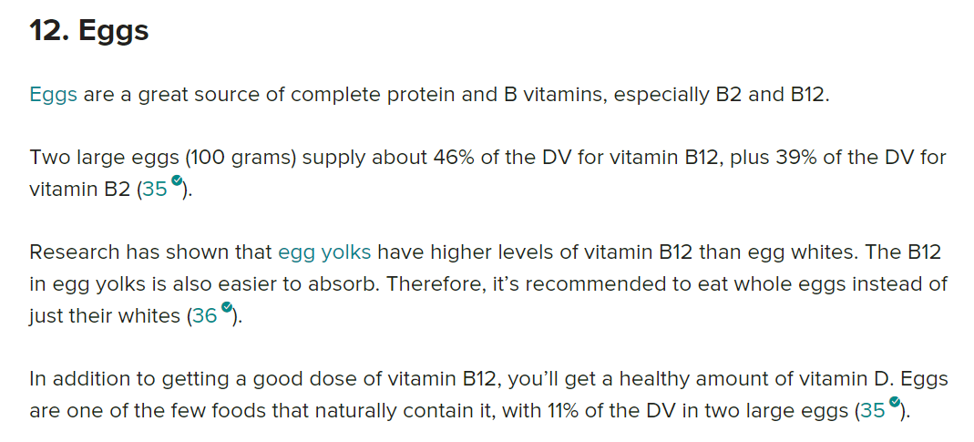

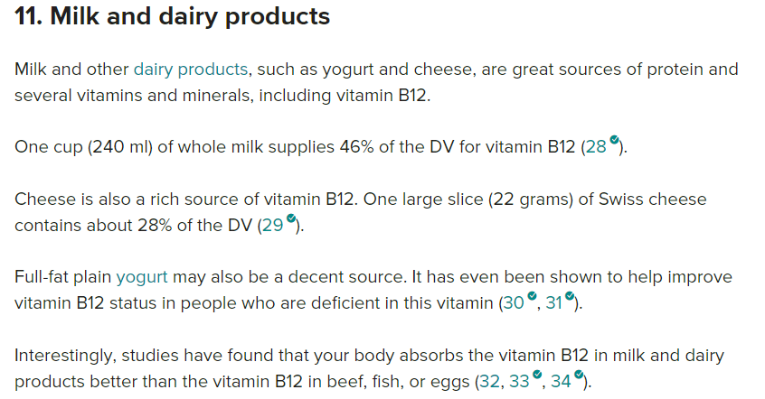

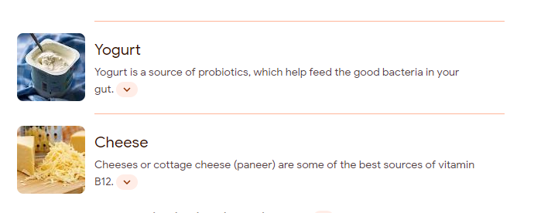

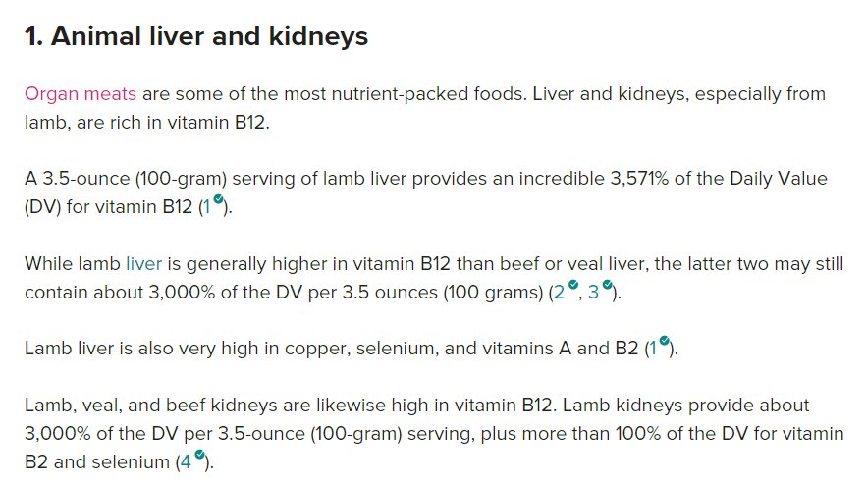

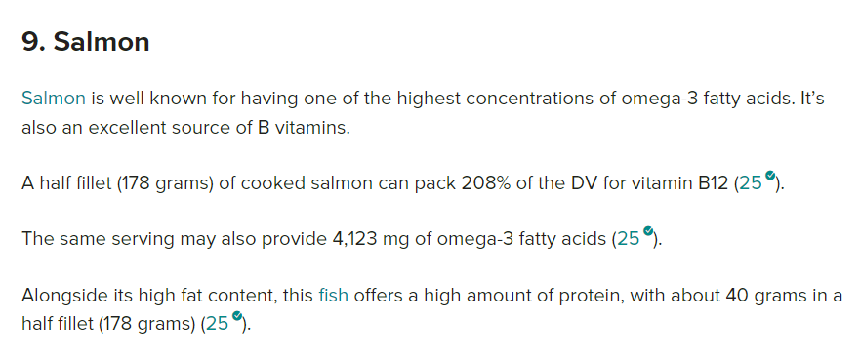

Prebiotics

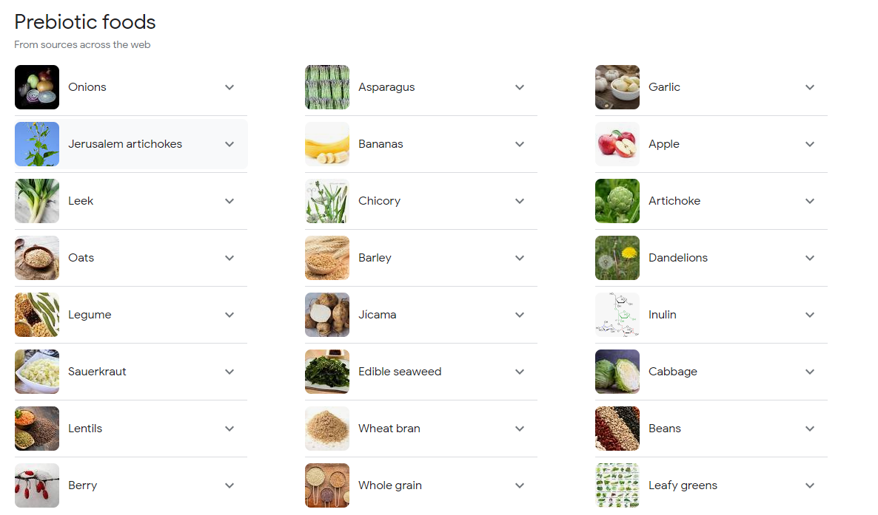

Probiotics

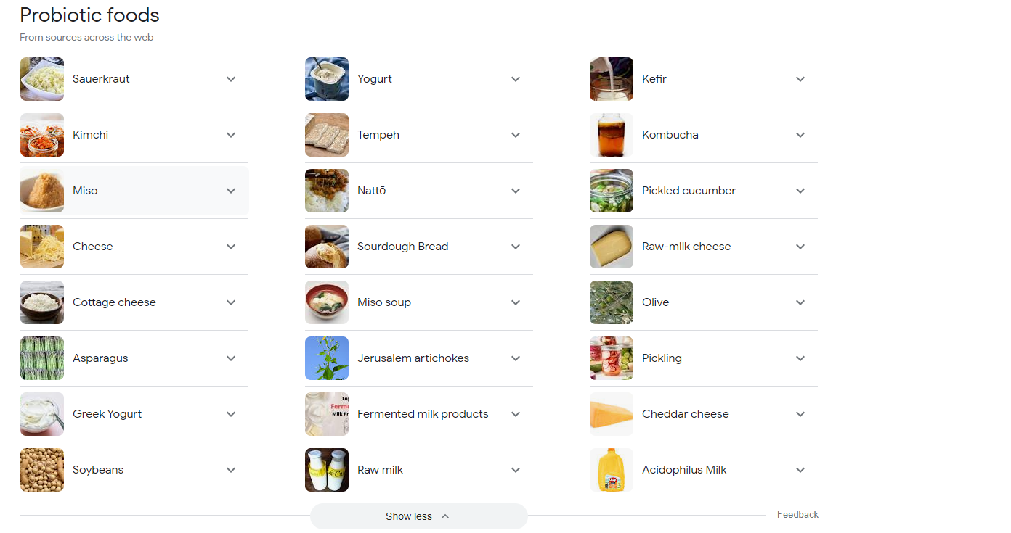

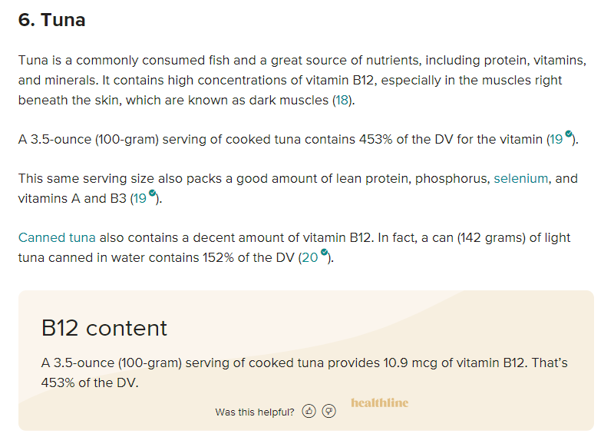

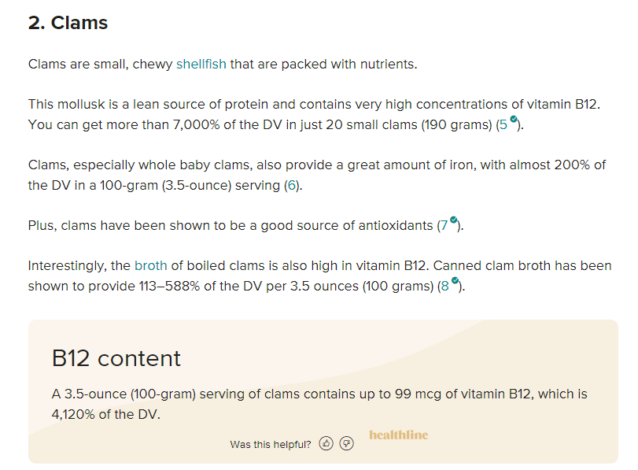

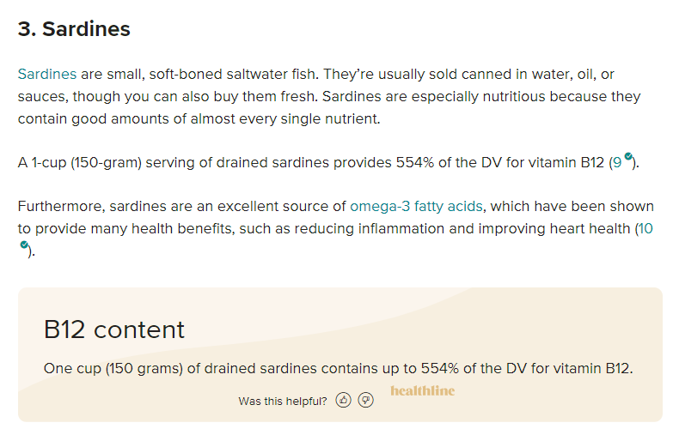

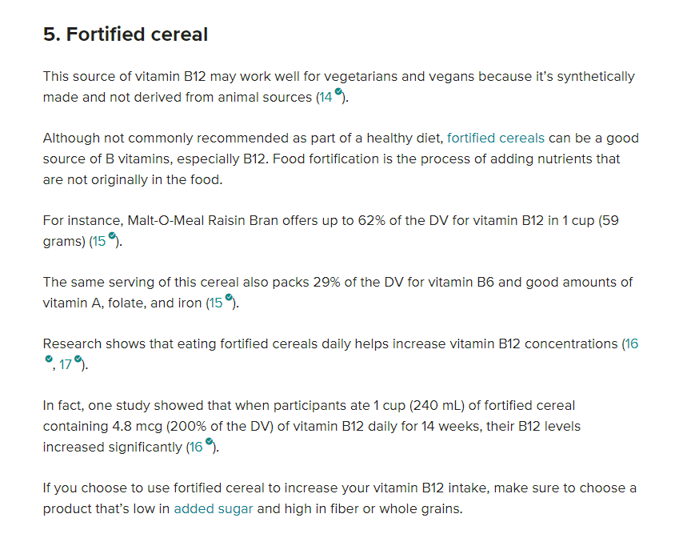

# GM Diet plan

<https://www.healthifyme.com/blog/gm-diet-plan-weight-loss/>