## Survey numbers

## 284/3A (Owner Lakshmamma)

32 gunte no division

## 283/2A

Old 29 gunte

Then divided into 283/2A(13 gunte) (Owner Andani gowda bin side gowda)

and **283/5 (16 gunte) (Owner Lakshmamma)**

## 283/2B

Old 36 Gunte

Then divided into **283/2B (16 gunte)** (Owner Lakshman)

283/7 (20 Gunte) (Owner Lakshmamma)

## Our property:

284/3A: 32 Gunte (RTC proper)

283/7: 20 Gunte (RTC proper)

## Their property

283/5 (282/2A): 16 Gunte

283/2B: 16 Gunte (earlier it was 36 Gunte)

1. What is MR number?
2. Compare their Aadhar numbers.
3. Bharathi’s Aadhar number is not mentioned.
4. Add Jayamma
5. Survey numbers
6. 283/2A: 16 Gunte: what is Podi
7. 283/2B: 36 Gunte

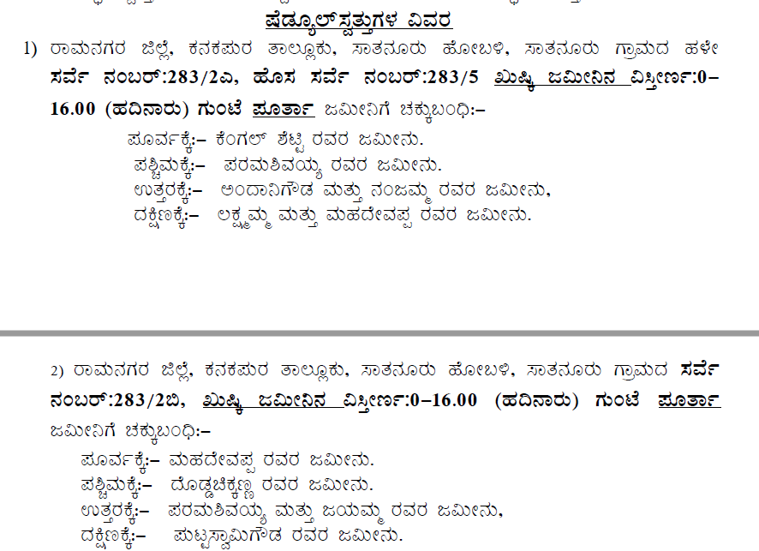

1. Cross verifies this data with existing sale deed and RTC.

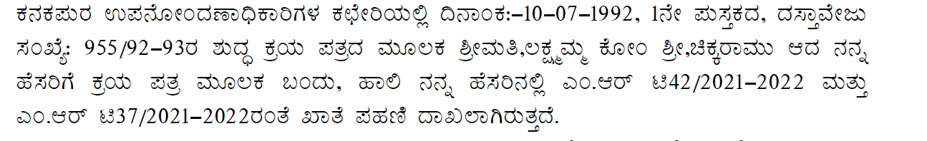

# Scenario understanding

## Mom Registered paper.

283/2A: 29 Gunte palki 16 Gunte

283/2B: 36 Gunte

# Recently registered Paper to mom

284/3A: 32 Gunte