# 23 Aug 2023

Research Report of Recent Rebalance

<https://drive.google.com/file/d/1InJLbBSdLxop-g9vAgV5l_GoIvpiZvNK/views>

# During investment

When we attempt to invest, there is an option: we can choose either a one-time investment + SIP or SIP.

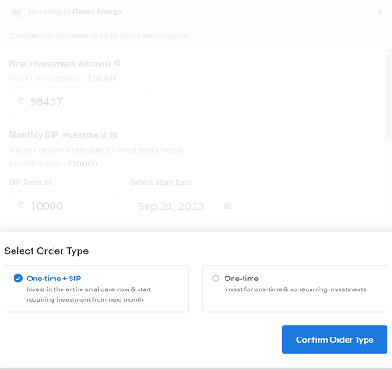

When opting for a one-time SIP, the initial investment should be at least 98437. Subsequently, for monthly SIPs, the minimum monthly amount is 10,000.

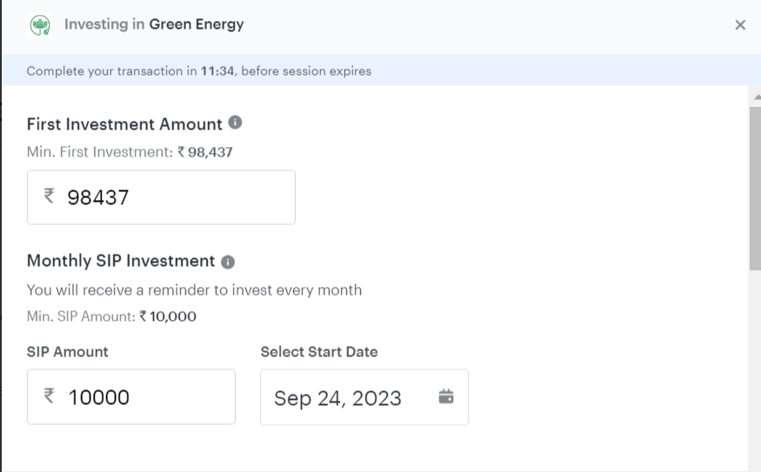

Below are the order details

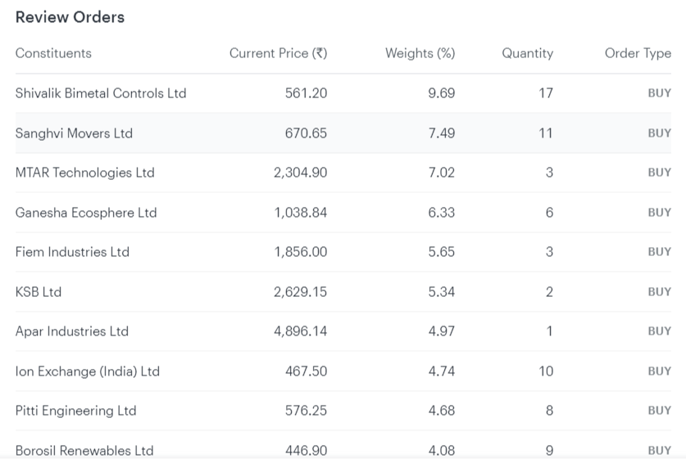

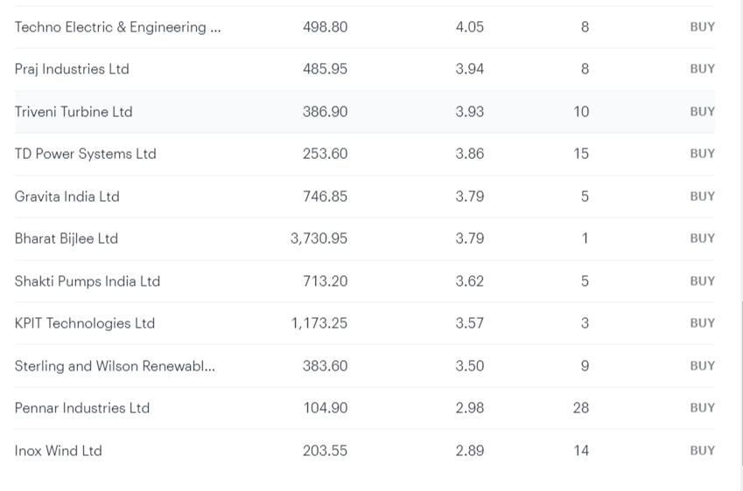

The required funds amount to 1,01,390, which is based on today's stock price.

