# Stock Market

## Is investing in stock market very risk?

Yes: If we invest on short term.

No: If we invest on long term

## What is dividend?

The money which we get as profit by investing in stock market.

It is up to the company whether to give dividend or not.

Dividend is tax free. (subject to limits)

Dividend is given based on face value of the company share not market value

## Difference between dividend and interest?

*Interest*:

From FD, debentures

Taxable

*Dividend*

From stock

Taxfree

## Long term capital gain tax (LTCGT)?

If person hold share more than one year and earn profit. It is known as LTCG

## Who is promoter?

Promoter is the person or group of persons who starts the company

## What is Face value?

Original price at which share was bought by the promoters of the company.

## TV channel to watch for Stock market?

CNBC

## What is the full form of De-Mat?

De-materialized.

## What is top line growth?

Top line is turnover

## What is bottom line growth?

Bottom line is profit or profit after tax

## What is stock split?

## What is LTP?

Latest traded price

## What are the Market hours?

9:15 am to 3:30 pm

## What is Pre opening market Session?

9:00 am to 9:15am is called as pre-opening market session. People can also buy and sell at this time.

It is 15 min session from 9 to 9:15 am to absorb heavy fluctuations in the market.

## Should I place order in pre-opening market session or not?

## What are aftermarket hours?

4:00 pm to 9:00 am

## What is aftermarket order (AMO)?

Buy or Sell orders of the stocks placed between 4:00 pm to 9:00 am are called as aftermarket order (AMO).

But they will be executed at 9:00 am

## What is bonus?

Bonus will be announced by companies. If bonus is 1:10 then 1 share will be given for every 10 shares holding.

## What is announcement date?

Date on which company announces the bonus.

## Record Date?

Date on which we should have shares on demat account to enjoy bonus shares.

## Ex-bonus date?

Date at which shares starts trading at revised price

## Stock Exchange?

## 

## Members of Stock Exchange?

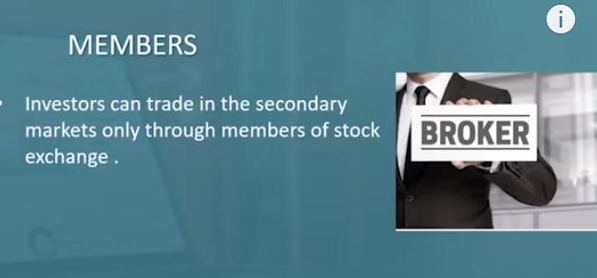

## Investors?

RII: Retail Individual Investors

HNI: High Net worth Individuals

DII: Domestic Institutional Investor

FII/FPI: Foreign Institutional investor/Foreign portfolio investor

## Depositories?

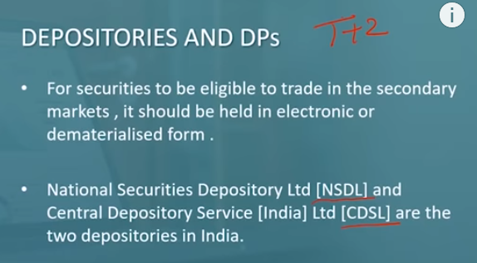

# Reference to know about company and its stock

<https://www.moneycontrol.com/>

# To Research

How to check top line growth and bottom line growth of any company.

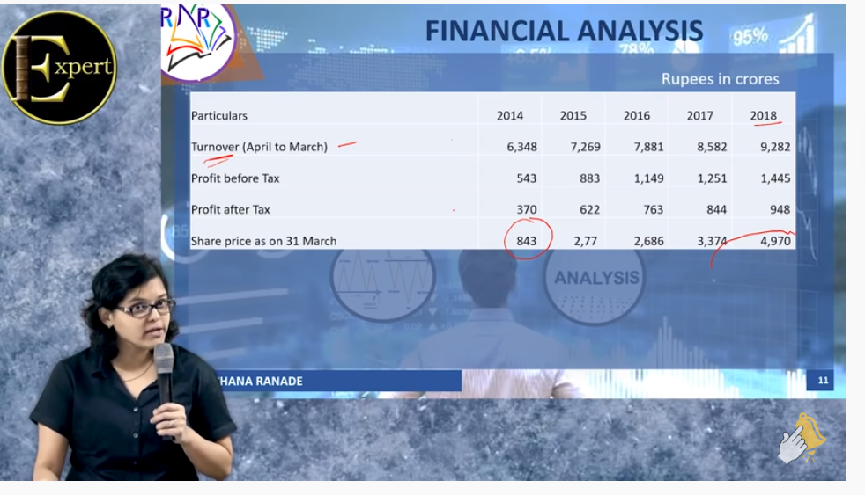

IPO?

porinju veliyath : follow this guy?

Companies which will benefit most because of anti-Chinese sentiment?

Alchol

Food

Motor

medicine

# To Learn?

How to know which companies announced bonus and its record date?

Research more on this it can earn money

MCX

CDSL

NSE

BSE

Learn to browse entire money control?

Need to gain strong knowledge on finance?

What is liquidity?

What is the limit for taxfree dividend?

What is the limit for tax free LTCG?

How a physical share certificate look like?

Equity Share?

What is IPO value of share?

How to find undervalued stocks?