* **Factory Need to know all kind of factory patterns**
* **What is this pattern?**

In Factory pattern, we create object without exposing the creation logic to the client and refer to newly created object using a common interface.

Plan p = getPlan(planType);

* **How to Design?**

Example:

We're going to create a Shape interface which will have method draw(); the way we draw each shape is different and concrete classes implementing the Shape interface each concrete class provide implementation for draw.

Create a factory class ShapeFactory which returns shape objects.

Create a FactoryPatternDemo our demo class will use ShapeFactory to get a Shape object. It will pass information (CIRCLE / RECTANGLE / SQUARE) to ShapeFactory to get the type of object it needs.

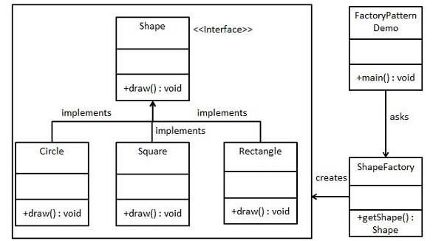

**Step 1**

Create an interface

**Shape.java**

public interface Shape {

void draw();

}

Step 2

Create concrete classes implementing the same interface.

**Rectangle.java**

public class Rectangle implements Shape {

@Override

public void draw() {

System.out.println("Inside Rectangle::draw() method.");

}

}

**Square.java**

public class Square implements Shape {

@Override

public void draw() {

System.out.println("Inside Square::draw() method.");

}

}

**Circle.java**

public class Circle implements Shape {

@Override

public void draw() {

System.out.println("Inside Circle::draw() method.");

}

}

Step 3

Create a Factory to generate object of concrete class based on given information.

**ShapeFactory.java**

public class ShapeFactory {

//use getShape method to get object of type shape

public Shape **getShape(String shapeType){**

if(shapeType == null){

return null;

}

if(shapeType.equalsIgnoreCase("CIRCLE")){

return new Circle();

} else if(shapeType.equalsIgnoreCase("RECTANGLE")){

return new Rectangle();

} else if(shapeType.equalsIgnoreCase("SQUARE")){

return new Square();

}

return null;

}

}

Step 4

Use the Factory to get object of concrete class by passing an information such as type.

**FactoryPatternDemo.java**

public class FactoryPatternDemo {

public static void main(String[] args) {

ShapeFactory shapeFactory = new ShapeFactory();

//get an object of Circle and call its draw method.

Shape shape1 = shapeFactory.getShape("CIRCLE");

//call draw method of Circle

shape1.draw();

//get an object of Rectangle and call its draw method.

Shape shape2 = shapeFactory.getShape("RECTANGLE");

//call draw method of Rectangle

shape2.draw();

//get an object of Square and call its draw method.

Shape shape3 = shapeFactory.getShape("SQUARE");

//call draw method of circle

shape3.draw();

}

}

Step 5

Verify the output.

Inside Circle::draw() method.

Inside Rectangle::draw() method.

Inside Square::draw() method.

* **What is the Advantage of Factory Design pattern?**

It promotes the **loose-coupling**

In future if any new shape comes it will be really easy to added there will not be much code change