* **Core-JVM**

1. **JVM Architecture https://www.javatpoint.com/internal-details-of-jvm**

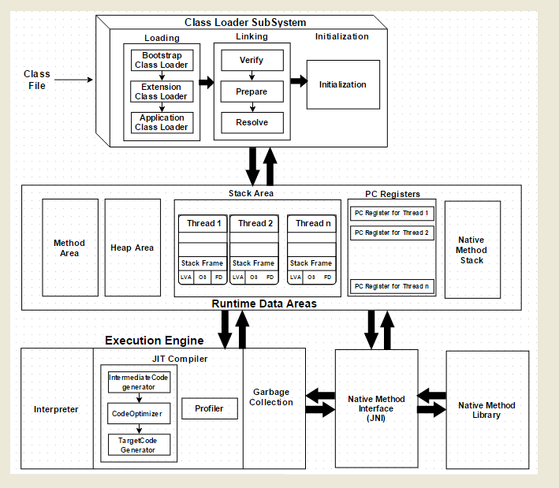

1. **What is classloader? IMP**

Java ClassLoader loads a java class file into java virtual machine.

Types of class loaders:

**Bootstrap Class Loader:**

Loads java’s core classes like java.lang, java.util etc. These are classes that are part of JRE.

Bootstrap class loader is native implementation and so they may differ across different JVMs.

**Extensions Class Loader:**

Extensions class loader loads classes from JAVA_HOME/jre/lib/ext folder.

Using the system environment propery java.ext.dirs you can add ‘ext’ folders and jar files to be loaded using extensions class loader.

**System Class Loader**

Loads Java classes that are available in the java class path.

1. **How JVM processes byte code? IMP**

When you compile something in Java, the compiler generates bytecode. This is native code for the JVM. The JVM then translates the bytecode to native code for your processor/architecture; this is where the JIT happens. Without JIT, the JVM would translate one instruction at a time, which is very slow.

1. **What is JIT Just-In-Time compiler? IMP**

Converts Instruction set of a Java virtual machine (JVM) to the instruction set of a specific CPU.

JIT compiles parts of the byte code that have similar functionality at the same time, so the performance of the compiler is increased.

1. **JVM Memory Model? IMP**

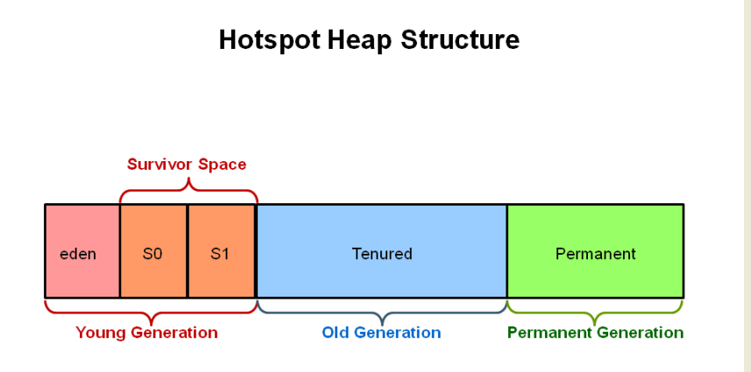

**Young Generation**

In Eden space new objects are created. When the space is filled up to a certain percentage, GC is performed. This event is called **as Minor GC**.

The surviving objects from Eden space are moved to survivor spaces(S0 & S1).

Minor GC checks the object in survivor spaces and move to other survivor spaces (S0->S1).

Objects surviving multiple minor GC are moved to old generation.

**Old Generation**

When an old generation is full, the major GC takes place to remove the unused objects. This event can cause a minor pause in the working of application. Too many frequent major GC can trigger performance issue in the application. While designing an application, one should be considerate about it.

**Perm Gen**

Perm Gen contains the metadata of the classes.

1. Names of the classes
2. Methods of a class
3. Constant pool(e.g String pool) information.
4. Internal objects created by the JVM
5. Object arrays and type arrays associated with a class (e.g., an object array containing references to methods).

Note: Perm Gen is not available in Java 8 anymore

When an object does becomes eligible for GC.

When a object is not referred by other objects or all its references are set to null.

Object moves out of the scope.

Weak reference objects, such as WeakHashMap

1. **How JVM and JRE works Internally ? IMP**