* Garbage Collection

1. **What is Garbage Collection?**

Process of reclaiming the runtime unused objects.

It is performed for memory management.

1. **What is gc()?**

gc() is a daemon thread.gc() method is defined in System class that is used to send request to JVM to perform garbage collection.

1. **What is the purpose of finalize() method?**

finalize() method is invoked just before the object is garbage collected.

It is used to perform cleanup processing.

1. **Can an unrefrenced objects be refrenced again?**

Yes.It is possible we can get the reference of unreferenced objects by this keyword in finalize method.

1. **What kind of thread is the Garbage collector thread?**

Demon

1. **What is difference between final, finally and finalize?**

**final**:

final can be used with class, such a class can't inherit

final can be used with variable we can't change the value of final variable

final can be used with method such a method can not be overrriden

**finally**: finally block is used in exception handling. finally block is always executed**.**

**finalize():**finalize() method is used in garbage collection.finalize() method is invoked just before the object is garbage collected.

The finalize() method can be used to perform any cleanup processing.

1. **What are available garbage collector algorithms? IMP**

<http://stackoverflow.com/questions/15616919/java-available-garbage-collection-algorithms>

As of today, there are 4 GC algorithms available in the Java Hotspot VM:

**The Serial GC** - recommended for client-style applications that do not have low pause time requirements.

**The Parallel GC** - use when the **throughput** matters: Indicates the **number of transactions per second** an application can handle, the amount of transactions produced over time during a test.

**The Mostly-Concurrent GC** (also known as **Concurrent Mark-Sweep GC(**CMS)) - use when the **latency** matters. Latency of a request is travel time from client to server or server to client.

**Garbage First GC** (G1) - new GC algorithm, for CMS replacement.

1. **How to change garbage collector? Specially in tomcat**

The GC algorithm/garbage collector can be changed by changing option –XX

Options are shown below

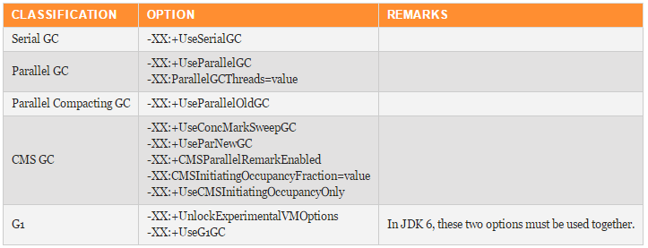

<https://dzone.com/articles/how-tune-java-garbage>

http://stackoverflow.com/questions/13865931/optimizing-tomcat-garbage-collection

1. **What is the purpose of the Runtime class?**

The purpose of the Runtime class is to provide access to the Java runtime system.

1. **How will you invoke any external process in Java?**

By Runtime.getRuntime().exec(?) method.