- Queue
https://www.geeksforgeeks.org/queue-data-structure/

- What is queue?
A Queue is a linear structure which follows a particular order in which the operations are performed. The order is First in First out (FIFO)

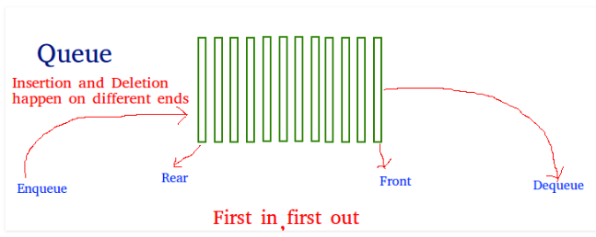

- Real time example of Queue?
A good example of a queue is any queue of consumers for a resource where the consumer that came first is served first.

- What are the operations performed on queue?

Enqueue: Adds an item to the queue. If the queue is full, then it is said to be an Overflow condition.

Dequeue: Removes an item from the queue. The items are popped in the same order in which they are pushed. If the queue is empty, then it is said to be an Underflow condition.

Front: Get the front item from queue.

Rear: Get the last item from queue.

- Applications of queue?

1) When a resource is shared among multiple consumers. Examples include CPU scheduling, Disk Scheduling.
2) When data is transferred asynchronously (data not necessarily received at same rate as sent) between two processes. Examples include IO Buffers, pipes, file IO, etc.

