https://www.geeksforgeeks.org/stack-data-structure/

What is Stack?
Stack is a linear data structure which follows a particular order in which the operations are performed.

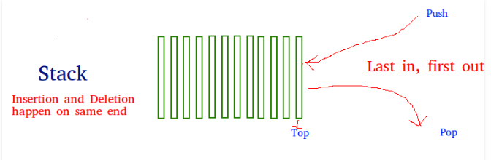

What are the orders in stack?
LIFO (Last In First Out) and FILO (First In Last Out)

Real time Examples of Stack?
Plates stacked over one another in the canteen, the plate which is at the top is the first one to be removed i.e. the plate which has been placed at the bottommost position remains in the stack for the longest period of time. So, it can be simply seen to follow LIFO (Last In First Out)/FILO(First In Last Out) order.

What are the operations performed on stack?
- Push: Adds an item in the stack. If the stack is full, then it is said to be an Overflow condition
- Pop: Removes an item from the stack. The items are popped in the reversed order in which they are pushed. If the stack is empty, then it is said to be an Underflow condition.
- Peek or Top: Returns top element of stack.
- isEmpty: Returns true if stack is empty, else false.

What are the applications of stack?
- Redo-undo features at many places like editors, photoshop.
- Forward and backward feature in web browsers.

- What are the ways to implement a stack?
We can implement stack using
- Array
- Linked List

- Stack class in Java?

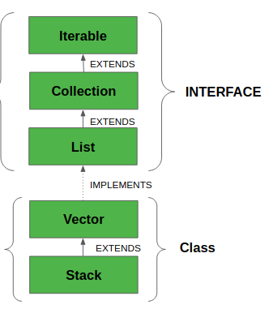

https://www.geeksforgeeks.org/time-complexities-of-different-data-structures/

Time complexity of stack?
Access: O(N)
Search: O(N)
Insertion: O (1)
Deletion: O (1)

