- Spring interview Questions

- What is spring?
  - Open source development framework using spring we can develop enterprise level java applications.
  - It promotes good programming practice by enabling POJO –based programming model.
  - Created to simplify java application development.
  - It is container based modular framework.
Note: Spring was created / invented by rod Johnson. Spring is owned by VMware.

- What are the benefits of spring?

Lightweight: Spring is lightweight when it comes to size. The basic version of spring framework is around 2MB.

Loose coupling: Loose coupling is achieved in spring using the technique Inversion of Control

Container: Spring has its own container; it manages the life cycle of the object

Aspect oriented (AOP): Separates application business logic from system services like Logging, Security.

MVC Framework: Spring has well designed web MVC framework, it is great alternative for other frameworks such as struts and other frameworks

Transaction Management − Spring provides a consistent transaction management interface that can scale down to a local transaction (using a single database, for example) and scale up to global transactions (using JTA, for example).

Exception Handling − Spring provides a convenient API to translate technology-specific exceptions (thrown by JDBC, Hibernate, or JDO, for example) into consistent, unchecked exceptions.

- Which are spring framework modules?

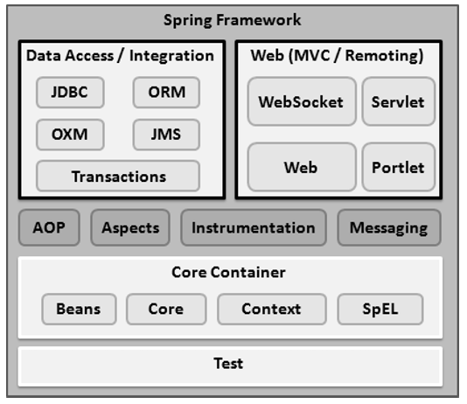
I:\ProffessionalCareer\BackendDevelopment\JAVA\Spring\Releases\libs

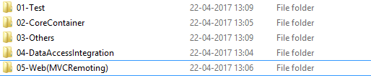

- What is dependency Injection? IMP try to explain better

Dependency injection is concrete implementation of general concept called Inversion of control.
Generally speaking application invokes framework methods and get their work done from the framework in case of Inversion of Control, the framework calls implementations provided by the application.

Dependency Injection is way of programming where we decouple the conventional relationship between 2 objects to achieve loose coupling.

For Example we have a controller class and it has a get method which is mapped to some URL. When somebody hits that URL get method will be invoked by spring framework and serve the request.
Ex: Shape- circle and triangle
Note:
Loose Coupling: When writing a complex Java application, application classes should be as independent as possible of other Java classes to increase the possibility to reuse these classes and to test them independently of other classes while unit testing.
Dependency Injection helps in gluing these classes together and at the same time keeping them independent.

How loose coupling is achieved in spring?
Using Dependency injection
Loose coupling can be achieved
    - Coding to interface.
    - Favour has-a relationship over is- a relationship
    - Declare member variables as private and provide getters and setters.
    - Avoid using static implantations
    - Inject the dependency

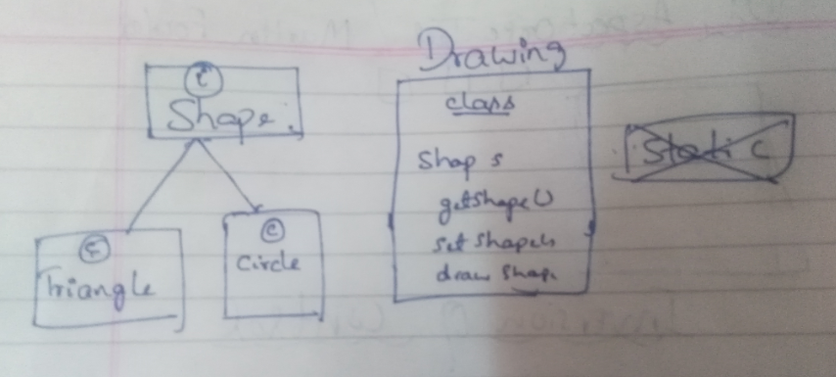

REF: I:\ProffessionalCareer\BackendDevelopment\JAVA\Spring\Videoes\Spring Tutorial 01 - Understanding Dependency Injection – YouTube.
https://www.youtube.com/watch?v=GB8k2-Egfv0

- Dependancy injection or IOC is based on what Hollywood principles? IMP
Do not call us we call you.

- What are the different types of IoC (dependency injection)? IMP
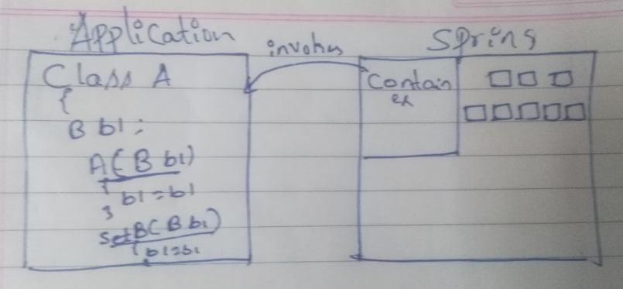

- Constructor-based dependency injection: container invokes a class constructor with a number of arguments, each representing a dependency on other class.
- Setter-based dependency injection:
Container invokes a class’s setter method after invoking a no-argument constructor or no-argument static factory method to instantiate your class, the argument in the setter method is dependency in another class.

- Which DI would you suggest Constructor-based or setter-based DI?
We can mix both depending upon the situation.
Constructor based dependency injection can be used for mandatory dependencies.
Setter based dependencies can be used for optional dependencies.

For Example: For a Car object Engine can be in constructor argument as it is mandatory and AC can be in setter as it is optional.

- What are the benefits of dependency injection or IOC? IMP
  - Loose Coupling: It promoted loose coupling.
  - Minimizes amount of code
  - Easy test

- What is Spring IoC container?
Creates the objects, wire them together, configure them, and manage their complete lifecycle from creation till destruction. The spring container uses dependency injection (DI) to manage the components that make up an application.
These objects are called as spring beans

- What are types of IoC containers? Explain them. IMP
  - Bean Factory container: It is the main and basic way to access spring container. It is represented by org.springframework.beans.factory.BeanFactory
Otherways to access spring container are Application Context, ListableBeanFactory,ConfigurableBeanFactory etc are built upon BeanFactory
Bean Factory Provides below Functionalities for the spring container.

- It provides DI/IoC mechanism for the spring.
- It loads bean definition and its property descriptions from bean configuration file configuration file which is XML
- Instantiates the bean when they are requested.
- While instantiating the bean it wires dependencies and properties for the bean according to their configuration defined in configuration file.
- Manages the bean life cycle by its bean life cycle interfaces and calling initialization and destruction methods.
Note: when it loads the configuration for beans from configuration file Only the bean definitions and their property descriptions are loaded.Beans are instantiated and their properties are set only when they are requested such as by getBean() method.

  - Application context Container: Same as BeanFactory container additionally provides enterprise-specific functionalities such as resolve textual messages from a properties file, publish application events to interested event listeners. This container is defined by org.springframework.context.ApplicationContext interface

Ref : https://www.youtube.com/watch?v=vGuMaRcDkSY
For Example : https://www.tutorialspoint.com/spring/spring_beanfactory_container.htm

- Give an example of BeanFactory implementation?
XmlBeanFactory container reads the configuration metadata from an XML file and uses it to create a fully configured system or application.

- What are the common implementations of the ApplicationContext? IMP
All three container loads the definitions of the beans from an XML file.

The three commonly used implementation of 'Application Context' are

FileSystemXmlApplicationContext: Here you need to provide the full path of the XML bean configuration file to the constructor.

ClassPathXmlApplicationContext: Here you do not need to provide the full path of the XML file but you need to set CLASSPATH properly because this container will look bean configuration XML file in CLASSPATH.

WebXmlApplicationContext: This container loads the XML file with definitions of all beans from within a web application

- What is the difference between Bean Factory and ApplicationContext?
Bean factory and application context are almost similar but application context provides additional features such as,

Ability to resolve textual messages from a properties file.
Ability to publish application events to interested event listeners.
Load file resources, such as images.
Certain operations on the container or beans in the container, which have to be handled in a programmatic fashion with a bean factory, can be handled declaratively in an application context.
The application context implements MessageSource, an interface used to obtain localized messages, with the actual implementation being pluggable.

- What are Spring beans?
The objects that form the backbone of your application and that are managed by the Spring IoC container are called beans.

A bean is an object that is instantiated, assembled, and otherwise managed by a Spring IoC container.

These beans are created within the container by using, configuration metadata that you supply to the container, for example, in the form of XML <bean/> definitions.

- What does a bean definition contain?
The bean definition contains the information called configuration metadata using which container will know the followings-
How to create a bean?
What are the bean dependencies?
Lifecycle details of the bean

- How do you provide configuration metadata to the Spring Container?
XML based configuration file.
Annotation-based configuration
Java-based configuration
- How do add a bean in spring application?
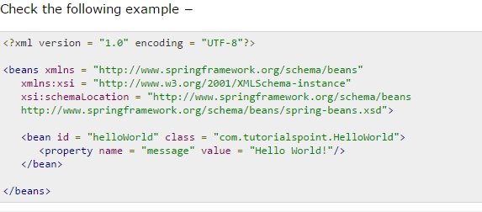

- How do you define a bean scope?
When defining a <bean> in spring xml configuration file, we will have the option of declaring a scope for that bean.
If scope of the bean is prototype when the bean is requested spring IOC container returns new bean each time.
If scope of the bean is singleton when the bean is requested spring IOC container returns same bean each time.

- What bean scopes does Spring support? Explain them.

Singleton: when the bean is requested spring IOC container returns new bean each time.
Prototype: when the bean is requested spring IOC container returns new bean each time.
Request: One bean per http request. Only valid in the context of a web-aware Spring ApplicationContext.
Session: One bean per http session. Only valid in the context of a web-aware Spring ApplicationContext.
global-session: One bean per global http session. Only valid in the context of a web-aware Spring Application Context.

- What is default scope of bean in Spring framework?
The default scope of bean is Singleton for Spring framework.

- Which bean scope attribute produces new bean every time needed?
Prototype

- Are Singleton beans thread safe in Spring Framework?
No, singleton beans are not thread-safe in spring framework.

- Explain Bean lifecycle in spring framework?

Instantiate: First the spring container finds the bean's definition from the XML file and instantiates the bean.

Populate properties: Using the dependency injection, spring populates all of the properties as specified in the bean definition.

Set Bean Name: If the bean implements BeanNameAware interface, spring passes the bean's id to setBeanName() method.

Set Bean factory: If Bean implements BeanFactoryAware interface, spring passes the beanfactory to setBeanFactory() method.

Pre Initialization: If there are any bean BeanPostProcessors associated with the bean, Spring calls postProcesserBeforeInitialization() method.

Initialize beans: If the bean implements IntializingBean,its afterPropertySet() method is called. If the bean has init method declaration, the specified initialization method is called.

Post Initialization: If there are any BeanPostProcessors associated with the bean, their postProcessAfterInitialization() methods will be called.

Ready to use − Now the bean is ready to use by the application.

Destroy − If the bean implements DisposableBean , it will call the destroy() method .

- What are inner beans in spring?
A <bean/> element inside the <property/> or <constructor-arg/> elements defines a so-called inner bean.

An inner bean definition does not require a defined id or name; the container ignores these values.

It also ignores the scope flag. Inner beans are always anonymous and they are always scoped as prototypes.

- How can you inject Java Collection in spring?

<list> − This helps in wiring i.e. injecting a list of values, allowing duplicates.

<set> − This helps in wiring a set of values but without any duplicates.

<map> − This can be used to inject a collection of name-value pairs where name and value can be of any type.

<props> − This can be used to inject a collection of name-value pairs where the name and value are both Strings.

- What is bean auto wiring?
The spring container is able to auto wire relationships between collaborating beans without using <constructor-arg> and <property> elements.

- What are different Modes of auto wiring?

no: This is default setting which means no auto wiring and you should use explicit bean reference for wiring.

by name: Spring container looks at the properties of the beans on which autowire attribute is set to by name, then tries to match and wire if it is found in xml configuration file.

by Type: Spring container looks at the properties of the beans on which autowire attribute is set to byType, then tries to match and wire if bean same type found in configuration file. If more than one bean exists, a fatal exception is thrown.

Constructor: Similar to byType, but type applies to constructor arguments. If there is not exactly one bean of the constructor argument type in the container, a fatal error is raised.

autodetect: Spring first tries to wire using auto wire by constructor, if it does not work, Spring tries to autowire by by Type.

- What are the limitations with autowiring?

Overriding possibility: You can still specify dependencies using <constructor-arg> and <property> settings which will always override autowiring.

Primitive data types: You cannot autowire primitives, Strings, and Classes.

Confusing nature: Auto wiring is less exact than explicit wiring, so if possible prefer using explicit wiring.

- Can you inject null and empty string values in spring?
Yes.

- What is Annotation-based container configuration?
- How to create your own Annotations? IMP
- What is bean inheritance? IMP
- What attribute is used to add inheritance to the bean? IMP
- Spring inheritance? IMP
- Bean definition Template in spring? IMP

Pending Questions:
What is AOP?

