**Vertical-Axis-Wind-Turbine**

Brief of Wind Power & Basics of Vertical Axis Wind Turbine

1. **Turbine:** 
   1. **What is Turbine** : - A **turbine** is a rotary mechanical device that extracts [energy](https://en.wikipedia.org/wiki/Energy) from a [fluid](https://en.wikipedia.org/wiki/Fluid) flow and converts it into useful [work](https://en.wikipedia.org/wiki/Work_(physics)). The work produced by a turbine can be used for generating electrical power when combined with a [generator](https://en.wikipedia.org/wiki/Electric_generator). A turbine is a [turbomachine](https://en.wikipedia.org/wiki/Turbomachinery) with at least one moving part called a rotor assembly, which is a shaft or drum with [blades](https://en.wikipedia.org/wiki/Turbine_blade) attached. Moving fluid acts on the blades so that they move and impart rotational energy to the rotor. Early turbine examples are [windmills](https://en.wikipedia.org/wiki/Windmill) and [waterwheels](https://en.wikipedia.org/wiki/Waterwheel).
   2. **Types of Turbine: -** Steam Turbine, Gas Turbine, Statorless Turbine, Bladeless Turbine, Water turbine, Screw Turbine
   3. **Uses of Turbine: -** Almost all electrical power on Earth is generated with a turbine of some type. Very high efficiency steam turbines harness around 40% of the thermal energy, with the rest exhausted as waste heat. Most jet engines rely on turbines to supply mechanical work from their working fluid and fuel as do all nuclear ships and power plants. Turbines are often part of a larger machine. A gas turbine, for example, may refer to an internal combustion machine that contains a turbine, ducts, compressor, combustor, heat-exchanger, fan and (in the case of one designed to produce electricity) an alternator. Combustion turbines and steam turbines may be connected to machinery such as pumps and compressors, or may be used for propulsion of ships, usually through an intermediate gearbox to reduce rotary speed.
2. **Wind Turbine:** 
   1. **What is Wind Turbine**: - A wind turbine is a device that converts the **wind's kinetic energy into electrical energy**. Wind turbines are manufactured in a wide range of vertical and horizontal axis. The smallest turbines are used for applications such as battery charging for auxiliary power for boats or caravans or to power traffic warning signs. Slightly larger turbines can be used for making contributions to a domestic power supply while selling unused power back to the utility supplier via the electrical grid. Arrays of large turbines, known as wind farms, are becoming an increasingly important source of intermittent renewable energy and are used by many countries as part of a strategy to reduce their reliance on fossil fuels. One assessment claimed that, as of 2009, wind had the "lowest relative greenhouse gas emissions, the least water consumption demands and... the most favorable social impacts" compared to photovoltaic, hydro, geothermal, coal and gas.
   2. 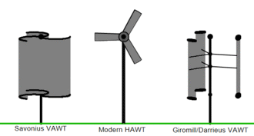**Types of Wind Mill: -** Wind turbines can rotate about either a horizontal or a vertical axis, the former being both older and more common. They can also include blades or be bladeless. Vertical designs produce less power and are less common. 1. Horizontal Axis 2. Vertical Axis.
   3. **Efficiency :** - Conservation of mass requires that the amount of air entering and exiting a turbine must be equal. Accordingly, Betz's law gives the maximal achievable extraction of wind power by a **wind turbine as 16/27 (59.3%) of the total kinetic energy** of the air flowing through the turbine.

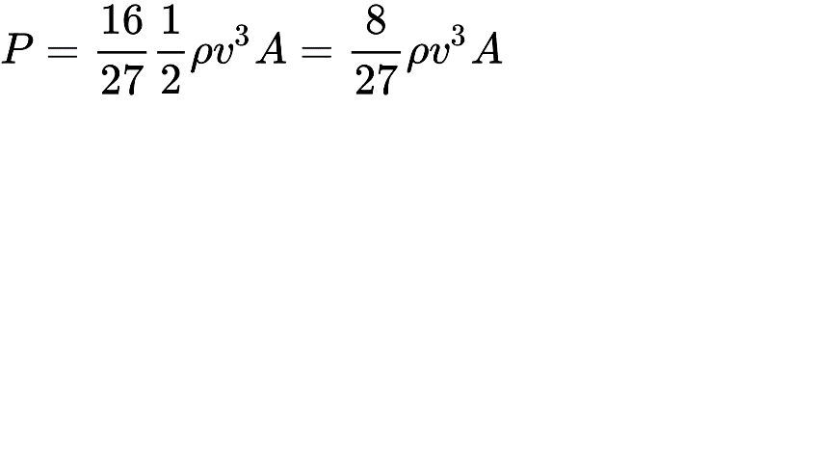The maximum theoretical power output of a wind machine is thus 16/27 times the kinetic energy of the air passing through the effective disk area of the machine. If the effective area of the disk is A, and the wind velocity v, the maximum theoretical power output P is:

where ρ is the air density.

As wind is free (no fuel cost), wind-to-rotor efficiency (including rotor blade friction and drag) is one of many aspects impacting the final price of wind power. Further inefficiencies, such as gearbox losses, generator and converter losses, reduce the power delivered by a wind turbine. To protect components from undue wear, extracted power is held constant above the rated operating speed as theoretical power increases at the cube of wind speed, further reducing theoretical efficiency. In 2001, **commercial utility-connected turbines deliver 75% to 80% of the Betz limit of power extractable from the wind, at rated operating speed.**

Efficiency can decrease slightly over time, one of the main reasons being dust and insect carcasses on the blades which alters the aerodynamic profile and essentially reduces the lift to drag ratio of the airfoil. Analysis of 3128 wind turbines older than 10 years in Denmark showed that half of the turbines had no decrease, while the other half saw a production decrease of 1.2% per year.Vertical turbine designs have much lower efficiency than standard horizontal designs.

1. 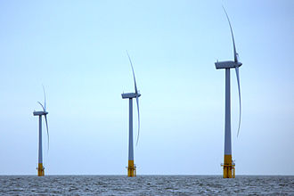**Horizontal axis Wind Turbine** : -

Components of a horizontal axis wind turbine (gearbox, rotor shaft and brake assembly) being lifted into position Large three-bladed horizontal-axis wind turbines (HAWT), with the blades upwind of the tower produce the overwhelming majority of windpower in the world today. These turbines have the main rotor shaft and electrical generator at the top of a tower and must be pointed into the wind. Small turbines are pointed by a simple wind vane, while large turbines generally use a wind sensor coupled with a yaw system. Most have a gearbox, which turns the slow rotation of the blades into a quicker rotation that is more suitable to drive an electrical ge nerator. Some turbines use a different type of generator suited to slower rotational speed input. These don't need a gearbox, and are called direct-drive, meaning they couple the rotor directly to the generator with no gearbox in between. While permanent magnet direct-drive generators can be costlier due to the rare earth materials required, these gearless turbines are sometimes preferred over gearbox generators because they "eliminate the gear-speed increaser, which is susceptible to significant accumulated fatigue torque loading, related reliability issues, and maintenance costs."

Most horizontal axis turbines have their rotors upwind of its supporting tower. Downwind machines have been built, because they don't need an additional mechanism for keeping them in line with the wind. In high winds, the blades can also be allowed to bend which reduces their swept area and thus their wind resistance. Despite these advantages, upwind designs are preferred, because the change in loading from the wind as each blade passes behind the supporting tower can cause damage to the turbine.

Turbines used in wind farms for commercial production of electric power are usually three-bladed. These have low torque ripple, which contributes to good reliability. The blades are usually colored white for daytime visibility by aircraft and range in length from 20 to 80 meters (66 to 262 ft). The size and height of turbines increase year by year. Offshore wind turbines are built up to 8MW today and have a blade length up to 80 meters (260 ft). Usual tubular steel towers of multi megawatt turbines have a height of 70 m to 120 m and in extremes up to 160 m.

1. **Vertical Axis Wind Turbine: -**

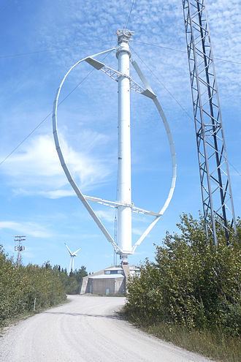A vertical-axis wind turbines (VAWT) is a type of wind turbine where the main rotor shaft is set transverse to the wind (but not necessarily vertically) while the main components are located at the base of the turbine. This arrangement allows the generator and gearbox to be located close to the ground, facilitating service and repair. VAWTs do not need to be pointed into the wind, which removes the need for wind-sensing and orientation mechanisms. Major drawbacks for the early designs (Savonius, Darrieus and giromill) included the significant torque variation or "ripple" during each revolution, and the large bending moments on the blades. Later designs addressed the torque ripple issue by sweeping the blades helically. Vertical-axis wind turbines (or VAWTs) have the main rotor shaft arranged vertically. One advantage of this arrangement is that the turbine does not need to be pointed into the wind to be effective, which is an advantage on a site where the wind direction is highly variable. It is also an advantage when the turbine is integrated into a building because it is inh erently less steerable. Also, the generator and gearbox can be placed near the ground, using a direct drive from the rotor assembly to the ground-based gearbox, improving accessibility for maintenance. However, these designs produce much less energy averaged over time, which is a major drawback.

When a turbine is mounted on a rooftop the building generally redirects wind over the roof and this can double the wind speed at the turbine. If the height of a rooftop mounted turbine tower is approximately 50% of the building height it is near the optimum for maximum wind energy and minimum wind turbulence. While wind speeds within the built environment are generally much lower than at exposed rural sites, noise may be a concern and an existing structure may not adequately resist the additional stress.

Vertical Axis Wind Turbine :

1. Types of Vertical Axis wind Turbines
   1. 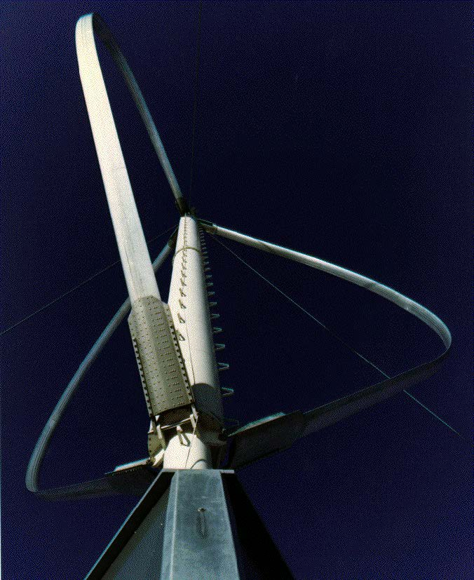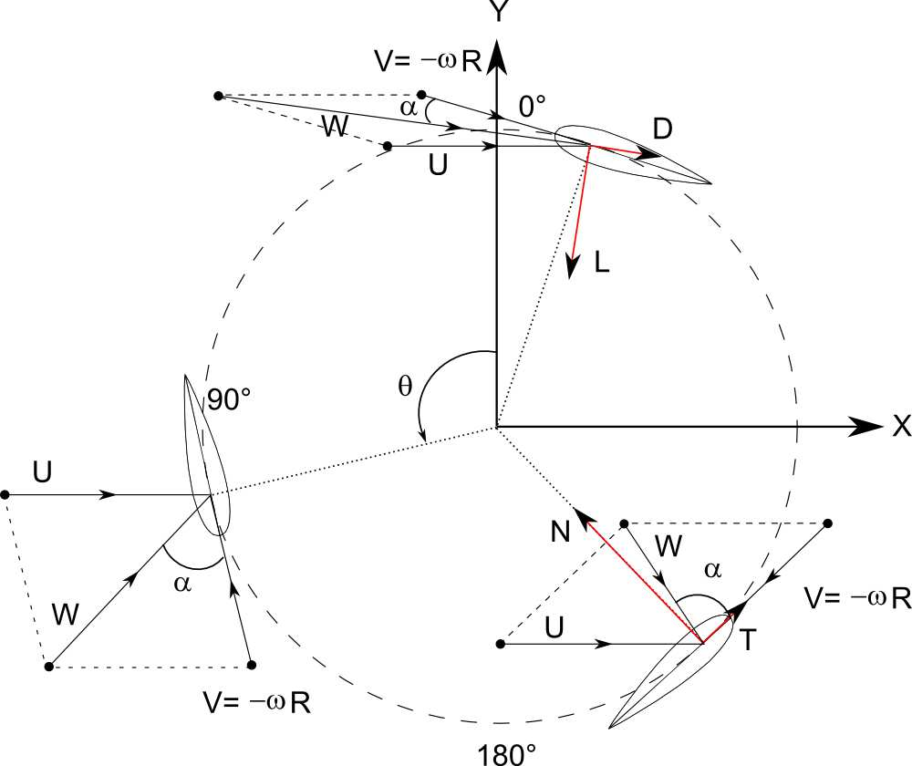**Darrieus wind turbine: -** Darrieus turbines, were named after the French inventor, Georges Darrieus. **“Turbine having its shaft transverse to the flow of the current”** They have good efficiency, but produce large torque ripple and cyclical stress on the tower, which contributes to poor reliability. They also generally require some external power source, or an additional Savonius rotor to start turning, because the starting torque is very low. The torque ripple is reduced by using three or more blades which results in greater solidity of the rotor. Solidity is measured by blade area divided by the rotor area. Newer Darrieus type turbines are not held up by guy-wires but have an external superstructure connected to the top bearing.

***Fig.Three-bladed Darrieus wind turbine Fig. Forces that act on the turbines***

* 1. ***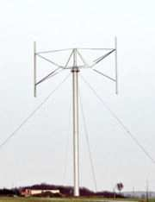*Giromill : -** A subtype of Darrieus turbine with straight, as opposed to curved, blades. The cycloturbine variety has variable pitch to reduce the torque pulsation and is self-starting. The advantages of variable pitch are: high starting torque; a wide, relatively flat torque curve; a higher coefficient of performance; more efficient operation in turbulent winds; and a lower blade speed ratio which lowers blade bending stresses. Straight, V, or curved blades may be used.
  2. **Savonius wind turbine : -**These are drag-type devices with two (or more) scoops that are used in anemometers, Flettner vents (commonly seen on bus and van roofs), and in some high-reliability low-efficiency power turbines. They are always self-starting if there are at least three scoops.Twisted Savonius is a modified savonius, with long helical scoops to provide smooth torque. This is often used as a rooftop windturbine and has even been adapted for ships.
  3. **Use and operation:-** The Savonius is a drag-type VAWT, so it cannot rotate faster than the wind speed. This means that the tip speed ratio is equal to 1 or smaller, making this turbine not very suitable for electricity generation. Moreover, the efficiency is very low compared to other types, so it can be employed for other uses, such as pumping water or grinding grain. Much of the swept area of near the ground, making the overall energy extraction less effective due to lower wind speed at lower heights. Its best qualities are the simplicity, the reliability and very low noise production. It can operate well also at low wind speed because the torque is very high especially in these conditions. However, the torque is not constant, so often some improvements like helical shape are used.



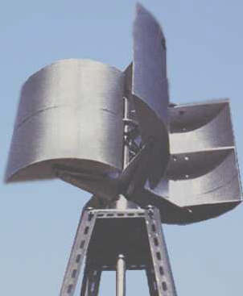

Fig. Savonious rotor Fig. Savonious wind mill