Spark Streaming

1、课程目标

目标1：掌握Spark Streaming的原理

目标2：熟练使用Spark Streaming完成流式计算任务

2、Spark Streaming介绍

2.1、Spark Streaming概述

2.1.1、什么是Spark Streaming
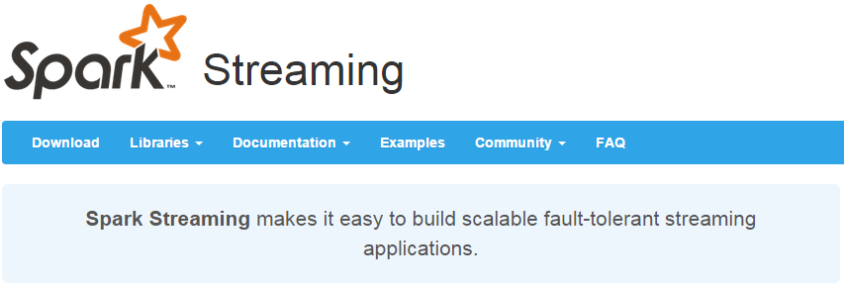
Spark Streaming类似于Apache Storm，用于流式数据的处理。根据其官方文档介绍，Spark Streaming有高吞吐量和容错能力强等特点。Spark Streaming支持的数据输入源很多，例如：Kafka、Flume、Twitter、ZeroMQ和简单的TCP套接字等等。数据输入后可以用Spark的高度抽象原语如：map、reduce、join、window等进行运算。而结果也能保存在很多地方，如HDFS，数据库等。另外Spark Streaming也能和MLlib（机器学习）以及Graphx完美融合。
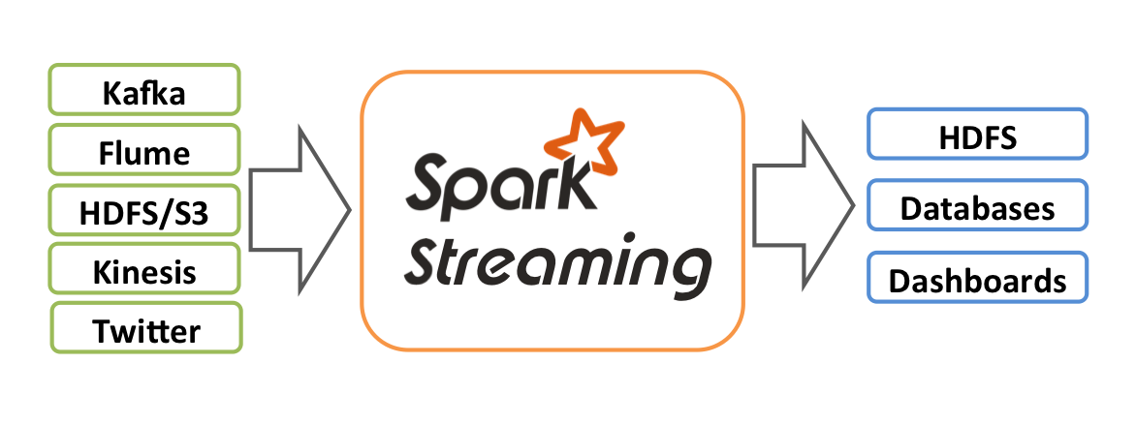

2.1.2、为什么要学习Spark Streaming

- 易用
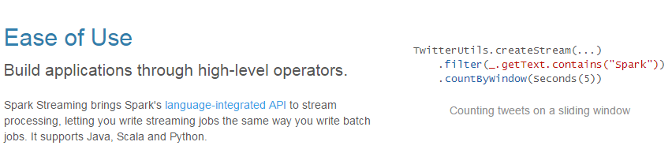
- 容错
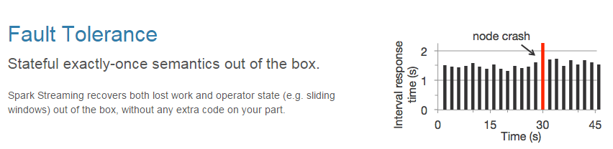
- 易整合到Spark体系
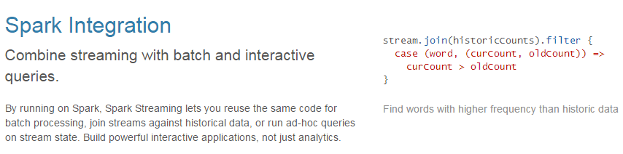

2.1.3、Spark与Storm的对比
Spark | Storm
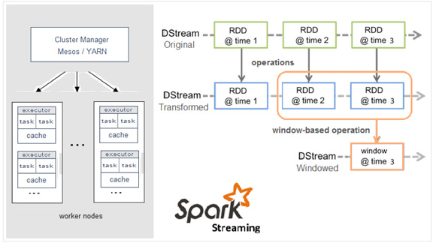 | 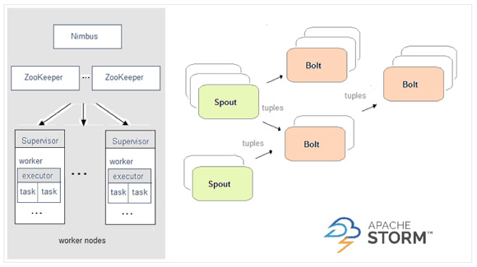
开发语言：Scala | 开发语言：Clojure
编程模型：DStream | 编程模型：Spout/Bolt
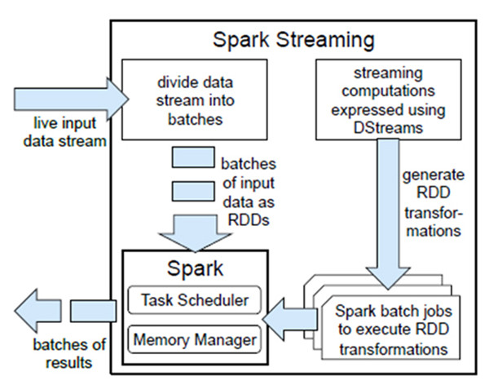 | 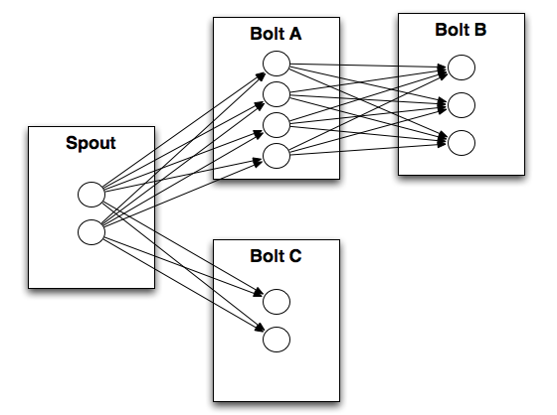

3、DStream

3.1、什么是DStream
Discretized Stream是Spark Streaming的基础抽象，代表持续性的数据流和经过各种Spark原语操作后的结果数据流。在内部实现上，DStream是一系列连续的RDD来表示。每个RDD含有一段时间间隔内的数据，如下图：
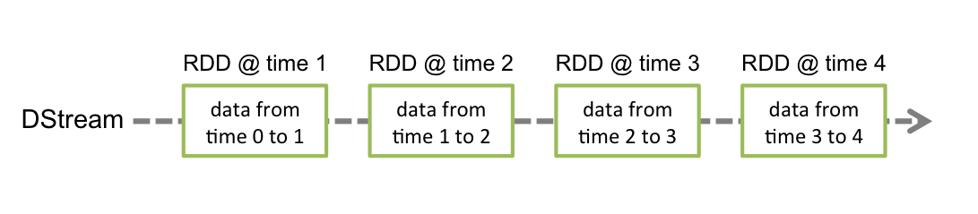
对数据的操作也是按照RDD为单位来进行的
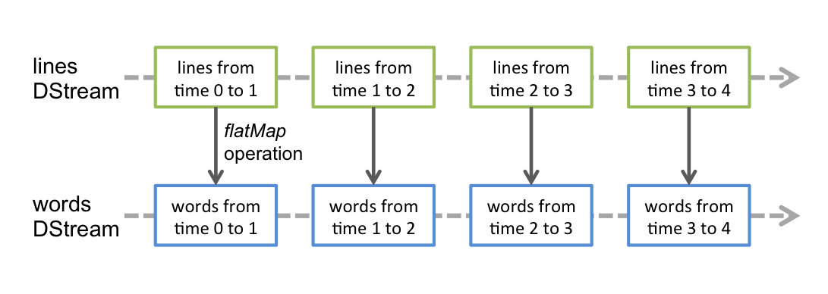
计算过程由Spark engine来完成
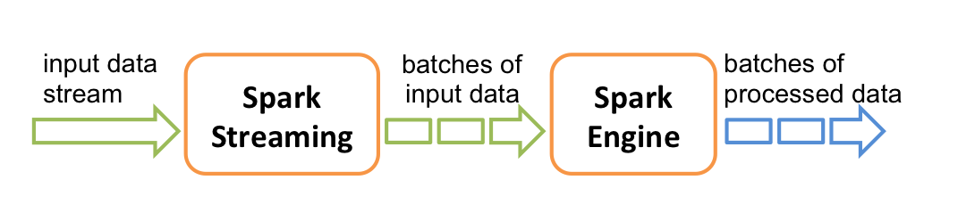

3.2、DStream相关操作
DStream上的原语与RDD的类似，分为Transformations（转换）和Output Operations（输出）两种，此外转换操作中还有一些比较特殊的原语，如：updateStateByKey()、transform()以及各种Window相关的原语。

3.2.1、Transformations on DStreams
Transformation | Meaning
map(func) | Return a new DStream by passing each element of the source DStream through a function func.
flatMap(func) | Similar to map, but each input item can be mapped to 0 or more output items.
filter(func) | Return a new DStream by selecting only the records of the source DStream on which func returns true.
repartition(numPartitions) | Changes the level of parallelism in this DStream by creating more or fewer partitions.
union(otherStream) | Return a new DStream that contains the union of the elements in the source DStream and otherDStream.
count() | Return a new DStream of single-element RDDs by counting the number of elements in each RDD of the source DStream.
reduce(func) | Return a new DStream of single-element RDDs by aggregating the elements in each RDD of the source DStream using a function func (which takes two arguments and returns one). The function should be associative so that it can be computed in parallel.
countByValue() | When called on a DStream of elements of type K, return a new DStream of (K, Long) pairs where the value of each key is its frequency in each RDD of the source DStream.
reduceByKey(func, [numTasks]) | When called on a DStream of (K, V) pairs, return a new DStream of (K, V) pairs where the values for each key are aggregated using the given reduce function. Note: By default, this uses Spark's default number of parallel tasks (2 for local mode, and in cluster mode the number is determined by the config property spark.default.parallelism) to do the grouping. You can pass an optional numTasks argument to set a different number of tasks.
join(otherStream, [numTasks]) | When called on two DStreams of (K, V) and (K, W) pairs, return a new DStream of (K, (V, W)) pairs with all pairs of elements for each key.
cogroup(otherStream, [numTasks]) | When called on a DStream of (K, V) and (K, W) pairs, return a new DStream of (K, Seq[V], Seq[W]) tuples.
transform(func) | Return a new DStream by applying a RDD-to-RDD function to every RDD of the source DStream. This can be used to do arbitrary RDD operations on the DStream.
updateStateByKey(func) | Return a new "state" DStream where the state for each key is updated by applying the given function on the previous state of the key and the new values for the key. This can be used to maintain arbitrary state data for each key.

特殊的Transformations

- UpdateStateByKey Operation
UpdateStateByKey原语用于记录历史记录，上文中Word Count示例中就用到了该特性。若不用UpdateStateByKey来更新状态，那么每次数据进来后分析完成后，结果输出后将不在保存

- Transform Operation
Transform原语允许DStream上执行任意的RDD-to-RDD函数。通过该函数可以方便的扩展Spark API。此外，MLlib（机器学习）以及Graphx也是通过本函数来进行结合的。

- Window Operations
Window Operations有点类似于Storm中的State，可以设置窗口的大小和滑动窗口的间隔来动态的获取当前Steaming的允许状态
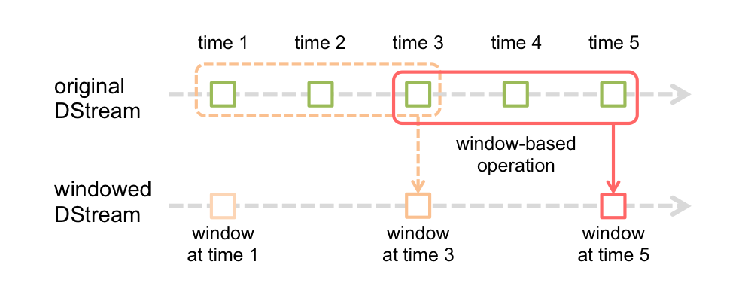

3.2.2、Output Operations on DStreams
Output Operations可以将DStream的数据输出到外部的数据库或文件系统，当某个Output Operations原语被调用时（与RDD的Action相同），streaming程序才会开始真正的计算过程。
Output Operation | Meaning
print() | Prints the first ten elements of every batch of data in a DStream on the driver node running the streaming application. This is useful for development and debugging.
saveAsTextFiles(prefix, [suffix]) | Save this DStream's contents as text files. The file name at each batch interval is generated based on prefix and suffix: "prefix-TIME_IN_MS[.suffix]".
saveAsObjectFiles(prefix, [suffix]) | Save this DStream's contents as SequenceFiles of serialized Java objects. The file name at each batch interval is generated based on prefix and suffix: "prefix-TIME_IN_MS[.suffix]".
saveAsHadoopFiles(prefix, [suffix]) | Save this DStream's contents as Hadoop files. The file name at each batch interval is generated based on prefix and suffix: "prefix-TIME_IN_MS[.suffix]".
foreachRDD(func) | The most generic output operator that applies a function, func, to each RDD generated from the stream. This function should push the data in each RDD to an external system, such as saving the RDD to files, or writing it over the network to a database. Note that the function func is executed in the driver process running the streaming application, and will usually have RDD actions in it that will force the computation of the streaming RDDs.

4、实战

4.1、用Spark Streaming实现实时WordCount
架构图：
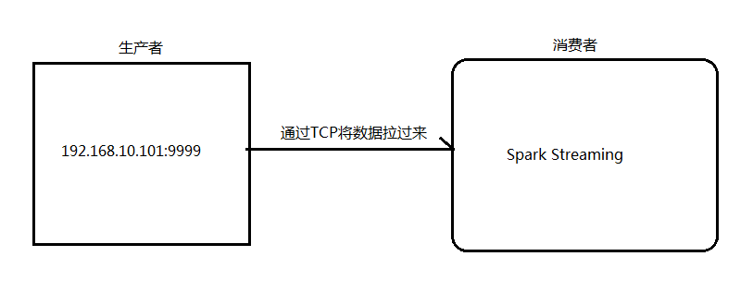
- 安装并启动生成者
首先在一台Linux（ip：192.168.10.101）上用YUM安装nc工具
yum install -y nc

启动一个服务端并监听9999端口
nc -lk 9999

- 编写Spark Streaming程序
package cn.itcast.spark.streaming
import cn.itcast.spark.util.LoggerLevel
import org.apache.spark.SparkConf
import org.apache.spark.streaming.{Seconds, StreamingContext}
object NetworkWordCount {
def main(args: Array[String]) {
//设置日志级别
LoggerLevel.setStreamingLogLevels()
//创建SparkConf并设置为本地模式运行
//注意local[2]代表开两个线程
val conf = new SparkConf().setMaster("local[2]").setAppName("NetworkWordCount")
//设置DStream批次时间间隔为2秒
val ssc = new StreamingContext(conf, Seconds(2))
//通过网络读取数据
val lines = ssc.socketTextStream("192.168.10.101", 9999)
//将读到的数据用空格切成单词
val words = lines.flatMap(_.split(" "))
//将单词和1组成一个pair
val pairs = words.map(word => (word, 1))
//按单词进行分组求相同单词出现的次数
val wordCounts = pairs.reduceByKey(_ + _)
//打印结果到控制台
wordCounts.print()
//开始计算
ssc.start()
//等待停止
ssc.awaitTermination()
}
}

3.启动Spark Streaming程序：由于使用的是本地模式"local[2]"所以可以直接在本地运行该程序
注意：要指定并行度，如在本地运行设置setMaster("local[2]")，相当于启动两个线程，一个给receiver，一个给computer。如果是在集群中运行，必须要求集群中可用core数大于1
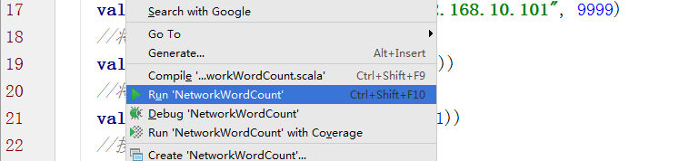

4.在Linux端命令行中输入单词
- 在IDEA控制台中查看结果
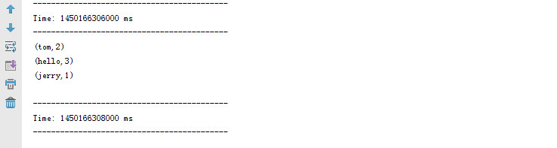
问题：结果每次在Linux段输入的单词次数都被正确的统计出来，但是结果不能累加！如果需要累加需要使用updateStateByKey(func)来更新状态，下面给出一个例子：
package cn.itcast.spark.streaming
import cn.itcast.spark.util.LoggerLevel
import org.apache.spark.{HashPartitioner, SparkConf}
import org.apache.spark.streaming.{StreamingContext, Seconds}
object NetworkUpdateStateWordCount {
/**
* String : 单词 hello
* Seq[Int] ：单词在当前批次出现的次数
* Option[Int] ： 历史结果
*/
val updateFunc = (iter: Iterator[(String, Seq[Int], Option[Int])]) => {
//iter.flatMap(it=>Some(it._2.sum + it._3.getOrElse(0)).map(x=>(it._1,x)))
iter.flatMap{case(x,y,z)=>Some(y.sum + z.getOrElse(0)).map(m=>(x, m))}
}
def main(args: Array[String]) {
LoggerLevel.setStreamingLogLevels()
val conf = new SparkConf().setMaster("local[2]").setAppName("NetworkUpdateStateWordCount")
val ssc = new StreamingContext(conf, Seconds(5))
//做checkpoint 写入共享存储中
ssc.checkpoint("c://aaa")
val lines = ssc.socketTextStream("192.168.10.100", 9999)
//reduceByKey 结果不累加
//val result = lines.flatMap(_.split(" ")).map((_, 1)).reduceByKey(_+_)
//updateStateByKey结果可以累加但是需要传入一个自定义的累加函数：updateFunc
val results = lines.flatMap(_.split(" ")).map((_,1)).updateStateByKey(updateFunc, new HashPartitioner(ssc.sparkContext.defaultParallelism), true)
results.print()
ssc.start()
ssc.awaitTermination()
}
}

4.2、Spark Streaming整合Kafka完成网站点击流实时统计
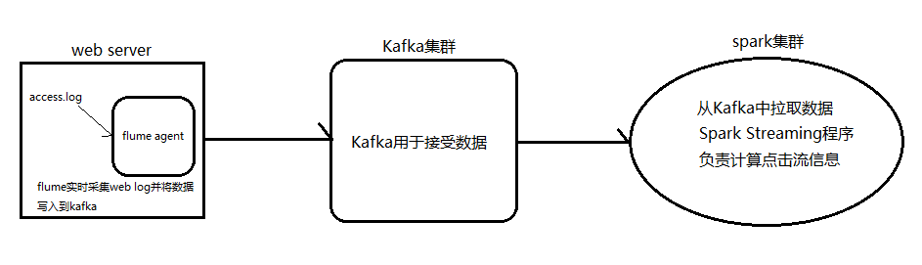
- 安装并配置zk
- 安装并配置Kafka
- 启动zk
- 启动Kafka
- 创建topic
bin/kafka-topics.sh --create --zookeeper node1.itcast.cn:2181,node2.itcast.cn:2181 \
--replication-factor 3 --partitions 3 --topic urlcount
- 编写Spark Streaming应用程序
package cn.itcast.spark.streaming
package cn.itcast.spark
import org.apache.spark.{HashPartitioner, SparkConf}
import org.apache.spark.storage.StorageLevel
import org.apache.spark.streaming.kafka.KafkaUtils
import org.apache.spark.streaming.{Seconds, StreamingContext}
object UrlCount {
val updateFunc = (iterator: Iterator[(String, Seq[Int], Option[Int])]) => {
iterator.flatMap{case(x,y,z)=> Some(y.sum + z.getOrElse(0)).map(n=>(x, n))}
}
def main(args: Array[String]) {
//接收命令行中的参数
val Array(zkQuorum, groupId, topics, numThreads, hdfs) = args
//创建SparkConf并设置AppName
val conf = new SparkConf().setAppName("UrlCount")
//创建StreamingContext
val ssc = new StreamingContext(conf, Seconds(2))
//设置检查点
ssc.checkpoint(hdfs)
//设置topic信息
val topicMap = topics.split(",").map((_, numThreads.toInt)).toMap
//重Kafka中拉取数据创建DStream
val lines = KafkaUtils.createStream(ssc, zkQuorum ,groupId, topicMap, StorageLevel.MEMORY_AND_DISK).map(_._2)
//切分数据，截取用户点击的url
val urls = lines.map(x=>(x.split(" ")(6), 1))
//统计URL点击量
val result = urls.updateStateByKey(updateFunc, new HashPartitioner(ssc.sparkContext.defaultParallelism), true)
//将结果打印到控制台
result.print()
ssc.start()
ssc.awaitTermination()
}
}

spark on yarn介绍

5.1、官方文档
http://spark.apache.org/docs/latest/running-on-yarn.html

5.2、配置安装

5.2.1、安装hadoop：
需要安装HDFS模块和YARN模块，HDFS必须安装，spark运行时要把jar包存放到HDFS上。

5.2.2、安装Spark：
解压Spark安装程序到一台服务器上，修改spark-env.sh配置文件，spark程序将作为YARN的客户端用于提交任务
export JAVA_HOME=/usr/local/jdk1.7.0_80
export HADOOP_CONF_DIR=/usr/local/hadoop-2.6.4/etc/hadoop

5.2.3、启动HDFS和YARN

5.3、运行模式（cluster模式和client模式）

5.3.1、cluster模式
./bin/spark-submit --class org.apache.spark.examples.SparkPi \
--master yarn \
--deploy-mode cluster \
--driver-memory 1g \
--executor-memory 1g \
--executor-cores 2 \
--queue default \
lib/spark-examples*.jar \
10

----------------------------------------------------------------------------------------------------------------------
./bin/spark-submit --class cn.itcast.spark.day1.WordCount \
--master yarn \
--deploy-mode cluster \
--driver-memory 1g \
--executor-memory 1g \
--executor-cores 2 \
--queue default \
/home/bigdata/hello-spark-1.0.jar \
hdfs://node-1.itcast.cn:9000/wc hdfs://node-1.itcast.cn:9000/out-yarn-1

5.3.2、client模式
./bin/spark-submit --class org.apache.spark.examples.SparkPi \
--master yarn \
--deploy-mode client \
--driver-memory 1g \
--executor-memory 1g \
--executor-cores 2 \
--queue default \
lib/spark-examples*.jar \
10

spark-shell必须使用client模式
./bin/spark-shell --master yarn --deploy-mode client

5.3.3、两种模式的区别
cluster模式：Driver程序在YARN中运行，应用的运行结果不能在客户端显示，所以最好运行那些将结果最终保存在外部存储介质（如HDFS、Redis、Mysql）而非stdout输出的应用程序，客户端的终端显示的仅是作为YARN的job的简单运行状况。
client模式：Driver运行在Client上，应用程序运行结果会在客户端显示，所有适合运行结果有输出的应用程序（如spark-shell）

- 原理
cluster模式：
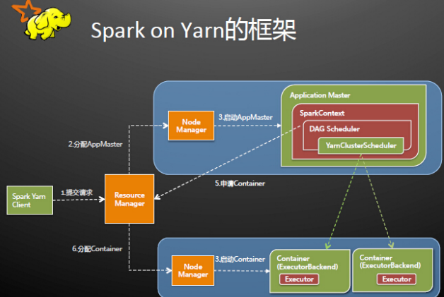
Spark Driver首先作为一个ApplicationMaster在YARN集群中启动，客户端提交给ResourceManager的每一个job都会在集群的NodeManager节点上分配一个唯一的ApplicationMaster，由该ApplicationMaster管理全生命周期的应用。具体过程：
1. 由client向ResourceManager提交请求，并上传jar到HDFS上
这期间包括四个步骤：
a).连接到RM
b).从RM的ASM（ApplicationsManager ）中获得metric、queue和resource等信息。
c). upload app jar and spark-assembly jar
d).设置运行环境和container上下文（launch-container.sh等脚本)
2. ResouceManager向NodeManager申请资源，创建Spark ApplicationMaster（每个SparkContext都有一个ApplicationMaster）
3. NodeManager启动ApplicationMaster，并向ResourceManager AsM注册
4. ApplicationMaster从HDFS中找到jar文件，启动SparkContext、DAGscheduler和YARN Cluster Scheduler
5. ResourceManager向ResourceManager AsM注册申请container资源
6. ResourceManager通知NodeManager分配Container，这时可以收到来自ASM关于container的报告。（每个container对应一个executor）
7. Spark ApplicationMaster直接和container（executor）进行交互，完成这个分布式任务。

client模式：
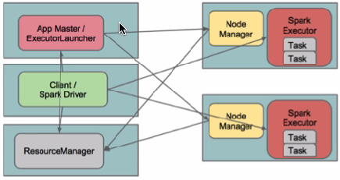
在client模式下，Driver运行在Client上，通过ApplicationMaster向RM获取资源。本地Driver负责与所有的executor container进行交互，并将最后的结果汇总。结束掉终端，相当于kill掉这个spark应用。一般来说，如果运行的结果仅仅返回到terminal上时需要配置这个。
客户端的Driver将应用提交给Yarn后，Yarn会先后启动ApplicationMaster和executor，另外ApplicationMaster和executor都 是装载在container里运行，container默认的内存是1G，ApplicationMaster分配的内存是driver- memory，executor分配的内存是executor-memory。同时，因为Driver在客户端，所以程序的运行结果可以在客户端显 示，Driver以进程名为SparkSubmit的形式存在。

