Software Requirements Specification
for
Stock Market Dashboard
Version 1.0 approved
Prepared by
Vaishnavi Mishra(16IT145)
Farris Suhale (16IT218)
Software Engineering (IT350) Mini-Project
Date created: 17/01/2019
Table of Contents
Table of Contents ii
Revision History ii
1. Introduction 1
1.1 Purpose 1
1.2 Document Conventions 1
1.3 Intended Audience and Reading Suggestions 1
1.4 Product Scope 1
1.5 References 1
2. Overall Description 2
2.1 Product Perspective 2
2.2 Product Functions 2
2.3 User Classes and Characteristics 2
2.4 Operating Environment 2
2.5 Design and Implementation Constraints 2
2.6 User Documentation 2
2.7 Assumptions and Dependencies 3
3. External Interface Requirements 3
3.1 User Interfaces 3
3.2 Hardware Interfaces 3
3.3 Software Interfaces 3
3.4 Communications Interfaces 3
4. System Features 4
4.1 System Feature 1 4
4.2 System Feature 2 (and so on) 4
5. Other Nonfunctional Requirements 4
5.1 Performance Requirements 4
5.2 Safety Requirements 5
5.3 Security Requirements 5
5.4 Software Quality Attributes 5
5.5 Business Rules 5
6. Other Requirements 5
Appendix A: Glossary 5
Appendix B: Analysis Models 5
Appendix C: To Be Determined List 6

Revision History
Name | Date | Reason For Changes | Version
Created SRS | 17.01.19 | Initial commit | 1.0
SRS structuring | 23.02.19 | Structured document using IEEE format | 1.0

Introduction

Purpose
Stock Market Dashboard is a website with real time stock prices, stock history of selected stocks, live news updates related to stocks and chatroom facilities for discussing with experts. Login capabilities enable personalization. The purpose of this document is to present a detailed description of the E-commerce web application. It will explain the purpose and features of the system, the interfaces of the system, what the system will do, the constraints under which it must operate and how the system will react to external stimuli. This document is intended for both the stakeholders and the developers of the system.
Release 1, revision 1.

Document Conventions
- The document is prepared in standard IEEE template using Google Docs .
- All the headings in the document are in 18 point Times New Roman with single spacing.
- The sub-headings are 14 point Times New Roman.
- The font of the corresponding body is 11 point Arial.

Intended Audience and Reading Suggestions
The Software Requirements Specification document provided in intended for a plethora of
readers. These include and not limited to,Developers,Project Managers,Database
Managers,Marketing Staff,Quality Assurance testers,Interface Designers,Documentation Writers
and the Users.
The intended order of reading to be followed is to start from the beginning,followed by the
particular sections intended for each of the different types of readers.
For example,it is imperative for a Developer or Quality Assurance tester to read all the
sections:Introduction,Overall Description,External Interface Requirements,System
Features,Non-functional Requirements and Other Requirements along with the glossary,as they
need to understand the project thoroughly to implement it further or test the various features that
the project offers.
However,a User,Marketing Employee or Manager who will not directly be affecting the
development of the project need not have a technical understanding of the project.They will
however be required to read the sections of:Introduction,Overall Description and System
Features to gain a good understanding of the workings of the project.

A Designer would have to understand the project in order to create the design language and
features in the User Interface,therefore the sections pertinent to him/her are:Introduction,Overall
Description,External Interface Requirements and System Features.

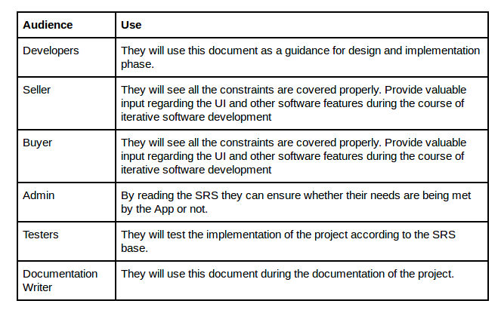

Product Scope
This software system will be a Web Application which is created for users to check real time stock prices along with stock history of selected stocks, live news updates related to stocks and chatroom facilities. This helps in better understand of the stock market and understanding what to invest in when.

References
IEEE. IEEE Std 830-1998 IEEE Recommended Practice for Software Requirements
Specifications. IEEE Computer Society, 1998.

Overall Description

Product Perspective
The product originated from our interest in the stock market but lack of understanding of it. Using financial experts and graphical displays stock market trends can be analyzed more easily. This is our replacement for existing stock market dashboards as real-time news updates enable better up-to-date decisions.
This software system will be a Web Application which is created for users to check real time stock prices along with stock history of selected stocks, live news updates related to stocks and chatroom facilities. This helps in better understand of the stock market and understanding what to invest in when.

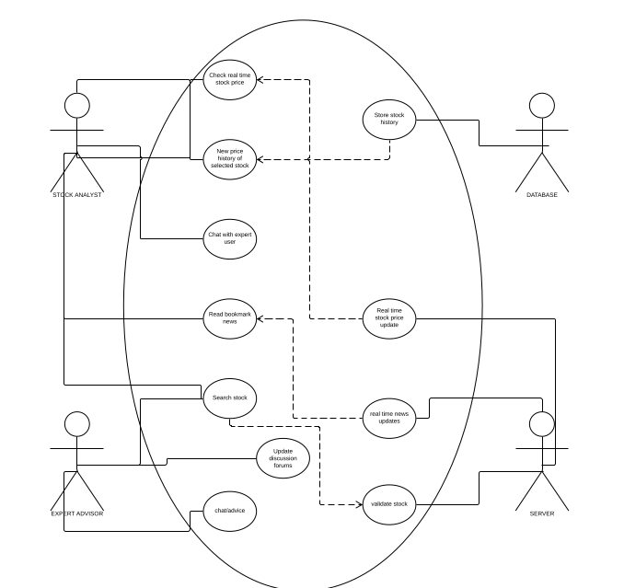

Product Functions
Functions of our software include:
1. View live stock prices
2. View stock price history and trends
3. View real time news updates related to stocks
4. Chat with experts or other users
5. Login and personalize- bookmark stocks

User Classes and Characteristics
User classes that would use this software:
1. Stock market analysts – login functions to save favourite stocks.
2. Financial experts – provide advise
3. Novice user requiring real time stock market updates- will require pictorial graphs for better understanding of financial trends. Require advise of financial experts
The most important user class of these is the Stock market analyst.

Operating Environment
Regarding Hardware and Software environments,the application has been optimized to run on
all browsers. It has also been optimized to run on all devices,including Personal
Computers,Laptops,Tablets and Mobile Phones.
The only other software required to run the application is any Web Browser(Mozilla
Firefox,Google Chrome,Apple Safari,Opera etc).
The application is not resource- or graphics-intensive, so there are no practical hardware constraints. The application will rely on Django for the backend and Bootstrap for the frontend.

Design and Implementation Constraints
Our web application, being easy to use and requiring no programming, designing or financial skills, is usable by all users.
No items or issues will limit the options available to the developers. These include: corporate or regulatory policies; hardware limitations (timing requirements, memory requirements); interfaces to other applications; specific technologies, tools, and databases to be used; parallel operations; language requirements; communications protocols; security considerations; design conventions or programming standards.
Simply opening up the dashboard will get you started.

User Documentation
SRS will be delivered along with the website.
<List the user documentation components (such as user manuals, on-line help, and tutorials) that will be delivered along with the software. Identify any known user documentation delivery formats or standards.>

Assumptions and Dependencies
We assume that the user is capable physically and mentally of accessing the internet and therefore our application.

External Interface Requirements

User Interfaces
The website is user friendly, easily navigable by novice users and intuitive. The colour schemes, positioning of text, images, news updates etc are all aesthetic, understandable and follows logical sequencing or positioning. Standard buttons and functions (e.g., help) will appear on every screen, keyboard shortcuts, error message display standards, and so on and any user familiarizing with this website will understand it easily and adapt to using it.
<Describe the logical characteristics of each interface between the software product and the users. This may include sample screen images, any GUI standards or product family style guides that are to be followed, screen layout constraints, standard buttons and functions (e.g., help) that will appear on every screen, keyboard shortcuts, error message display standards, and so on. Define the software components for which a user interface is needed. Details of the user interface design should be documented in a separate user interface specification.>

Hardware Interfaces
Our website deals with front end and therefore hardware interfaces are irrelevant here.
<Describe the logical and physical characteristics of each interface between the software product and the hardware components of the system. This may include the supported device types, the nature of the data and control interactions between the software and the hardware, and communication protocols to be used.>

Software Interfaces
Software interfaces used:
- We propose to use some API for fetching the live stock price information.
- We will use an API for obtaining real time news updates
- We will also use APIs in chatroom facilities
- For designing Web App we will be using Django and as for mobile,the web app can be accessed using any web browser commonly available.
- Website Development will require framework like Django.
- Most of the softwares used will be Open Source.
- Communication between server and Database is done using MySQL

Communications Interfaces
- Chatroom facilities require a communication-based API.
- APIs will inherently use various communication protocols like HTTP or database might employ FTP
- Communicating with the database of the server requires MySQL

System Features
The multitude of usages our product provides are evident in its manyfold features which are listed below.

Live Stock Prices
4.1.1 Description and Priority
This high priority feature is the focus of our website. Real-time stock prices are fetched by the server using an API and returned to the user at a time interval that is selectable by the user. These stock prices are constantly updated even without prompting from the user. The time period of updation is also selectabgle by the user.

4.1.2 Stimulus/Response Sequences
Opening up of the main page I.e the dashboard on the web browser will display a list of live stock prices to the side. This can either be viewed right there or can be enlarged to a full screen. In response to this, all live stock prices will show up on the screen and the user is free to scroll and browse.
4.1.3 Functional Requirements
- This feature uses a predefined API in order to fetch the live stock prices. The API in recurringly accessed in order to keep stock prices up-to-date.
- On the user end, only a web browser is needed and a good wifi connection.

Stock Search and History
4.2.1 Description and Priority
This high priority feature is another focus of our website. By using the search bar to search for a particular stock of user interest, real-time stock prices are fetched by the server using an API and returned along with a stock history for a selectable time period. Stock history for selected stocks is stored in the database.

4.2.2 Stimulus/Response Sequences
Opening up of the main page I.e the dashboard on the web browser will display a search bar on top. The stock name can be entered in this search bar, and in case of a valid search, the said details of the particular stock will be returned.
4.2.3 Functional Requirements
- This feature uses a predefined API in order to fetch the live stock prices. The API in recurringly accessed in order to keep stock prices up-to-date.
- MySQL is required in order to fetch stock price history of the particular stored stocks from the database.
- On the user end, only a web browser is needed and a good wifi connection.

Real-time News Updates
4.3.1 Description and Priority
This high priority feature is another focus of our website. Through an API,

4.3.2 Stimulus/Response Sequences
Opening up of the main page I.e the dashboard on the web browser will display a search bar on top. The stock name can be entered in this search bar, and in case of a valid search, the said details of the particular stock will be returned.
4.3.3 Functional Requirements
- This feature uses a predefined API in order to fetch the live news updates.
- On the user end, only a web browser is needed and a good wifi connection.

Other Nonfunctional Requirements

Performance Requirements
- Data from the server should be fetched within 2 seconds.
- Query results must return within 5 seconds
- News updates must be fetched within 2 seconds

Safety Requirements
- Under failure, system should be able to come back at normal operation in one or two hours.
- Stock prices should be made available within 5 seconds of change in actual index

Security Requirements
- All external communications between the data’s server and client must be encrypted.
- All data must be stored and protected.

Software Quality Attributes
- The website is easy to use.
- All the features present in the website are easy to locate.
- The website uses simple English so that the user does not get confused with the terms

Business Rules
- System Admin - It will be the system administrator. He will maintain the overall website.
- Stock analyst - It includes the people who will view stock-related information.
- Financial expert- Academia who gives advice about stocks and trends

Other Requirements
Appendix A: Glossary
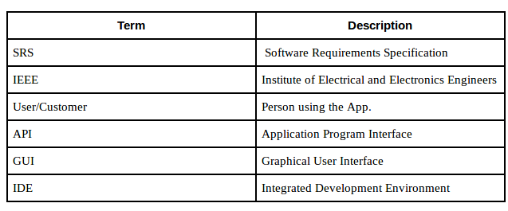

Appendix B: Analysis Models
Not yet done as the application is still in development phase.

Appendix C: To Be Determined List
Not yet done as the application is still in development phase.

